Hanoi University of Science and Technology

School of Engineering Physics

LAB REPORT

For Electrics and Thermodynamics

**Experiment 2**

Student name : Nguyen Viet Anh

Student ID : 20150143

Group number : 1

Name: Nguyen Viet Anh Date: 1stApril 2017

ID : 20150143

**Experiment 2**

**Measurement of magnetic field inside a solenoid with finite length**

1. **Purpose**

* Explore the relationship between the magnetic field and the current through the solenoid.
* Calculate the magnetic field produced by a short, thick solenoid considered as theoretical prediction then compare to the measured fields.

1. **Experiment results:**
2. **Investigation of the magnetic field at the positions along the axis of solenoid - B(x)**

**\*\*\* Measurement result (***I = 0.35 (A) U = 6(V))*

**Table 1:**

|  |  |  |  |  |  |  |  |  |  |  |  |
| --- | --- | --- | --- | --- | --- | --- | --- | --- | --- | --- | --- |
| **x (cm)** | 0 | 1 | 2 | 3 | 4 | 5 | 6 | 7 | 8 | 9 | 10 |
| **B (mT)** | 0.79 | 1.24 | 1.43 | 1.52 | 1.56 | 1.59 | 1.50 | 1.51 | 1.51 | 1.52 | 1.53 |

|  |  |  |  |  |  |  |  |  |  |  |
| --- | --- | --- | --- | --- | --- | --- | --- | --- | --- | --- |
| **x (cm)** | 11 | 12 | 13 | 14 | 15 | 16 | 17 | 18 | 19 | 20 |
| **B (mT)** | 1.53 | 1.53 | 1.53 | 1.53 | 1.53 | 1.53 | 1.53 | 1.53 | 1.53 | 1.53 |

|  |  |  |  |  |  |  |  |  |  |  |
| --- | --- | --- | --- | --- | --- | --- | --- | --- | --- | --- |
| **x (cm)** | 21 | 22 | 23 | 24 | 25 | 26 | 27 | 28 | 29 | 30 |
| **B (mT)** | 1.52 | 1.52 | 1.50 | 1.50 | 1.59 | 1.57 | 1.52 | 1.45 | 1.29 | 0.92 |

**\*\*\* Calculate using theory:**

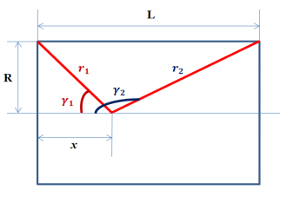

**-** The theoretical magnetic field :



where:

|  |  |  |
| --- | --- | --- |
| n = 2500turn/m | R = 2.02 cm | L = 30 cm |
|  |  |  |

* **Theoretical data table**

|  |  |  |  |  |  |  |  |  |  |  |  |
| --- | --- | --- | --- | --- | --- | --- | --- | --- | --- | --- | --- |
| **x (cm)** | 0 | 1 | 2 | 3 | 4 | 5 | 6 | 7 | 8 | 9 | 10 |
| **B (mT)** | 0.78 | 1.12 | 1.32 | 1.42 | 1.47 | 1.50 | 1.51 | 1.52 | 1.53 | 1.53 | 1.54 |

|  |  |  |  |  |  |  |  |  |  |  |
| --- | --- | --- | --- | --- | --- | --- | --- | --- | --- | --- |
| **x (cm)** | 11 | 12 | 13 | 14 | 15 | 16 | 17 | 18 | 19 | 20 |
| **B (mT)** | 1.54 | 1.54 | 1.54 | 1.54 | 1.54 | 1.54 | 1.54 | 1.54 | 1.54 | 1.54 |

|  |  |  |  |  |  |  |  |  |  |  |
| --- | --- | --- | --- | --- | --- | --- | --- | --- | --- | --- |
| **x (cm)** | 21 | 22 | 23 | 24 | 25 | 26 | 27 | 28 | 29 | 30 |
| **B (mT)** | 1.53 | 1.52 | 1.51 | 1.50 | 1.47 | 1.42 | 1.32 | 1.12 | 0.78 | 1.53 |

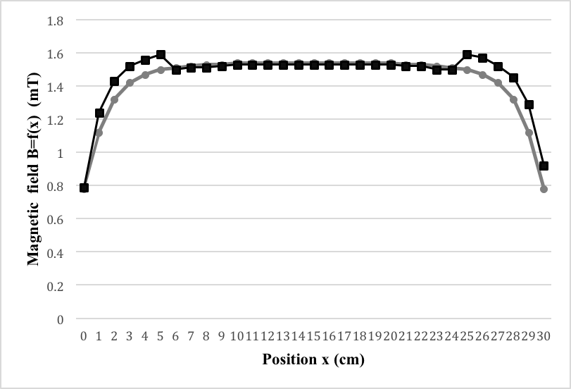





Plot of ***B = f(x)*** based on the measured results.

**Comment:**

* The graph show that the magnetic field inside a solenoid depends on the position of the probe inside. The magnitude of the magnetic field increase from 0.79 to 1.59 when x from 0 -> 5 cm, and then stable until x = 25cm then decrease with exact the same pace as it increase. The graph is symmetric around the point x=15 (cm)

=> The magnetic field is uniform at the middle and less uniform at two ends.

1. **Measurement of the relationship between the magnetic field and the current through the solenoid - B(I)**

**\*\*\* Measurement result**

*x = 15cm*

|  |  |  |  |  |  |  |  |
| --- | --- | --- | --- | --- | --- | --- | --- |
| **I (A)** | 0.1 | 0.2 | 0.3 | 0.4 | 0.5 | 0.6 | 0.7 |
| **B (mT)** | 0.65 | 1.05 | 1.56 | 2.06 | 2.54 | 3.02 | 3.53 |

**\*\*\* Calculate using theory:**

Theoretical equation:



where:

|  |  |  |  |
| --- | --- | --- | --- |
|  |  | n = 2500turn/m |  |

* **Theoretical data table:**

|  |  |  |  |  |  |  |  |
| --- | --- | --- | --- | --- | --- | --- | --- |
| **I (A)** | 0.1 | 0.2 | 0.3 | 0.4 | 0.5 | 0.6 | 0.7 |
| **B (mT)** | 0.44 | 0.89 | 1.33 | 1.78 | 2.22 | 2.67 | 3.11 |

Make a plot of ***B = f(I)*** based on the measured results.

***Theoretical graph***

***Experimental graph***





**Comment:** The graph shows that the magnitude of the magnetic field and the current has a linear relationship (the magnetic field is proportional to the current).

1. **Comparison of experimental and theoretical magnetic field**

I = 0.4 A

|  |  |  |  |
| --- | --- | --- | --- |
| **x (cm)** | 0 | 15 | 30 |
| **B (mT)** | 0.92 | 1.98 | 1.05 |

From the measured result table, we see that:

* With a fixed current, the magnetic field has maximum value at $x=15\left(cm\right)$ ( at the middle of the solenoid) and min value at $x=0(cm)$ and $x=30(cm)$ (the beginning and ending point).

We have: $$B=\frac{μ_{0}μ_{r}}{2}.I.n_{0}(cosγ_{1}-cosγ_{2})$$

In this case, µ­r=1

n0=

+) x=0 (cm): =0; =-0.998

$B=\frac{μ_{0}μ_{r}}{2}.I.n_{0}\left(cosγ_{1}-cosγ_{2}\right)=\frac{1.256×{10}^{-6}}{2}×0.566×2500×\left(0+0.998\right)=0.89$

+) x=15 (cm): $cosγ_{1}$ 0.991; $cos$ =-0.991

$B=\frac{μ_{0}μ_{r}}{2}.I.n_{0}\left(cosγ_{1}-cosγ_{2}\right)=\frac{1.256×{10}^{-6}}{2}×0.566×2500×\left(0.991+0.991\right)=1.76$

+) x=30 (cm): $cosγ_{1}$ =0.998; $cosγ_{2}$ =0

$B=\frac{μ_{0}μ_{r}}{2}.I.n_{0}\left(cosγ_{1}-cosγ_{2}\right)=\frac{1.256×{10}^{-6}}{2}×0.566×2500×\left(0.998-0\right)=0.89$

**\*\*\* Comparison between theoretical values and experimental values**

|  |  |  |
| --- | --- | --- |
| x (cm) | Btheoretical (mT) | Bexperimental (mT) |
| 0 | 0.89 | 0.92 |
| 15 | 1.76 | 1.98 |
| 30 | 0.89 | 1.05 |

The result from the experiment is approximately close to the theoretical values. The different due to the uncertainty of the instruments used.