Hanoi University of Science and Technology

School of Engineering Physics

LAB REPORT

For Electrics and Thermodynamics

**Experiment 3**

Student name : Nguyen Viet Anh

Student ID : 20150143

Group number : 1

Name: Nguyen Viet Anh Date: 8stApril 2017

ID : 20150143

**Experiment 3**

**Investigation of Electric Oscillation of RL and RLC Circuits**

**I. EXPERIMENTAL MOTIVATION:**

**-** Understanding the current across an inductor-resistor and RLC circuit, then calculate the energy of oscillation RLC circuit

**II. Experimental Result**

**1. Resistance and Inductance of the Coil:**

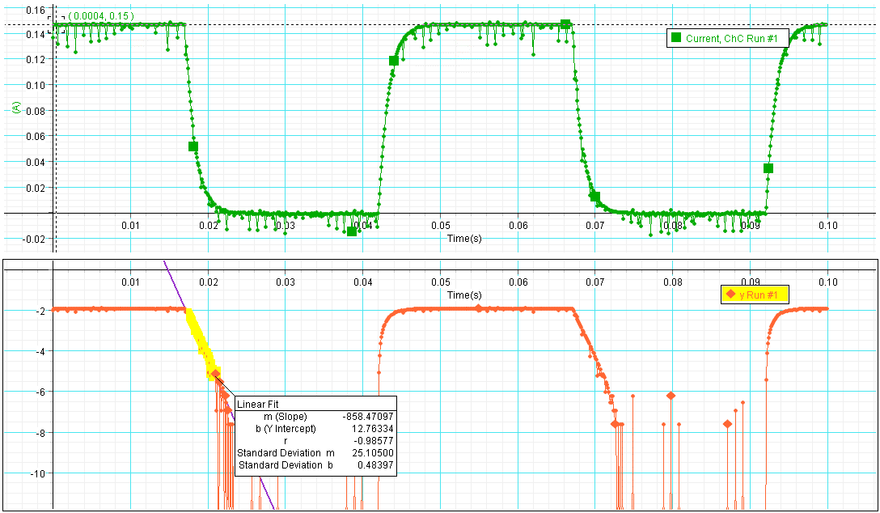

(Fig1: Current in RL without core)

**\* Question 1: Measure and calculate the resistance RL of your coil L**

Input voltage is *U = 1V*.

Measured current is *I = 0.16(A)*.

* Apply the Ohm’s law the RL of the coil is:

$$R_{L}=\frac{U}{I}=\frac{1}{0.15}=6.67(Ω)$$

\***Question 2**: **Calculate the inductance of the coil without iron core base on the value of slope obtained by Data Studio software:**

By using graph, the function *ln(i) = -(RT /L)t + ln(i0)* has a slope *m= -858.47097*;

=> *-(RT /L)= -858.47097*

|  |
| --- |
| Lw/c = |

Then we have:

**2. Free oscillation of RLC circuit:**

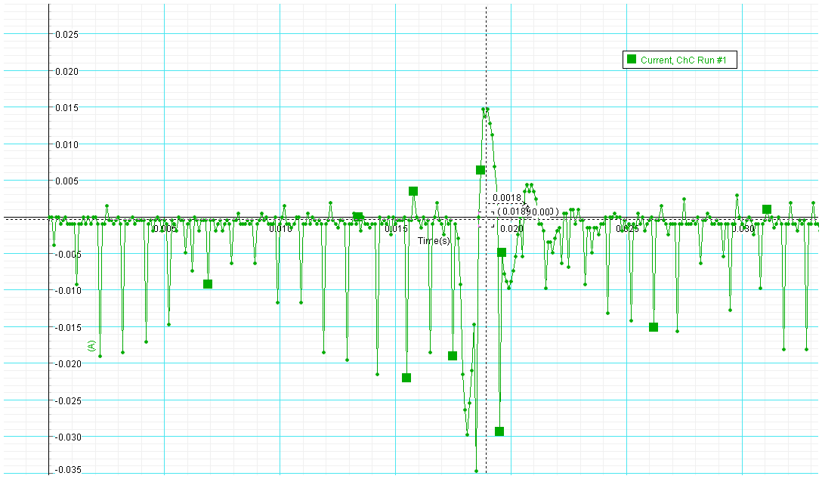

(Fig 2: Current in RLC circuit without core)

**\*Question 3: Calculate the frequency, fmeasured=1/T(Hz) base on the period of oscillation determined by tools of Data Studio software**

The graph of RLC circuit without core show that the period of the RLC circuit oscillations is T=0.0018(s)

Hence $f_{measured}=\frac{1}{T}=\frac{1}{0.0018}=555.56(Hz)$

**\*Question 4: For your circuit parameters, compute the expected value of *fprediction= 1/(2π√LC)* (Hz) and compare it to your measured value. Do you expect your result to be greater, equal, or less than the measured value *(∆f = fprediction- fmeasured)*?**

(as we assume the value L= $7.7×{10}^{-3}$ (H) and C=10 (µF) )

So, the expected value of f is l larger than the measured value amount of $∆f$

$$∆f=f_{prediction}-f_{measured}=573,56-555.56≈18(Hz)$$

It is obvious that in the process of computing the measured value, there is the appearance of R of the coil according to the formula:

$$ω_{w/c}^{2}= \frac{1}{L_{w/c} C}- \frac{R_{total}^{2}}{4 L_{w/c}^{2}}$$

This make $ω$ smaller => the frequency  is also smaller.

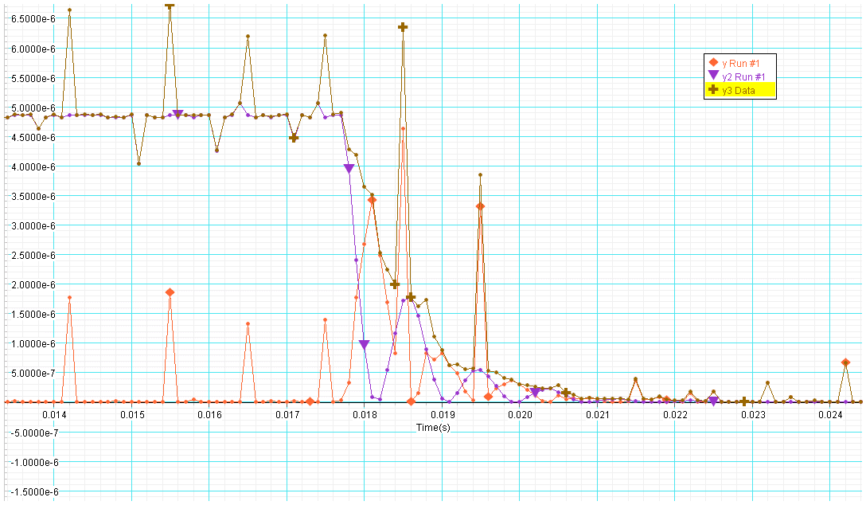**3. Observe the energy in RLC circuit:**

(Fig 3: energy relationship in RLC circuit)

**\*Question 5: The circuit is losing energy most rapidly at times when the graph of total energy is steepest; these times occur at about the same times that the magnetic energy reaches a local maximum. Briefly explain why**?

As current oscillates in RLC circuit, energy would be stored in both:

+ Magnetic field energy of inductor:

+ Electric field energy of the capacitor: $U\left(E\right)=\frac{1}{2}CV^{2}$

The total energy is:

$$U=U\left(B\right)+ U\left(E\right)= \frac{1}{2}Li^{2}+\frac{1}{2}CV^{2}$$

This energy lost gradually as heat in the resistor at the rate: I2R, then over the period of oscillation T the dissipated energy is

$$∆U=\int_{0}^{t}{I^{2}Rdt}$$

It means that the energy in the circuit decreases faster for larger R because it disappear more rapidly into Joule heating.