Hanoi University of Science and Technology

School of Engineering Physics

LAB REPORT

For Electrics and Thermodynamics

**Experiment 4**

Student name : Nguyen Viet Anh

Student ID : 20150143

Group number : 1

Name: Nguyen Viet Anh Date: 8stApril 2017

ID : 20150143

**Experiment 4**

**verification of faraday’s law of electromagmetic induction**

**I. Experiment Motivation**

* The purpose of this activity is to measure the voltage across a coil of wire when a bar magnet moves through the coil of wire.
* Compare the voltage to the number of turns of wire in the coil.

**II. Experimental Result**

***1. Measurement Results***

***a) 150 turn coil:***

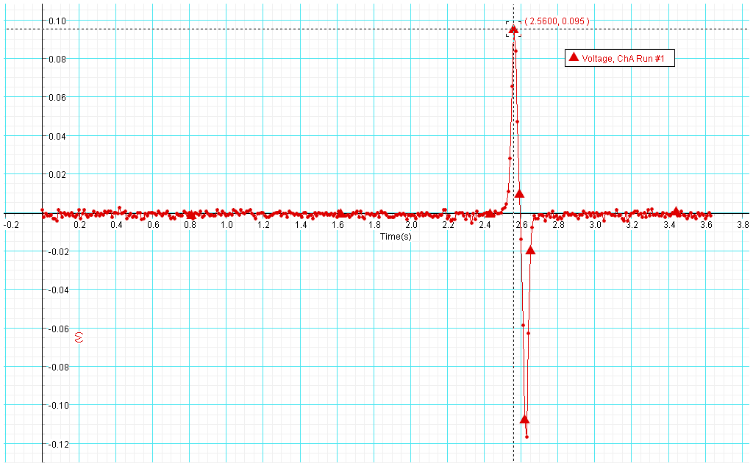

**Fig 1. North end of the magnet bar**

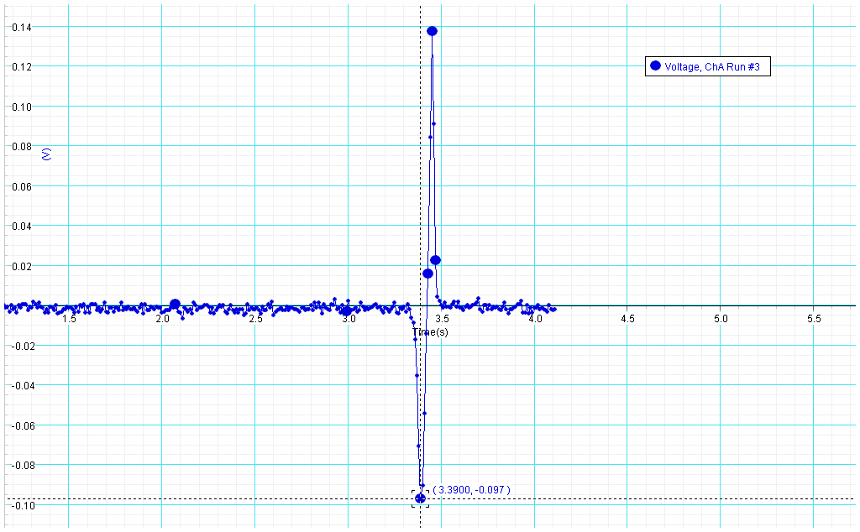

**Fig 2. South end of the magnet bar**

***\*\*\* Double bar magnet* :**

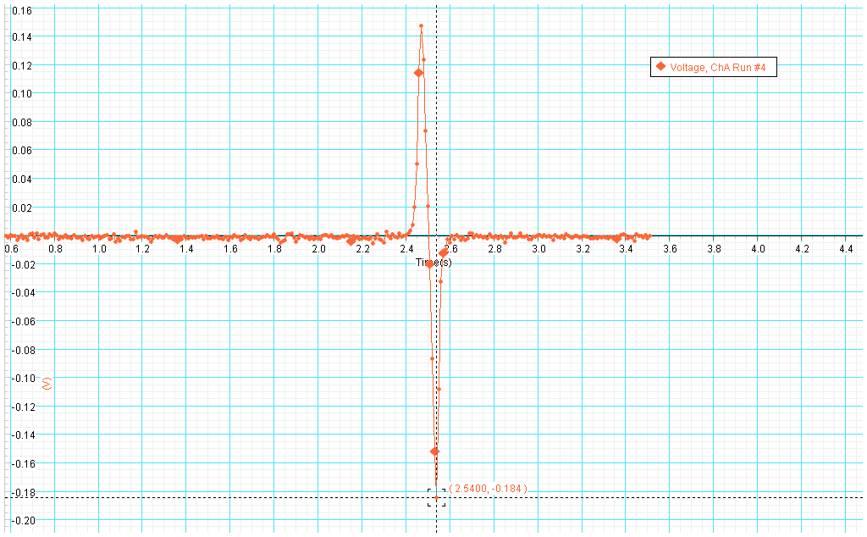

**Fig 3. North- North poles**

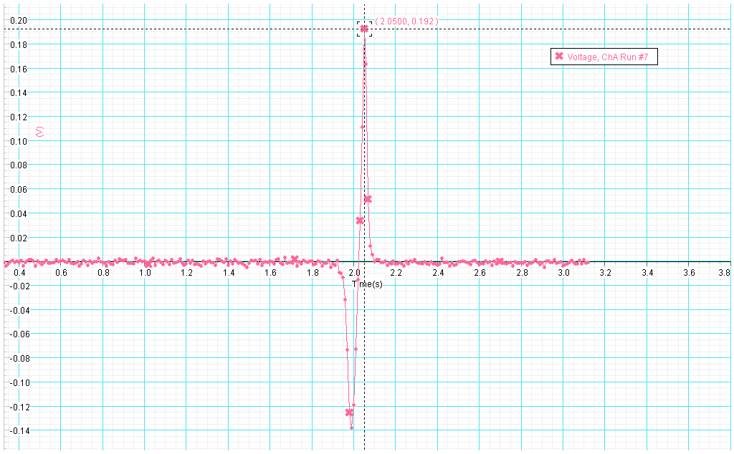

**Fig 4 . South- South poles**

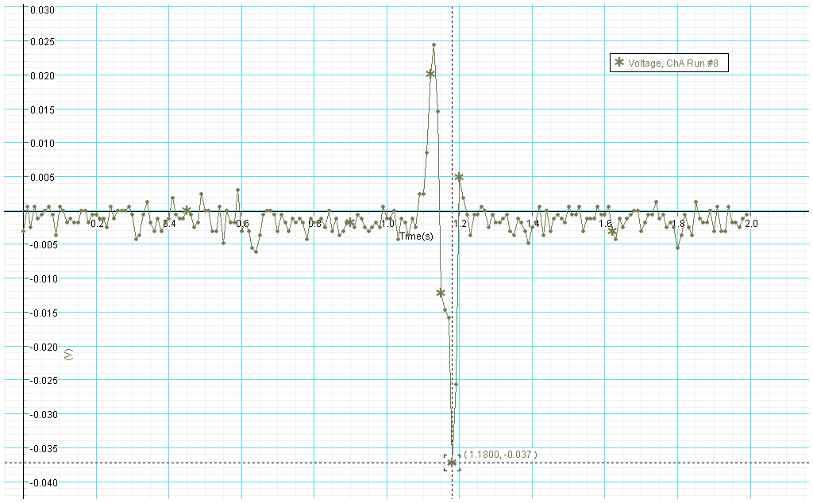

**Fig 5. North-South pole**

***b) 1200 Turn Coil:***

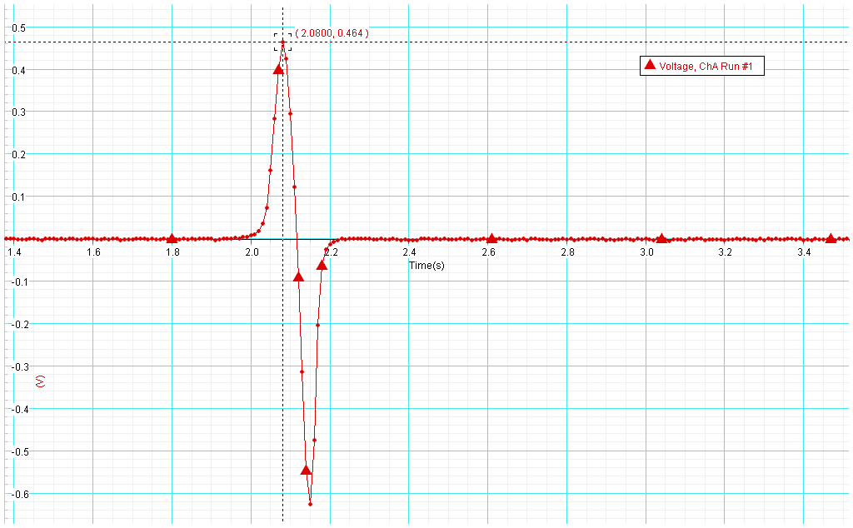

**Fig 6. North end of the magnet bar**

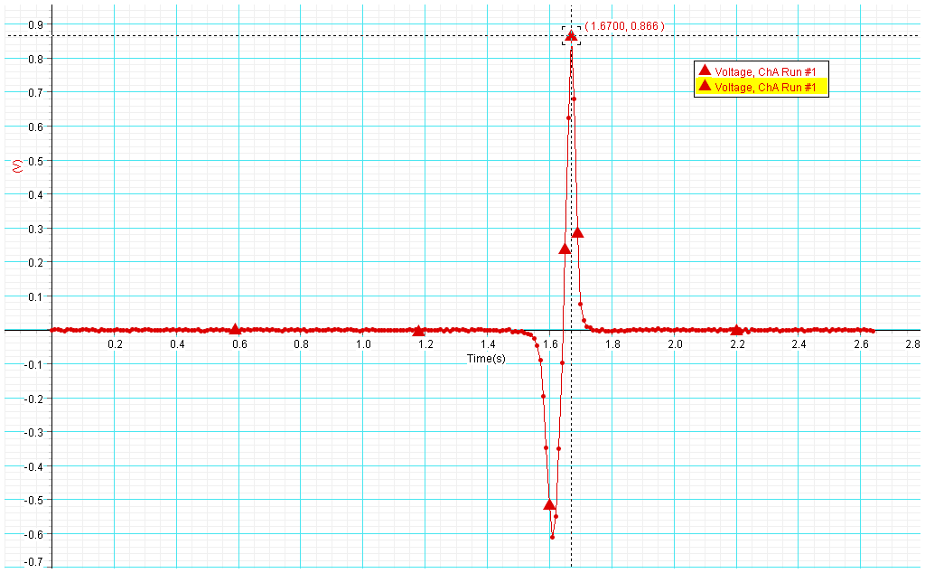

**Fig 7. South end of the magnet bar**

***Double bar magnet* :**

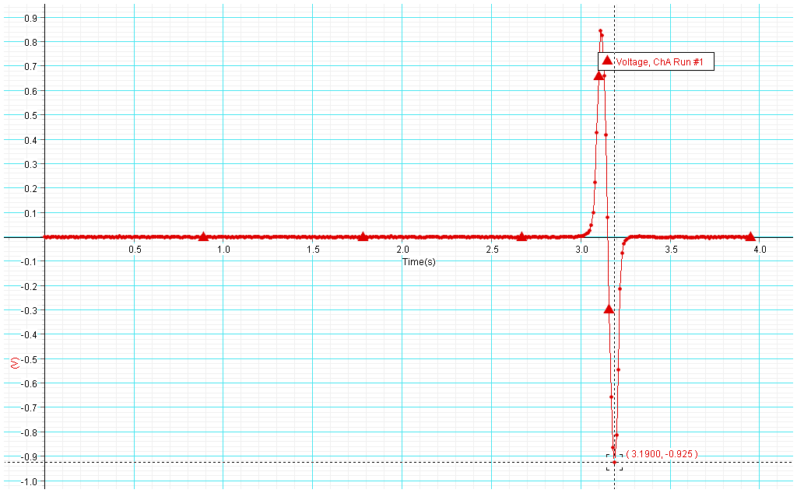

**Fig 8. North-North end of the magnet bar**

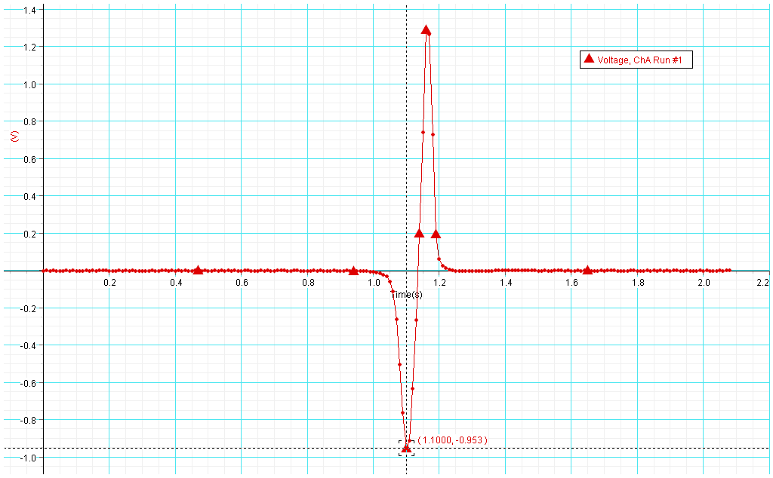

**Fig 9. South- South poles**

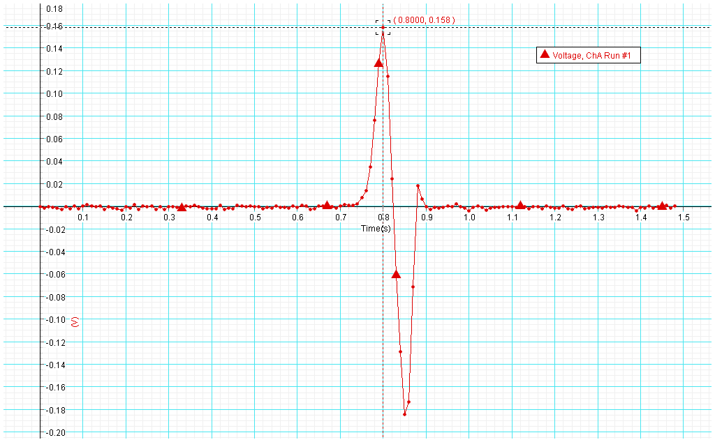

**Fig 10. North - South poles**

**Data table**

|  |  |  |  |  |
| --- | --- | --- | --- | --- |
|  | 1200-turn coil | | 150-turn coil | |
|  | Voltage Peak 1(V) | Voltage Peak 2(V) | Voltage Peak 1(V) | Voltage Peak 2(V) |
| North | 0.464 | -0.626 | 0.095 | -0.117 |
| South | -0.611 | 0.866 | -0.097 | 0.137 |
| N-N | 0.845 | -0.925 | 0.147 | -0.184 |
| S-S | -0.953 | 1.29 | -0.138 | 0.192 |
| N-S | 0.158 | -0.184 | 0.024 | -0.037 |

**Question 1**: **How does the voltage of the second peak compare to the first peak?**

* There are two peaks: one for when you push the magnet in and one for when you pull the magnet out.

1. The magnitude of voltage of the first peak is smaller than the magnitude of voltage of the second peak.
2. Two peaks’ voltages have different signs (if the first peak has negative sign, then the second peak has positive sign).

**Question 2**: **For each run, how does the magnitude (amount) of the voltage of the second peak compare to the magnitude (amount) of the voltage of first? Explain why you think this happens.**

* The magnitude of the second peaks is greater than that of the first peaks.

**Explain:**

* + The motion of the magnet is free fall as it is released with zero velocity, so the into-velocity (velocity of magnet bar when falling into the coil) is small than the out-velocity (velocity of magnet bar when falling out the coil).
  + The rate of change of magnetic field through the coil also increases.

Apply Faraday’s Law



With same N,  increases ,  will increase too.

=> 

**Question 3:** **How does the shape of the voltage versus time graph when the north pole of the magnet bar is dropped first compare to the overall shape of the graph when the south pole of the magnet bar is dropped first?**

* + When the North pole of magnet is dropped first, the first peak is negative, and the second peak is positive.
  + When the South of magnet is dropped first, the first peak is positive, and the second peak is negative.

**Explain:**

* They are opposite in direction because of Lenz’s Law: The direction of any magnetic induction effect is to oppose the cause of the effect.
* When the north end of the magnet is pushed in, the current I changes direction. => ɛ change the sign. Suppose the sign of ɛ when magnet fall in is negative, the sign of ɛ when magnet fall out is positive.
  + When the south end of the magnet is pushed in, the current I when the magnet bar fall in and fall out change direction (inversely to ex1). That means ɛ change the sign. The sign of ɛ when magnet falls in is same as when the magnet falls out in ex1 is positive, the sign of ɛ when the magnet falls out is same as when the magnet falls in in ex1 is negative.

**Question 4**: **How does the maximum voltage for the coil with more turns compare to the maximum voltage for the coil with fewer turns?**

* From the **Data Table**, we can see that the maximum voltage of the coil with more turns is bigger than the maximum voltage of the coil with fewer turns.
* If we have coil with N identical turns, the flux varies at the same rate through each turn. Total rate of change through all the turns will be N time as large for a single turn. If ф is the flux through each turn, the total Emf in a coil with N turns is:



Therefore, the coil with more turns will have higher maximum voltage.

**Question 5: Do your results support your prediction?**

* + The phenomenon is occurred the same as our prediction.