HANOI UNIVERSITY OF SCIENCE AND TECHNOLOGY

School of Information and communications technology

Software Requirement Specification

Version 2.0

**eStoreManager**

**Store management solution**

Subject: ITSS Software Development

**Group 01**

Nguyễn Sỹ An

Nguyễn Việt Anh

Theo Mercurio

*Hanoi, 12/2018*

1. Table of contents

1 Introduction 4

1.1 Objective 4

1.2 Scope 4

1.3 Glossary 4

1.4 References 5

2 Overall Description 6

2.1 Actors 6

2.2 Overall use case diagram 6

2.3 Decomposition of Use cases 7

2.3.1 Use case diagram for “Manage customer list” 7

2.3.2 Use case diagram for “Manage products” 8

2.3.3 Use case diagram for “Manage employees” 9

2.3.4 Use case diagram for “Manage suppliers” 10

2.3.5 Use case diagram for “Manage finance” 11

2.3.6 Use case diagram for “Create reports” 11

2.4 Business processes 13

2.4.1 Process of add bill 13

2.4.2 Process of return product 14

2.4.3 Process of import products 14

2.4.4 Process of add employee 15

2.4.5 Process of add supplier 16

2.4.6 Process of add customer 16

3 Specific requirements 18

3.1 Specification of Use case UC001 - “Log in” 18

3.2 Specification of Use case UC002- “Change password” 19

3.3 Specification of Use case UC003 - “Add Employee” 20

3.4 Specification of Use case UC004- “Add Customer” 20

3.5 Specification of Use case UC005 - “Add supplier” 21

3.6 Specification of Use case UC006 - “Modify customer information” 22

3.7 Specification of Use case UC007 - “Add bill” 23

3.8 Specification of Use case UC008- “Import products” 24

3.9 Specification of Use case UC009 - “Return products” 25

4 Supplementary 26

Functionality 26

Usability 26

Reliability 26

Performance 26

Supportability 26

Other requirements 26

# Introduction

## Objective

This document presents the detailed description for eStore Manager – a store management system user group and their usable function at run time. This document also describes the objectives and features of the system, interfaces and constraints of the system in response to external action.

*This document is for stakeholders and related software developers.*

## Scope

In reality, any software needs to have the function of managing users or group of users, and dynamically granting permissions for usage of certain functions in the system.

This software will be built as a management tool for a small store, with only 1 branch.

The software’s goal includes creating following components:

- Interface to make bills and sell products.

- Interface to manage suppliers, import products.

- Interface to manage employees.

- Interface to manage customer list

- Interface to manage store finance.

*Each function may be utilised by many roles of users in:* *Admin, cashier, warehouse manager.*

## Glossary

*-* ***Admin:*** *administrator in this software often is the store owner. This user can interact with the system in full permission.*

*-* ***Cashier:*** *This user is a role of shop keeper: make bills and sell products. Cashier also can have access to history of bills, remove a bill in the past (to modify some information in the bill).*

*-* ***Warehouse:*** *is a place where goods may be stored before their export or distribution for sale.*

***- Warehouse manager:*** *is a user who can manage suppliers, add import bills and be responsible to manage goods in warehouse.*

*-* ***Supplier:*** *a vendor who provide product for the store at whole sale price. The store imports goods there to sell to to their customers.*

## References

*- An online store management system: Kiot Viet: [https://kiotviet.vn](https://kiotviet.vn/)*

# Overall Description

## Actors

There are 3 main actors in the system: *Admin, Cashier, Warehouse manager.*

## Overall use case diagram

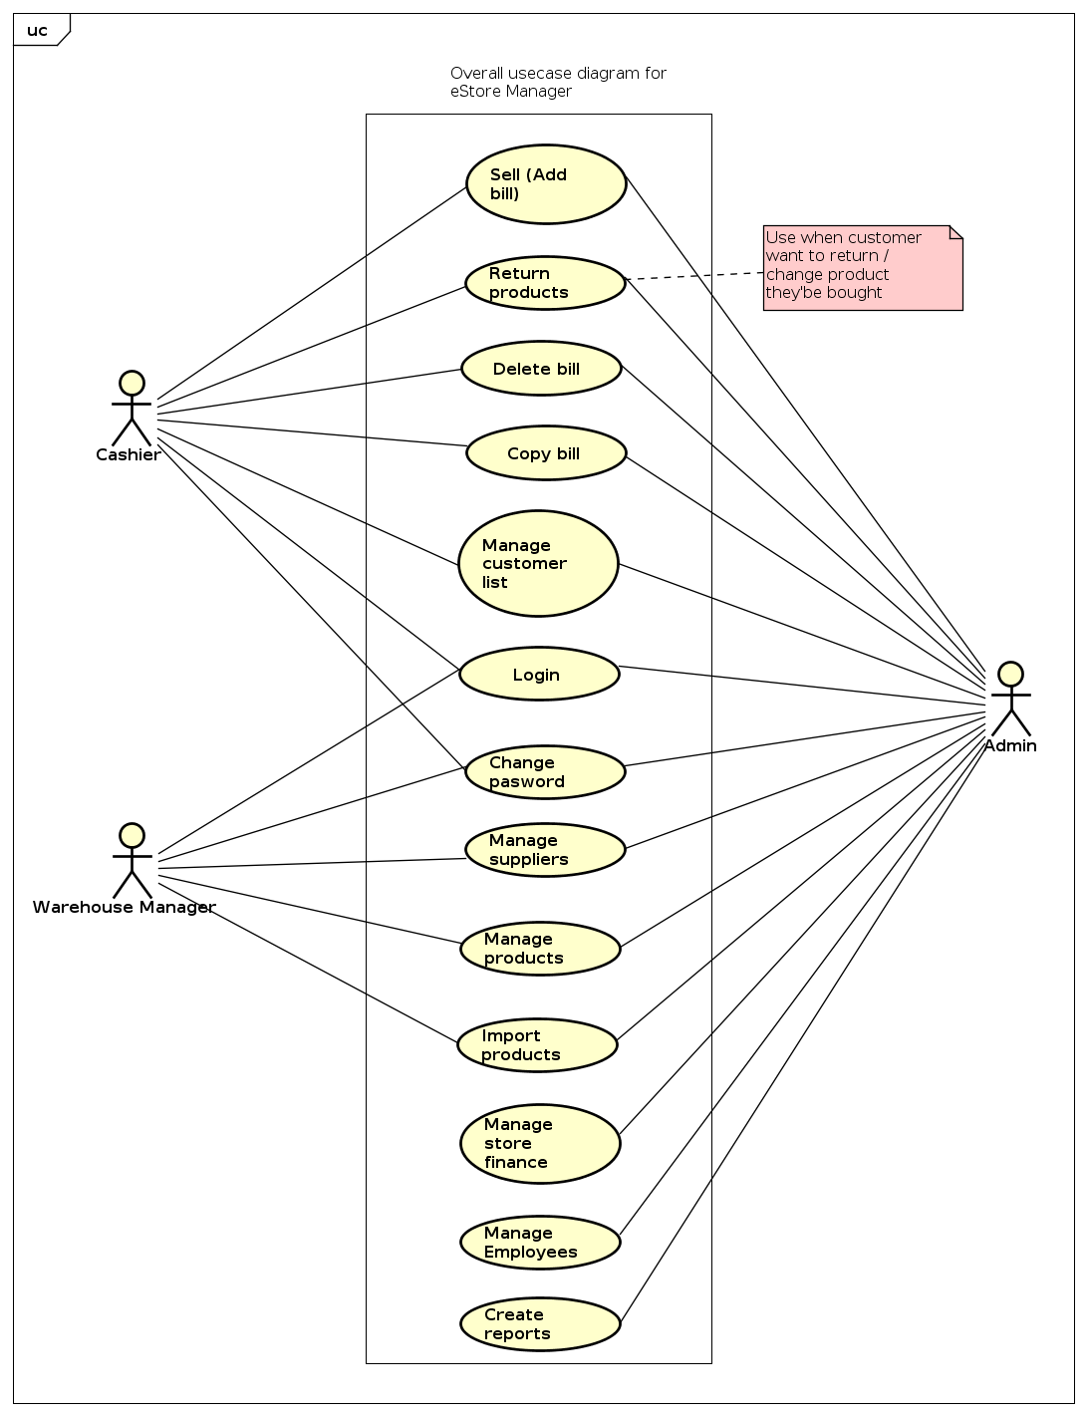

## Decomposition of Use cases

### Use case diagram for “Manage customer list”

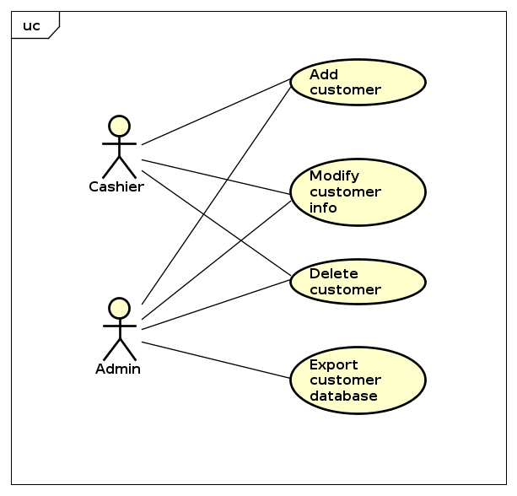

### Use case diagram for “Manage products”

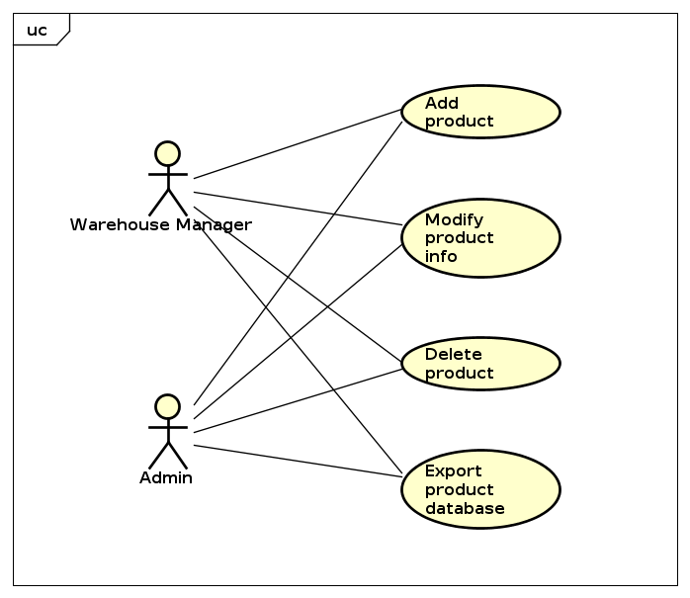

### Use case diagram for “Manage Employees”

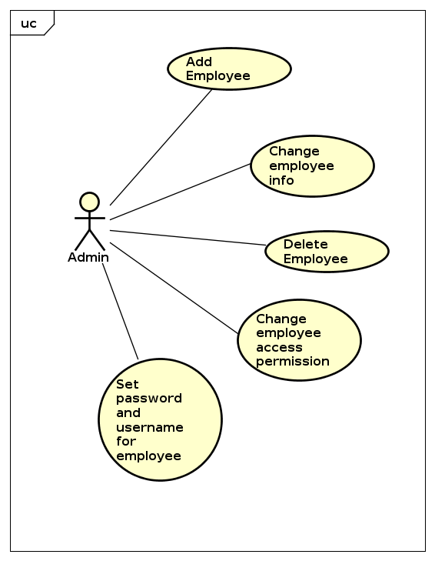

### Use case diagram for “Manage suppliers”

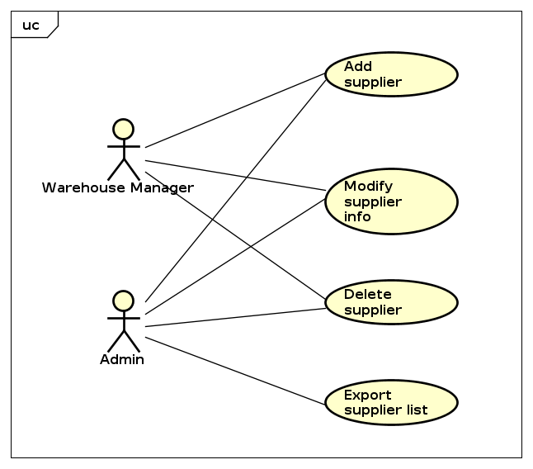

### Use case diagram for “Manage finance”

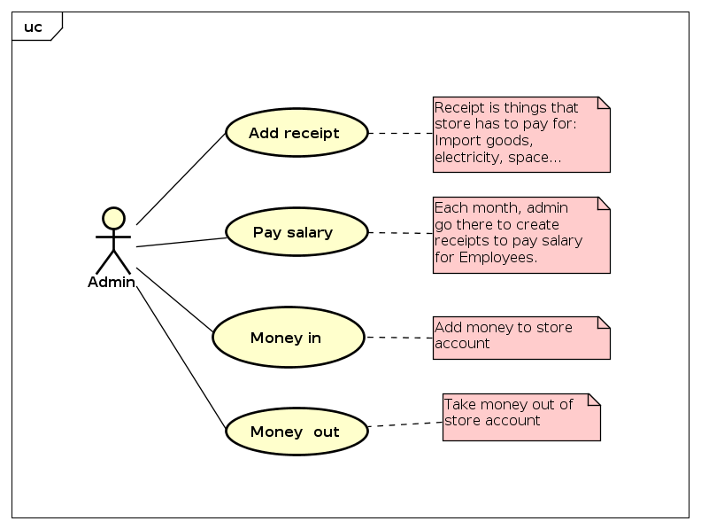

### Use case diagram for “Create reports”

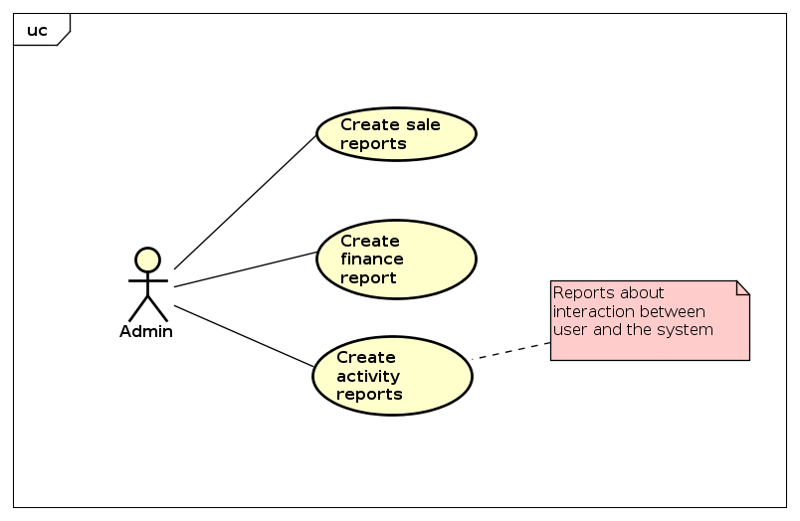

## Business processes

In this subsystem, there are 4 main professional processes:

The details of these processes are modeled in the sub-section of each process.

### **Process of add bill**

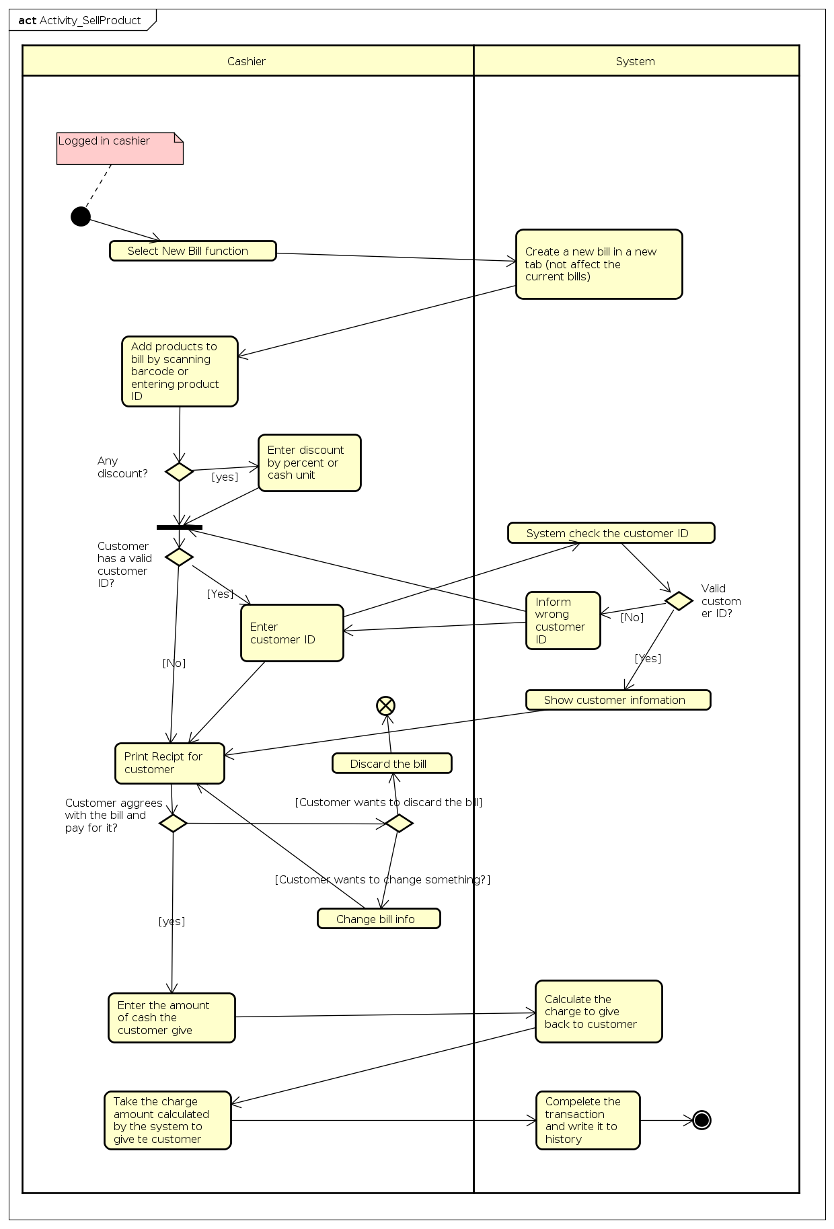

### **Process of return product**

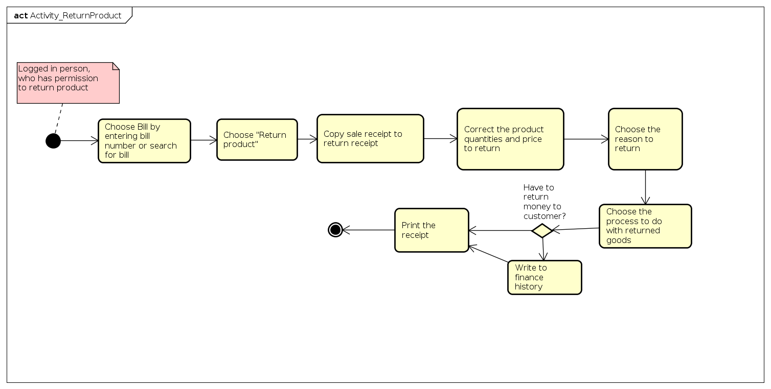

### **Process of import products**

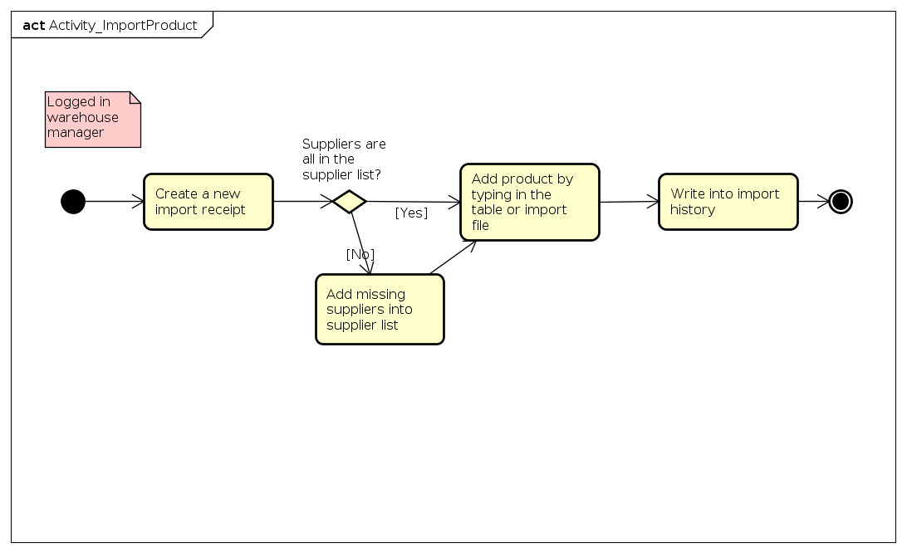

### **Process of add employee**

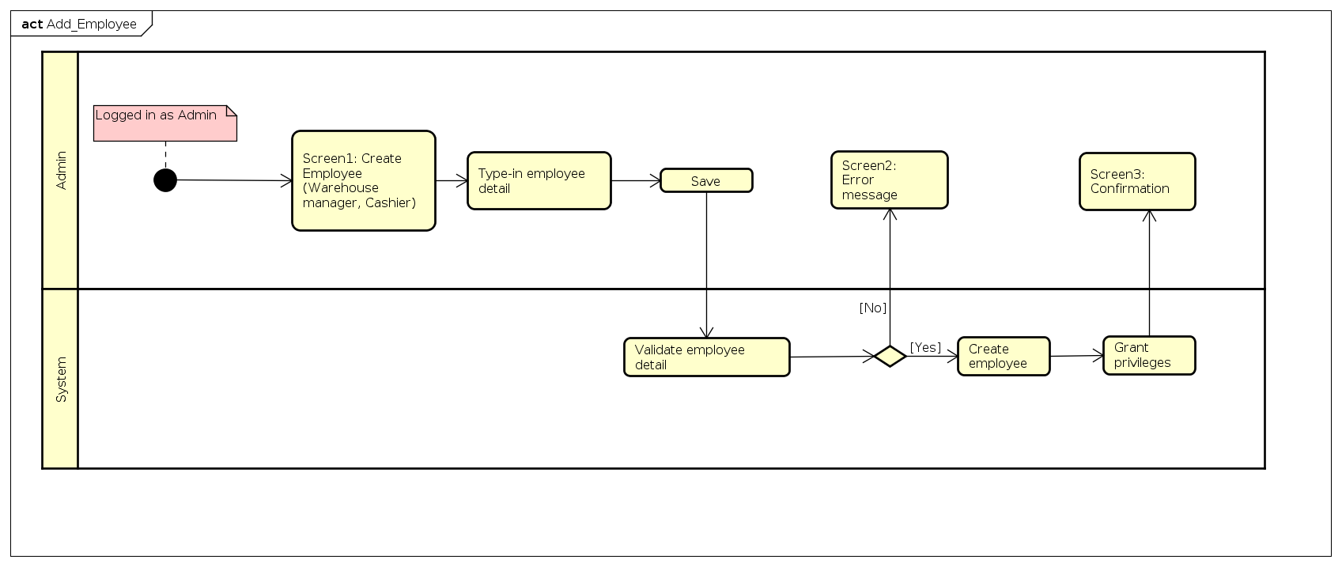

### **Process of add supplier**

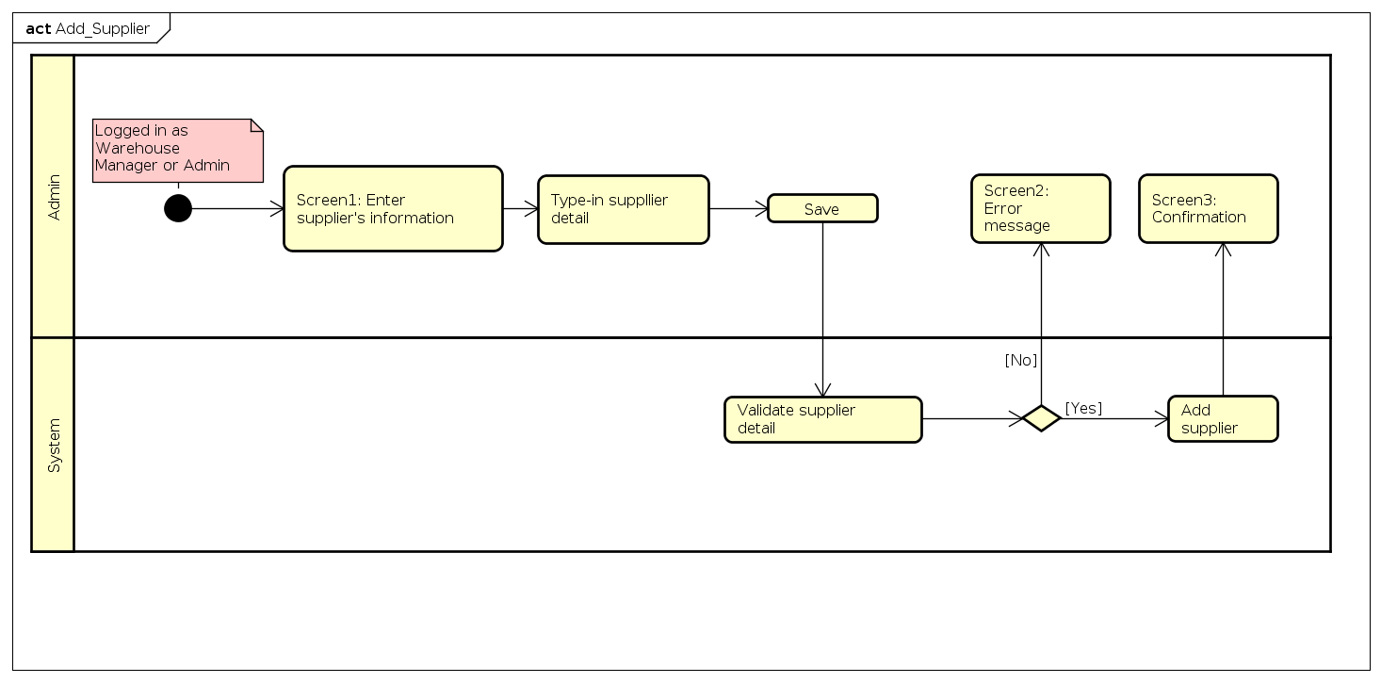

### **Process of add customer**

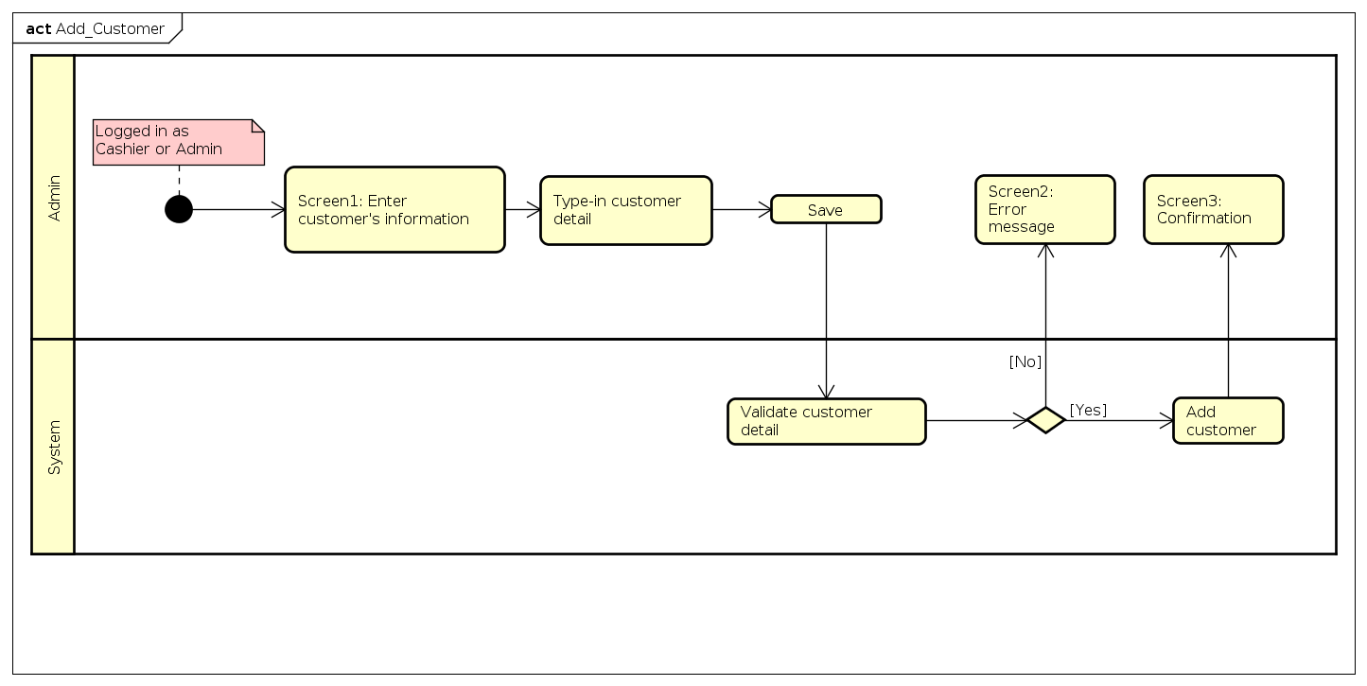

# Specific requirements

Details of the use cases given in following sections are specified below.

## Specification of Use case UC001 - “Log in”

|  |  |  |  |
| --- | --- | --- | --- |
| Use case code | UC001 | Use case name | Sell Product |
| Actor | User (Cashier, Warehouse Manager, Admin) | | |
| Pre-condition | None | | |
| Main flow of events (Success) | |  |  |  | | --- | --- | --- | | No | Actor | Action | | 1 | User | Select Log in function | | 2 | System | Display log in interface | | 3 | User | Input user name and passwords | | 4 | User | Request log in | | 5 | System | Check whether user had input the required field | | 6 | System | Validate the user name and password | | 7 | System | Log user into the system | | 8 | Sytem | Display the Main Form and the use case end | | | |
| Alternative flow of events | |  |  |  | | --- | --- | --- | | No | Actor | Action | | 6a | Cashier | Output error: need to put into the missing required field if had not done so | | 7a | System | Output error: If the user name and password is invalid, require user enter user name and password again | | | |
| Post-condition | None | | |

## Specification of Use case UC002- “Change password”

|  |  |  |  |
| --- | --- | --- | --- |
| Use case code | UC002 | Use case name | Change password |
| Actor | User (Cashier, Warehouse Manager, Admin) | | |
| Pre-condition | User logged in to system | | |
| Main flow of events (Success) | |  |  |  | | --- | --- | --- | | No | Actor | Action | | 1 | User | Select change password function | | 2 | System | Display change password interface, require confirm old password and new password | | 3 | Cashier | Enter old password and new password | | 4 | Cashier | Check whether user had input the required field | | 5 | Cashier | Check the new password is secure enough or not | | 6 | Cashier | Check the old password is right or not | | 7 | System | Display change password successfully, save new password | | | |
| Alternative flow of events | |  |  |  | | --- | --- | --- | | No | Actor | Action | | 5a. | Cashier | Output error: need to put into the missing required field if had not done so | | 6a. | System | Output error: the new password is not secure enough, back to step confirm password | | 7a. | System | Output error: the old password is not right, back to step confirm password | | | |
| Post-condition | None | | |

## Specification of Use case UC003 - “Add Employee”

|  |  |  |  |
| --- | --- | --- | --- |
| Use case code | UC003 | Use case name | Add Employee |
| Actor | Admin | | |
| Pre-condition | Admin logged in to system | | |
| Main flow of events (Success) | |  |  |  | | --- | --- | --- | | No | Actor | Action | | 1 | Admin | Select add employee function | | 2 | System | Display form to enter employee information | | 3 | Admin | Enter employee information then choose save | | 4 | System | Validate employee information | | 5 | System | Create new employee in system | | 6 | System | Grant privileges for employee | | 7 | System | Confirm save new employee successfully | | | |
| Alternative flow of events | |  |  |  | | --- | --- | --- | | No | Actor | Action | | 5a | System | Display error in validating employee information | | | |
| Post-condition | None | | |

## Specification of Use case UC004- “Add Customer”

|  |  |  |  |
| --- | --- | --- | --- |
| Use case code | UC004 | Use case name | Add Customer |
| Actor | Cashier/Admin | | |
| Pre-condition | Cashier/Admin logged in to system | | |
| Main flow of events (Success) | |  |  |  | | --- | --- | --- | | No | Actor | Action | | 1 | Cashier/Admin | Select add customer function | | 2 | System | Display form to enter customer information | | 3 | Cashier/Admin | Enter customer information then choose save | | 4 | System | Validate customer information | | 5 | System | Create new customer in system | | 6 | System | Confirm save new employee successfully | | | |
| Alternative flow of events | |  |  |  | | --- | --- | --- | | No | Actor | Action | | 5a | System | Display error in validating employee information | | | |
| Post-condition | None | | |

## Specification of Use case UC005 - “Add supplier”

|  |  |  |  |
| --- | --- | --- | --- |
| Use case code | UC005 | Use case name | Add Supplier |
| Actor | Warehouse Manager/Admin | | |
| Pre-condition | Warehouse Manager/Admin logged in to system | | |
| Main flow of events (Success) | |  |  |  | | --- | --- | --- | | No | Actor | Action | | 1 | Warehouse Manager/Admin | Select add supplier function | | 2 | System | Display form to enter supplier information | | 3 | Warehouse Manager/Admin | Enter supplier information then choose save | | 4 | System | Validate supplier information | | 5 | System | Create new supplier in system | | 6 | System | Confirm save new supplier successfully | | | |
| Alternative flow of events | |  |  |  | | --- | --- | --- | | No | Actor | Action | | 5a | System | Display error in validating supplier information | | | |
| Post-condition | None | | |

## Specification of Use case UC006 - “Modify customer information”

|  |  |  |  |
| --- | --- | --- | --- |
| Use case code | UC006 | Use case name | Modify customer information |
| Actor | Cashier/Admin | | |
| Pre-condition | Cashier/Admin logged in to system | | |
| Main flow of events (Success) | |  |  |  | | --- | --- | --- | | No | Actor | Action | | 1 | Admin | Select modify customer information function | | 2 | System | Display form to enter customer information (with copy of old information) | | 3 | Admin | Enter new customer information then choose save | | 4 | System | Validate customer information | | 6 | System | Save change | | 7 | System | Confirm save change successfully | | | |
| Alternative flow of events | |  |  |  | | --- | --- | --- | | No | Actor | Action | | 5a | System | Display error in validating customer information | | | |
| Post-condition | None | | |

## Specification of Use case UC007 - “Add bill”

|  |  |  |  |
| --- | --- | --- | --- |
| Use case code | UC007 | Use case name | Add bill |
| Actor | Cashier/Admin | | |
| Pre-condition | Cashier/Admin has logged in | | |
| Main flow of events (Success) | |  |  |  | | --- | --- | --- | | No | Actor | Action | | 1 | Cashier/Admin | Select New Bill function | | 2 | System | Create a new bill in a new tab (not affect the current bills) | | 3 | Cashier/Admin | Add products to bill by scanning barcode or entering product ID | | 4 | Cashier/Admin | Enter discount by percent or cash unit if there is any discount | | 5 | CCashier/Admin | Print receipt for customer | | 6 | Cashier/Admin | Receive cash from customer and Enter the amount of cash the customer give | | 7 | System | Calculate the charge to give back to customer | | 8 | Cashier/Admin | Take the charge amount calculated by the system to give te customer | | 9 | System | Compelete the transaction and write it to history | | | |
| Alternative flow of events | |  |  |  | | --- | --- | --- | | No | Actor | Action | | 5a1 | Cashier/Admin | Enter customer ID if customer has a valid id (may be from customer card) | | 5a2 | System | Check the customer id | | 5a3 | System | Display the customer information | | 7a | Cashier/Admin | If customer does not agree with the bill, discard it | | 7b | Cashier/Admin | If customer wants to correct something, change the bill and go back to step 5. | | | |
| Post-condition | None | | |

## Specification of Use case UC008- “Import products”

|  |  |  |  |
| --- | --- | --- | --- |
| Use case Code | UC008 | Use case Name | Import products |
| Actor | Warehouse manager | | |
| Pre-condition | Warehouse manager has logged in | | |
| Main flow of events (Success) | | No | Actor | Action | | --- | --- | --- | | 1 | Warehouse manager | Create a new import receipt | | 2 | Warehouse manager | Add product by typing in the table or import file | | 3 | System | Write into import history | | | |
| Alternative flow of events | |  |  |  | | --- | --- | --- | | No | Actor | Action | | 2a | Warehouse manager | If goods are importing from unlisted supplier, the ware house manager go to supplier list to add. | | | |
| Post-conditions | None | | |

## Specification of Use case UC009 - “Return products”

|  |  |  |  |
| --- | --- | --- | --- |
| Use case code | UC009 | Use case name | Return products |
| Actor | Cashier/Admin | | |
| Pre-condition | Cashier/Admin has logged in | | |
| Main flow of events (Success) | |  |  |  | | --- | --- | --- | | No | Actor | Action | | 1 | Cashier/Admin | Entering bill number or search for bill | | 2 | System | Find bill match to searching then display to screen | | 3 | Cashier/Admin | Choose bill to edit, return product | | 4 | System | Copy “sale receipt” to “return receipt” | | 5 | Cashier/Admin | Correct the product quantities and price to return | | 6 | Cashier/Admin | Choose the reason to return | | 7 | Cashier/Admin | Choose the process to do with return goods (return money to customer or not) | | 8 | System | Save the new receipt | | 9 | System | Print the receipt | | | |
| Alternative flow of events | |  |  |  | | --- | --- | --- | | No | Actor | Action | | 8 | System | Write to finance history in case returning money to customer | | | |
| Post-condition | None | | |

# 4 Supplementary

## Functionality

*2 platforms of using: Web and PC*

## Usability

Train the employees and store owner to use the system

## Reliability

*Automatically restart the server after a system failure.*

## Performance

*Acceptable performance. No lag when using.*

## Supportability

*Host and maintain the system for the stores.*

## Other requirements

*Nice and modern user interface.*