HANOI UNIVERSITY OF SCIENCE AND TECHNOLOGY
School of Information and communications technology

Software Requirement Specification
Version 1.0

eStore Manager
Store management solution
Subject: ITSS Software Development

Group 01
Nguyễn Sỹ An
Nguyễn Việt Anh
Theo Mercurio

Hanoi, 09/2018
- Table of contents

1.1 Objective 2
1.2 Scope 2
1.3 Glossary 2
1.4 References 3
2 Overall Description 4
2.1 Actors 4
2.2 Overall use case diagram 4
2.3 Decomposition of Use cases 5
2.3.1 Use case diagram for “Manage customer list” 5
2.3.2 Use case diagram for “Manage products” 5
2.3.3 Use case diagram for “Manage Employees” 6
2.3.4 Use case diagram for “Manage suppliers” 6
2.3.5 Use case diagram for “Manage finance” 7
2.3.6 Use case diagram for “Create reports” 7
2.4 Business processes 8
2.4.1 Process of sell products 9
2.4.2 Process of return products 10
2.4.3 Process of import products 10
2.4.4 Process of xxxx 10
3 Specific requirements 11
3.1 Specification of Use case UC001 - “Sell Product” 11
3.2 Specification of Use case UC002 - “Return products” 12
3.3 Specification of Use case UC003 - “Import products” 13
3.4 Specification of Use case UC005 - “CRUD function” 14
4 Supplementary specification 18
Functionality 18
Usability 18
Reliability 18
Performance 18
Supportability 18
Other requirements 18

Objective
This document presents the detailed description for eStore Manager – a store management system user group and their usable function at run time. This document also describes the objectives and features of the system, interfaces and constraints of the system in response to external action.
This document is for stakeholders and related software developers.

Scope
In reality, any software needs to have the function of managing users or group of users, and dynamically granting permissions for usage of certain functions in the system.
This software will be built as a management tool for a small store, with only 1 branch.
The software’s goal includes creating following components:
- Interface to make bills and sell products.
- Interface to manage suppliers, import products.
- Interface to manage employees.
- Interface to manage customer list
- Interface to manage store finance.
Each function may be ultilised by many roles of users in: Admin, cashier, warehouse manager.

Glossary
- Admin: administrator in this software often is the store owner. This user can interact with the system in full permission.
- Cashier: This user is a role of shop keeper: make bills and sell products. Cashier also can have access to history of bills, remove a bill in the past (to modify some information in the bill).
- Warehouse: is a place where goods may be stored before their export or distribution for sale.
- Warehouse manager: is a user who can manage suppliers, add import bills and be responsible to manage goods in warehouse.
- Supplier: a vendor who provide product for the store at whole sale price. The store imports goods there to sell to to their customers.

References
- An online store management system: Kiot Viet: https://kiotviet.vn

Overall Description

Actors
There are 3 main actors in the system: Admin, Cashier, Warehouse manager.

Overall use case diagram
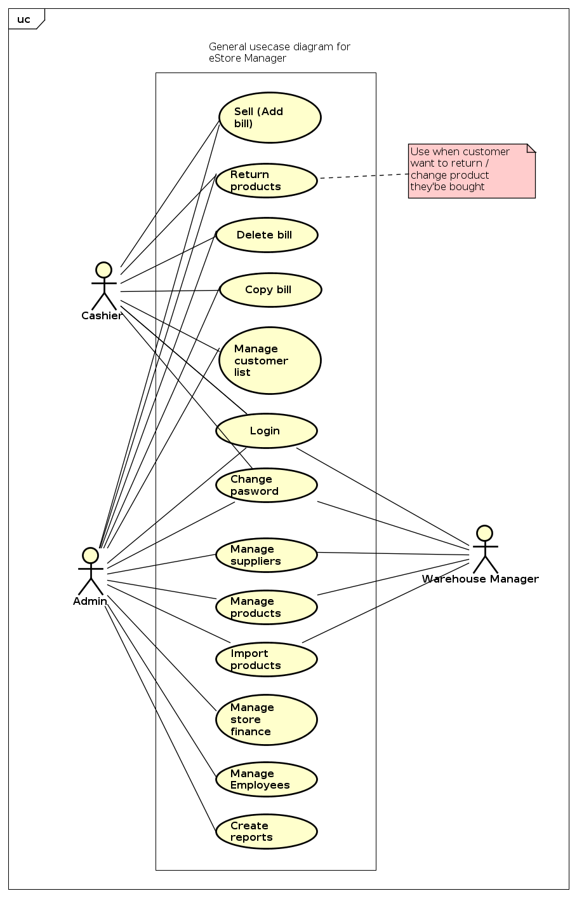

Decomposition of Use cases

Use case diagram for “Manage customer list”
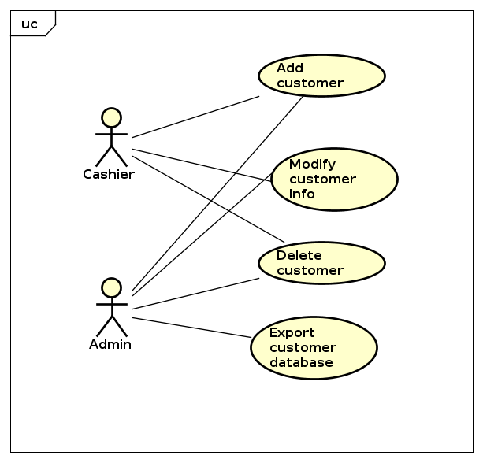

Use case diagram for “Manage products”

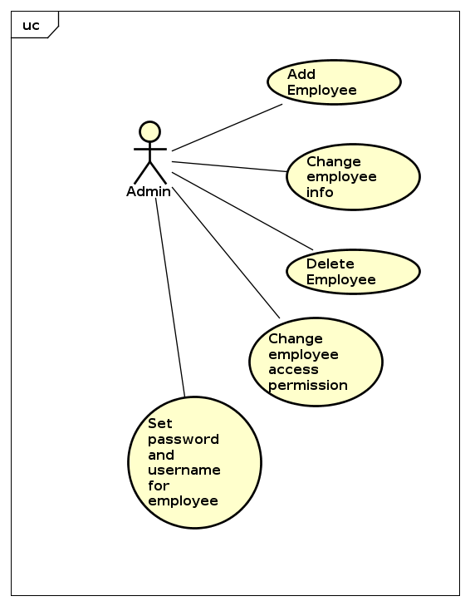

Use case diagram for “Manage Employees”
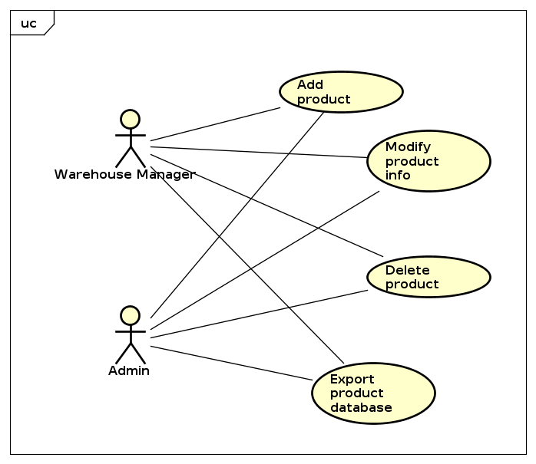

Use case diagram for “Manage suppliers”
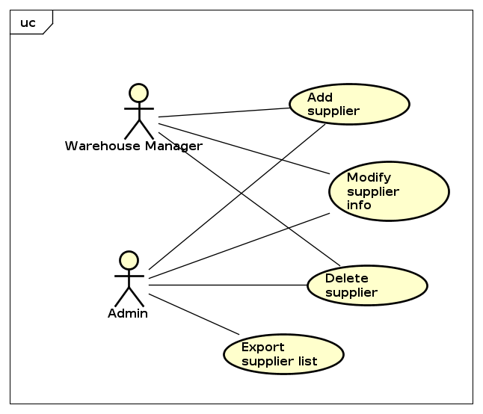

Use case diagram for “Manage finance”
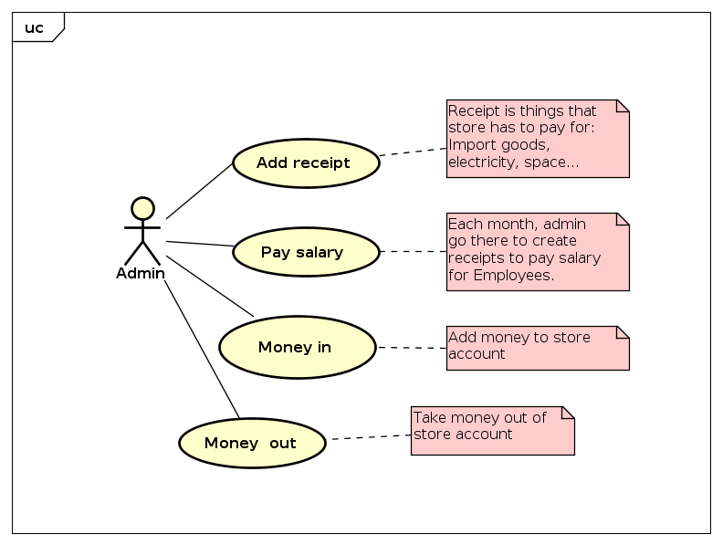

Use case diagram for “Create reports”
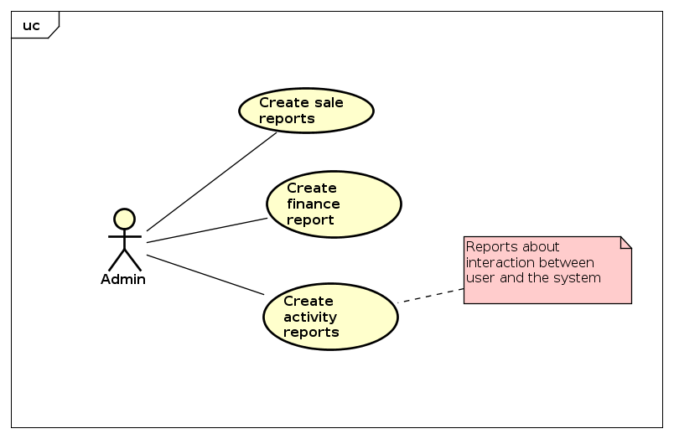

Business processes
In this subsystem, there are 4 main professional processes:
The details of these processes are modeled in the sub-section of each process.

Process of sell products
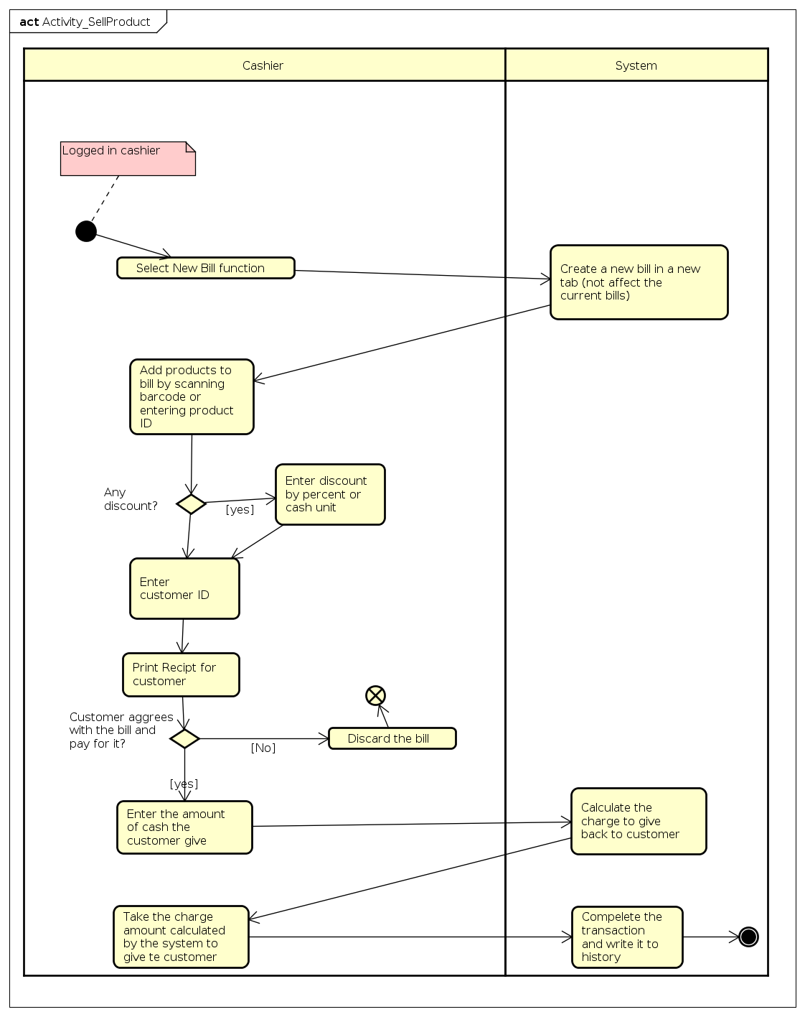

Process of return products
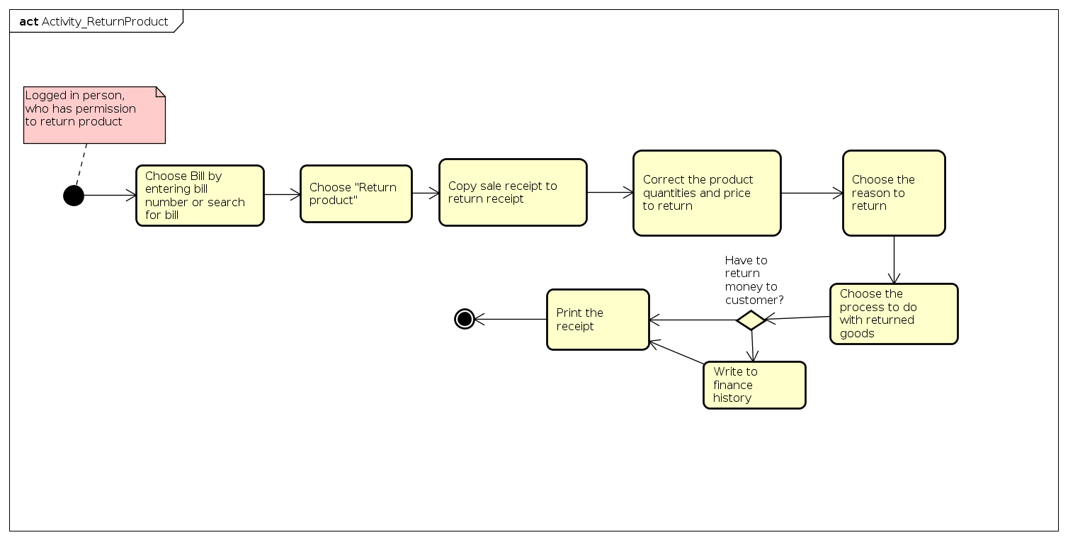

Process of import products

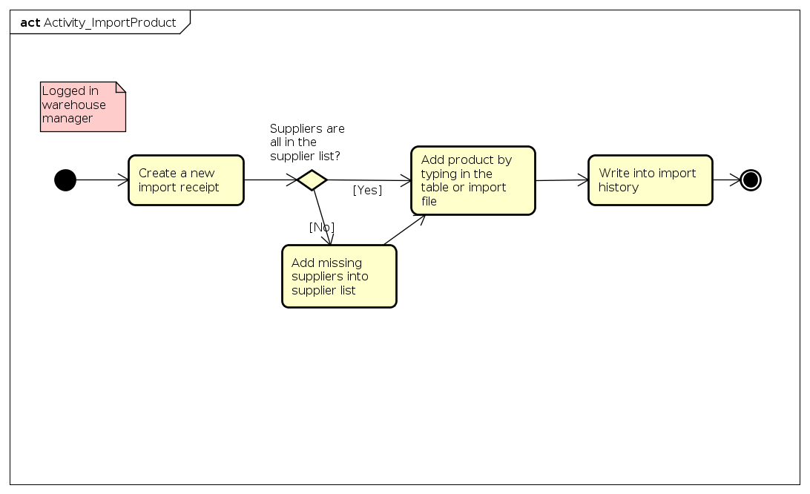
Process of xxxx

Specific requirements
Details of the use cases given in following sections are specified below.

Specification of Use case UC001 - “Sell Product”
Use case code | UC001 | Use case name | Sell Product
Actor | Cashier
Pre-condition | Cashier has logged in
Main flow of events (Success)
  No | Actor | Action
   | Cashier | Select New Bill function
   | System | Create a new bill in a new tab (not affect the current bills)
   | Cashier | Add products to bill by scanning barcode or entering product ID
   | Cashier | Enter discount by percent or cash unit if there is any discount
   | Cashier | Print receipt for customer
   | Cashier | Receive cash from customer and Enter the amount of cash the customer give
   | System | Calculate the charge to give back to customer
   | Cashier | Take the charge amount calculated by the system to give te customer
   | System | Compelete the transaction and write it to history
Alternative flow of events
  No | Actor | Action
  5a1. | Cashier | Enter customer ID if customer has a valid id (may be from customer card)
  5a2. | System | Check the customer id
  5a3. | System | Display the customer information
  7a. | Cashier | If customer does not agree with the bill, discard it
  7.b | Cashier | If customer wants to correct something, change the bill and go back to step 5.
Post-condition | None

Specification of Use case UC002 - “Return products”
Use case code | UC002 | Use case Name | Return products
Actors | Cashier
Pre-condition | Cashier has logged in
Main flow of events (Success)
  No | Actor | Action
   | Cashier | Choose Bill by entering bill number or search for bill
   | Cashier | Choose "Return product"
   | Cashier | Copy sale receipt to return receipt
   | Cashier | Correct the product quantities and price to return
   | Cashier | Choose the reason to return
   | Cashier | Choose the process to do with returned goods
   | Cashier | Print the receipt
Alternative flow of eventss
  No | Actor | Action
  7a | Cashier | If the store has to return cash to customer, cashier enter the amount to receipt and give the customers
Post-condition | None

Specification of Use case UC003 - “Import products”
Use case Code | UC003 | Use case Name | Import products
Actor | Warehouse manager
Pre-condition | Warehouse manager has logged in
Main flow of events (Success)
  No | Actor | Action
   | Warehouse manager | Create a new import receipt
   | Warehouse manager | Add product by typing in the table or import file
   | System | Write into import history
Alternative flow of events
  No | Actor | Action
  2a. | Warehouse manager | If goods are importing from unlisted supplier, the ware house manager go to supplier list to add.
Post-conditions | None
*Input data of import information includes these data fields:
No | Data Fields | Description | Mandatory | Valid condition | Example

Specification of Use case UC005 - “CRUD function”
<Note: To avoid spending too much time on CRUD function, only 1 CRUD should be specified, other CRUD can be written as similar to Use case UC005 for example and only need to have input/output data specification>

Use case code | UC005 | Use case Name | CRUD function
Actor | Administrator
Pre-condition | Guest successfully logged in as administrator
Read:
Main flow of events | No | Actor | Action
Main flow of events |  | Administrator | request “Seeing list of function”
Main flow of events |  | System | retrieve list of functions groups
Main flow of events |  | System | retrieve list of functions
Main flow of events |  | System | Display interface for “Seeing list of function” including:  - Upper: List the function groups so that the user can filter the function by group  - Center: List of functions (Detailed description below *)
Alternative flow of events | 5a1 | Administrator | choose one of the function group
Alternative flow of events | 5a2 | System | retrieve the functions in the selected function group, display in the interface
Update:
Main flow of events | No | Actor | Action
Main flow of events |  | Administrator | choose one function and request to update it
Main flow of events |  | System | retrieve detailed information of the function and display the old information of the function in the “update function” interface
Main flow of events |  | User | update the function information (detailed description below **) and request to update it
Main flow of events |  | System | checking the required data fields
Main flow of events |  | System | checking for the data fields that need to be unique
Main flow of events |  | System | updating the changed information and inform “update success”
Alternative flow of event | 5a | System | output error: “all the required fields have not been filled yet” if administrator did so
Alternative flow of event | 6a | System | output error: specify fields that are not unique if administrator repeat them

Delete:
Main flow of events | No | Actor | Action
Main flow of events |  | Administrator | choose one function and request deleting
Main flow of events |  | System | display the notification that request the user to confirm deleting
Main flow of events |  | User | confirm deletion
Main flow of events |  | System | delete the function and inform “Deletion success”
Alternative flow of events | 4a | System | end the use case if the user denied the deletion

Create:
Main flow of events | No | Actor | Action
Main flow of events |  | Administrator | request adding new function
Main flow of events |  | System | retrieve the list of function groups and display the interface for adding function
Main flow of events |  | User | input the information for the function (detailed description below **) and request modification
Main flow of events |  | System | check for the required data fields
Main flow of events |  | System | check for the data fields that need to be unique
Main flow of events |  | System | update the changed information and inform “Update success”
Alternative flow of event | 5a | System | output error: “all the required fields have not been filled yet” if administrator did so
Alternative flow of event | 6a | System | output error: specify fields that are not unique if administrator repeat them

Post-condition | None
* Output data for displaying list of functions:
No | Data fields | Description | Display format | Example
 | No | Ordinal number |  | 1
 | Function name |  |  | Find user
 | Function group | Name of the function group that the function belongs to |  | User
 | Boundary Class | Name of the boundary class that interacts with that function’s actor |  | SearchUserForm
**Input data when adding/updating features:
No | Data fields | Description | Mandatory | Valid condition | Example
 | Function name |  | Yes | Unique | Change the activity state of user
 | Function group | Choose one of the function groups in the list | Yes |  | User
 | Boundary class |  | Yes | Unique | SearchUserForm

Supplementary specification

Functionality
<Functional requirements that are general to many use cases>

Usability
<Requirements that relate to, or affect, the usability of the system. Examples include ease-of-use requirements or training requirements that specify how readily the system can be used by its actors>

Reliability
<Any requirements concerning the reliability of the system. Quantitative measures such as mean time between failure or defects per thousand lines of code should be stated>

Performance
<The performance characteristics of the system. Include specific response times. Reference related use cases by name>

Supportability
<Any requirements that will enhance the supportability or maintainability of the system being built>

Other requirements
<Descriptions of other requirements are located here>

