**Experiment in photo compression with JPEG standard**

**Raw size:** 640 x 480 x 3 = 921600 bytes ~ 921 kilobytes. (1)

** Quality = 80 % - Size = 59192 bytes ~ 59 kilobytes. (2)

** Quality = 50 % - Size = 33507 bytes ~ 33 kilobytes. (3)

** Quality = 25 % - Size = 21917 bytes ~ 21 kilobytes. (4)

**After resized:** 320 x 240 x 3 = 230400 bytes ~ 230 kilobytes.

** Quality = 80 % - Size = 18282 bytes ~ 18 kilobytes. (5)

** Quality = 50 % - Size = 11070 bytes ~ 11 kilobytes. (6)

** Quality = 25 % - Size = 7503 bytes ~ 7 kilobytes. (7)

**(1)**

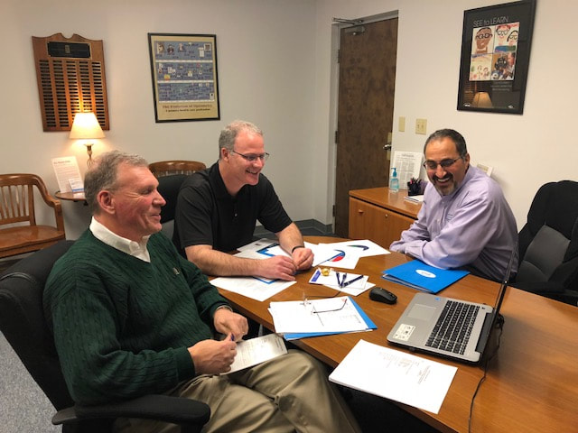

**(2)**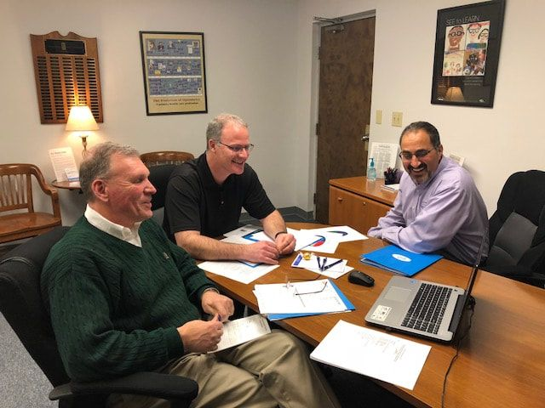

1. 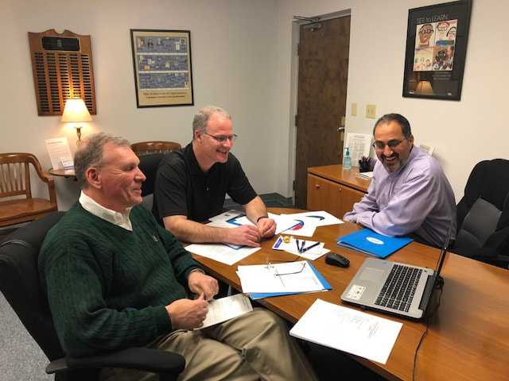

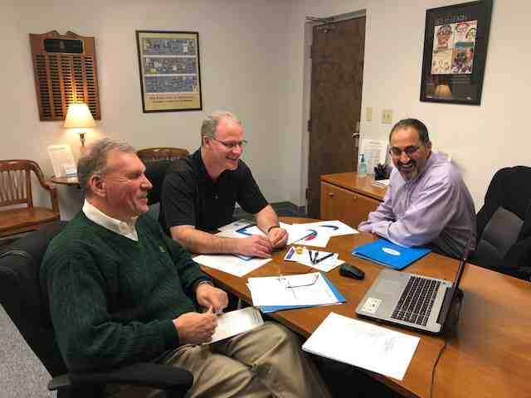

**(5)**

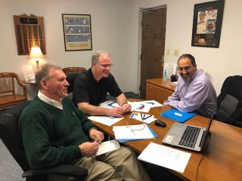

**(6)**

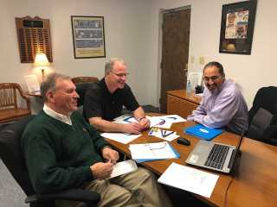

**(7)**

