

Lê Việt Anh

HE160318 | IA1604

**Student Grading Manage**

DBI202 – Lecturer: sonnt5

# Mục lục

# Introduce the assignment

1. DESCRIBE THE ASSIGNMENT

Officially established on September 8, 2006, under the decision of the Prime Minister, FPT University became the first university in Vietnam established by a company with 100% investment capital from the Corporation. FPT. Along with many differences compared to other universities, the University is currently training groups in IT, Economics, Languages, and Applied Arts. Because of the growth and the huge number of students, there is an urgent problem that needs a database to manage student data. Therefore, this assignment is made to strengthen and create a professional management environment for FPT University, as well as acquire and learn more.

1. MANAGEMENT OBJECTIVES

* Student can check their result during and at the end of semester.
* Student can manage their score in each course by seeing assessments in each subject.
* The Lecture can give score to many students in each assessment.
* School can control score of students.

# I. dATA ANALYZING

1. Assessment

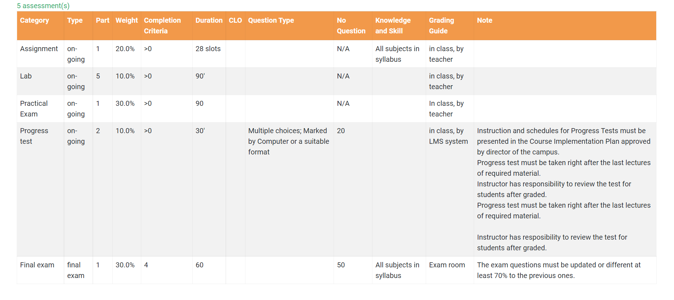

It can be seen that this is the component score information table, this table contains the points that throughout a subject in a semester students will be assessed by their Lecture. Thereby determining the Data:

* Category: types of tests to review students.
* Type: Status of Category.
* Part: The number of categories.
* Weight: Percentage of points affects the grade point average in subject.
* Completion Criteria: Condition of points to pass the course.
* Duraion: Time to finish the test.
* Question type: The style of question.
* No Question: The number of questions in one test.
* Knowledge and Skill: The requirement to pass the exam.
* Granding Guilde: Instruction to give score.
* Note: Short explanation of information gived by Lecture.

2. Subjects And Course Of Students

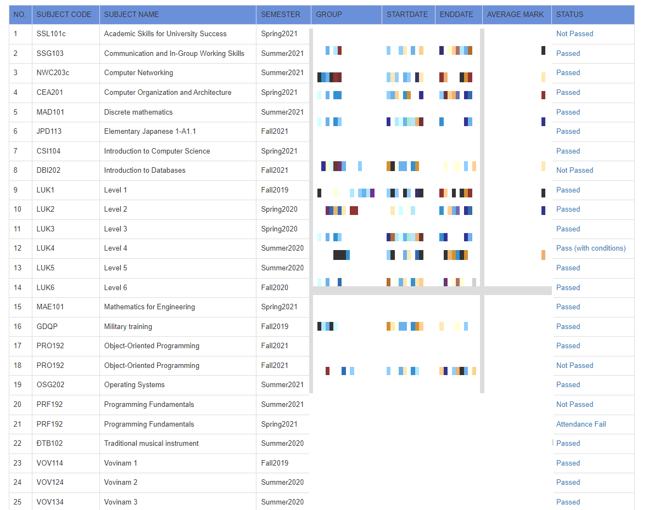

In this table, Students could see the basic information of all cousres that they have been joined in each semester:

* No: Serial
* Subject code: Code of each course.
* Subject name: Name of course.
* Semester: Describe seasons and years.
* Group: Describe the class that student has been joined.
* Start/End Date: The start day and the end day of the course.
* Average Mark: GPA
* Status: Standing (Passed, Not Passed, Passed with conditions)

This table contain many information and could be a lot of attributes. So, this table could not stand alone. Must dived to many tables to avoid 3NF.

3. Student Transcripts

In this table, there are many categories that students have taken during and after the course. This student transcripts contains:

* Grade category: Score students have in courses.
* Grade Item: types of tests to review students in courses.
* Weight: Percentage of points affects the grade point average in courses.
* Value: Score stutens get and gived by Lecture.
* Comment: Note of the lecture.