Local run:

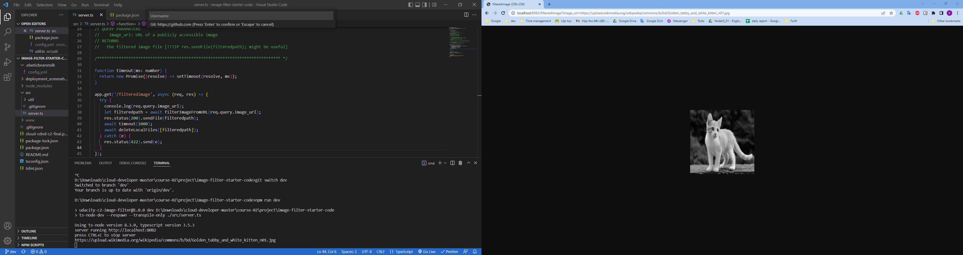

Eblink: <http://image-filter-starter-code-dev2222222222222.us-east-1.elasticbeanstalk.com/>

Deploy:

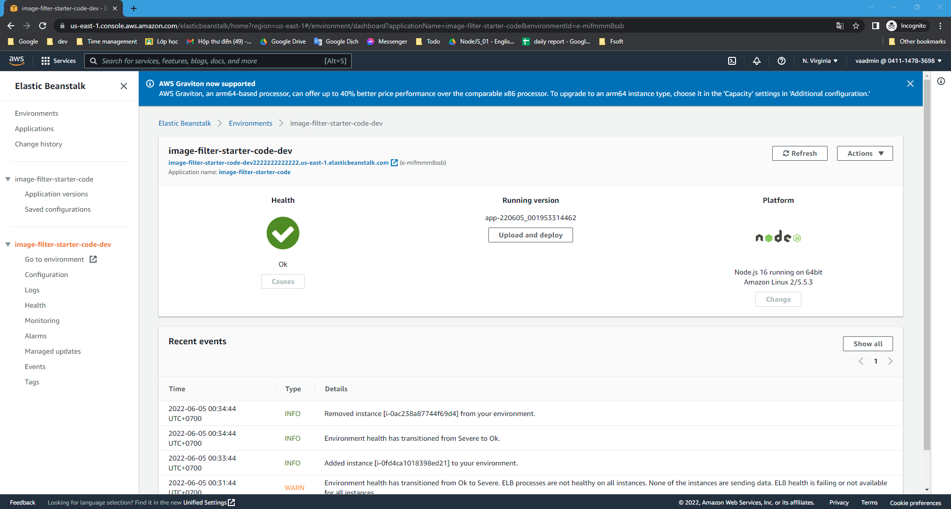

Deploy run:

