CYBER AI FPTx
Library Management System
UML Design Assignment — All 5 Questions
Software Engineer | Cyber AI FPTx

Question 1 — Class Diagram

1.1 Business Scenario
The system models how books are organized inside the university library, following these rules:
- A Library contains many Bookshelves.
- Each Bookshelf is a physical part of the Library and cannot exist without it.
- A Book is placed on exactly one Bookshelf.
- Books are classified as either Fiction or NonFiction, each with different categorization attributes.

1.2 Diagram Type Chosen
UML Class Diagram (entity level) — showing class names and relationships only, without attributes or methods, as specified by the task.

1.3 Class Diagram
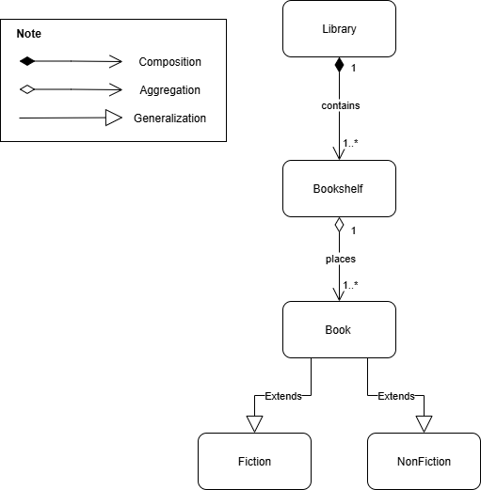

1.4 Relationships Summary
Relationship | Type | Multiplicity | Explanation
Library → Bookshelf | Composition | 1 to 1..* | Bookshelf cannot exist without Library
Bookshelf → Book | Aggregation | 1 to 1..* | Book is placed on exactly one Bookshelf
Book → Fiction | Generalization | — | Fiction inherits all Book properties
Book → NonFiction | Generalization | — | NonFiction inherits all Book properties

1.5 Relationship Details
Composition — Library ◆─── Bookshelf (1 to 1..*)
A Bookshelf is a physical component of the Library. It is created with the Library and is destroyed when the Library no longer exists. This strong whole–part dependency is represented by a filled diamond on the Library side. One Library must contain one or more Bookshelves.

Aggregation — Bookshelf ◇─── Book (1 to 1..*)
A Book is placed on exactly one Bookshelf, but is an independent object that can be moved, transferred, or removed without ceasing to exist. This weak whole–part relationship is represented by an open diamond on the Bookshelf side. One Bookshelf holds one or more Books.

Generalization — Book ◁─── Fiction / NonFiction
Fiction and NonFiction are specializations of Book. They inherit all general book properties and extend them with their own categorization attributes (e.g., genre for Fiction; subject or field for NonFiction). This is shown by open triangle (inheritance) arrows pointing from the subclass toward the parent class.

Question 2 — Sequence Diagram

2.1 Business Scenario
A student wants to borrow a book. The process involves the following objects and steps:
- Student brings the book to CheckOutCounter (boundary object).
- Counter staff triggers the system, which calls LoanController (control object).
- LoanController checks student membership status via MembershipService (service object).
- If the account is active, LoanController updates the book status via BookRepository (entity object) to 'On Loan'.

2.2 Diagram Type Chosen
Sequence Diagram — chosen because this scenario requires showing the step-by-step, time-ordered flow of messages between objects. It is superior to a Communication Diagram here for three reasons:
- Messages are shown top-to-bottom in strict chronological order, making the sequence immediately readable.
- It clearly distinguishes synchronous calls (solid arrows) from return messages (dashed arrows).
- Activation boxes show which object is actively processing at each step.

2.3 Object Stereotypes
«boundary» CheckOutCounter | Interface between the Student actor and the system. Receives user input and delegates to the controller.
«control» LoanController | Orchestrates the business logic. Coordinates calls to MembershipService and BookRepository.
«service» MembershipService | Handles membership validation. Checks whether the student account is active.
«entity» BookRepository | Manages persistent book data. Updates book status to 'On Loan' in the database.

2.4 Sequence Diagram
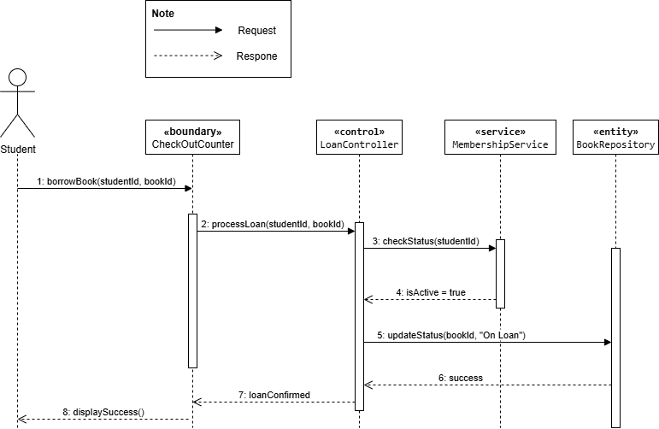

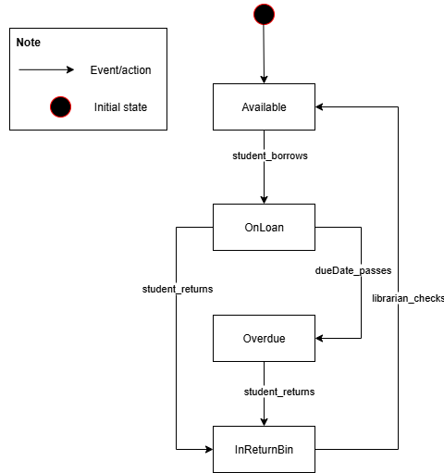2.5 Message Flow — Step by Step
# | From → To | Message | Arrow Type
1 | Student → CheckOutCounter | borrowBook(studentId, bookId) | Request
2 | CheckOutCounter → LoanController | processLoan(studentId, bookId) | Request
3 | LoanController → MembershipService | checkStatus(studentId) | Request
4 | MembershipService → LoanController | isActive = true | Respone
5 | LoanController → BookRepository | updateStatus(bookId, 'On Loan') | Request
6 | BookRepository → LoanController | success | Respone
7 | LoanController → CheckOutCounter | loanConfirmed | Respone
8 | CheckOutCounter → Student | displaySuccess() | Respone

2.6 Design Justification (BCE Pattern)
The flow follows the standard Boundary–Control–Entity (BCE) pattern:
- The boundary object (CheckOutCounter) handles all user interaction and input.
- The control object (LoanController) contains all business logic and decision-making.
- The service object (MembershipService) and entity object (BookRepository) handle specialized responsibilities — validation and data persistence respectively.
- This separation of concerns ensures the system is maintainable and easy to extend.

Question 3 — Statechart Diagram

3.1 Business Scenario
A physical book in the library has a lifecycle. It starts in the Available state. When a student borrows it, it transitions to OnLoan. If not returned on time, the dueDate_passes event occurs and it enters Overdue. When the student returns the book, it enters InReturnBin for processing. After a librarian checks it, it returns to Available.

3.2 Statechart Diagram


3.3 States and Descriptions
Available | Initial state. The book is on the shelf and ready to be borrowed. Entry action: setStatus('Available').
OnLoan | The book has been borrowed by a student. Entry action: notifyDueDate(). Two exit paths: return on time → InReturnBin, or due date passes → Overdue.
Overdue | The book was not returned by the due date. Entry action: sendOverdueAlert(). Exits when the student eventually returns the book.
InReturnBin | The book has been returned and is waiting for the librarian to process. Entry action: awaitLibrarianCheck().

3.4 Transitions and Events
From State | Event | To State
(initial) | — | Available
Available | student_borrows | OnLoan
OnLoan | dueDate_passes | Overdue
OnLoan | student_returns | InReturnBin
Overdue | student_returns | InReturnBin
InReturnBin | librarian_checks | Available

Question 4 — Software Architecture

4.1 Architecture Chosen
Layered Architecture (3-Layer Architecture)

4.2 Architecture Diagram

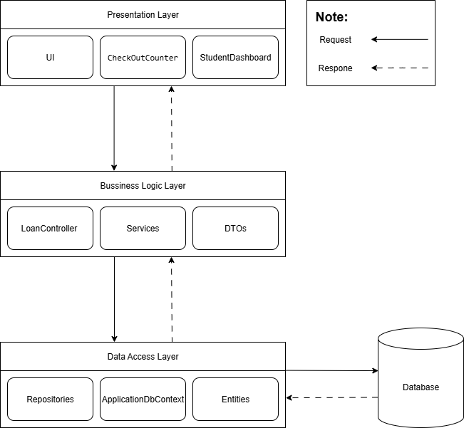

4.3 Why This Architecture?
The Library Management System is a medium-sized university application with clearly separated concerns — user interface, business rules, and data storage. The Layered Architecture is the best fit because:
- It maps directly to the BCE pattern used in the UML design: «boundary» objects in the Presentation Layer, «control»/«service» objects in the Business Logic Layer, and «entity» objects in the Data Access Layer.
- Each layer only communicates with the layer directly below it, creating clear boundaries and reducing coupling.
- The development team can be divided by layer — frontend, backend, and database — allowing parallel development.
- Each layer can be tested independently, making unit testing and integration testing straightforward.

4.4 Key Advantage
Easy to maintain and extend — when the UI needs to change (e.g., adding a mobile app), only the Presentation Layer needs updating. When the database engine changes (e.g., MySQL to PostgreSQL), only the Data Access Layer is affected. The other layers remain untouched.

4.5 Key Disadvantage
Performance overhead — every request must travel through all layers in sequence, even simple ones that do not require business logic processing. This can create unnecessary latency, known as the sinkhole anti-pattern, where a request simply passes through a layer without any real processing occurring.

Question 5 — Design Pattern

5.1 Pattern Chosen
Strategy Pattern (Behavioral Design Pattern)

5.2 What is the Strategy Pattern?
The Strategy Pattern defines a family of algorithms, encapsulates each one in a separate class, and makes them interchangeable. The client (or context) can switch between algorithms at runtime without changing its own code.

5.3 Class Diagram — Strategy Pattern Applied

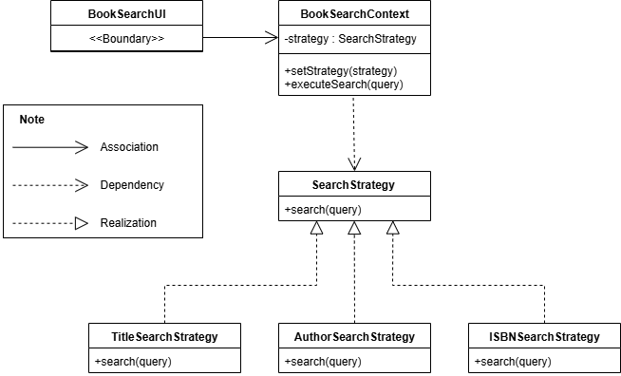

5.4 Components Explained
SearchStrategy (interface) | The common contract. Declares the search(query) method that all concrete strategies must implement.
TitleSearchStrategy | Concrete strategy that searches books by matching the title string.
AuthorSearchStrategy | Concrete strategy that filters books by author name.
ISBNSearchStrategy | Concrete strategy that performs an exact lookup by ISBN code.
BookSearchContext | Holds a reference to a SearchStrategy. Exposes setStrategy() to switch algorithms and executeSearch() to run the current one.
BookSearchUI («boundary») | The client. Lets the user pick a search type, calls setStrategy() on the Context, then calls executeSearch(query). It has no knowledge of how any algorithm works.

5.5 Why Strategy Pattern is the Best Solution
The problem statement contains three exact requirements that map directly to the three goals of the Strategy Pattern:

Problem Requirement | How Strategy Pattern Solves It
"define a family of algorithms" | Three concrete strategy classes: TitleSearchStrategy, AuthorSearchStrategy, ISBNSearchStrategy — each one a self-contained algorithm.
"encapsulate each one" | Every algorithm lives in its own class, isolated from the others. Changing one does not affect the rest.
"make them interchangeable" | All three implement the same SearchStrategy interface, so BookSearchContext can swap between them with a single setStrategy() call at runtime.
"interface not knowing the details" | BookSearchUI only calls executeSearch(query) on the Context. It never references any concrete strategy class directly.

5.6 Why Not Other Patterns?
if/else or switch | Simple but violates the Open/Closed Principle — adding a new search type requires modifying existing code, risking new bugs.
Factory Pattern | Solves object creation, not algorithm switching. Cannot swap algorithms at runtime after creation.
Template Method Pattern | Uses inheritance instead of composition. The algorithm cannot be changed at runtime since the subclass is fixed at compile time.
Strategy Pattern | The only pattern that allows runtime algorithm switching with zero changes to the UI or Context code. Perfectly matches all three requirements in the problem.

5.7 Runtime Flow Example
User selects 'Search by Author' and types 'Nguyen Nhat Anh':
- BookSearchUI calls: context.setStrategy(new AuthorSearchStrategy())
- BookSearchUI calls: context.executeSearch('Nguyen Nhat Anh')
- BookSearchContext delegates to: strategy.search('Nguyen Nhat Anh')
- AuthorSearchStrategy executes its algorithm and returns matching books.
- User switches to ISBN search — only one line changes: context.setStrategy(new ISBNSearchStrategy())

— End of Submission —

