|  |  |
| --- | --- |
|  | **FPT ACADEMY INTERNATIONAL**  **FPT – APTECH COMPUTER EDUCATION** |

**Centre Name: ACE-HCMC-2-FPT.**

**Address: 590 Cach Mang Thang 8, District 3, Ho Chi Minh City, Viet Nam.**

**AllAbtNobel**

|  |  |  |  |
| --- | --- | --- | --- |
| **Supervisor.** | Mr. Nguyen Phat Tai | | |
| **Batch.** | T1.2209.E0 | | |
| **Group.** | Group 2 | | |
| **Serial No.** | **Enrollment Number** | **Student Name** |
| 1. | Student1421363 | Truong Tuan Binh |
| 2. | Student1420715 | Bui Quoc Viet |
| 3. | Student1416022 | Ha Truong Nam |
| 4. | Student1420702 | Tran Huu Thao |

Month 12 Year 2022

**This is to certify that**

**Mr./Ms.:**

Truong Tuan Binh

Bui Quoc Viet

Ha Truong Nam

Tran Huu Thao

**has successfully designed & developed**

eProject: AllAbtNobel

**Submitted by: Truong Tuan Binh**

**Date of issue: 14-Jan-2023**

**Authorized Signature: Binh**

**TABLE OF CONTENTS**

FPT – APTECH COMPUTER EDUCATION 1

ACKNOWLEGMENT 3

SYNOSIS 3

PROBLEM DEFINITION 3

CUSTOMER'S REQUIREMENTS SPECIFICATIONS (CRS) 4

Business/Project Objective: 4

Hardware/ Software Requirements: 5

SCOPE OF THE WORK (IN BRIEF) 6

Architecture and design of the system 7

Diagram of the website 8

TASK SHEET REVIEW 1 9

***SITE MAP ............................................................................................................................................... 10* *MOCK OF THE WEBSITE ......................................................................................…………………………………..11***

1. Home Page .................................................................................................. ………………………………….12

2. Nobel Prizes & Laureates .......................................................................................................... …….13

3. Nomination .................................................................................................... ……………………………….14

4. Alfred Nobel ....................................................................................................... …………………………..15

5.News & Events ..................................................................................................................................16

6.About Us ....................................................................................................... ………………………………...17

7.Video………………………………………………………………………………………………………………………………………….…18

***TASK SHEET REVIEW 2 .......................................................................................................................... 19***

WEBSITE DESCRIPTION 18

**1.** Home Pages **18**

**2.** Nomination page **20**

**3.** Nobel Prizes & Laureates Page **23**

**4.** News & Event Page **24**

**5.** Video Page **25**

**4.** Contact Us Page **26**

**5.** About Us Page **27**

HTML, CSS, JAVASCRIPT DESCRIPTION 28

TASK SHEET REVIEW 3 29

# ACKNOWLEGMENT

On behalf of all the members of group 2, I would like to thank you all for the hard works, supports to make this eProject complete successfully. Especially, Mr. Nguyen Phat Tai, our teacher, he helped us a lot from the day that we started to study at FPT Aptech. With this eProject, he has guided us with his enthusiasm and rigorous. Thanks for his guiding, we would be able to finish this project. Besides, I want to thank all the team member of group 2, each of the team members has been working continuously in 4 weeks in order to complete this project. The last but not least, we would like to say thank you to our family for always supporting us, creating the best conditions for us to focus on the project, and putting faith in the dreams we pursue.

# SYNOSIS

Nobel Prizes are awarded in the fields of Physics, Chemistry, Physiology or Medicine, Literature, and Peace (Nobel characterized the Peace Prize as " to the person who has done the most or best to advance fellowship among nations, the abolition or reduction of standing armies, and the establishment and promotion of peace congresses"). In 1968, Sveriges Riksbank (Sweden's central bank) funded the establishment of the Prize in Economic Sciences in Memory of Alfred Nobel, to also be administered by the Nobel Foundation. Nobel Prizes are widely regarded as the most prestigious awards available in their respective fields.

The website is to be developed for the Windows Platform using HTML5, JavaScript and Geolocation. The site should work well in all leading browsers including Chrome, IE, Firefox etc.

# PROBLEM DEFINITION

The Web site is to be created based on the following requirements.

1. The Home Page should be created with proper sections, graphics and with a

suitable logo

1. Link on the home page must be included such as Home, About us, Gallery etc
2. The look and feel of the project must be made user friendly and uniformity in

the color combination must be maintained.

1. The site should include
   * How and when Nobel Prize awards started
   * Various fields in which Nobel prize is awarded
   * Nominations in all field in all years
   * Related news
   * Related events
   * Informative videos (related to the topic)
2. Each category mentioned above should brief user about respective topic.
3. Details of winners along with their career brief to be included.
4. Videos of important inventions should be included (size limit should be

considered)

1. Navigation of the project must be made smooth.
2. Site Map
3. Gallery
4. FAQs

# CUSTOMER'S REQUIREMENTS SPECIFICATIONS (CRS)

**Client: AllAbtNobel**

### Business/Project Objective:

The Objective of this program is to give a sample project to work on real life projects. These applications help you build a larger more robust application.

The objective is not to teach you HTML/JavaScript/Dreamweaver/HTML5 but to provide you with a real life scenario and help you create basic applications using the tools.

You can revise the chapters before you start with the project.

This project is meant for students who have completed the module of *HTML5*. These programs should be done in the Lab sessions with assistance of the faculty if required.

It is very essential that a student has a clear understanding of the subject. Students should go through the project and solve the assignments as per requirements given.

Kindly get back to eProjects Team in case of any doubts regarding the application or its objectives.

**Input to the system:**

* + - * Enter information about Nobel Prizes of Physics, Chemistry, Physiology or Medicine, Literature, and Peace.

**Output from the system:**

- A menu will categorize all the functions of the website.

- Display list of all Nobel awards by category.

- Perform a search based on a characteristic: category, award, winner, .

- The website may provide a brief introduction/history of the origin, Related News Related Events.

- The location of the company under Contact-Us page.

- The look and feel of the project must be made user friendly and uniformity in the color combination must be maintained.

**Expected delivery date:** 14-Jan-2023.

**List of deliverables:**

* + - * Document Word.
      * User Guide.
      * Source code.

### Hardware/ Software Requirements:

* **For developer**

**Hardware**

* + Intel Pentium 4 processor or higher
  + 1 Gigabytes of RAM or higher

**Software**

* + Windows 7 OS or higher
  + Adobe Dreamweaver
  + Web browsers such as IE, Chrome or Firefox are supporting HTML5, CSS3 and Javascript.
* **For web users**

**Hardware**

* + Intel Pentium 4 processor or higher
  + 512 Megabytes of RAM or higher

**Software**

* + Windows XP OS or higher
  + Web browsers such as IE, Chrome or Firefox are supporting HTML5, CSS3 and Javascript.

# SCOPE OF THE WORK (IN BRIEF)

After a long and detailed discussion, our group has decided to create a website contain the following webpages:

1. ***Homepage***: Display information about all Nobel Prizes.
2. ***Nobel Prizes & Laureates***: Display nobel interpretation and award recipient.
3. ***Nomination***: Winning conditions for each category.
4. ***Alfred Nobel***: Nobel Prize history.
5. ***News & Events***: Information about the Nobel Prize.
6. **About us**: Website founder.
7. ***Video***: Nobel Prize videos.

# Architecture and design of the system

# Diagram of the website

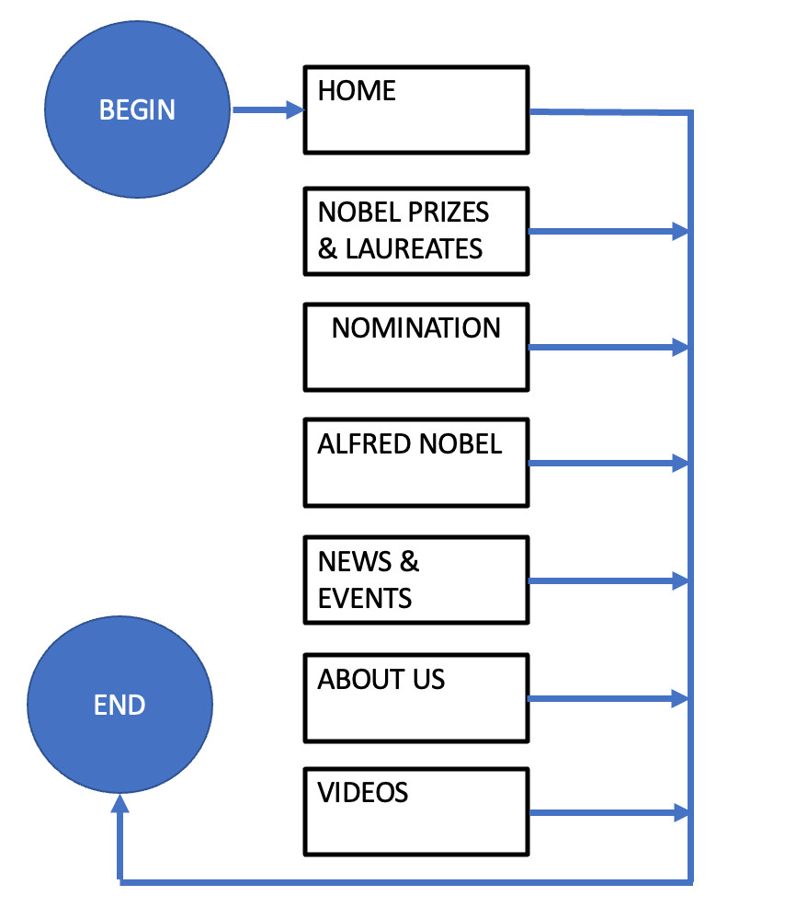



# TASK SHEET REVIEW 1

|  |  |  |  |  |  |  |  |
| --- | --- | --- | --- | --- | --- | --- | --- |
| **Project Ref. No.:**  **eP/** **Portal Management**  **System/01** | | **Project Title:** | **Activity Plan Prepared By:** | **Date of Preparation of Activity Plan:** | | | |
| **Sr.**  **No.** | **Task** | **Actual**  **Start Date** | **Actual Days** | **Team**  **Mate Names** | **Status** |
| 1 | Problem Statement | Nobel Prizes | Binh | 14-Dec-2022 | 1 | Viet | Completed |
| 2 | Analysis of Nobel Prizes about the website | 14-Dec-2022 | 1 | Viet | Completed |
| 3 | The scope of the work (in brief) | 14-Dec-2022 | 1 | Viet | Completed |
| 4 | Architecture and design of the system | 14-Dec-2022 | 1 | Binh | Completed |
| 5 | Diagram of the website | 14-Dec-2022 | 1 | Binh | Completed |
| 6 | Task Sheet | 14-Dec-2022 | 1 | Binh | Completed |

|  |  |
| --- | --- |
| **Date: 12-Dec-2022** | |
| Signature of Instructor:  **Mr. Nguyen Phat Tai** | Signature of Team Leader:  **Mr. Truong Tuan Binh** |

# SITE MAP

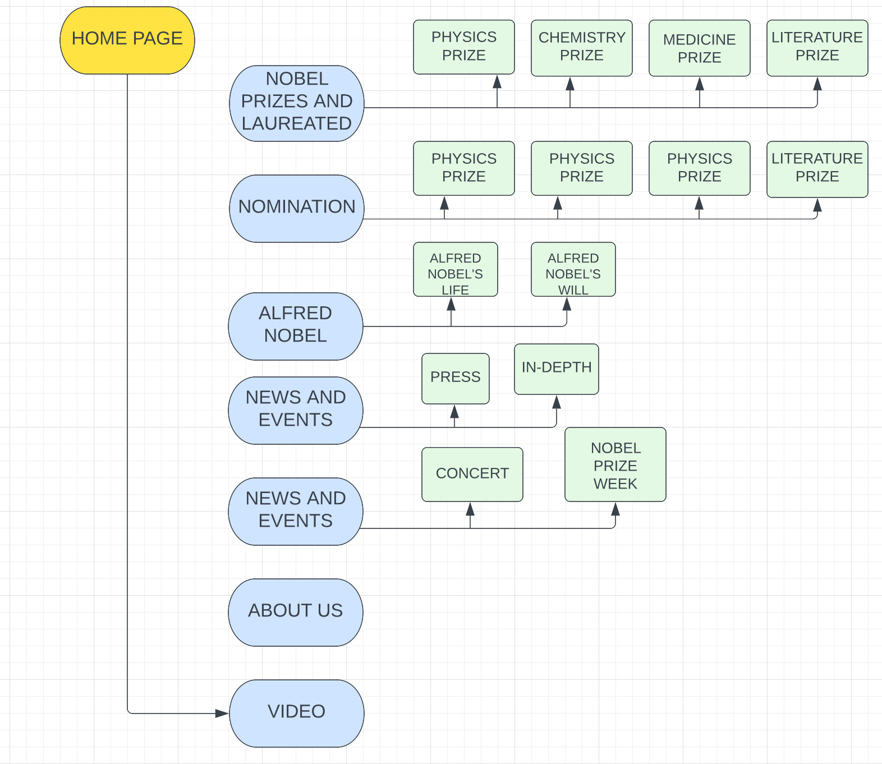

# MOCK OF THE WEBSITE

1. **HOMEPAGE**

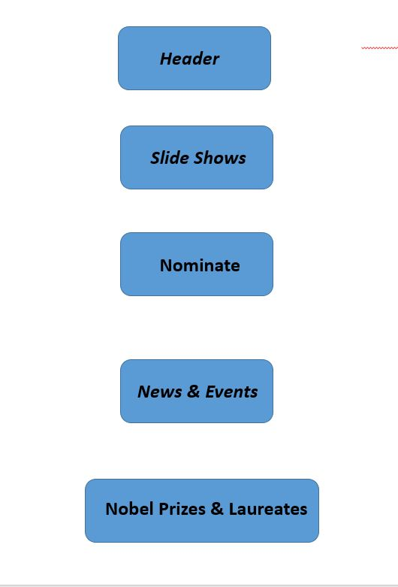

1. ***NOBEL PRIZES & LAUREATES***

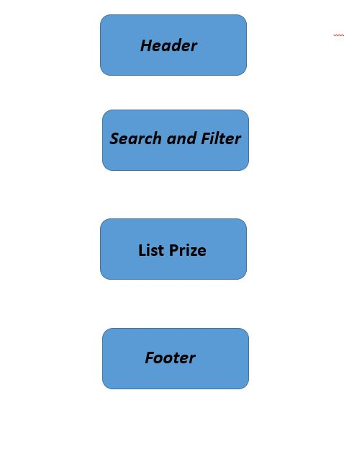

1. ***Nomination***

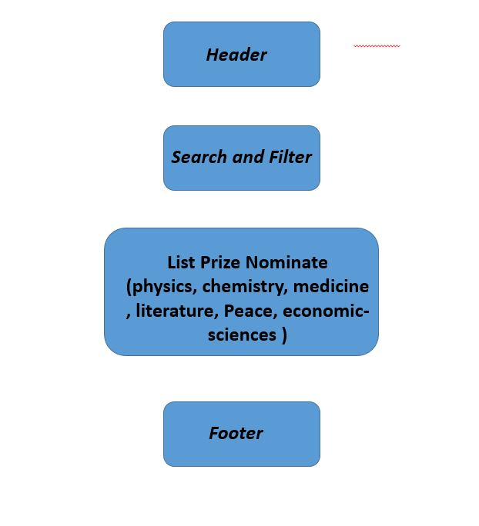

1. ***Alfred Nobel***

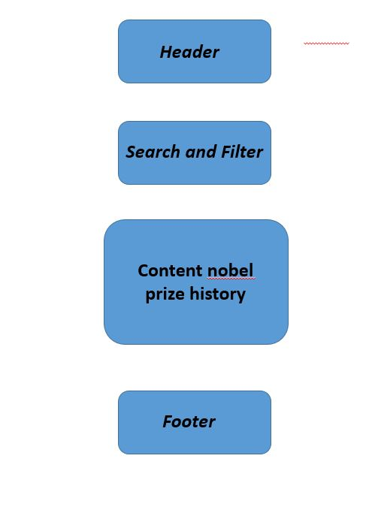

1. **New & Event**

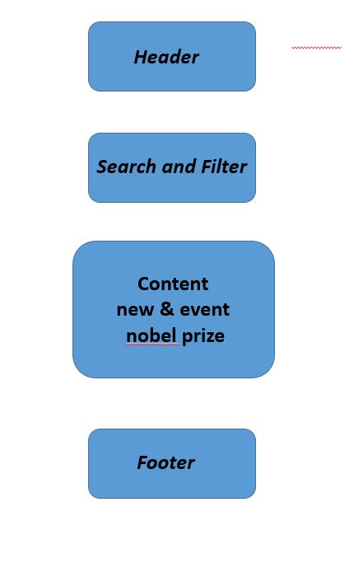

1. **About us**

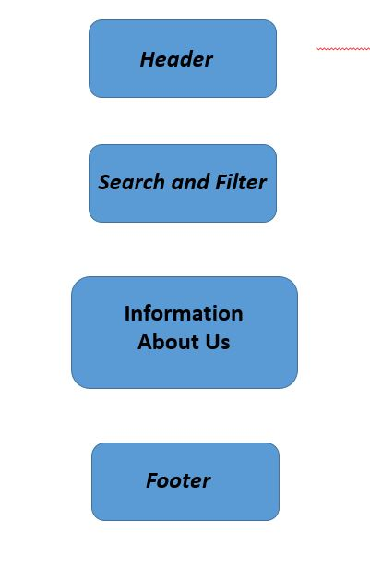

**7.Video**

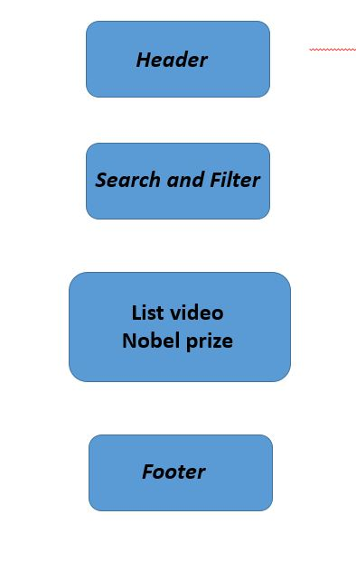

# 

# TASK SHEET REVIEW 2

|  |  |  |  |  |  |  |  |
| --- | --- | --- | --- | --- | --- | --- | --- |
| **Project Ref. No.:**  **eP/Advertisement**  **Portal Management System/01** | | **Project Title:** | **Activity Plan Prepared By:** | **Date of Preparation of Activity Plan:** | | | |
| **Sr.**  **No.** | **Task** | **Actual**  **Start Date** | **Actual Days** | **Team**  **Mate Names** | **Status** |
| 1 | Site map | *AllAbtNobel* | Binh | 25-Dec-2022 | 2 | Binh, Viet | Completed |
| 2 | Mock of the website | 25-Dec-2022 | 2 | Binh, Viet | Completed |
| 3 | Task Sheet | 29-Dec-2022 | 1 | Binh | Completed |

|  |  |
| --- | --- |
| **Date: 30/12/2022** | |
| Signature of Instructor:  **Mr. Nguyen Phat Tai** | Signature of Team Leader:  **Mr. Truong Tuan Binh** |

**WEBSITE DESCRIPTION**

1. **HOME PAGE:**

**.**Description

Home page displays following information:

* + - * Banner content nobel prize
      * Current outstanding award ceremony post
      * Nominate And Select Winners
      * Performance information including news and events site
      * Contact and information footer

.Screenshot

**Home menu and banner**

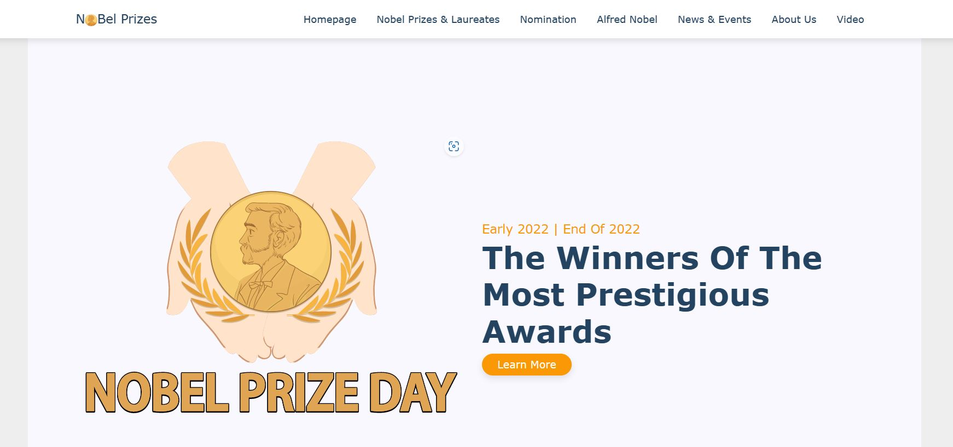

**Hot New and Nominate**

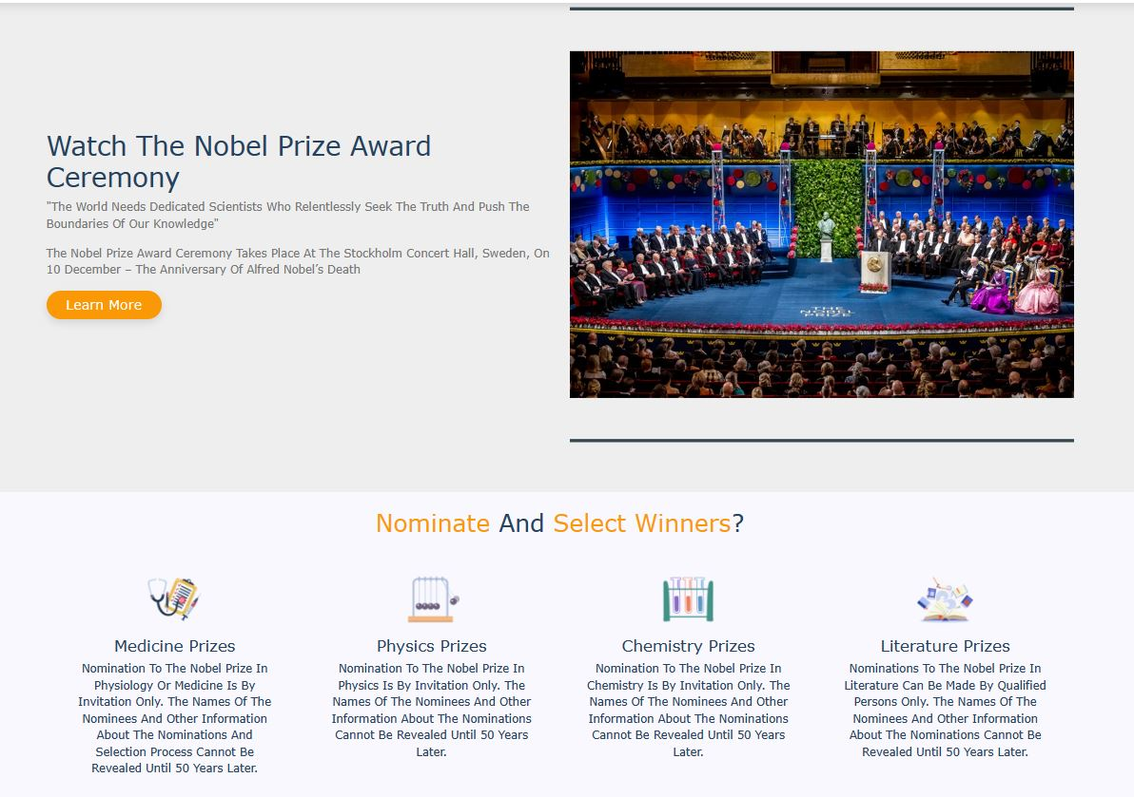

**Home page New Event and Contact**

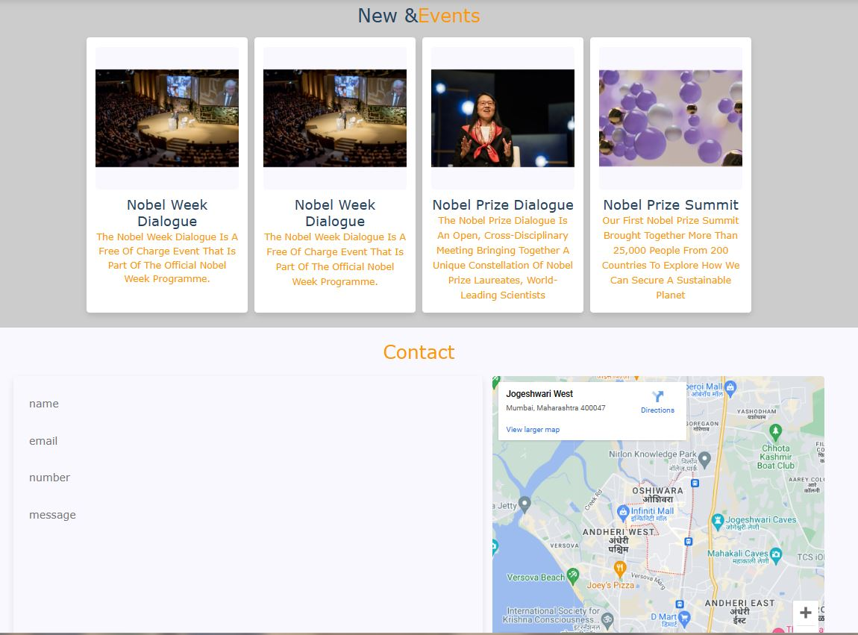

**Home page Nobel Prize and Footer**

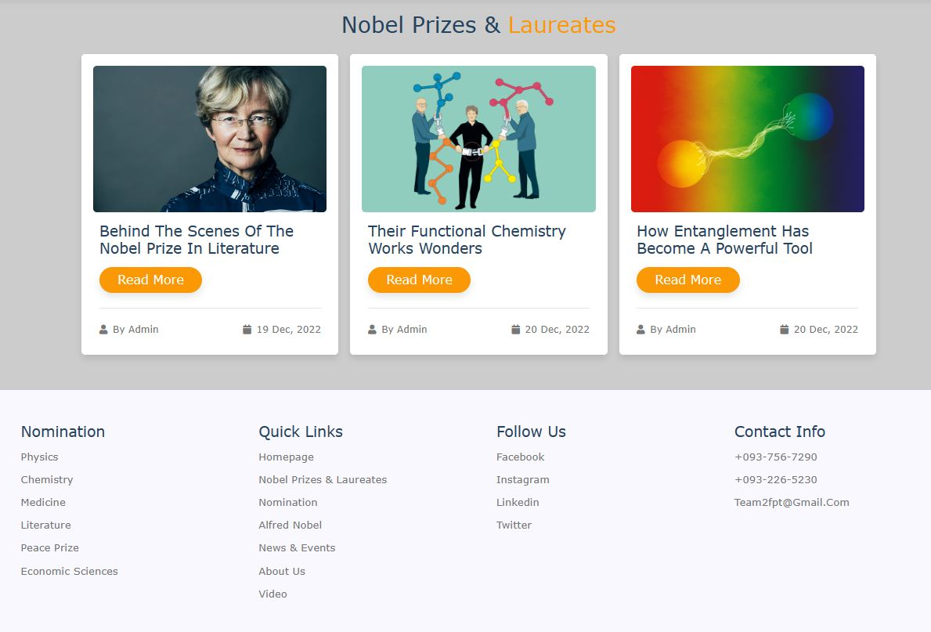

**Page Nomination**

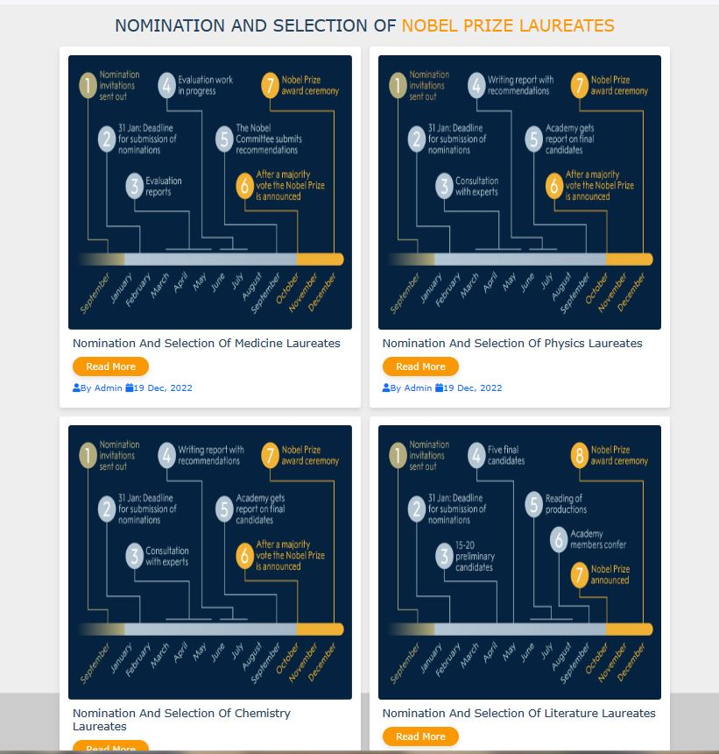

**Content Nobel Prize**

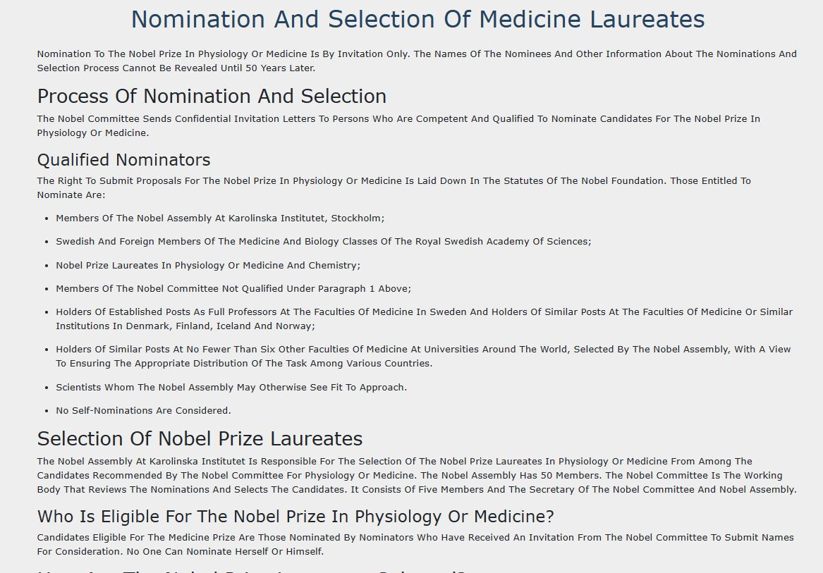

**Page Alfred Nobel**

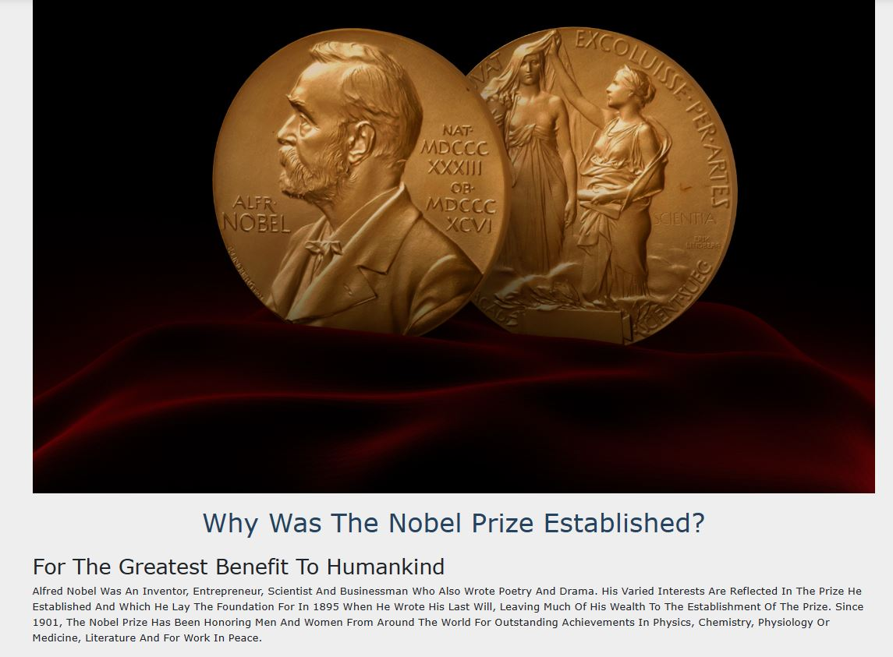

Video Nobel Prize

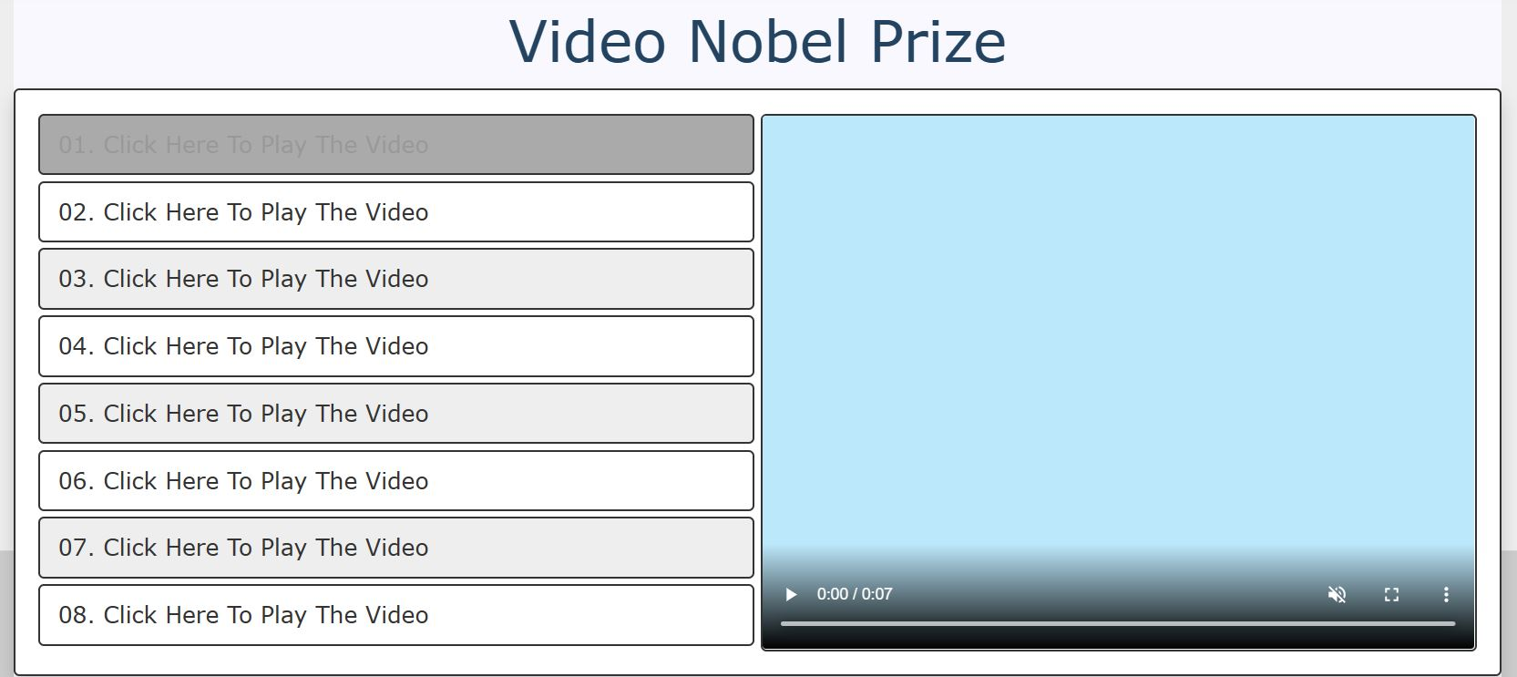

**Code Web Site**

**1.Home page**

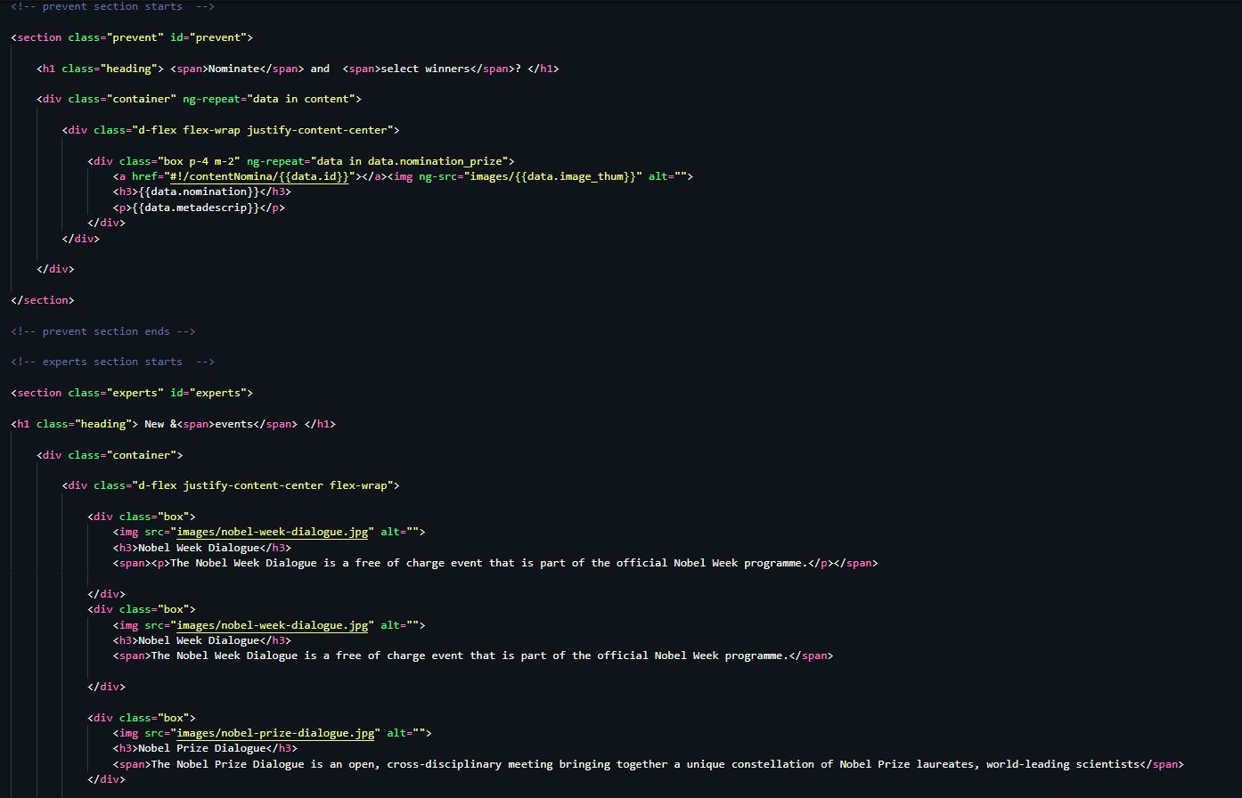

1. **File css**

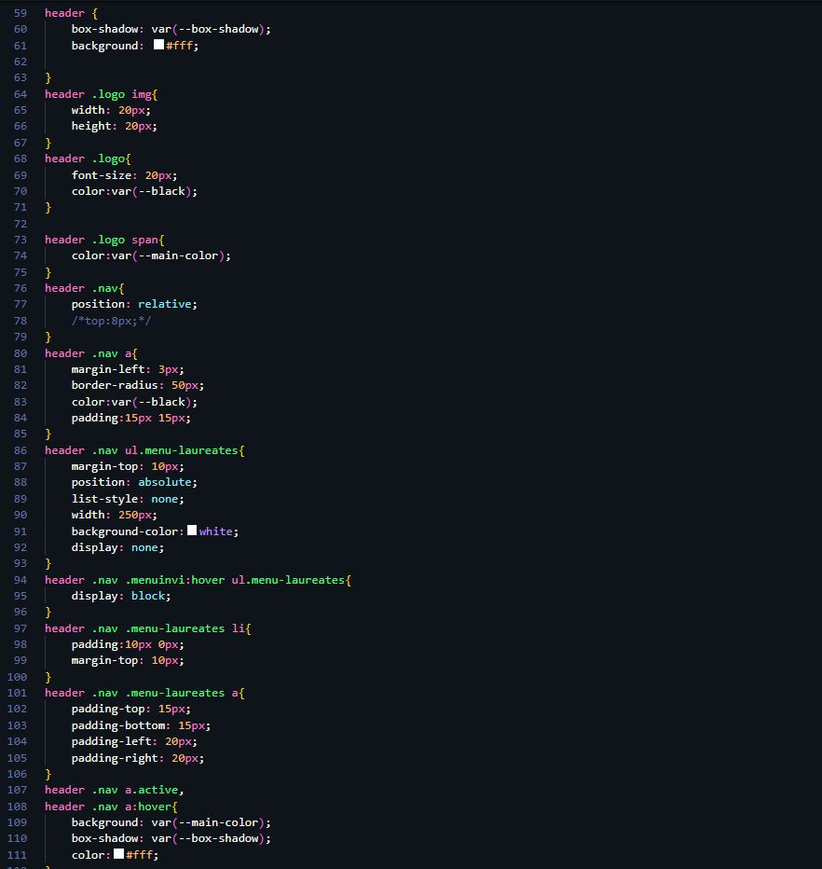

**3.Menu Code**

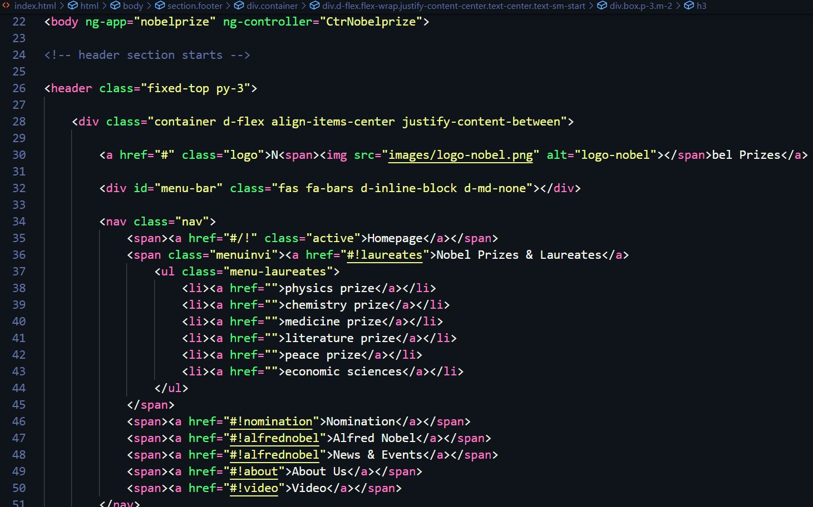

**4.File Js Link**

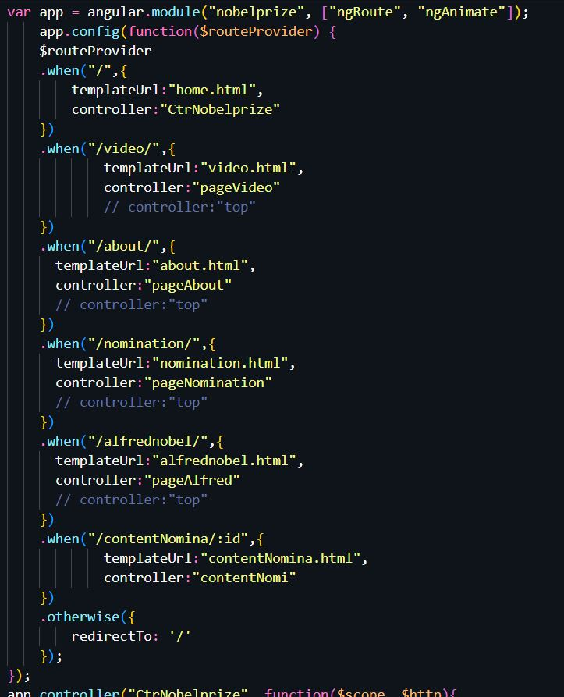

**5.JS Link file Json**

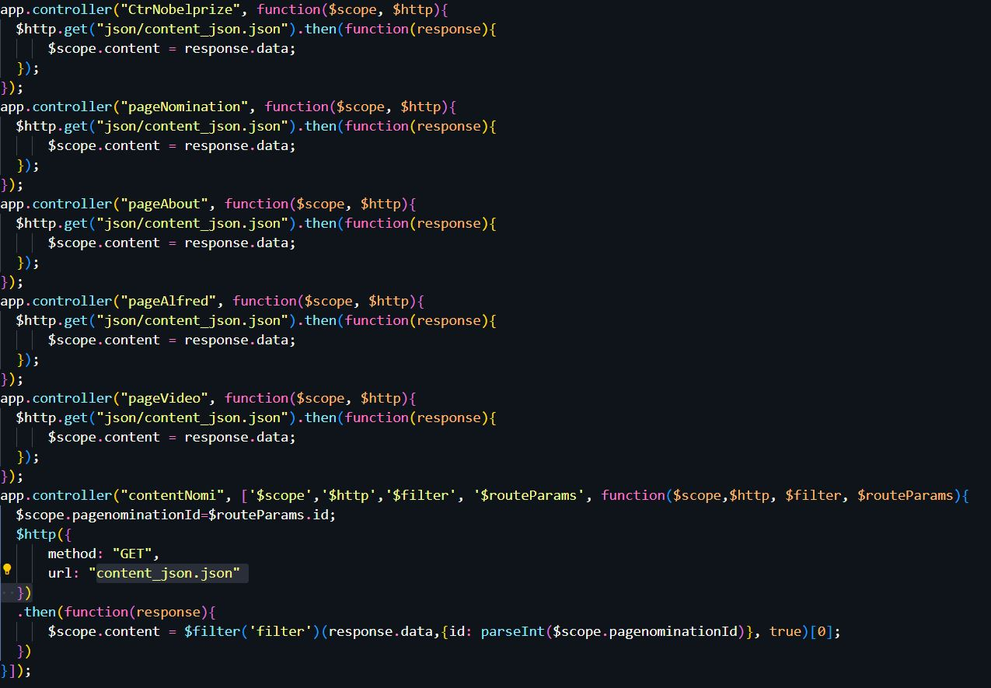

**6.Code Page Video**

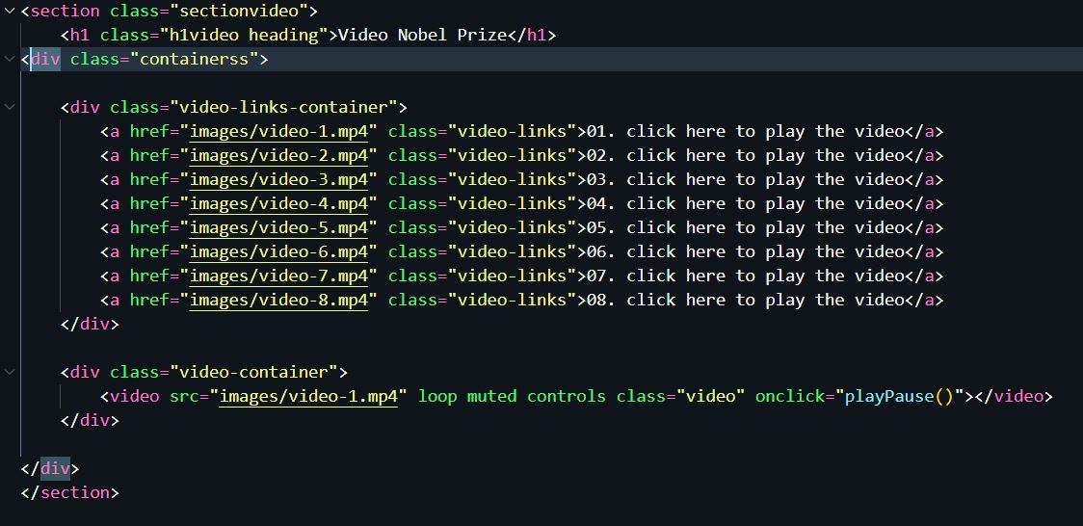

**7.File json**

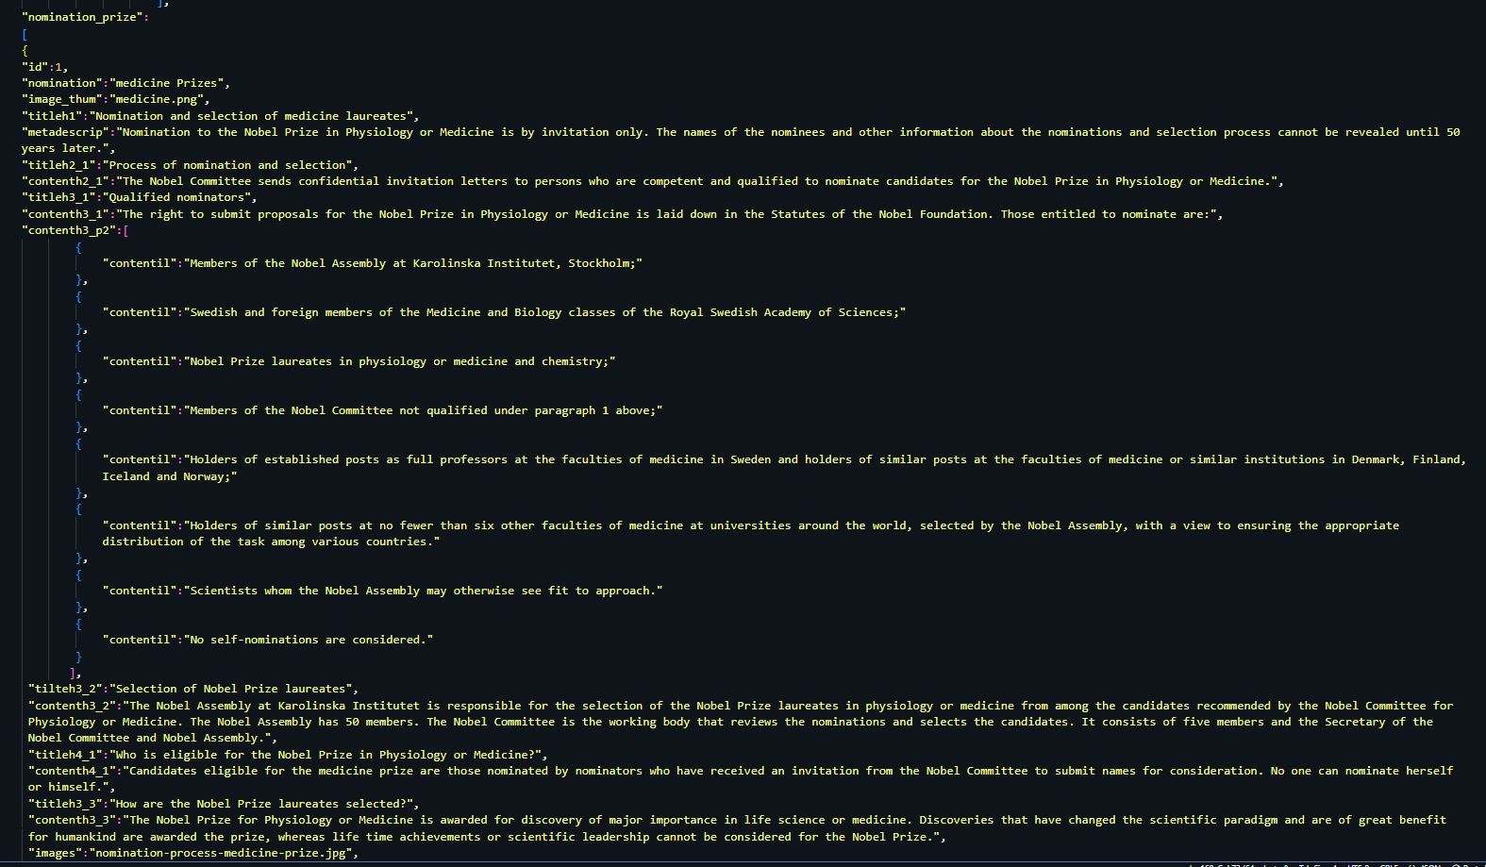

# TASK SHEET REVIEW 3

|  |  |  |  |  |  |  |  |
| --- | --- | --- | --- | --- | --- | --- | --- |
| **Project Ref. No.:**  **eP/Advertisement**  **Portal Management System/01** | | **Project Title:** | **Activity Plan Prepared By:** | **Date of Preparation of Activity Plan:** | | | |
| **Sr.**  **No.** | **Task** | **Actual**  **Start Date** | **Actual Days** | **Team**  **Mate Names** | **Status** |
| 1 | Home page | *AllAbtNobel* | Binh | 03-Jan-2023 | 2 | Binh | Completed |
| 2 | Nomination | 03- Jan-2023 | 2 | Binh, Viet | Completed |
| 3 | Contact us | 04- Jan-2023 | 1 | Binh | Completed |
| 4 | About us | 03- Jan-2023 | 1 | Viet | Completed |
| 5 | json | 03- Jan-2023 | 1 | Viet | Completed |
| 6 | video | 03- Jan-2023 | 1 | Binh | Completed |
| 7 | Task sheet | 02- Jan-2023 | 3 | Binh | Completed |
| 8 | Alfred Nobel | 06- Jan-2023 | 1 | Viet | Completed |

|  |  |
| --- | --- |
| **Date: 06/01/2023** | |
| Signature of Instructor:  **Mr. Nguyen Phat Tai** | Signature of Team Leader:  **Mr. Truong Tuan Binh** |