Installation Guide for The Application

Welcome to the installation guide for the Majestic Application. This simple guide will walk you through the process of downloading and running the application on your Windows computer. No technical knowledge is required; just follow these steps:

**Step 1: Running the Application**

* Open the **MSSS-PY_APP** folder.
* Inside, navigate to the **dist** folder.
* You will find the executable file for the Majestic Application here. It will have an **.exe** extension, for example, **MajesticApp.exe**.
* Double-click on the **.exe** file to run the application.
* If a security warning appears asking if you want to run the file, click **Run**.

**Note:** The first time you run the application, your antivirus software might perform a routine check to ensure the application is safe. This is a standard procedure for new files.

**Troubleshooting**

* If you receive a message stating that the application can’t be run on your PC, click on **More info** and then select **Run anyway**.
* Make sure to extract the ZIP file before trying to run the application. The application will not run directly from within the ZIP file.

User Guide for Majestic Application

When you first start up the application you will see this on your main window. Make sure to enlarge the window to be able to see all the features. The RFID chips are labeled and numbered on the shirt figured as shown below.

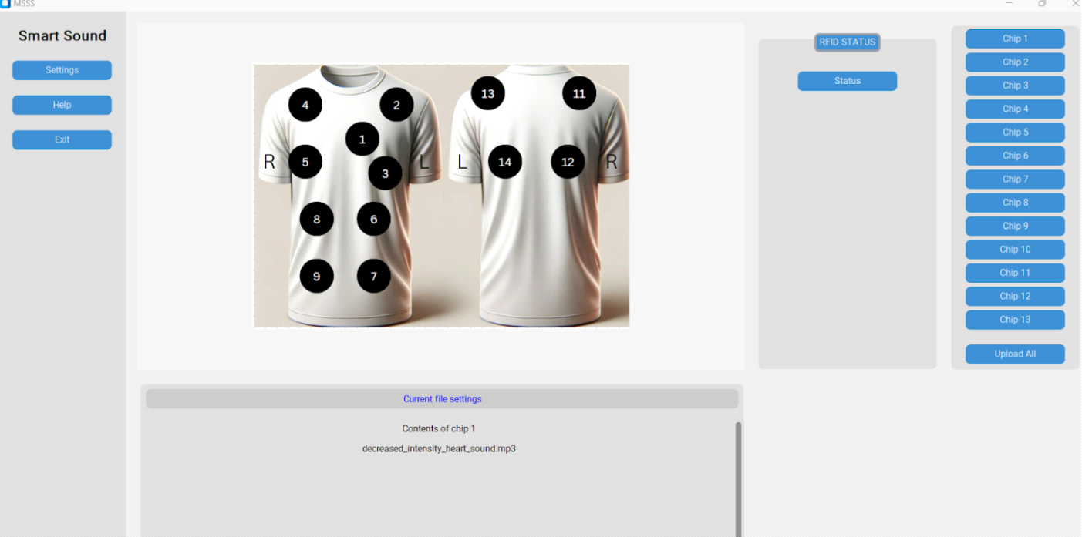

These are the steps to take when wanting to load a file into the smart stethoscope:

* First select which chip you want to load the file into. The chip can be selected on the right side showing all chips numbered from 1-13 on the side bar as shown below.

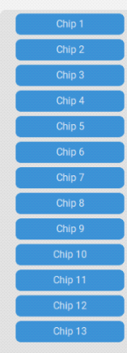

* Once you select a chip, a window will show up where you will be prompted to select a sound file. The application will only look for sound files. Once you find one go ahead and select ok and you will see that a sound file is ready to be loaded on to its designated chip and it is indicated by the check mark next to the selected chip. You can do this to all the chips that need to be updated/

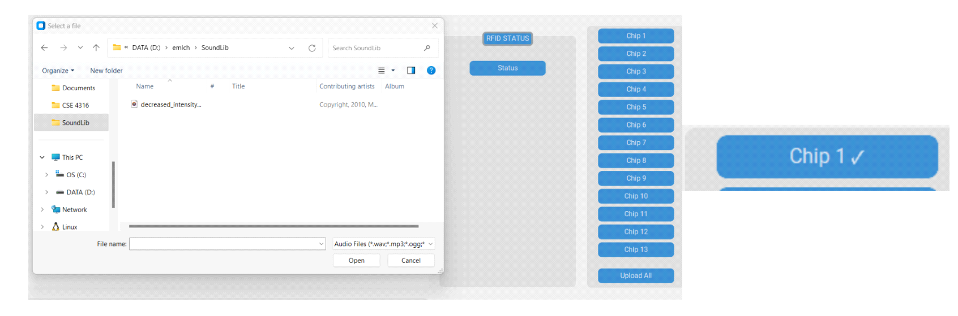

* Finally, you will go ahead and select the upload all button to load and overwrite the chip files into the shared folder that contains all the RFID chip tags for the pi.

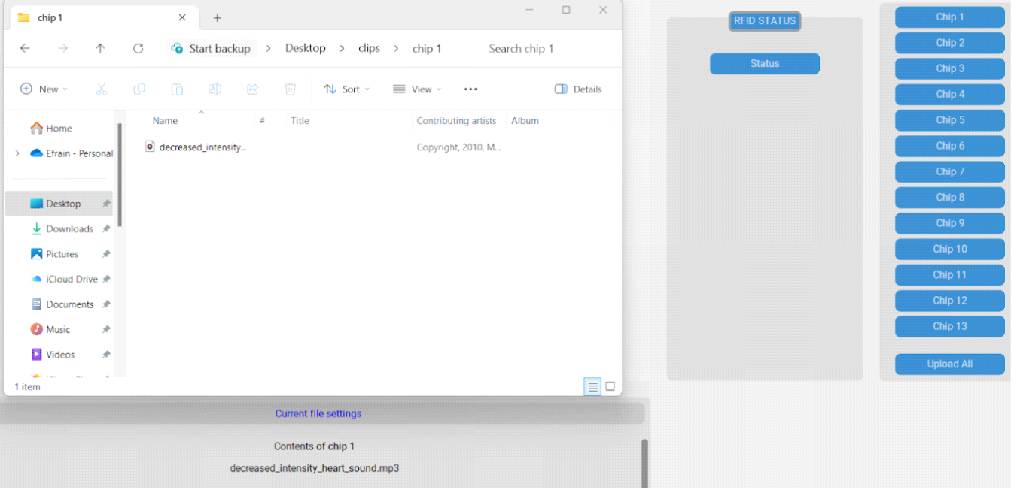

As you can see above the shared file has the sound file that corresponds to the chip selection with its designated sound file. This can also be shown under the “Current file settings” section below. This can be done as many times as needed including any new changes to keep overwriting and updating the files for the RFID chips on the pi. Now you are ready to test the stethoscope with its new sounds.

Thank you for choosing Majestic Application. We hope you enjoy using it!