Accomodation proposal

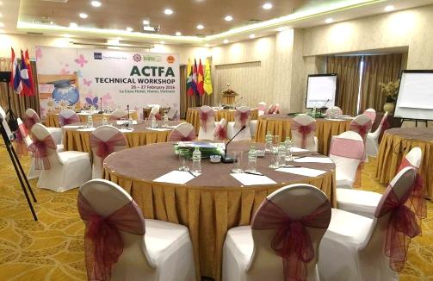 | 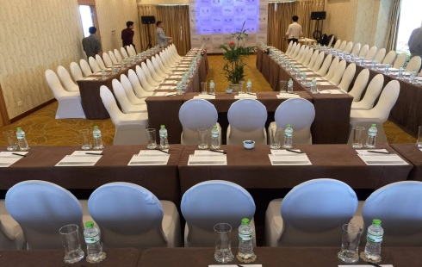 | 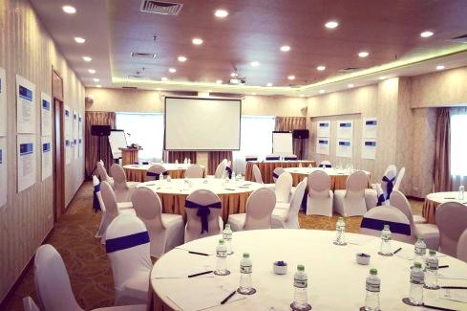
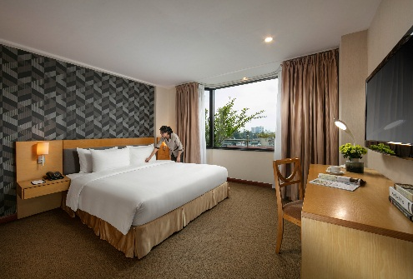 | 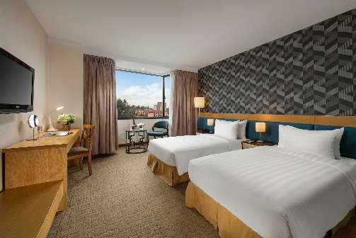 | 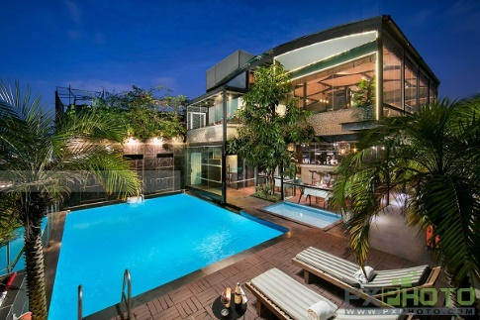

Dear JCCI,
Thank you very much for your interest in La Casa Hanoi Hotel!
Further to your request, we are pleased to send you the Hotel proposal as below for your consideration:
ACCOMODATION/ PHÒNG NGHỈ
ROOM TYPE | ROOM RATE | NOTE
Deluxe room | VND1,900,000net/room/night | + Room size: 28m2-Large window -city view  + Rate is inclusive room rental; breakfast
Premium room | VND2,200,000net/room/night | + Room size: 35m2-Large window -city view  + Rate is inclusive room rental; breakfast
Junior Suite room (48m2-Large window -city view) | VND2,700,000net/room/night | + Room size: 48m2-Large window -city view  + Rate is inclusive room rental; breakfast
Notes:
- Surcharge for the second person sharing room is VND 500,000 net/pax/night (Twin/Double room)
- Above rates are inclusive 5% service charge and VAT
- Check in time: 14:00; Check out: 12:00. Early check in or late check out can be arranged subject to the Hotel availability.

Room Rates are inclusive of:
- Complimentary wireless access;
- Complimentary coffee and tea setup in room;
- Complimentary welcome fruit upon check in;
- Complimentary 02 bottles of water daily;

With the competitive rate above, we are looking forward to hearing positive news from you soon.
At the meantime, please feel free to contact me if you need any further assistance.
Thank you and best regards,

Hoang Thanh Huong | Sales Manager
Add: 17 Pham Dinh Ho Str., Hai Ba Trung Dist. Hanoi, Vietnam
Tel: +84 (24) 3333 56 56 | Mob: +84 (0) 981 121 610 | Email: sales@lacasahotel.vn

