5Steps
“A traditional chess of Viet Nam”
Platform: S8000, android
1.Overview:
Each player has 4 chesses, one player per session. Player can move once chess on available place on board. If 2 chesses of each player have free place between them, this player can kill 2nd player’s chess. Game is completed when one side has no chess on board or all chess have no way to move.
2.Gameplay:
One side has 4 chess. Chesses are placed on board follow below figure:
Board:
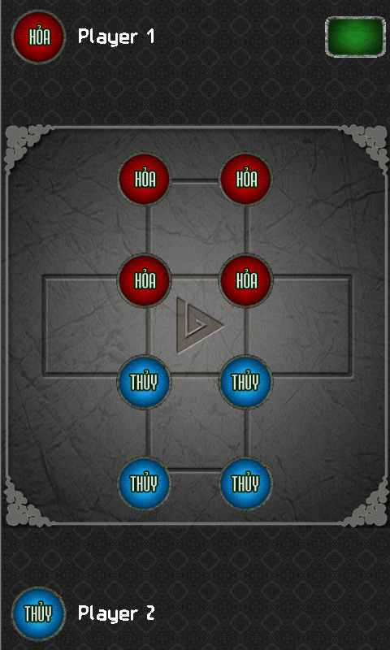
Move:
- Each chess can move up, down, left, right if those dimensions have empty position by drag and drop your chess. If wrong position on board, chess will be returned at start position
- One moving only 1 cell.
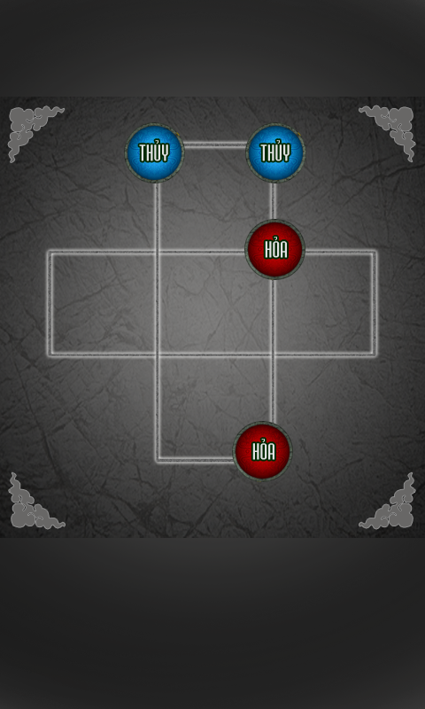
This chess can’t move any where
- If 2 chesses of 2 sides have 3 empty places, It can kill together. You must touch next empty position to path enemy then touch on 2nd chess to kill it. 1st chess will replace 2nd position then.
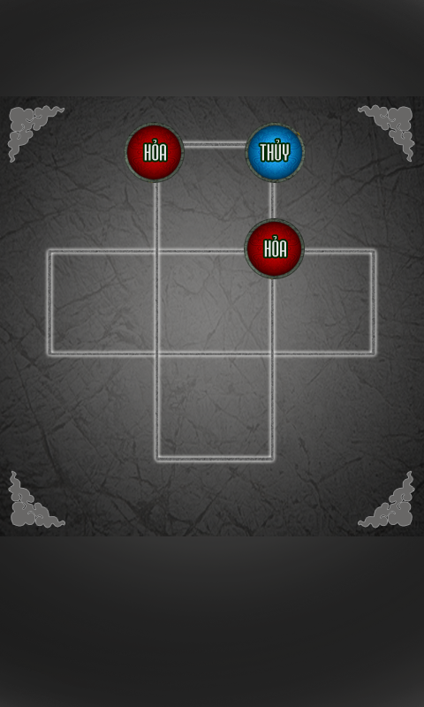

- Game is finished when having one side have no chess on board or all remain chess have no way to move 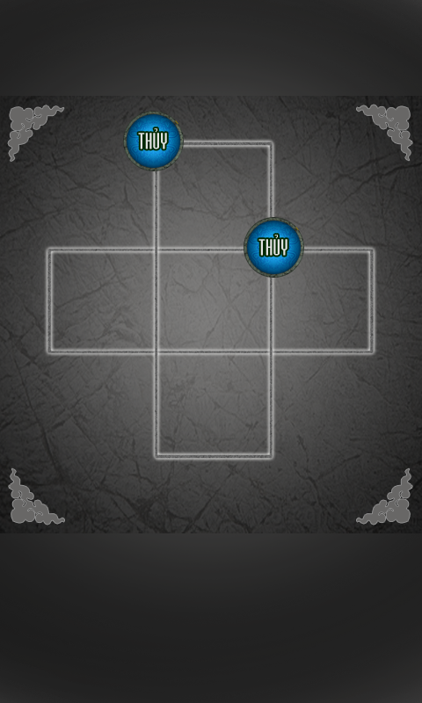 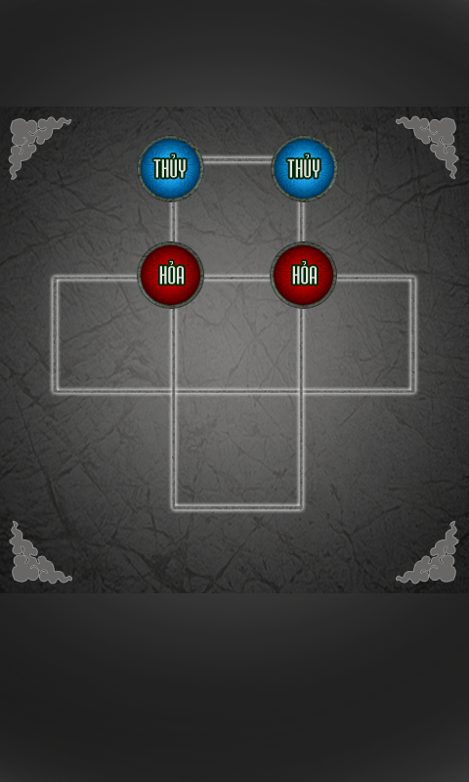

- Game has 2 modes: Single player and two player.
+ Single player: You will battle with robot with AI
+ Two players: You can battle with other in turn.

3. Detail design
3.1.Game state
Flow chart
Logo
Ask for sound
Splash
Loading
Main menu
Ingame
Load all data
Single player
Two players
Option
Exit
Help
About
Chose object
Ingame Menu

Resume

Re-play

3.2.Graphic:

Icon:

Logo AskForSound Loading
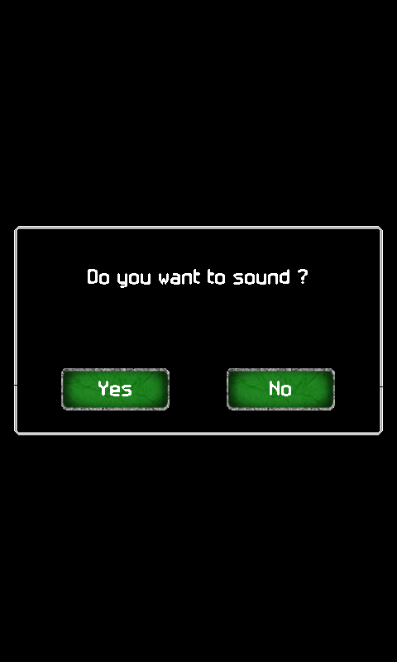

Splash Main menu Option
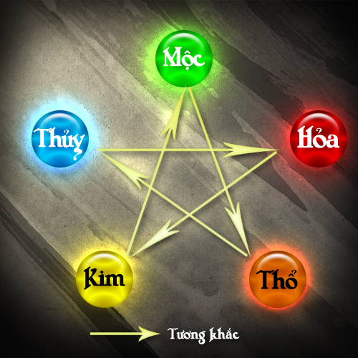

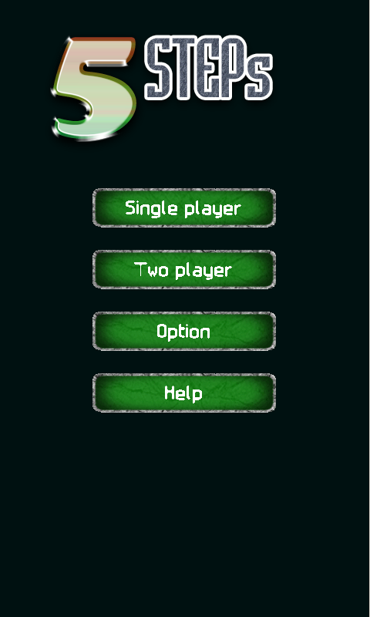

Touch the screen to continue
Touch the screen to continue
Option
Mucis On
Sfx: On
Select pieces (single player) Select pieces (Two player) Menu confirm
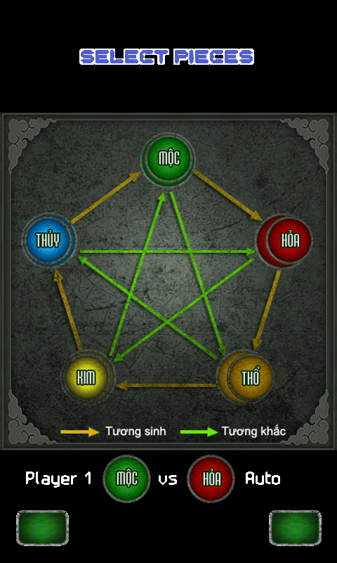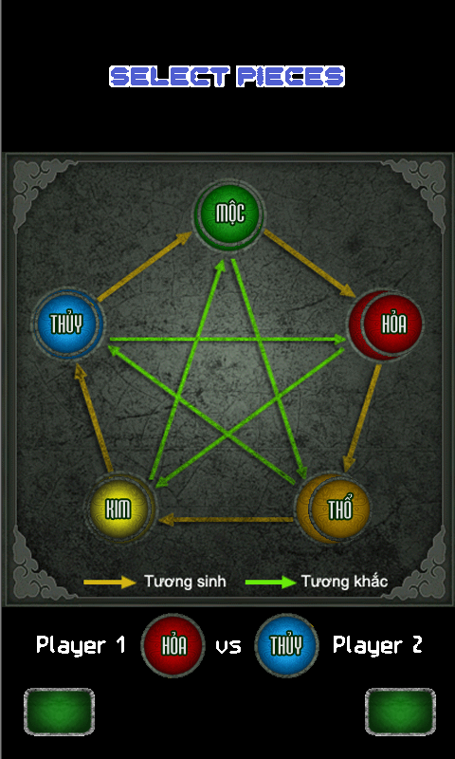
Do you want exit game
Yes
No

Help + About
Help

In game menu Option in game (single player) Option in game (Two)
Option
Mucis On
Sfx: On
Difficult No
Option
Mucis On
Sfx: On
