

Hoang Viet Tran (student number: e1601115)

**Snake game Project**

Basics of Mathematical Software

Unit (Technology) 2018

## CONTENTS

1. INTRODUCTION 3

2. PROGRAMMING STRUCTURE 4

3. RESULT 6

1. **INTRODUCTION**

The object of this project is to create a 2D Snake game which the player can control the movement direction of the snake and scoring by taking the snake to reach the position of the food. The food’s position will be generate randomly on the map.

Some function will be used in this project:

* randi(x)
* grid (x,y)
* set(h_fig,'menubar','none')
* disp(‘text');

# PROGRAMMING STRUCTURE

1. **Generate the “playing area”**

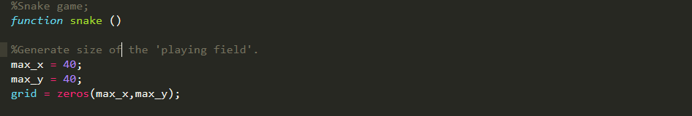

Call out the playing are by setting the coordinates for the height (max_y) and width (max_x) and use the grid function to create.

1. **Create the Snake**

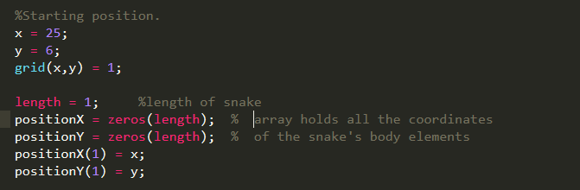

Define the starting position (x,y) and the starting length of the snake.

Create 2 arrays, one for the vertical one for horizontal. Arrays to hold the coordinates of the snake’s body element if length is extend (or not).

1. **Create and adding the food to Snake’s body**

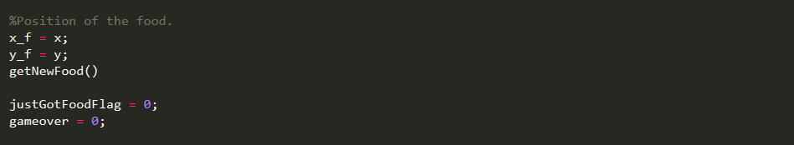

This is for defining the food’s position on the playing area.

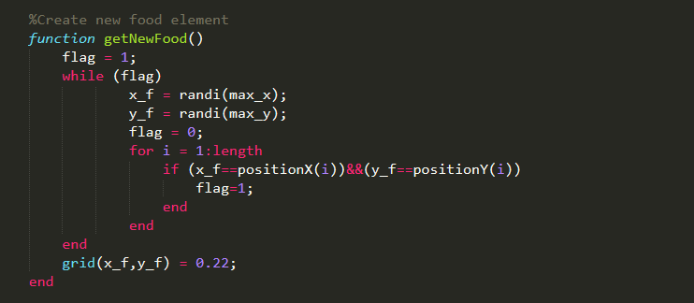

The function getNewFood() use randi() to generate the coordinates of the food randomly on the map.

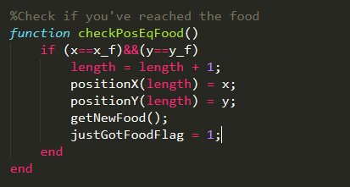

Function checkPosEqFood() is to add the length to the snake body if the position of the snake is equal to the position of the food. Then the snake’s length is increase by 1.

1. **Change the snake’s movement to the direction of which a Direction key is pressed.**

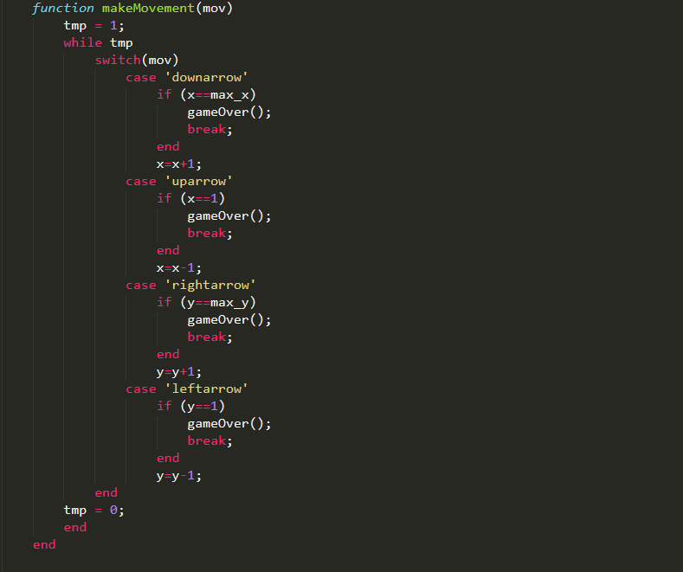

Function makeMovement(mov) change the moving direction of the snake to the direction of the pressed Direction key.

When the snake reach the rear point of the playing area, where x= 1, x = max_x or y=1, y = max_y . The game will be over by calling the gameOver function.

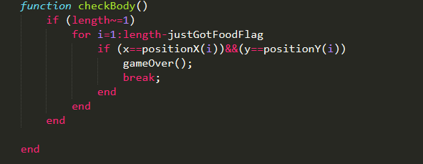

Check if new position is part of snake's body

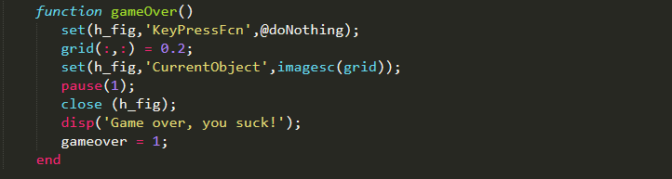

When gameOver function is called, the line “Game over, you suck!” will appear.

1. **Generate function after a direction key is pressed**

These 2 function is for the program to recognize which direction key is pressed.

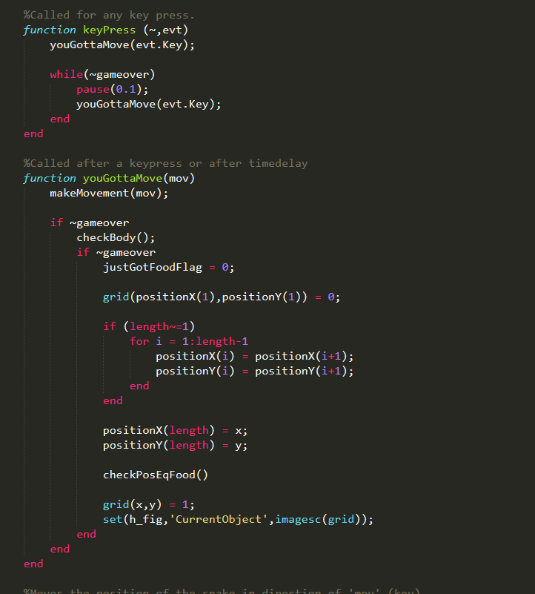

When youGottaMove(mov) function is called, the makeMovement(mov) run and take the snake to the pressed direction.

And keypress() function runs everytime a direction key is pressed and call out youGottaMove function.

# RESULT

