1)
a) What is mining
- Mining is the process of adding transactions to the blockchain
b) How does it work ?
• Every node on the blockchain network shares information about new transactions. They store these transactions in their memory pool.
• The memory pool is a node’s temporary storage area for transaction data.
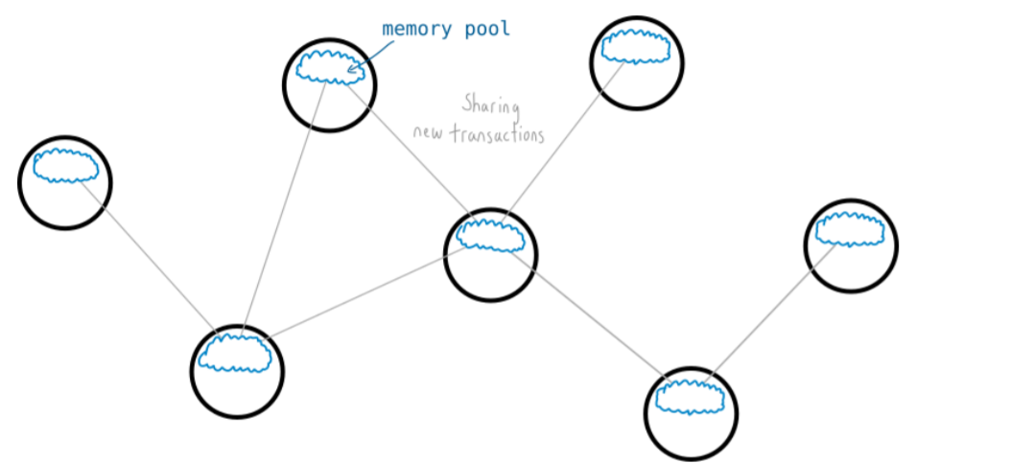
c) Mining:
• Each node also has the option to try and “mine” the transactions in their memory pool in to a file. This file is a ledger of every bitcoin transaction, and it’s called the BLOCKCHAIN
• You could think of the memory pool as “floating” transactions and the blockchain as “archived” transactions.
• However, to add transactions from the memory pool to the blockchain, a node has to use a lot of computer processing power.
• This processing power is forced through the existence of a challenge in the memory pool.
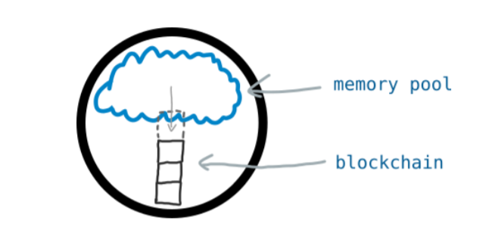
d) What is this challenge?
• Imagine you’re a node. At any moment in time you can condense the transactions in your memory pool in to a single “string” of numbers and letters. • This string represents all of the transactions in your memory pool.
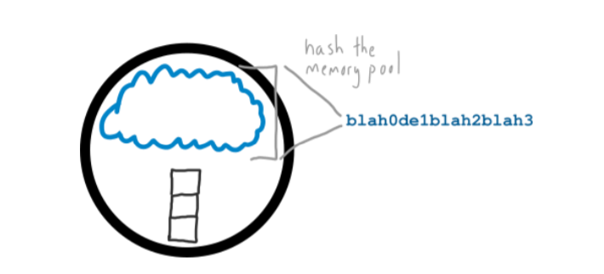
• Now, your objective is to HASH this string with another number to try and get a new string that begins with a certain number of zeros.
• The “certain number of zeros” comes from the difficulty. This is set by the network and changes based on the volume of miners – the more people mining, the greater the difficulty and the more zeros are needed at the start (which makes it harder to find a winning result).
• Most of the time you will get a result that isn’t even close.
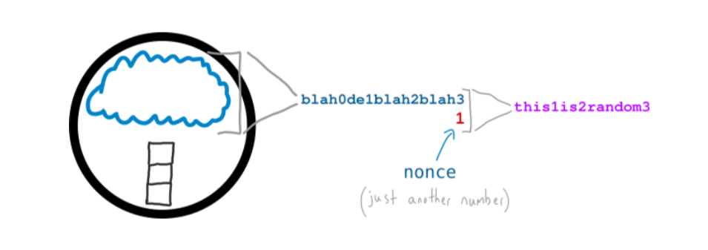
▪ But if you keep going you may stumble upon a number that works
▪ Now, this sounds easy enough, but it’s actually difficult. It’s utterly random, and you can only hope to find a winning result through trial and error. And that’s what Mining is – lots of hashing (using lots of your computer’s processing power) and hoping to get lucky.
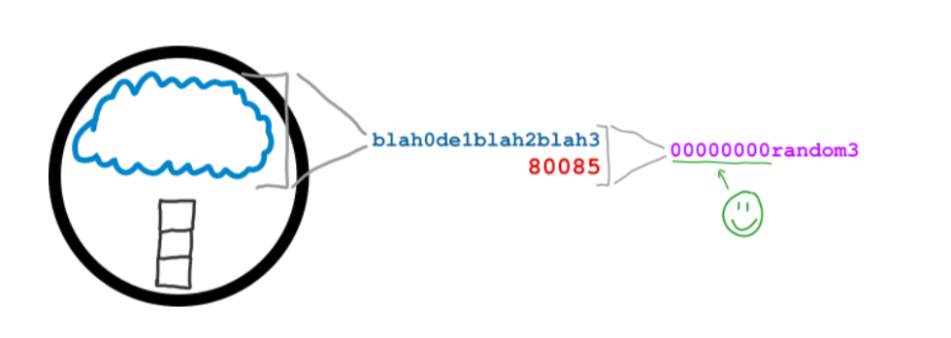
• But if you are lucky enough to find a successful hash result, the transactions in your memory pool get added to the blockchain, and every other node on the network adds your block of transactions to their blockchain.
• You’ll also receive a 25BTC reward for your effort, as well as picking up any fees that were tacked on to the transactions that you just added to the blockchain.
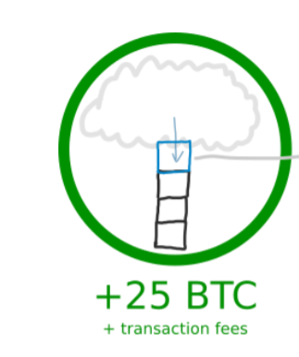
e) Why is mining necessary?
• Because mining allows the entire Bitcoin Network to agree on which transactions get “archived”, and this is how you prevent fraud in a digital currency.
• When you make a bitcoin transaction, nodes on the network do not hear about it instantly. Instead, transactions travel across the blockchain network by being passed from one node to the next.
• However, it’s actually possible to make another transaction using those same bitcoins and insert that transaction in to the network too.
• For example, you could buy a beer with some bitcoins, then quickly attempt to buy a slice of pizza with those same bitcoins too.
• Some nodes would get the pizza transaction first (and ignore the beer transaction), whereas others would get the beer transaction first (and ignore the pizza transaction).
• Yet even though you make the pizza transaction after the beer transaction, due to the way transactions travel across the Bitcoin Network, the network would be in a disagreement about whether you should get the beer or the pizza.
SO , HOW TO TACKLE??
Mining, of course
• If a node on the network completes the challenge, then it’s the transactions in their memory pool that get added to the blockchain.
• If a node with the pizza transaction successfully mines a block, then that’s the transaction that gets added to the blockchain, and the beer transaction evaporates from the network.
• If you want to try and control the blocks (i.e. transactions) that get added to the blockchain, you have to compete to solve block puzzles with every other mining node on the bitcoin network.

