17/12/2021:
1)
- Four components in secure commnunication:
+ Authentication: xác thực (who am I talking to?) : identification and assurance of the origin of information
+ confidentiality: bảo mật (Is my data hidden?) : Concealment of information
+ Integrity: toàn vẹn (Has my data been modified?) : Prevent improper and unauthorized changes
+ Availability : khả dụng (Can I use the resources?) : The ability to use the information or resource desired

From the perspective of Bitcoin:
+ Authentication: Am I paying the right person?
->Public Key Crypto: Digital Signatures
+ Integrity: Is the coin double-spent? Can an attacker reverse or change transactions?
->Digital Signatures and Cryptographic Hash
+Availability: Can I make a transaction anytime I want?
-> PVP (peer-to-peer)
+Confidentiality: Not very relevant. But privacy is important.

Note 1: What is public key in digital signature?
- In a public-key cryptosystem, a public key is a key that can be used for verifying digital signatures generated using a corresponding private key. In some cryptosystems, public keys can also be used for encrypting messages so that they can only be decrypted using the corresponding private key.
Note 2: (P2P) Mạng ngang hàng, còn gọi là mạng đồng đẳng, là một mạng máy tính trong đó hoạt động của mạng chủ yếu dựa vào khả năng tính toán và băng thông của các máy tham gia chứ không tập trung vào một số nhỏ các máy chủ trung tâm như các mạng thông thường.

2) Three basic concepts of blockchain:
a) Peer-to-peer networking:
P2P:
+ no sever role.
+ direct connection between nodes
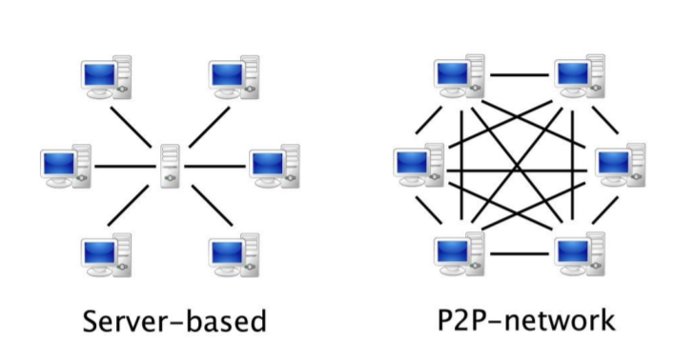
b) Public Key Cryptography:
+ Public key
+ Private key
+ Digital signature
Key pair: public key and private key
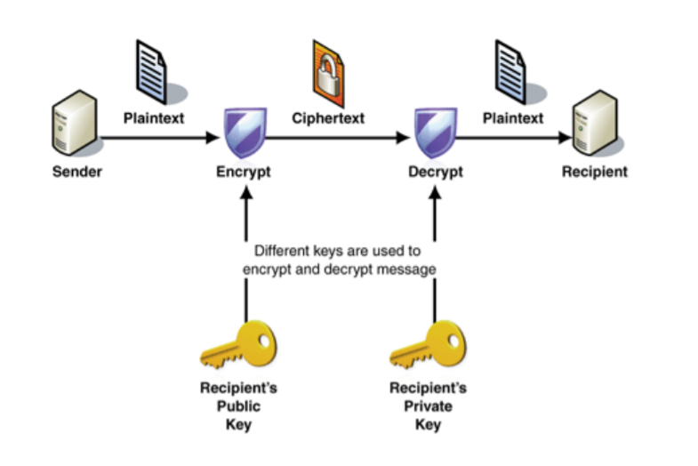
c) Cryptographic hash function:
+ A function which takes a message (arbitrary length) as an input and returns a fixed length alphanumetric string, called ‘hash’
3)
Merkel tree: allow us to map a large volume of data and easily identify where changes in the data occur.
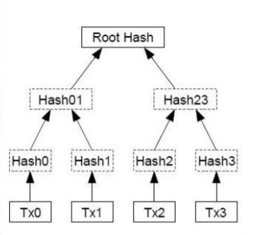

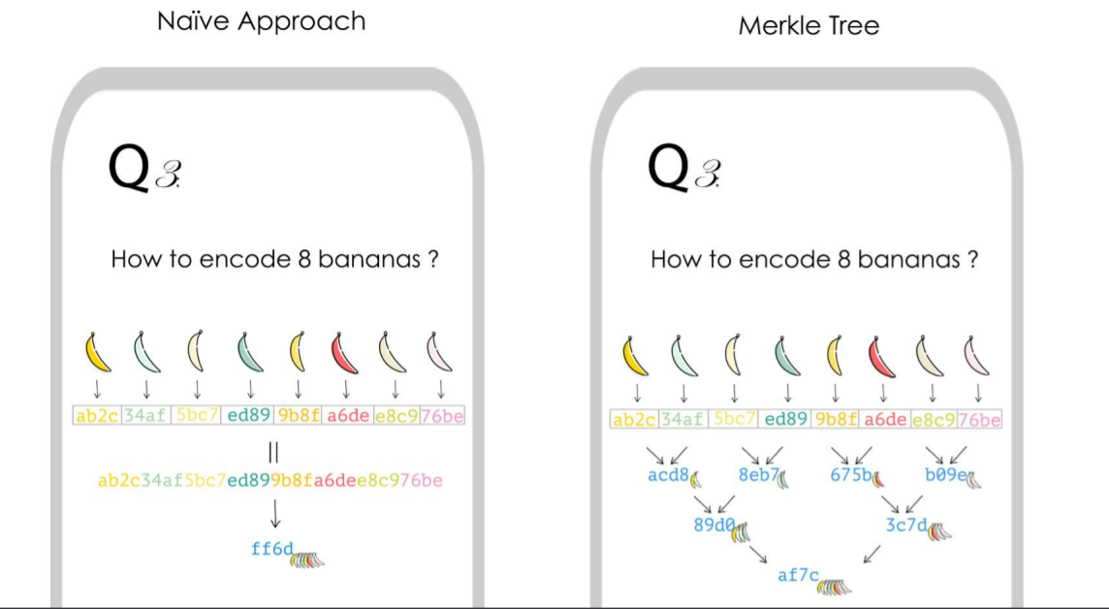

-timestamp: dấu thời gian
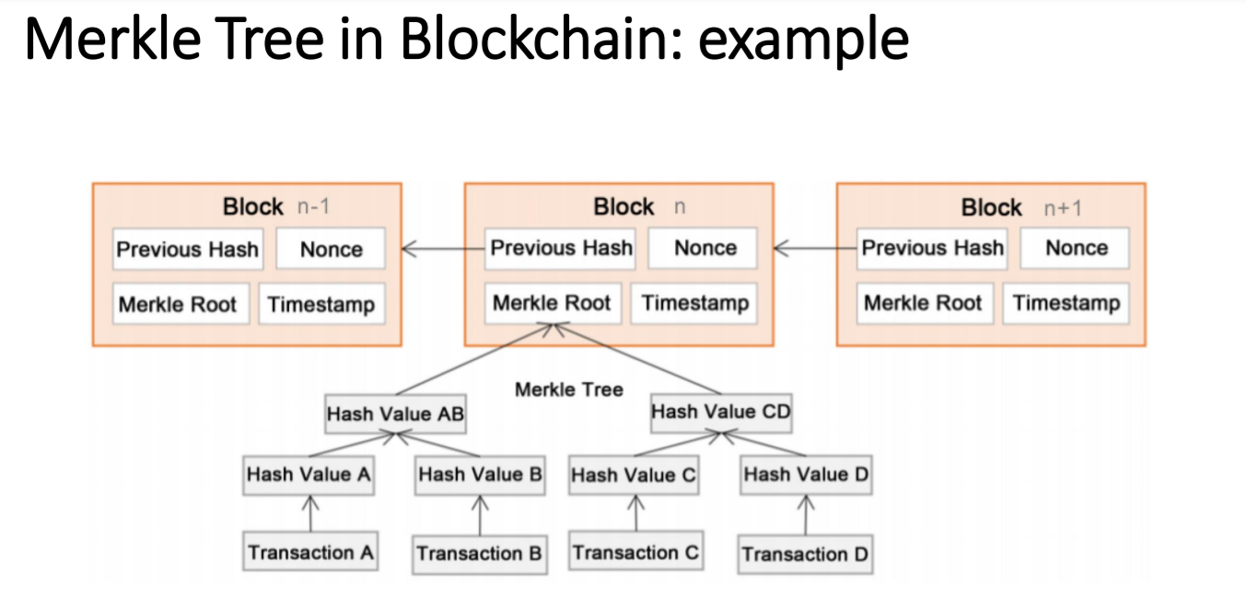
Chain of blocks in blockchain: linked list type
So if there is a change , for example block 2, since block 3 contains hash(block 2) -> need to recompute and update block 3, continue like that.
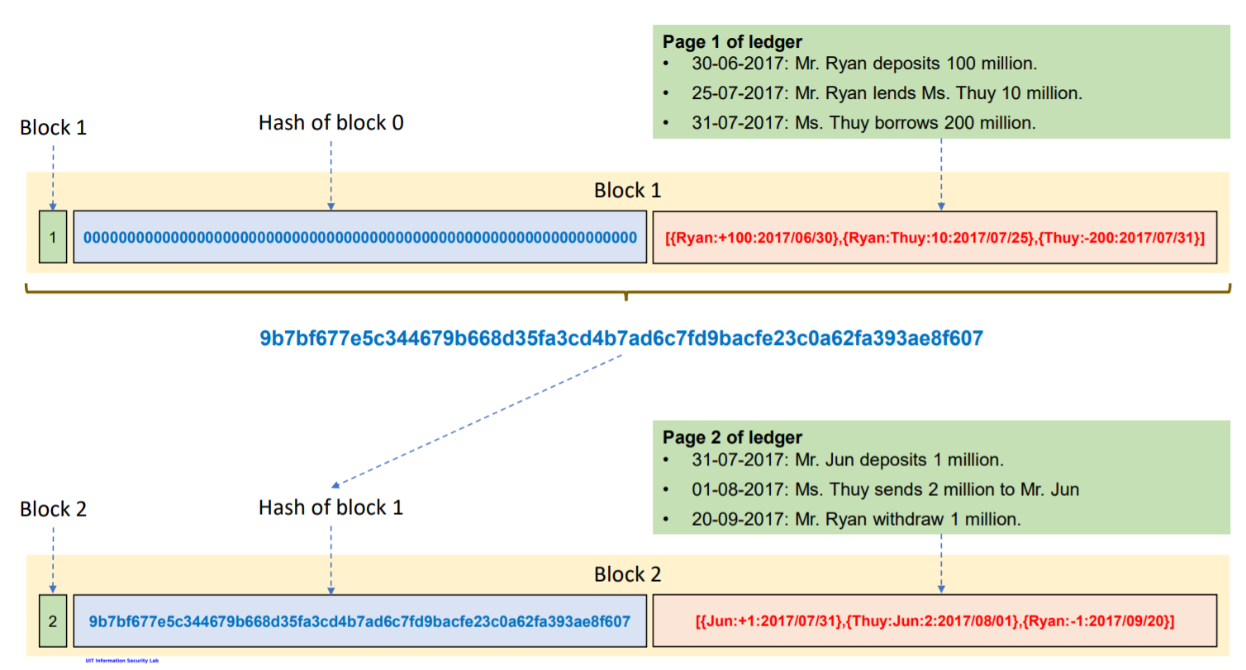
4) How Block chain work ?
Proof of work blockchain.
A block contains transactions, where each transaction has:
+ input, output

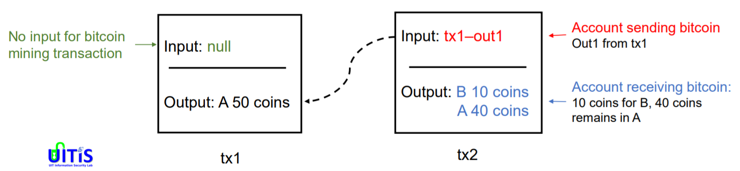
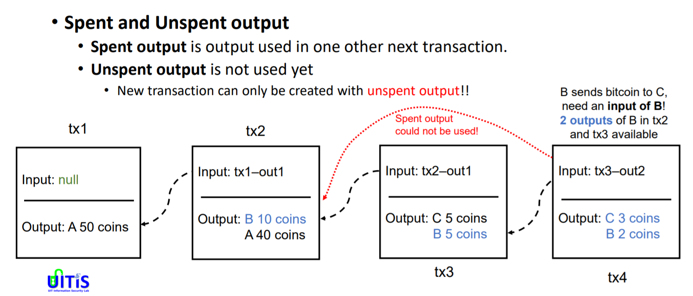
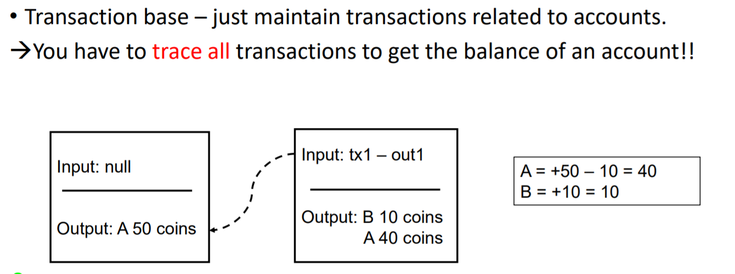

18/12/2021:
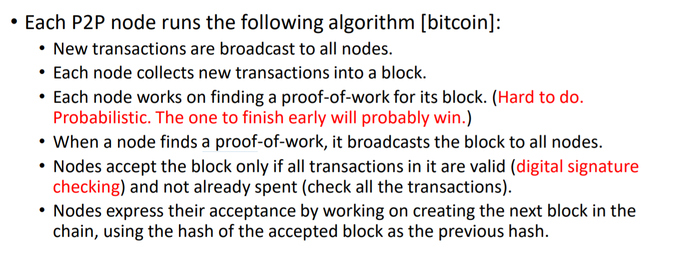
1)
+ Reverting gets exponentially hard as the chain grows since it the next and next blocks must recompute nonce.
+ Optimizations: Only keep the root hash, delete the interior hash values to save disk, Block header (80 bytes) only contains the root hash.
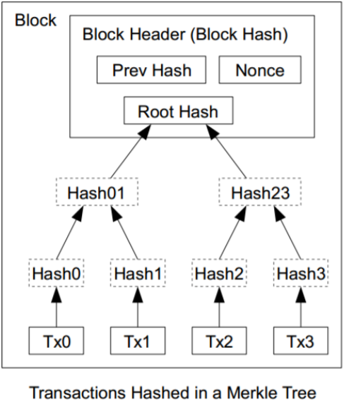

02/01/2022:
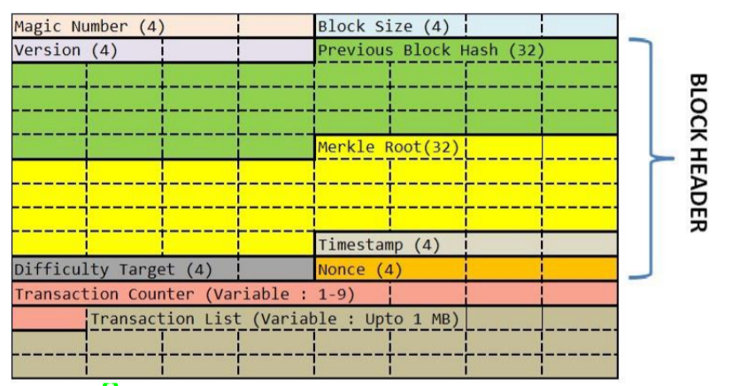
1)Block in Bitcoin :
+ Block header is about 80 bytes. The block header is composed of the fields from Version to Nonce
+ Block size: indicates how large the block is (4 bytes)
+ Magic number: this is an identifier for the Bitcoin Blockchain network. It has a constant value of 0xD9B4BEF9. ( 4 bytes)
+ Version: Each node running the Bitcoin protocol has to implement the same version and it is mentioned in this field. (4 bytes)
+ Previous block hash : This is a digital fingerprint (hash) of the block header of the previous (last added) block of the blockchain. It is calculated by taking all the fields of the header. (32 bytes)
+ Merkle root (32 bytes)
+ Timestamp : using in mining process ( 4 bytes)
+ Difficulty Target : using in mining process (4 bytes)
+ Nonce : using in mining process ( 4 bytes)
+ Transaction Counter: This is the count of transactions that are included with the block ( variable: 1-9 bytes)
+ Transaction List: Stores the digital finger-print of all the transactions of that block ( variable: 1 MB)
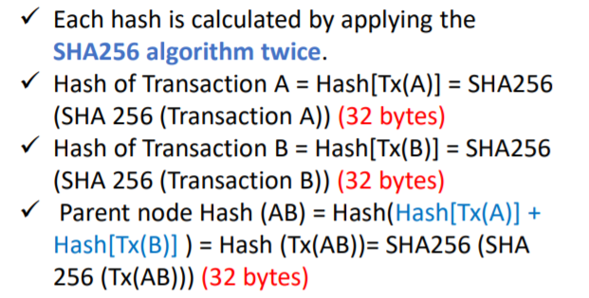

2) Blockchain concept:
- What does a node do? -> 3 jobs:
+ Follow rules
+ Share information
+ Keep a copy of confirmed transaction
a) Follow rules:
+ Each node has been programmed to follow a set of rules.
+ By following these rules a node is able to check the transactions it receives and only relay them if everything is cool.
+ If there are any problems, the transaction isn’t passed on.
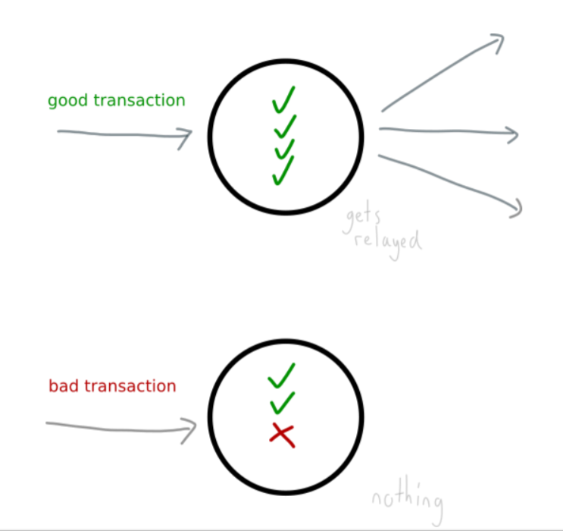

b) Share information
Now, there are two types of transactions that nodes share:
▪ Fresh transactions – transactions that have recently entered the network.
▪ Confirmed transactions – transactions that have been “confirmed” and written to a file. These are shared in blocks of transactions, and not individually.
c) Keep a copy of confirmed transactions
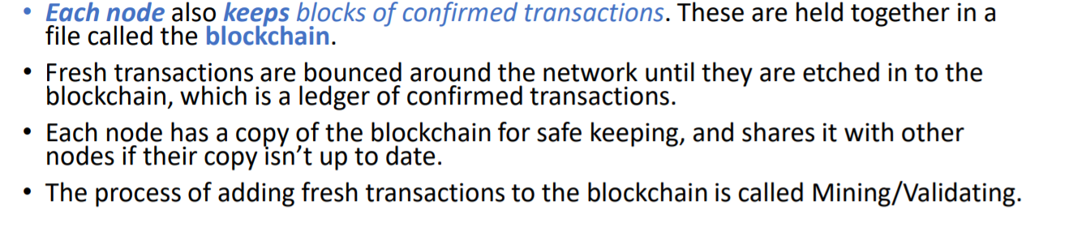
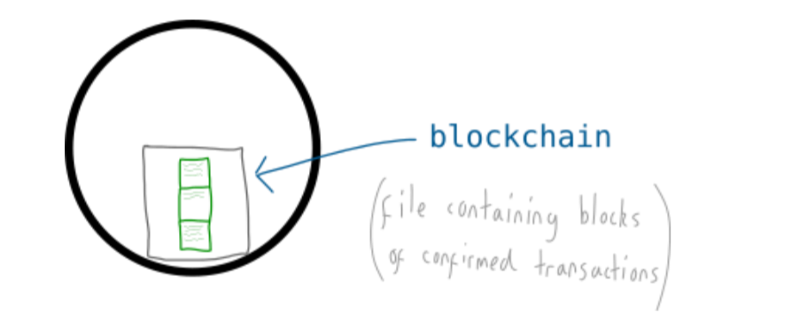
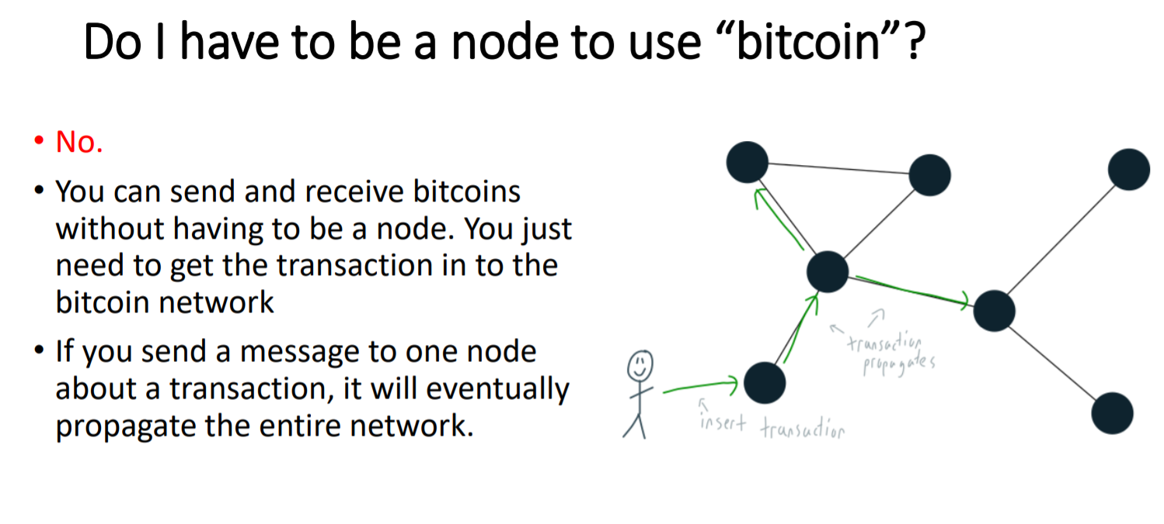
d) What is the blockchain ?
• The blockchain is a file that contains a list of every transaction ever made.
• The blockchain is like a logbook, or a ledger.
• Ledger – a book in which the monetary transactions of a business are posted in the form of debits and credits.
• Everyone on the blockchain network shares a copy of this file, and it updates regularly with the latest transactions.
e) Why is it called the blockchain ?
▪ Because transactions aren’t added to the file individually. Instead, they are bunched together and added in blocks. Hence, blockchain.
▪ Also, these blocks are linked together, so any changes made to a block lower down the chain will change the blocks above it. So linkedblocks, or blockchain.

-63-

