1) Remind:
• The memory pool is a temporary storage area for transactions.
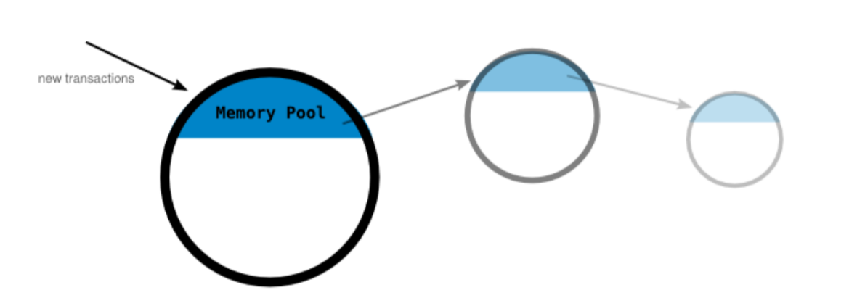
• When a new transaction is received by a node, it will hold it in its memory pool with all the other latest transactions it has received. From here the transaction will be hoping to get selected for inclusion in the candidate block.
2) Block:
• A block is a bunch of transactions that have been added to the blockchain.
• Blocks are formed by miners/validators.
• When you make a transaction, it isn’t added to the blockchain straight away. Instead, it is held in a TRANSACTION POOL (or memory pool).
• If you are a miner/validator, your job is to gather transactions from the transaction pool in to a “candidate block”, and to try and add this candidate block to the blockchain.
• A candidate block is a temporary block created using transactions selected from the memory pool.
• Nodes (mining nodes) select transactions from their memory pool to form their own candidate blocks.
• Anyone who is mining can choose which transactions to include in their candidate block.
Each node then tries to add their candidate block to the blockchain through the process of mining.
• Every block starts life as a candidate block, but only the ones that are successfully mined get added to the blockchain.
• Each miner starts working on a new candidate block, as soon as they hear about the latest one being found.
3) Block header:
• A block header is like the metadata at the top of a block of transactions.
• The fields in the block header provide a unique summary of the entire block.
• Version: Describes the structure of the data inside the block. This is used so that computers can read the contents of each block correctly.
• Last Block: An identification number for the previous block. We are trying to get one of these for the current candidate block.
• Merkle Root (Transactions): All of the transactions inside the block hashed together to form a single line of text. All of the fields are unique, but it would be fair to think of this as the most significant part of the block header.
• Time: The current time. Always handy.
• Target: A value that miners work with to try and add candidate block to the blockchain. It is set by the bitcoin network, and will make more sense in a moment.
Structure:
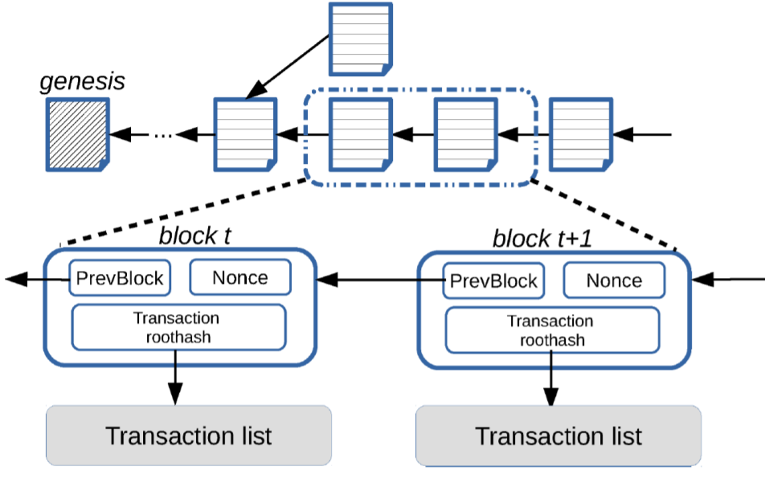
a) Merkle root:
• The Merkle Root is a field in the block header.
• The “Merkle root" acts as a representation of every transaction included in the block.
• By repeatedly hashing together pairs of Transaction IDs until you end up with a single hash as a result.
• Steps:
• Take each pair of Transaction IDs from the block, and hash them together through SHA256 twice.
• Keep doing this for each pair Transaction IDs, until you end up with a new list of hashes.
• Note: If you have an odd number of transactions, hash the remaining transaction with itself.
• Repeat steps 1-2 for every new list of hashes you create until you finally end up with one hash.
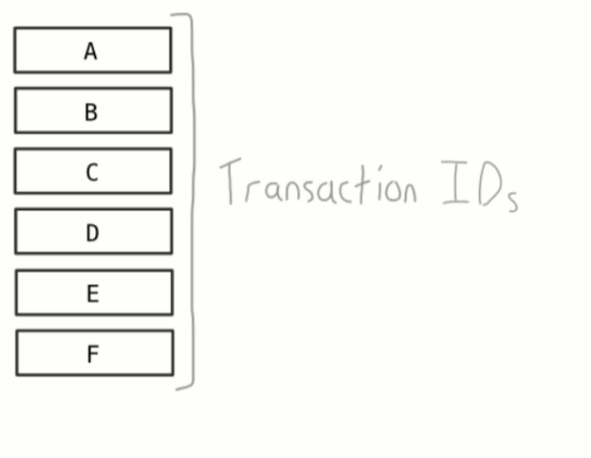
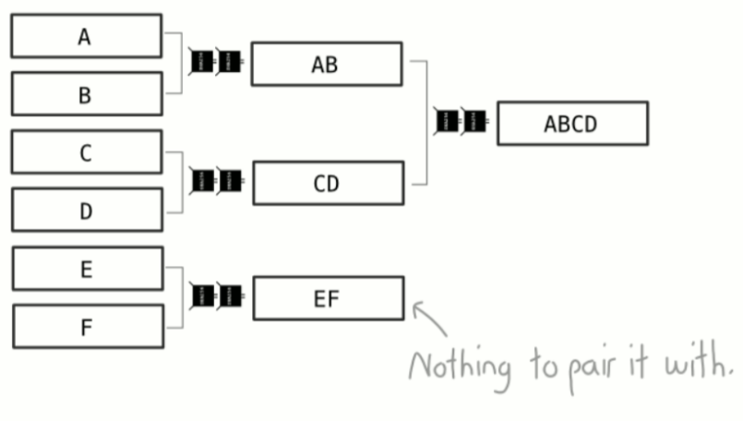
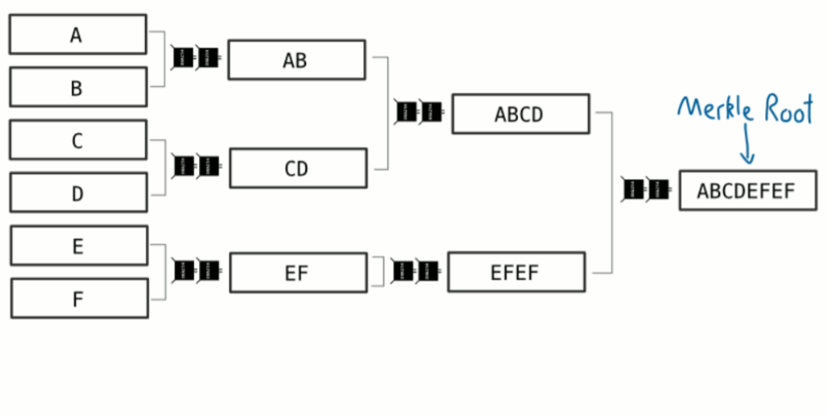
Why does bitcoin use the Merkle root method?
• Because if you want to check that a transaction is part of the final hash, a Merkle root is a more efficient way of doing it
How are blocks added to the blockchain?
• To add a candidate block to the blockchain, you hash the data in the block header and hope that the result is below a certain target value.
• The TARGET is calculated from the DIFFICULTY, which is a value set by the network to regulate how difficult it is to add a block of transactions to the blockchain.
b) Difficulty and target
The difficulty is a number that regulates how long it takes for miners to add new blocks of transactions to the blockchain.
• This difficulty value updates every 2 weeks to ensure that it takes 10 minutes (on average) to add a new block to the blockchain.
• Why is the difficulty important?
▪ Because it ensures that blocks of transactions are added to the blockchain at regular intervals, even as more miners join the network.
▪ If the difficulty remained the same, it would take less time between adding new blocks to the blockchain as new miners join the network.
When does the difficulty change?
▪ The difficulty adjusts every 2016 blocks (roughly every 2 weeks).
▪ At this interval, each node takes the expected time for these 2016 blocks to be mined (2016 x 10 minutes), and divides it by the actual time it took (however many minutes):
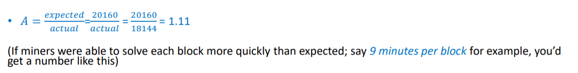
▪ Each node then uses this number to adjust the difficulty for the next 2016 blocks:
• If 𝑛𝑒𝑤_𝑑𝑖𝑓𝑓𝑖𝑐𝑢𝑙𝑡𝑦 >1 (i.e. blocks were mined quicker than expected), the difficulty increases.
• If 𝑛𝑒w_difficulty <1 (i.e. blocks were mined slower than expected) the difficulty decreases.
• Every miner on the bitcoin network now works with this new difficulty for the next 2016 blocks.
• 0.25<=A(of difficulty)<= 4, prevent abrupt changes from one difficulty to the next.
But how does the difficulty control time between blocks?
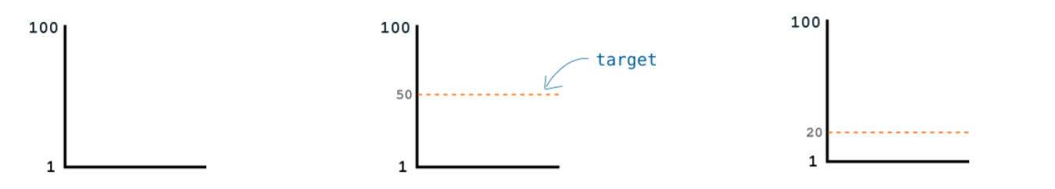
• Let’s say I give you a range of numbers from 1 to 100.
• Now, you are able to randomly generate a number between 1 and 100 once every minute. And your goal is to generate a number below my target number.
• Target = 50, you’re only able to generate a number between 1 and 100 once a minute, this should take you 2 minutes
• Target = 20, you’re only going to be able to generate a winning number 1/5 of the time, or once every 5 minutes
• The lower the target, the more difficult it gets to generate a winning number.
• It’s not going to be 5 minutes every time because you could get lucky with the first number you generate. But over the long run it will work out to be 5-minute intervals
• Therefore, based on how many numbers you are able to generate per minute, I can use the height of the target to control how long it takes you to find a winning number.
Target:
• Set the target by dividing the range of numbers with a new number… This new number is able to control the height of the target
• This new number is the difficulty, and it’s used as an easy way for me to modify the height of the target.
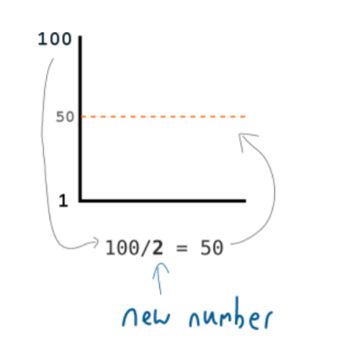
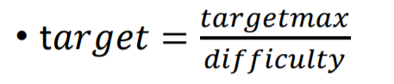
• Furthermore, I can use this DIFFICULTY value to help me set the target to any level I want.
• So I use the DIFFICULTY to control the TARGET, and therefore how long it takes for you to generate a winning number.
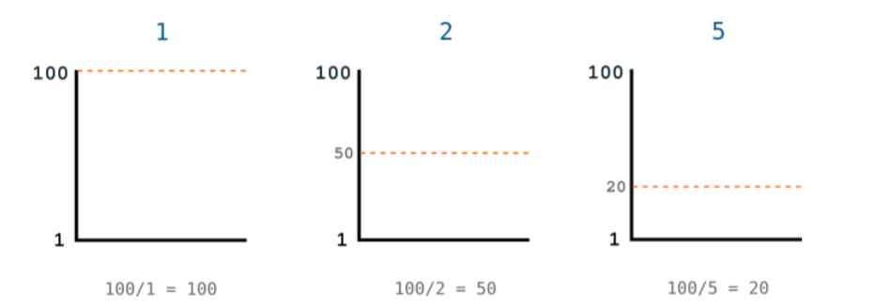
Bits (aka Target):
• The bits field is a compact way of storing the target in the block header
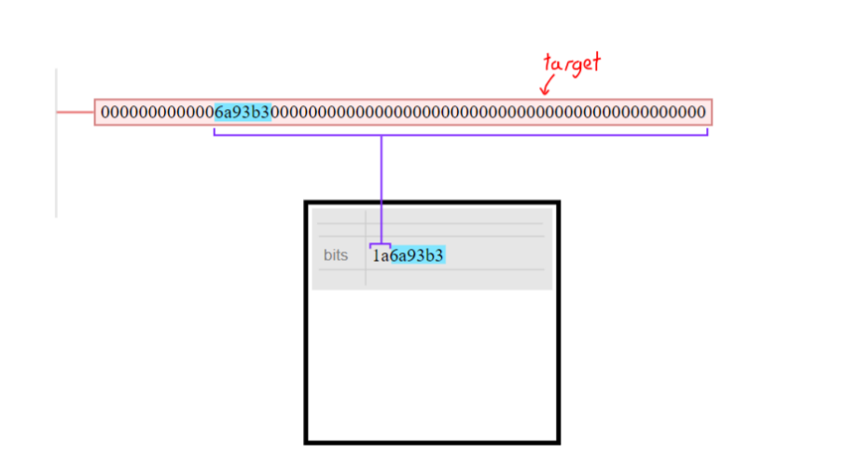
Example:
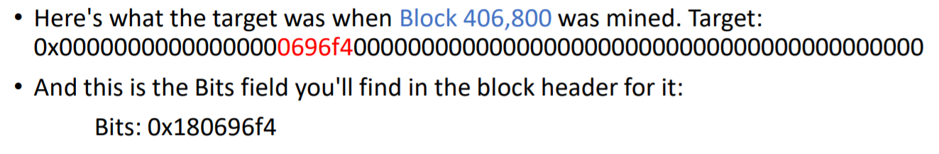
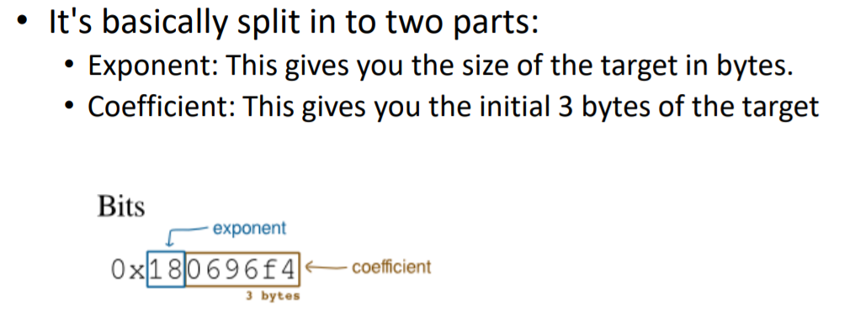
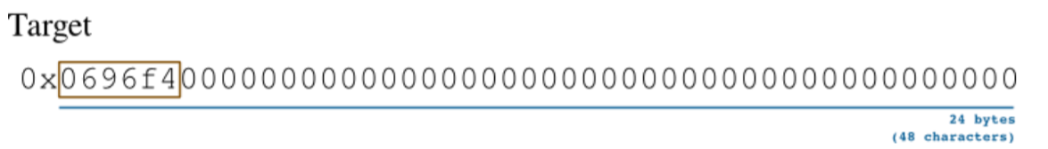

Why have Bits?
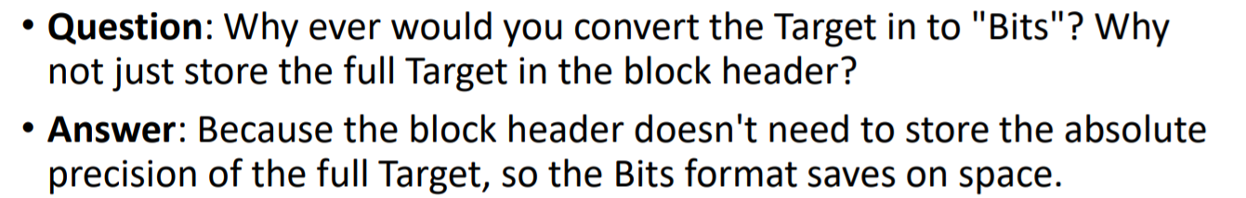
Difficulty: It’s used to set a target value, and miners keep generating numbers (hashing their candidate blocks) in the hope that they will find a number lower than this target value.
• Because these target numbers are so big, computers prefer to work with them in hexadecimal format.
• So the target is a hexadecimal value, and miners are trying to get a hexadecimal hash value below the target.
c) Nonce:
• You actually hash it with an extra number.
• This number is called a nonce, and it’s basically a dummy field that miners use to help them get a block hash below the target value.
• nonce – an arbitrary number used only once in a cryptographic communication.
If the first nonce doesn’t work (starting at 0), keep incrementing it and hashing the block header.
• Eventually you’ll find a nonce that returns a block hash that is less than the target value.
Once you’ve found nonce that works, the block is “solved” and all of the transactions in this block are added to the blockchain.
• All miners will now head back to the transaction pool and start work on the next candidate block.
• They will use your successful block hash in their next block header, and the race to add a new block of transactions to the blockchain starts again.

