1) What is a (bitcoin) transaction?

• A transaction is a bunch of data.
• This data contains information about the amount being sent, the account it is being sent from, and the account it is being sent to.
• This is basic information, so it can be easily represented in a single line of data
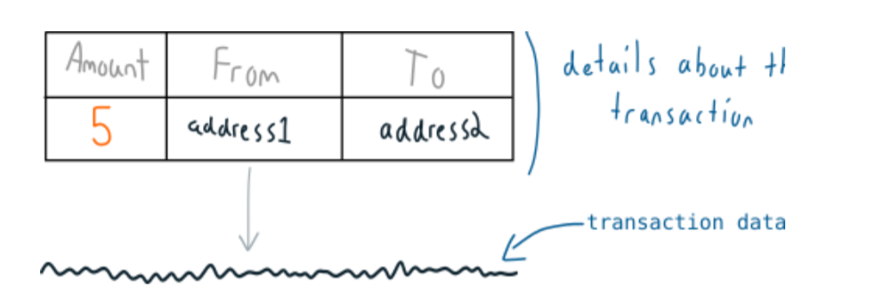
• And when you “make a transaction”, you just send this TRANSACTION DATA in to the (bitcoin) blockchain network.
• Eventually one of the nodes on the network will mine your transaction into a block, and this block (with your transaction in it) will be added to the file of confirmed transactions (the blockchain).
• And that’s all a (bitcoin) transaction is – feeding a simple line of data in to the bitcoin network and waiting for it to be mined in to the blockchain.

