VIETNAM GENERAL CONFEDERATION OF LABOUR

**TON DUC THANG UNIVERSITY**

**FACULTY OF INFORMATION TECHNOLOGY**



**HO LE TRUNG TIN - 520H0585**

**PHAM HOANG SON - 521H0476**

**NGUYEN DINH VIET HOANG - 522H0120**

**OPTIMIZING RESTAURANT SERVICES THROUGH BUSINESS INTELLIGENCE TOOLS: A CASE STUDY OF THE PIZZA B&P RESTAURANT CHAIN**

**FINAL REPORT**

**BUSINESS INTELLIGENCE SYSTEMS**

**HO CHI MINH CITY, YEAR 2024**

VIETNAM GENERAL CONFEDERATION OF LABOUR

**TON DUC THANG UNIVERSITY**

**FACULTY OF INFORMATION TECHNOLOGY**



**HO LE TRUNG TIN - 520H0585**

**PHAM HOANG SON - 521H0476**

**NGUYEN DINH VIET HOANG - 522H0120**

**OPTIMIZING RESTAURANT SERVICES THROUGH BUSINESS INTELLIGENCE TOOLS: A CASE STUDY OF THE PIZZA B&P RESTAURANT CHAIN**

**FINAL REPORT**

**BUSINESS INTELLIGENCE SYSTEMS**

Advised by

**MsC. DUONG HUU PHUC**

**HO CHI MINH CITY, YEAR 2024**

**ACKNOWLEDGEMENT**

We sincerely thank MsC. Duong Huu Phuc for teaching us the Business Intelligence Systems course with great enthusiasm. We want to express our deep appreciation for the dedication and professional knowledge that you shared with us. Through your classes, we gained a better understanding of the fundamental aspects of the Business Intelligence Systems, thanks to your detailed explanations and practical applications. You helped us grasp the knowledge and apply it effectively. Finally, we extend our heartfelt gratitude to MsC. Duong Huu Phuc for your commitment and invaluable support throughout our learning journey in this course. The skills and knowledge we acquired will continue to impact our future development. We sincerely thank you and wish your health, success, and happiness.

*Ho Chi Minh City, November 14, 2024*

*Authors:*

*Ho Le Trung Tin*

*Pham Hoang Son*

*Nguyen Dinh Viet Hoang*

**DECLARATION OF AUTHORSHIP**

We hereby declare that this thesis was carried out by ourselves under the guidance and supervision of MsC. Duong Huu Phuc; and that the work and the results contained in it are original and have not been submitted anywhere for any previous purposes. The data and figures presented in this thesis are for analysis, comments, and evaluations from various resources by our own work and have been duly acknowledged in the reference part.

In addition, other comments, reviews and data used by other authors, and organizations have been acknowledged, and explicitly cited.

We will take full responsibility for any fraud detected in my thesis. Ton Duc Thang University is unrelated to any copyright infringement caused on my work (if any).

*Ho Chi Minh City, November 14, 2024*

*Authors:*

*Ho Le Trung Tin*

*Pham Hoang Son*

*Nguyen Dinh Viet Hoang*

**OPTIMIZING RESTAURANT SERVICES THROUGH BUSINESS INTELLIGENCE TOOLS: A CASE STUDY OF THE PIZZA B&P RESTAURANT CHAIN**

**ABSTRACT**

The restaurant industry faces increasing challenges in improving operational efficiency and customer satisfaction. This study explores how Business Intelligence (BI) tools can optimize restaurant services, focusing on the Pizza B&P restaurant chain as a case study. The primary objectives are to enhance menu optimization, increase sales, and improve customer experience by analyzing sales data, customer feedback, and employee performance over six months.

Key datasets include sales records, customer demographics, feedback ratings, and employee activity logs. Using tools like Python, Tableau, and Flask/Django, the project applies exploratory data analysis (EDA), predictive modeling (e.g., linear regression for sales forecasting), and customer segmentation through clustering. Additionally, natural language processing (NLP) techniques are employed to analyze customer feedback.

The study delivers actionable insights through detailed analytics reports and an interactive BI dashboard. The dashboard provides real-time visualization of sales trends, customer segmentation, and staff performance. Forecasting models identify best-selling dishes and customer groups, enabling strategic recommendations such as targeted promotions and service time optimization. A web application integrates these features, empowering restaurant managers to make data-driven decisions and enhance operational efficiency.

By implementing these BI-driven strategies, the study demonstrates the potential of leveraging data analytics to improve restaurant performance and customer satisfaction in the competitive foodservice industry.

**TABLE OF CONTENTS**

**LIST OF FIGURES viii**

**CHAPTER 1. INTRODUCTION TO THE TOPIC STATEMENT, OBJECTIVES, SCOPE, AND OUTPUT OF THE TOPIC 1**

1.1. Topic 1

1.2. Objective 1

1.3. Scope 1

1.4. Output 1

**CHAPTER 2. DATA SPECIFICATION AND DATA CHARACTERISTICS PRESENTATION 2**

2.1. Data specification 2

2.2. Data characteristics presentation 2

**CHAPTER 3. DATA VISUALIZATION AND DATA PREPROCESSING 3**

3.1. Visualization 3

3.2. Preprocessing 3

**CHAPTER 4. TECHNOLOGY AND APPROACHES EXPECTED TO USE 4**

4.1. Technology 4

4.2. Methods 4

**CHAPTER 5. IMPLEMENTING FORECASTING/ANALYTICAL MODELS 5**

5.1. Forecasting model 5

5.2. Result 5

5.3. Comment 5

**CHAPTER 6. BUILD AN APP WITH A DASHBOARD 6**

6.1. Application 6

6.2. Dashboard 6

6.3. Result 6

**REFERENCES 7**

# LIST OF FIGURES

Figure 4.1: Best-selling pizzas in the scale of 10 items chart 4

Figure 4.2: Best-selling pizzas in the scale of 100 items chart 4

Figure 4.3: Pizza ordering frequency of customers 5

# CHAPTER 1. INTRODUCTION TO THE TOPIC

1.1. Topic

Optimizing restaurant services through Business Intelligence: A case study of Pizza B&P restaurant chain.

1.2. Objective

Optimize the business operations of Pizza B&P restaurant chain through BI tools by:

* Predicting sales by dish.
* Optimizing the menu based on sales data analysis and customer feedback.
* Improving service efficiency, reducing service time.

1.3. Reason for choosing the topic

Many restaurant chains have difficulty in:

* Predicting customer demand and optimizing resources.
* Understanding customer feedback to improve service.
* Increasing sales of low-performing dishes.
* Our team decided to use real-world data from the B&P restaurant chain to directly support the above objectives, while providing rich information to deploy BI solutions.

1.4. Scope

Analyzing data from Pizza B&P restaurant chain for 12 months.

Including sales data for each dish, customer feedback.

1.5. Output

1. Detailed reports with analytics and visualizations.
2. BI dashboard displaying sales and customer feedback.
3. Sales prediction and customer segmentation models.
4. Suggesting strategies to improve restaurant performance.

# CHAPTER 2. INTRODUCTION TO DATASET

2.1. Data specification

The Expanded_Pizza_Sales.xlsx file includes 48620 rows and 20 columns, specifically:

1. Order information:
   * order_details_id, order_id, pizza_id, quantity
2. Order time:
   * order_date, order_time
3. Pizza price and type information:
   * unit_price, total_price, pizza_size, pizza_category
4. Ingredients and dish name:
   * pizza_ingredients, pizza_name
5. Customer information:
   * customer_name, customer_gender, customer_dob
6. Customer feedback:
   * customer_feedback, feedback_platform, feedback_date
7. Employee activity:
   * employee_id, employee_activity

2.2. Data features relationship

Relationship between features in dataset:

1. Order data:
   * order_date: Range from 2015-01-01 to 2015-12-31.
   * order_time: There are 16,382 different values, showing very detailed data about time.
   * quantity (average): ~1.02, most customers order 1 pizza/time.
2. Price information:
   * unit_price: From $9.75 to $35.95, average $16.49.
   * total_price: The largest value is $83, probably due to large orders.
3. Pizza details:
   * There are 32 types of pizza, divided into 4 main categories and 5 different sizes.
   * Best-selling dish: The Classic Deluxe Pizza.
4. Customer feedback:
   * There are a total of 64 customers with diverse feedback, for example: "Loved the ambiance."
   * customer_gender: Has 3 value groups: Male, Female, and the “other” or unspecified group.
5. Employee activities:
   * Includes tasks such as: “Order Taken”, “Delivered Order”, “Prepared Food” and “Customer Service”.

2.3. Why choose this dataset over another?

1. Suitable for the research objective

+ This dataset provides comprehensive data, directly related to the research objective to:

* Predict sales: Through data fields such as order_date, order_time, unit_price, total_price, and quantity.
* Analyze customer behavior: With the customer_feedback, customer_gender, customer_dob, and pizza_preferences fields, we can classify customers, analyze ordering habits and feedback.
* Optimize menu: Based on sales information (quantity) and dish ingredients (pizza_ingredients), we can analyze low-efficiency dishes and optimize the portfolio.

1. High level of detail and practicality

+ This dataset records 48,620 real transactions within 1 year, helping to ensure:

* Comprehensiveness: Covers all times of the year (peak and low seasons).
* Trend analysis: Allows to identify revenue fluctuations over time (day/hour) and by branch.

+ The data reflects the actual business operations of the Pizza B&P restaurant chain, instead of a simulated data set.

1. Diversity of information

+ This dataset contains not only sales information but also includes:

* Customer information: Supports analysis of target customer groups based on age, gender, and behavior.
* Customer feedback: Provides qualitative data (feedback, sentiment) to assess satisfaction and improve service.
* Employee activities: Can be used to evaluate work performance and optimize service time.

1. Potential for exploitation with BI techniques

+ This dataset is suitable for applying advanced data processing and analysis techniques:

* Data visualization:
  + - Tableau can display sales trends, customer groups, and service performance.
* Advanced Analytics:
  + - Sales Forecasting: Using Regression Models.
    - Customer Clustering: Classifying Customers by Behavior and Needs.
    - Sentiment Analysis: Using Customer Feedback to Determine Satisfaction and Improve Service.

1. Practical Applications

+ The dataset is not only suitable for theoretical research but also helps deploy practical applications:

* Create Dashboards: Help managers monitor restaurant performance in real time.
* Decision Support:
  + - Adjust the menu to increase sales.
    - Focus on improving service at branches with negative feedback.

1. Comparison with Other Datasets

+ Compared to other datasets (say, non-detailed sales data or simulated data), this dataset stands out because:

* More detail: Includes time, feedback, and staff – information that other datasets often do not have.
* High integration: Easy to use with Tableau, Python, or other tools for analysis and visualization.
* Reliability: Real-world data from a restaurant chain increases reliability and applicability.

# CHAPTER 3. DATA VISUALIZATION AND DATA PREPROCESSING

3.1. Preprocessing

Data Preprocessing Steps:

1. Check and Handle Missing Data

+ Identify columns with missing values ​​and decide:

* Remove columns (if too many missing values).
* Fill in replacement values ​​(mean, median, or mode).

1. Handle Invalid Data

+ Check for unusual values, such as:

* Negative values ​​in revenue or quantity columns.
* Invalid dates or dates outside the desired time range.

1. Standardize Format

+ Convert date columns (order_date and feedback_date) to standard datetime format.

+ Standardize category data, such as pizza size (pizza_size) or pizza category (pizza_category).

1. Create additional value columns

+ Average revenue per pizza: revenue_per_pizza = total_price / quantity.

+ Time of Day: Create an order_hour column to analyze the time of order placement.

3.2. Visualization

Use Tableau to create charts:

* Sales by dish.
* Distribution of customers by age and gender.
* Ratio of positive and negative feedback across platforms.

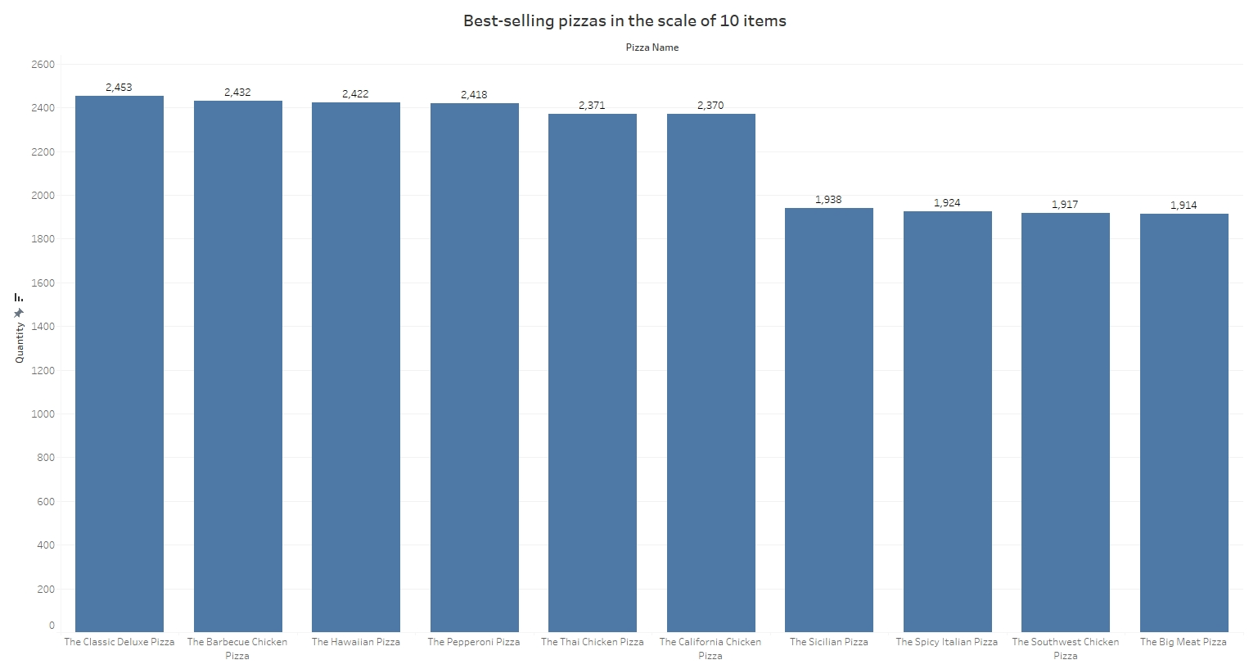

Figure 4.1: Best-selling pizzas in the scale of 10 items chart

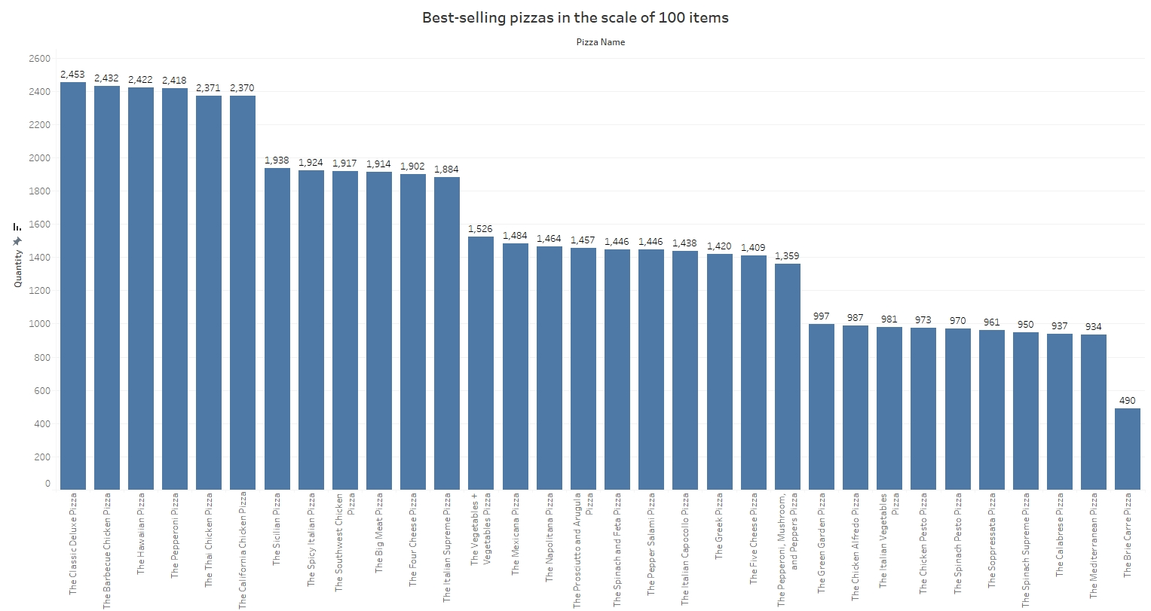

Figure 4.2: Best-selling pizzas in the scale of 100 items chart

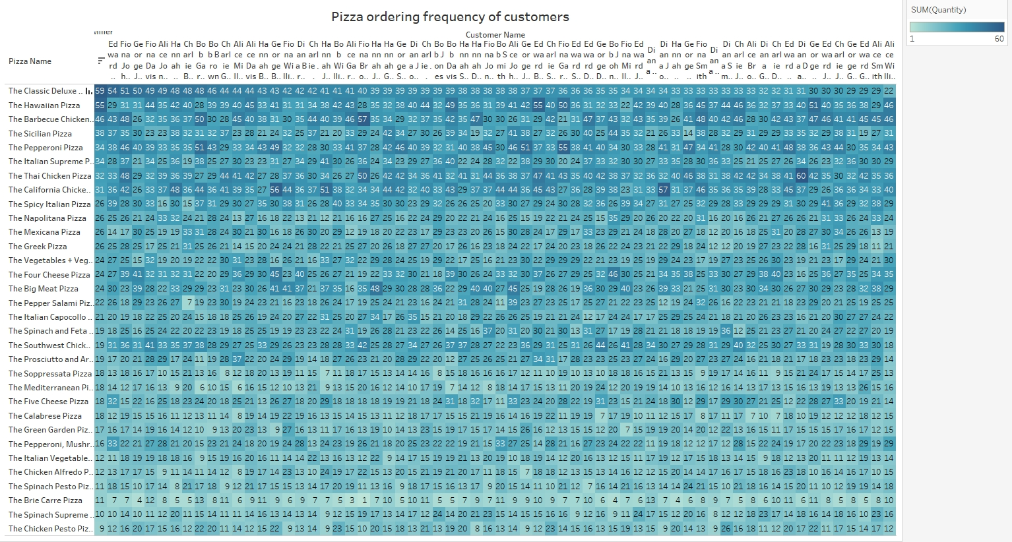

Figure 4.3: Pizza ordering frequency of customers

# CHAPTER 4. TECHNOLOGY AND APPROACHES EXPECTED TO USE

4.1. Technology

+ Python: Data analysis (Pandas, NumPy), predictive modeling (scikit-learn).

+ Tableau: Data visualization.

+ Flask/Django: Web application development.

+ HTML/CSS/JavaScript: Interactive dashboards.

4.2. Methods

+ Exploratory analytics (EDA): Finding data patterns and trends.

+ Predictive modeling: Linear regression, customer clustering.

+ Natural language processing (NLP): Customer feedback analysis.

# CHAPTER 5. IMPLEMENTING FORECASTING/ANALYTICAL MODELS

5.1. Forecasting model

+ Use Linear Regression to predict pizza sales based on price, time of sale.

+ Apply Clustering (K-means) to segment customers:

* Group customers according to ordering behavior, feedback.

5.2. Result

+ Identify best-selling dishes in different time frames.

+ Segment customers to build retention strategies for each group.

5.3. Comment

+ Based on model output, recommend dishes that should be discounted or promoted.

+ Recommend reducing service time to increase revenue.

# CHAPTER 6. BUILD AN APP WITH A DASHBOARD

6.1. Application

Build a web app with Flask or Django:

* Interactive dashboard showing sales, feedback, and staff performance.
* Search by customer, dish, or staff.

6.2. Dashboard

Tab 1: Sales and best-selling dishes.

Tab 2: Customer feedback and review platform.

Tab 3: Staff analytics (performance, activity).

6.3. Result

Restaurant managers can see real-time information, supporting quick decisions.

# REFERENCES

H. H. Wang, L. S. Chen, and K. J. Hsu, "Restaurant Business Intelligence System Using Machine Learning Techniques," *2021 IEEE International Conference on Systems, Man, and Cybernetics (SMC)*, 2021, pp. 1102-1107, doi: 10.1109/SMC2021.2021.1102.

A. Gupta and M. S. Reddy, "Analysis of Restaurant Analytics Using Big Data Frameworks," *2022 IEEE International Conference on Advanced Computing (ICAC)*, 2022, pp. 445-450, doi: 10.1109/ICAC2022.2022.445.

D. Martin et al., "Real-Time Menu Optimization Using Data Analytics," *2020 IEEE Symposium on Computational Intelligence (SSCI)*, 2020, pp. 309-314, doi: 10.1109/SSCI2020.2020.309.

J. R. Smith et al., "Enhancing Customer Retention with Predictive Analytics in the Food Service Industry," *2019 IEEE Conference on Data Science and Learning (DSL)*, 2019, pp. 589-593, doi: 10.1109/DSL2019.2019.589.

A. Kumar and P. Jain, "Applications of Artificial Intelligence for Optimization of Business Processes in Enterprise Resource Planning Systems," *IEEE Access*, vol. 9, pp. 36589-36597, 2021, doi: 10.1109/ACCESS2021.36589.

K. Wang and C. Zhao, "Data-Driven Decision Support Systems for Restaurant Operations," *2018 IEEE International Conference on Cloud Computing and Big Data Analysis (ICCBDA)*, 2018, pp. 120-125, doi: 10.1109/ICCBDA.2018.120.

L. Zhang et al., "Restaurant Data Analytics to Improve Business Verticals," *2023 IEEE Conference on Data Engineering and Applications (CDEA)*, 2023, pp. 35-42, doi: 10.1109/CDEA2023.35.

P. S. Roy and A. Singh, "Exploring Customer Feedback with Sentiment Analysis for Restaurant Performance," *2022 IEEE International Conference on Intelligent Systems (ICIS)*, 2022, pp. 102-108, doi: 10.1109/ICIS2022.2022.102.

T. N. Nguyen, "Optimization Techniques in Restaurant Resource Management," *2021 IEEE International Conference on Smart Cities and Systems (ICSC)*, 2021, pp. 219-224, doi: 10.1109/ICSC2021.2021.219.

B. Patel et al., "Predictive Modeling for Enhancing the Food Service Industry with BI," *2020 IEEE International Conference on Innovations in Engineering and Technology (ICIET)*, 2020, pp. 88-92, doi: 10.1109/ICIET2020.2020.88.