**7: MAP COLORING**

1. **Modeling a map by a graph**

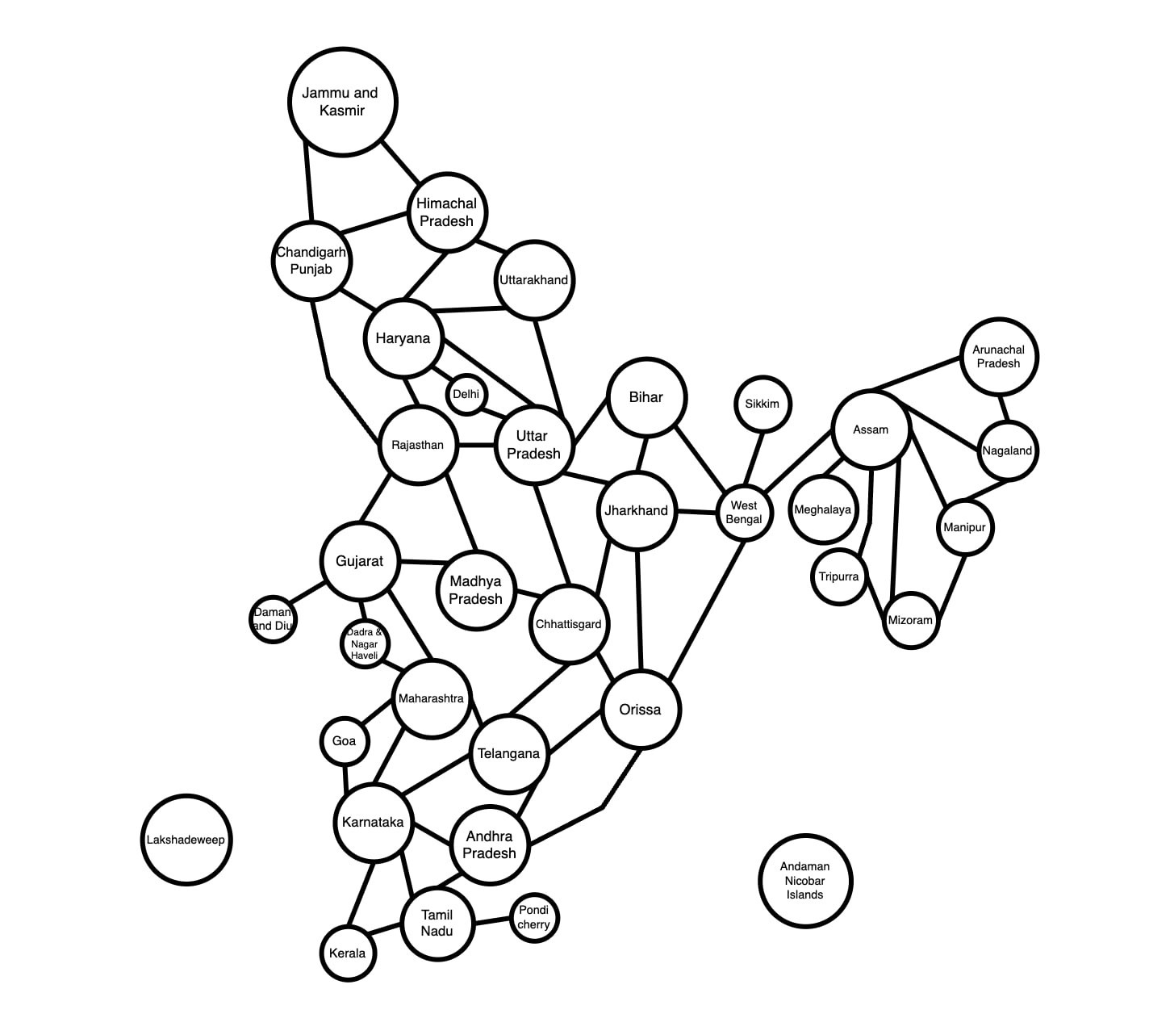

1. **Color the map (graph) with a minimum number of colors. Present your solution step by step.**

Let $\overline{abcd}$ be the 4-digit number combined by the last 4 digits in our StudentID*.* Our StudentID is 522H0024 so has $\overline{abcd}$ = 0024

0024 % 4 = 0 so start from Bihar.

In this question we use 4 color to color the map.

#1:

#2:

#3:

#4:

