VIETNAM GENERAL CONFEDERATION OF LABOUR

**TON DUC THANG UNIVERSITY**

**FACULTY OF INFORMATION TECHNOLOGY**



**Nguyễn Đình Việt Hoàng – 522H0120**

**MIDTERM REPORT**

**DISCRETE STRUCTURES**

**HO CHI MINH CITY, YEAR 2024**

VIETNAM GENERAL CONFEDERATION OF LABOUR

**TON DUC THANG UNIVERSITY**

**FACULTY OF INFORMATION TECHNOLOGY**



**Nguyễn Đình Việt Hoàng – 522H0120**

**MIDTERM REPORT**

**DISCRETE STRUCTURES**

**HO CHI MINH CITY, YEAR 2024**

**ACKNOWLEDGEMENT**

I sincerely thank Professor Nguyễn Quốc Bình for teaching me the Discrete Structures course with great enthusiasm. I want to express my deep appreciation for the dedication and professional knowledge that you shared with me. Through your classes, I gained a better understanding of the fundamental aspects of the Discrete Structures, thanks to your detailed explanations and practical applications. You helped me grasp the knowledge and apply it effectively. Finally, I extend my heartfelt gratitude to Professor Nguyễn Quốc Bình for your commitment and invaluable support throughout my learning journey in this course. The skills and knowledge I acquired will continue to impact my future development. I sincerely thank you and wish your health, success, and happiness.

*Ho Chi Minh City, April 14, 2024*

*Author*

*(sign and write your full name)*

*Hoàng*

*Nguyễn Đình Việt Hoàng*

**THE COMPLETION REPORT HAS BEEN SUBMITTED AT TON DUC THANG UNIVERSITY**

I assure that this is my own report and was guided by Professor Nguyễn Quốc Bình. The research content and results in this report are honest and have not been published in any form before. The figures in the tables used for analysis, comments, and evaluations were collected by the authors from various sources clearly stated in the reference section.

Additionally, the report includes some comments, evaluations, and data from other authors and organizations, all of which are cited and noted for their origin.

**If any fraud is detected, I fully take responsibility for the content of my midterm report for the second semester of the 2023-2024 academic year.** Ton Duc Thang University is not involved in any copyright or intellectual property violations that I may cause during the process (if any).

*Ho Chi Minh City, April 14, 2024*

*Author*

*(sign and write your full name)*

*Hoàng*

*Nguyễn Đình Việt Hoàng*

**INSTRUCTOR RUBRIC**

Supervisor’s Name: ……………………………………………………………..............

Comments: ……………………………………………………………………………...

Total Score Based on Rubric Evaluation: ……………………………………………….

*Ho Chi Minh City, date … month … year …*

*Supervisor*

*(sign and write your full name)*

**TABLE OF CONTENTS**

**Problems** 8

*Part 1* 8

**Problem 1: Password** 8

**Problem 2: Conditional statements** 8

**Problem 3: Fallacies** 11

*Part 2* 13

**Problem 4: Tarski's world** 13

**Problem 5: Symbolic form** 15

**Problem 6: Equivalence** 15

*Part 3* 17

**Problem 7: Prolog** 17

**LIST OF FIGURES**

Figure 2.4.a. My new Tarski's world 14

Figure 2.6.(a) Truth table 16

Figure 3.7.a. The results of the given queries 17

Figure 3.7.b. The result of the file hello1.pl 18

Figure 3.7.c. The result of the file hello2.pl 18

# **Problems**

## *Part 1*

### **Problem 1: Password**

+ According to clue e, we can say that 9, 5 and 6 are not in the password.

+ For the clue a, we can say that 4 or 7 or 2 can appear in the password but not in the current position like the topic show (472).

+ About the clue b and e, we discard 5 so 8 or 1 can appear in the password but not in the current position like the topic show (suggestion b is 581 and suggestion e is 956)

+ About clue c and e, we discard 8 and 4 because if 8 is not only the correct number, but also in the correct position then it will negate the clue b (one number is correct but in an incorrect position) or if 4 is both the correct number and in the current position then it will negate the clue a (one number is correct but in an incorrect position). => So, we will have 3 in the 3rd position in the password.

+ Based on clue d and e, 6 is discarded because clue e is described that 956: all numbers are incorrect. => So, 1 or 7 is in the password but not in the current position.

To sum up based on the above data that:

1. Number 3 is in 3rd position in the password.
2. Number 1 is in 1st position in the password because 3 is the 3rd number in the password and based on the data above, we can see that 5 and 8 are eliminated => 3 and 1 are two correct numbers, we have identified that number 3 is in 3rd position in the password and as trials b and e described, we can deduce that 1 is in 1st position in the password. => Number 1 is the 1st number in the password.
3. So, we’re just only have 2 and 7. Based on trial d, we have 7 is the incorrect number. => So, we will have number 2 is in 2nd position in the password.
4. Hacker knows that the password has 3 characters.

* PASSWORD: 123

### **Problem 2: Conditional statements**

a. “If a man, holding a belief which he was taught in childhood or persuaded of afterwards, keeps down and pushes away any doubts which arise about it in his mind, purposely avoids the reading of books and the company of men that call in question or discuss it, and regards as impious those questions which cannot easily be asked without disturbing it - the life of that man is one long sin against mankind.”

+ Converse: “If the life of a man is one long sin against mankind, then that man is holding a belief which he was taught in childhood or persuaded of afterwards, keeps down and pushes away any doubts which arise about it in his mind, purposely avoids the reading of books and the company of men that call in question or discuss it, and regards as impious those questions which cannot easily be asked without disturbing it.”

+ Inverse: “If a man is not holding a belief which he was taught in childhood or persuaded of afterwards, does not keep down and push away any doubts which arise about it in his mind, does not purposely avoid the reading of books and the company of men that call in question or discuss it, and does not regard as impious those questions which cannot easily be asked without disturbing it, then the life of that man is not one long sin against mankind.”

+ Contrapositive: “If the life of a man is not one long sin against mankind, then that man is not holding a belief which he was taught in childhood or persuaded of afterwards, does not keep down and push away any doubts which arise about it in his mind, does not purposely avoid the reading of books and the company of men that call in question or discuss it, and does not regard as impious those questions which cannot easily be asked without disturbing it.”

+ Non-conditional form negation: “A man is holding a belief which he was taught in childhood or persuaded of afterwards, keeps down and pushes away any doubts which arise about it in his mind, purposely avoids the reading of books and the company of men that call in question or discuss it, and regards as impious those questions which cannot easily be asked without disturbing it, and the life of that man is not one long sin against mankind.”

b. “If existing agricultural knowledge were everywhere applied, the planet could feed twice its present population.”

+ Converse: “If the planet could feed twice its present population, then existing agricultural knowledge is everywhere applied.”

+ Inverse: “If existing agricultural knowledge is not everywhere applied, then the planet cannot feed twice its present population.”

+ Contrapositive: “If the planet cannot feed twice its present population, then existing agricultural knowledge is not everywhere applied.”

+ Non-conditional form negation: “Existing agricultural knowledge is everywhere applied, but the planet cannot feed twice its present population.”

c. “But even if the initial colonists had consisted of only 100 people and their numbers had increased at a rate of only 1.1 percent per year, the colonists’ descendants would have reached that population ceiling of 10 million people within a thousand years.”

+ Converse: “If the colonists’ descendants would have reached that population ceiling of 10 million people within a thousand years, then the initial colonists had consisted of only 100 people and their numbers had increased at a rate of only 1.1 percent per year.”

+ Inverse: “If the initial colonists had not consisted of only 100 people and their numbers had not increased at a rate of only 1.1 percent per year, then the colonists’ descendants would not have reached that population ceiling of 10 million people within a thousand years.”

+ Contrapositive: “If the colonists’ descendants would not have reached that population ceiling of 10 million people within a thousand years, then the initial colonists had not consisted of only 100 people and their numbers had not increased at a rate of only 1.1 percent per year.”

+ Non-conditional form negation: “The initial colonists had consisted of only 100 people and their numbers had increased at a rate of only 1.1 percent per year, but the colonists’ descendants would not have reached that population ceiling of 10 million people within a thousand years.”

d. “If anyone looked out of their window now, even beady-eyed Mrs. Dursley, they wouldn’t be able to see anything that was happening down on the pavement.”

+ Converse: “If they wouldn’t be able to see anything that was happening down on the pavement, then anyone looked out of their window now, even beady-eyed Mrs. Dursley.”

+ Inverse: “If anyone did not look out of their window now, even beady-eyed Mrs. Dursley, then they would be able to see something that was happening down on the pavement.”

+ Contrapositive: “If they would be able to see something that was happening down on the pavement, then anyone did not look out of their window now, even beady-eyed Mrs. Dursley.”

+ Non-conditional form negation: “Anyone looked out of their window now, even beady-eyed Mrs. Dursley, and they would be able to see something that was happening down on the pavement.”

### **Problem 3: Fallacies**

1. Converse Error:

For a real-life example: “If it is raining, then the ground is wet”, the converse would be “If the ground is wet, then it is raining”. The converse is not necessarily true because there could be other reasons for the ground to be wet, such as someone watering the garden.  
References:

1/ [What Is a Converse Error Fallacy? (thoughtco.com)](https://www.thoughtco.com/what-is-a-converse-error-3126461)

2/ [11 Converse Accident Fallacy Examples in Media, Real Life, Politics, News & Ads 2024 (biznewske.com)](https://biznewske.com/converse-accident-fallacy-examples/)

1. Inverse Error:

For a real-life example: “If I am a bird, then I can fly”, the inverse would be “If I cannot fly, then I am not a bird”. The inverse is not necessarily true because there are birds that cannot fly, like penguins.

Reference:

1/ [Denying the antecedent - Wikipedia](https://en.wikipedia.org/wiki/Denying_the_antecedent)

1. A Valid Argument with a False Premise and a False Conclusion:

For a real-life example: "All dogs can speak English (False Premise). Fido is a dog, so Fido can speak English (False Conclusion)".

References:

1/ [logic - Suppose you have an argument with false premises and a false conclusion. Given this information, what do you know about the validity of this argument? - Philosophy Stack Exchange](https://philosophy.stackexchange.com/questions/60010/suppose-you-have-an-argument-with-false-premises-and-a-false-conclusion-given-t)

2/ [WorkshopSolution04.pdf (buffalo.edu)](https://www.acsu.buffalo.edu/~degray/CT13/WorkshopSolution04.pdf)

3/ [False Premise: When Arguments Are Built on Bad Foundations – Effectiviology](https://effectiviology.com/false-premise/)

1. An Invalid Argument with True Premises and a True Conclusion:

For a real-life example: "Paris is the capital of France (True Premise). Grass is green (True Premise). Therefore, a poodle is a dog (True Conclusion)". => The conclusion is true, but the premises do not logically lead to the conclusion.

References:

1/ [Invalid argument with true premisses and true conclusion – Ask a Philosopher](https://askaphilosopher.org/2012/02/08/invalid-argument-with-true-premisses-and-true-conclusion/)

2/ [logic - Invalid arguments with true premises and true conclusion - Philosophy Stack Exchange](https://philosophy.stackexchange.com/questions/17643/invalid-arguments-with-true-premises-and-true-conclusion)

3/ [WorkshopSolution04.pdf (buffalo.edu)](https://www.acsu.buffalo.edu/~degray/CT13/WorkshopSolution04.pdf)

1. Circular Reasoning:

For a real-life example: "I am trustworthy because I always tell the truth. How do you know I always tell the truth? Because I am trustworthy".

References:

1/ [Circular Reasoning (29 Examples + How to Avoid) - Practical Psychology (practicalpie.com)](https://practicalpie.com/circular-reasoning/)

2/ [Circular Reasoning Fallacy Examples in Media, Real Life, Politics, Movies & Ads 2024 (biznewske.com)](https://biznewske.com/circular-reasoning-fallacy-examples/)

3/ [Circular Reasoning - Definition & Examples | LF (logicalfallacies.org)](https://www.logicalfallacies.org/circular-reasoning.html)

4/ [What Is a Logical Fallacy? 15 Common Logical Fallacies | Grammarly](https://www.grammarly.com/blog/logical-fallacies/)

5/ [25 Fallacy Examples in Real Life – StudiousGuy](https://studiousguy.com/fallacy-examples-in-real-life/#3_The_Circular_Reasoning_Fallacy)

1. Using ambiguous premises and treating them as if they were unambiguous

For a real-life example: The word “light” can mean “not heavy” or “not dark”. If someone says “This box is light”, it’s ambiguous whether they mean the box is not heavy or the box is not dark.

References:

1/ [Fallacy of Ambiguity: Explanation and Examples (philosophyterms.com)](https://philosophyterms.com/fallacy-of-ambiguity/)

2/ [4.7: Fallacies of Ambiguity - Humanities LibreTexts](https://human.libretexts.org/Courses/Lumen_Learning/Book%3A_Introduction_to_Philosophy-2_%28Lumen%29/04%3A_Module_2%3A_Logic/04.7%3A_Fallacies_of_Ambiguity)

1. Jumping to a Conclusion:

For a real-life example: Concluding that a person must be rich because they drive a fancy car, without considering other possibilities.

References:

1/ [Jumping to Conclusions: When People Decide Based on Insufficient Information – Effectiviology](https://effectiviology.com/jumping-to-conclusions/)

2/ [Jumping to Conclusions: Why It Happens and How to Change (verywellmind.com)](https://www.verywellmind.com/jumping-to-conclusions-2584181)

3/ [Jumping To Conclusions | A Simplified Psychology Guide](https://psychology.tips/jumping-to-conclusions/)

4/ [Jumping to Conclusions (logicallyfallacious.com)](https://www.logicallyfallacious.com/logicalfallacies/Jumping-to-Conclusions)

1. Sound and Unsound Arguments

For some real-life examples of fallacies which lead to unsound arguments:

1. "Don’t listen to Dave’s argument on gun control. He’s not the brightest bulb in the chandelier."
2. "Katherine loves Tom Cruise. One day, she meets Tom Cruise and he tells her unicorns live in New York City. Without searching to find out if fairy tales have sprung to life in midtown Manhattan, she believes it to be true."
3. "People have been praying to God for years. No one can prove He doesn’t exist. Therefore, He exists."
4. "If aliens didn’t steal my newspaper, who did?"
5. "All swans are white, so if an animal is black then it isn’t a swan."

References:

1/ [Sound vs Unsound Arguments (Explained) (tagvault.org)](https://tagvault.org/blog/sound-vs-unsound-arguments-explained/)

2/ [False Premise: When Arguments Are Built on Bad Foundations – Effectiviology](https://effectiviology.com/false-premise/)

## *Part 2*

### **Problem 4: Tarski's world**

1. My new Tarski's world:

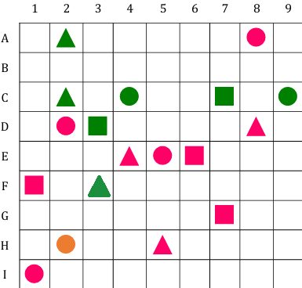

#### Figure 2.4.a. My new Tarski's world

1. Determine the truth or falsity of all the following statements, based on the modified Tarski's world. Give the reasons for your justification.

i. ∀x, Circle(x) → Green(x).

ii. ∀x, Triangle(x) → ~Orange(x).

iii. ∃x such that Red(x) ∧ Triangle(x).

iv. ∃x such that ~Green(x) ∧ BelowOf(x, E4).

v. ∀x, Square(x) → RightOf(E5, x).

vi. ∃x such that AboveOf(E5, x) ∧ LeftOf(x, E5).

vii. There is a triangle x such that for all squares y, x is above y.

viii. For all circles x, there is a square y such that y is to the right of x.

ix. There is a circle x and there is a square y such that y is below x.

x. For all circles x and for all triangles y, x and y have the same color.

To do

i. ∀x, Circle(x) → Green(x). False. Not all circles are green; there could be circles of other colors.

ii. ∀x, Triangle(x) → ~Orange(x). True. If every triangle is not orange, then this statement is true.

iii. ∃x such that Red(x) ∧ Triangle(x). True. There exists at least one red triangle.

iv. ∃x such that ~Green(x) ∧ BelowOf(x, E4). True. There exists at least one object that is not green and is below E4.

v. ∀x, Square(x) → RightOf(E5, x). False. Not every square is to the right of E5; some could be to the left or in the same column.

vi. ∃x such that AboveOf(E5, x) ∧ LeftOf(x, E5). True. There exists at least one object that is above and to the left of E5.

vii. There is a triangle x such that for all squares y, x is above y. False. Not every triangle is above all squares.

viii. For all circles x, there is a square y such that y is to the right of x. True. For each circle, there can be a square to its right.

ix. There is a circle x and there is a square y such that y is below x. True. There exists at least one circle with a square below it.

x. For all circles x and for all triangles y, x and y have the same color. False. Not all circles and triangles share the same color.

### **Problem 5: Symbolic form**

The symbolic form of:

a. $p∧¬r$

d. $r→p$

f. $s→q$

g. $q↔s$

### **Problem 6: Equivalence**

~ [(~ p ∧ ~ ~ q) ∨ ~ (p ∨ r)] ≡ (r ∨ p) ∧ (~ q ∨ p)

The above pair of statements are logically equivalent by:

1. using truth table:

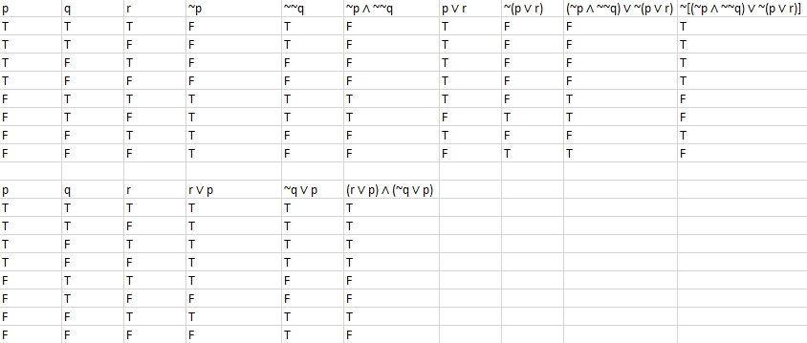

#### Figure 2.6.(a) Truth table

* The columns for ~[(~p ∧ ~~q) ∨ ~(p ∨ r)] and (r ∨ p) ∧ (~q ∨ p) are identical, which means the two statements are logically equivalent.

1. using logical equivalence laws:

1. Starting with the left-hand side of the equivalence: ~[(~p ∧ ~~q) ∨ ~(p ∨ r)] (1)

2. Applying De Morgan's law: ~~q ≡ q and ~(p ∨ r) ≡ (~p ∧ ~r). Therefore, (1) => ~[(~p ∧ q) ∨ (~p ∧ ~r)] (2)

3. Applying the distributive law: A ∨ (B ∧ C) ≡ (A ∨ B) ∧ (A ∨ C). Therefore, (2) => [~p ∨ (q ∧ ~r)] ∧ [~p ∨ (q ∧ ~r)] (3)

4. Using commutativity of ∧: A ∧ B ≡ B ∧ A. Therefore, (3) => [~p ∨ (q ∧ ~r)] ∧ [~p ∨ (q ∧ ~r)] (4)

5. Using idempotence of ∨: A ∨ A ≡ A. Therefore, (4) => ~p ∨ (q ∧ ~r)

6. Simplifying the right-hand side of the equivalence: (r ∨ p) ∧ (~q ∨ p) (6)

7. Using commutativity of ∨: A ∨ B ≡ B ∨ A. Therefore, (6) => (p ∨ r) ∧ (p ∨ ~q) (7)

8. Using distributive law: A ∧ (B ∨ C) ≡ (A ∧ B) ∨ (A ∧ C). Therefore, (7) => (p ∨ r) ∧ (~q ∨ p)

* Comparing the two simplified expressions (~p ∨ (q ∧ ~r) and (p ∨ r) ∧ (~q ∨ p)), we see that they are not in the same form. However, if we consider the commutative law (which states that p ∨ q is equivalent to q ∨ p), we can see that the two expressions are indeed equivalent. Therefore, the two original statements are logically equivalent.

## *Part 3*

### **Problem 7: Prolog**

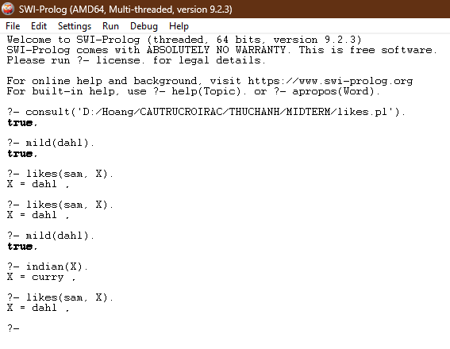

#### Figure 3.7.a. The results of the given queries

+ To calculate the result true for mild(dahl)., we need to define the rule or fact for the mild/1 predicate. In this situation, mild/1 represents a property of a food item being mild, we would need to have a fact or rule that states that dahl is mild.

+ To calculate the result for indian(X)., we need to define the rule or facts for the indian/1 predicate. Assuming indian/1 represents a property of a food item being Indian, we would need to have facts or rules that define which food items are considered Indian. In this situation, it would return curry.

+ To calculate the result for likes(sam, X)., we need to define the rule or facts for the likes/2 predicate. Assuming likes/2 represents the liking relationship between a person and a food item, we would need to have facts or rules that define which food items Sam likes. In this situation, the food item that Sam likes is dahl.

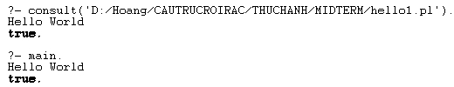

#### Figure 3.7.b. The result of the file hello1.pl

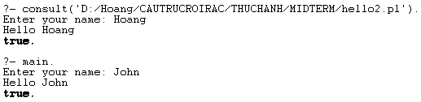

#### Figure 3.7.c. The result of the file hello2.pl

**REFERENCES**

1. [What Is a Converse Error Fallacy? (thoughtco.com)](https://www.thoughtco.com/what-is-a-converse-error-3126461)
2. [11 Converse Accident Fallacy Examples in Media, Real Life, Politics, News & Ads 2024 (biznewske.com)](https://biznewske.com/converse-accident-fallacy-examples/)
3. [Denying the antecedent - Wikipedia](https://en.wikipedia.org/wiki/Denying_the_antecedent)
4. [logic - Suppose you have an argument with false premises and a false conclusion. Given this information, what do you know about the validity of this argument? - Philosophy Stack Exchange](https://philosophy.stackexchange.com/questions/60010/suppose-you-have-an-argument-with-false-premises-and-a-false-conclusion-given-t)
5. [WorkshopSolution04.pdf (buffalo.edu)](https://www.acsu.buffalo.edu/~degray/CT13/WorkshopSolution04.pdf)
6. [False Premise: When Arguments Are Built on Bad Foundations – Effectiviology](https://effectiviology.com/false-premise/)
7. [Invalid argument with true premisses and true conclusion – Ask a Philosopher](https://askaphilosopher.org/2012/02/08/invalid-argument-with-true-premisses-and-true-conclusion/)
8. [logic - Invalid arguments with true premises and true conclusion - Philosophy Stack Exchange](https://philosophy.stackexchange.com/questions/17643/invalid-arguments-with-true-premises-and-true-conclusion)
9. [Circular Reasoning (29 Examples + How to Avoid) - Practical Psychology (practicalpie.com)](https://practicalpie.com/circular-reasoning/)
10. [Circular Reasoning Fallacy Examples in Media, Real Life, Politics, Movies & Ads 2024 (biznewske.com)](https://biznewske.com/circular-reasoning-fallacy-examples/)
11. [Circular Reasoning - Definition & Examples | LF (logicalfallacies.org)](https://www.logicalfallacies.org/circular-reasoning.html)
12. [What Is a Logical Fallacy? 15 Common Logical Fallacies | Grammarly](https://www.grammarly.com/blog/logical-fallacies/)
13. [25 Fallacy Examples in Real Life – StudiousGuy](https://studiousguy.com/fallacy-examples-in-real-life/#3_The_Circular_Reasoning_Fallacy)
14. [Fallacy of Ambiguity: Explanation and Examples (philosophyterms.com)](https://philosophyterms.com/fallacy-of-ambiguity/)
15. [4.7: Fallacies of Ambiguity - Humanities LibreTexts](https://human.libretexts.org/Courses/Lumen_Learning/Book%3A_Introduction_to_Philosophy-2_%28Lumen%29/04%3A_Module_2%3A_Logic/04.7%3A_Fallacies_of_Ambiguity)
16. [Jumping to Conclusions: When People Decide Based on Insufficient Information – Effectiviology](https://effectiviology.com/jumping-to-conclusions/)
17. [Jumping to Conclusions: Why It Happens and How to Change (verywellmind.com)](https://www.verywellmind.com/jumping-to-conclusions-2584181)
18. [Jumping To Conclusions | A Simplified Psychology Guide](https://psychology.tips/jumping-to-conclusions/)
19. [Jumping to Conclusions (logicallyfallacious.com)](https://www.logicallyfallacious.com/logicalfallacies/Jumping-to-Conclusions)
20. [Sound vs Unsound Arguments (Explained) (tagvault.org)](https://tagvault.org/blog/sound-vs-unsound-arguments-explained/)