VIETNAM GENERAL CONFEDERATION OF LABOUR

**TON DUC THANG UNIVERSITY**

**FACULTY OF INFORMATION TECHNOLOGY**



**Nguyễn Gia Mỹ - 521H0272**

**Nguyễn Phạm Thanh Uyên - 521H0329**

**Nguyễn Đình Việt Hoàng - 522H0120**

**CUSTOMER ORDER MANAGEMENT SUBSYSTEM**

**MIDTERM REPORT**

**ENTERPRISE SERVICE-ORIENTED ARCHITECTURE**

**HO CHI MINH CITY, YEAR 2024**

VIETNAM GENERAL CONFEDERATION OF LABOUR

**TON DUC THANG UNIVERSITY**

**FACULTY OF INFORMATION TECHNOLOGY**



**Nguyễn Gia Mỹ - 521H0272**

**Nguyễn Phạm Thanh Uyên - 521H0329**

**Nguyễn Đình Việt Hoàng - 522H0120**

**CUSTOMER ORDER MANAGEMENT SUBSYSTEM**

**MIDTERM REPORT**

**ENTERPRISE SERVICE-ORIENTED ARCHITECTURE**

Instructor

**MSc. Dương Hữu Phúc**

**HO CHI MINH CITY, YEAR 2024**

# ACKNOWLEDGEMENT

We sincerely thank MSc. Dương Hữu Phúc for teaching us the Enterprise Service-Oriented Architecture course with great enthusiasm. We want to express our deep appreciation for the dedication and professional knowledge that you shared with us. Through your classes, we gained a better understanding of the fundamental aspects of the Enterprise Service-Oriented Architecture, thanks to your detailed explanations and practical applications. You helped us grasp the knowledge and apply it effectively. Finally, we extend our heartfelt gratitude to MSc. Dương Hữu Phúc for your commitment and invaluable support throughout our learning journey in this course. The skills and knowledge we acquired will continue to impact our future development. We sincerely thank you and wish your health, success, and happiness.

*Ho Chi Minh City, April 21, 2024*

*Authors:*

*Nguyễn Gia Mỹ*

*Nguyễn Phạm Thanh Uyên*

*Nguyễn Đình Việt Hoàng*

**THE COMPLETION REPORT HAS BEEN SUBMITTED AT TON DUC THANG UNIVERSITY**

Our group assures that this is our own report and was guided by MSc. Dương Hữu Phúc. The research content and results in this report are honest and have not been published in any form before. The figures in the tables used for analysis, comments, and evaluations were collected by the authors from various sources clearly stated in the reference section.

Additionally, the report includes some comments, evaluations, and data from other authors and organizations, all of which are cited and noted for their origin.

**If any fraud is detected, we fully take responsibility for the content of our midterm report for the second semester of the 2023-2024 academic year.** Ton Duc Thang University is not involved in any copyright or intellectual property violations that we may cause during the process (if any).

*Ho Chi Minh City, April 21, 2024*

*Authors:*

*Nguyễn Gia Mỹ*

*Nguyễn Phạm Thanh Uyên*

*Nguyễn Đình Việt Hoàng*

# INSTRUCTOR RUBRIC

Supervisor’s Name: ……………………………………………………………..............

Comments: ……………………………………………………………………………...

Total Score Based on Rubric Evaluation: ………………………………………………

*Ho Chi Minh City, date … month … year …*

*Supervisor*

*(sign and write your full name)*

**TABLE OF CONTENTS**

ACKNOWLEDGEMENT 5

INSTRUCTOR RUBRIC 7

TABLE OF CONTENTS 8

LIST OF FIGURES 10

LIST OF TABLES 11

LIST OF ABBREVIATIONS 13

CHAPTER 1 –INTRODUCTION 14

1.1 Background: current situation & problem statement 14

1.2 Approach 15

CHAPTER 2 – REQUIREMENTS ANALYSIS AND SYSTEM DESIGN 16

2.1 Requirements Analysis 16

2.1.1 System actors 16

2.1.2 Use case diagram 17

2.1.3 Business Processes 18

2.1.4 Activity diagrams descriptions 18

2.1.5 Activity diagrams 23

2.1.6 Class diagram 32

2.2 System design 33

2.2.1 Entity Relationship Diagram 33

2.2.2 Services functionalities 33

2.2.3 APIs 34

2.2.4 Databases 35

CHAPTER 3 – IMPLEMENTATION 36

CHAPTER 4 – EPLOYMENT 36

CHAPTER 5 – CONCLUSION 36

REFERENCES 37

# LIST OF FIGURES

Figure 2.1.2 Use Case Diagram for Customer Management Subsystem .....................16

Figure 2.1.3 Business Processes for Customer Order Management Subsystem...........17

Figure 2.1.5.1 Activity Diagram for use case Sign In...................................................22

Figure 2.1.5.2 Activity Diagram for use case Create An Order....................................23

Figure 2.1.5.3 Activity Diagram for use case Take An Order......................................24

Figure 2.1.5.4 Activity Diagram for use case Close An Order.....................................24

Figure 2.1.5.5 Activity diagrams for use case View Total Invoices.............................25

Figure 2.1.5.6 System Activity for use case View Invoices History.............................26

Figure 2.1.5.7 Activity Diagram for use case Account Authentication........................27

Figure 2.1.5.8 System Activity for use case Read An Order........................................28

Figure 2.1.5.9 Activity Diagram for use case Mark Order As Completed...................28

Figure 2.1.5.10 System Activity for use case Manage Menu........................................29

Figure 2.1.6 Class Diagram for Customer Order Management Subsystem..................33

Figure 2.2.1 Entity Relationship Diagram for Customer Order

Management Subsystem...............................................................................................34

Figure 2.2.4 Databases for Services..............................................................................35

# LIST OF TABLES

Table 2.1.1 System Actors……………………………………………………………….16

Table 2.1.4.1 Sign-in use case description…………………………………………….18

Table 2.1.4.2 Create An Order.......................................................................................19

Table 2.1.4.3 Take An Order.........................................................................................19

Table 2.1.4.4 Close An Order........................................................................................20

Table 2.1.4.5 View Total Invoices.................................................................................20

Table 2.1.4.6 View Invoices History..............................................................................21

Table 2.1.4.7 Account Authentication...........................................................................21

Table 2.1.4.8 Read An Order.........................................................................................22

Table 2.1.4.9 Mark Order As Completed.......................................................................22

Table 2.1.4.10 Manage Menu.........................................................................................22

Table 2.1.5.1 System Actions for Sign In......................................................................23

Table 2.1.5.2 System actions for use case Create An Order..........................................24

Table 2.1.5.3 System actions for Take An Order...........................................................25

Table 2.1.5.4 System actions for Close An Order..........................................................26

Table 2.1.5.5 System actions for View Total Invoices..................................................26

Table 2.1.5.6 System actions for View Invoices History...............................................27

Table 2.1.5.7 System actions for Account Authentication.............................................28

Table 2.1.5.8 System action for Read An Order............................................................29

Table 2.1.5.9 System actions for Mark Order As Completed........................................29

Table 2.1.5.10 System actions for Manage Menu.........................................................30

Table 2.2.2 System services and functionalities............................................................32

Table 2.2.3 APIs for Customer Order Management Subsystem....................................33

# LIST OF ABBREVIATIONS

CHAPTER 1 –INTRODUCTION

* 1. Background: current situation & problem statement

A dine-in restaurant has required a system to manage the customers’ orders.

* + 1. The pain points and driver actions.

This restaurant’s service model is entirely manual. When a group of customers comes to the restaurant, a specific waitress will “serve” them by writing all the orders onto a piece of paper (including the table’s number). Then, that waitress comes to the kitchen and gives the order’s note to a chef. The chef then prepares the orders. Once ready, the chef informs the waitress to bring the food to the customers. This process has some restrictions:

* Time-consuming through all the process: from taking orders to checking out.
* Waitresses easily make mistakes such as missing items, not taking careful note of customer’s instructions, and becoming overloaded during peak hours.
* Difficulty in revenue summarization.
* Limits the ability to understand customer preferences and buying habits.

These limitations serve as a significant motivation for this restaurant to digitize its customer service process. The expected system alleviates serving pressure on staffs, reduces unexpected errors, and allows this restaurant to analyze customer consumption behaviors, leading to increased customer satisfactions.

* + 1. Who benefits from the investment?

Both the restaurant (reduces errors, enhances accuracy) and the customers (better experience) benefit from this investment.

* + 1. Which service (or services) this project would support?
* Ordering: the ability for customers/ waitresses to take/ place orders at the restaurant digitally.
* Kitchen order management: routing orders from customers to the kitchen, ensuring that the dishes are prepared correctly.
* Sales reporting: providing reports on sales revenue (invoices) by time (year, month, day).
  1. Approach
     1. Solution overview & Impact to community

The main change that will result from the project:

* Faster order processing times and improved accuracy in order completion by streamlining the order process to enhance the communication between waitresses and kitchen’s staffs.

As mentioned, the impacted user groups include both staffs and customers, who benefit from the investment. The restaurant’s staffs will experience an improved workflow and communication process that increases work efficiency. Customers will benefit from shorter wait times.

* + 1. Impacts on the other systems

The Customer Order Management Subsystem does not integrate with other systems. This subsystem operates independently from other subsystems within the restaurant management and operation system.

CHAPTER 2 – REQUIREMENTS ANALYSIS AND SYSTEM DESIGN

2.1 Requirements Analysis

2.1.1 System actors

Refer to the [instructor's requirements](https://drive.google.com/file/d/1dg359KPpe-l0DL5TjBS2GdQDk6XNXkVA/view) to find the actors in the Customer Order Management subsystem.

|  |  |
| --- | --- |
| # | Actor |
| 1 | Waitresses |
| 2 | Managers |
| 3 | Chefs |

Table 2.1.1 System Actors

2.1.2 Use case diagram

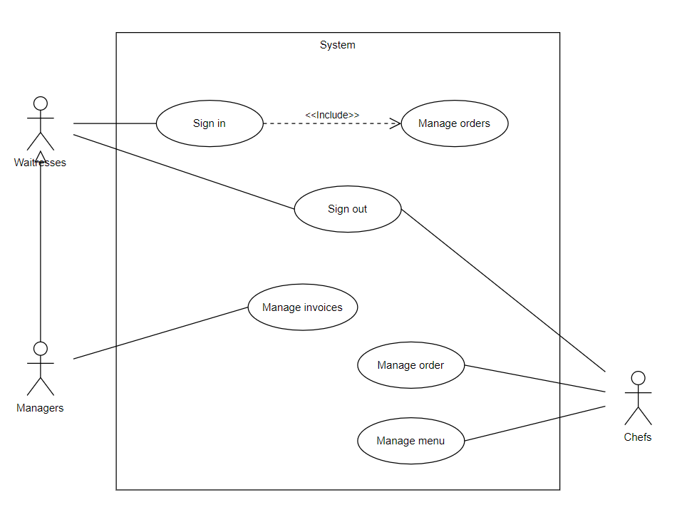Figure 2.1.2 General Use Case Diagram for Customer Management Subsystem

2.1.3 Business Processes

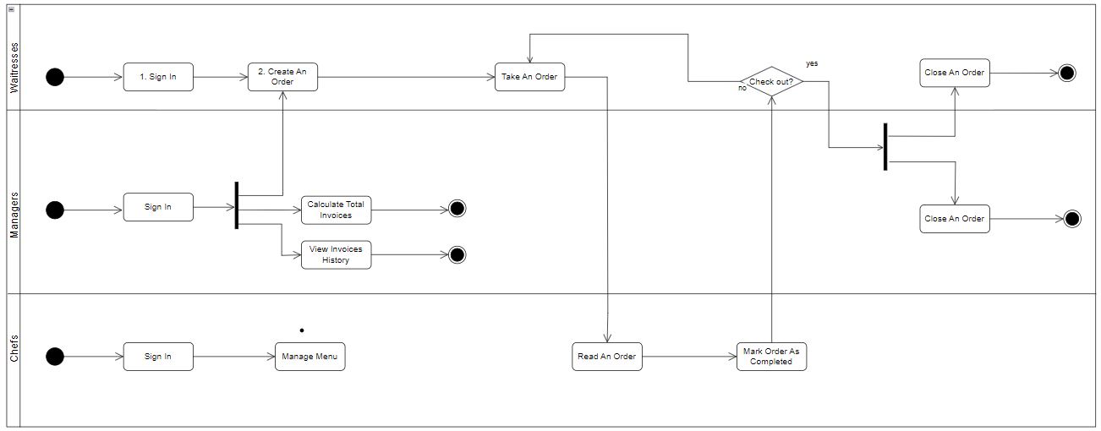Figure 2.1.3 Business Processes for Customer Order Management Subsystem

2.1.4 Activity diagrams descriptions

2.1.4.1 Sign in

|  |  |
| --- | --- |
| Activity | Sign in |
| Actor | Waitresses, Managers, Chefs |
| Summary | All staffs at the restaurant must sign in to the system to perform other functions. |
| Precondition | The staffs have been provided with sign-in accounts. |
| Trigger | The restaurant staffs begin their shift. |
| Main flow | * The staffs (Waitress, Manager, Chef) begin the shift. * The system requests that the staffs enter the sign-in form, including email and password (which are provided). * The staff chooses the Sign-in function for the system to authenticate. |
| Alternatives | * The staff activates the Sign-in function before providing all mandatory information. The system displays an error message and requests that missing information be supplied. |
| Postcondition | If the activity is successful, the system displays other functions based on the staff’s role. Otherwise, the system’s state is unchanged. |

Table 2.1.4.1 Sign in

2.1.4.2 Create orders

|  |  |
| --- | --- |
| Activity | Create orders |
| Actor | Waitresses, Managers |
| Summary | The staff creates a new order when welcoming guests into the restaurant. |
| Precondition | The staff has signed in to the system. |
| Trigger | The staff creates a new order. |
| Main flow | * The staff chooses the Create New Order function. * The system requires the staff to confirm to create a new order. |
| Alternatives | * The staff does not confirm the creation of a new order. |
| Postcondition | If the activity is successful, the system displays a sign-in/ member’s sign-up screen and allows customers to place orders directly, then displays the menu. Otherwise, the system’s state is unchanged. |

Table 2.1.4.2 Create orders

2.1.4.3 Take orders

|  |  |
| --- | --- |
| Activity | Take orders |
| Actor | Waitresses, Managers |
| Summary | The staff helps the customer choose the food items in the orders |
| Precondition | The staff has signed in to the system. |
| Trigger | The customer starts to order food. |
| Main flow | * The staff/ customer adds/ removes food items. * The system asks the staff/ customer to confirm to place an order (information about food items, quantities, and notes). |
| Alternatives | * The staff/ customer chooses the Order function without any items selected. The system does not send the food order list to the kitchen. |
| Postcondition | If the activity is successful, the system displays a message to notify and then displays the menu. Otherwise, the system’s state is unchanged. |

Table 2.1.4.3 Take orders

2.1.4.4 Close orders

|  |  |
| --- | --- |
| Activity | Close orders |
| Actor | Waitresses, Managers |
| Summary | The staff closes the other when the customer requests payment (check out). |
| Precondition | * The staff has signed in to the system. * The order must include at least one food item. |
| Trigger | The customer requests to check out. |
| Main flow | * The staff chooses the Close Order function. * The system requires the staff to confirm to close that order. * The staff confirms to close that order, the system then sends an electronic invoice to the email address of the customer who has registered as a member and returns to the staff main screen. |
| Alternatives | * The staff does not confirm to close the order. The system displays the menu. |
| Postcondition | If the activity is successful, the system displays the staff main screen and sends an e-invoice to the registered/ signed-in customer. Otherwise, the system’s state is unchanged. |

Table 2.1.4.4 Close orders

2.1.4.5 View total invoices

|  |  |
| --- | --- |
| Activity | View total invoices |
| Actor | Managers |
| Summary | The manager consolidates the generated invoices (bills) within the shift. |
| Precondition | The manager has signed in to the system. |
| Trigger | The manager wants to view all the invoices generated within the shift. |
| Main flow | * The manager chooses the View Invoices function. * The system requests the manager to choose the During this shift function. * The system displays the total number of invoices during the shift. |
| Alternatives | * No invoices were collected during the shift, the system displays an empty notification. * The manager does not choose the During this shift function, the system displays the wrong information/ empty notification. |
| Postcondition | If the activity is successful, the system displays all the information about the invoices during the shift. Otherwise, the system’s state is unchanged. |

Table 2.1.4.5 View total invoices

2.1.4.6 View invoices history

|  |  |
| --- | --- |
| Activity | View invoices history |
| Actor | Managers |
| Summary | The manager views the generated invoices (bills) by time (day, month, year). |
| Precondition | The manager has signed in to the system. |
| Trigger | The manager wants to view all the invoices generated by time. |
| Main flow | * The manager chooses the View Invoices function. * The system requests the manager to choose the By time function. * The system displays the total number of invoices by time. |
| Alternatives | The manager does not choose the By Time function, the system displays the empty information. |
| Postcondition | If the activity is successful, the system displays all the information about the invoices by time. Otherwise, the system’s state is unchanged. |

Table 2.1.4.6 View invoices history

2.1.4.7 Read orders

|  |  |
| --- | --- |
| Activity | Read orders |
| Actor | Chefs |
| Summary | The chef reads the food items from the customer’s order |
| Precondition | The chef has signed in to the system |
| Trigger | The customer/ waitress/ manager chooses Order function. |
| Main flow | * The system sends the customer’s order (including food items, quantities, and notes). * The chef receives it and prepares the food. |
| Alternatives | * The system does not send the customer’s order to the kitchen. * The customer/ waitress/ manager sends an empty list of food items. |
| Postcondition | If the activity is successful, the chef can receive the order. Otherwise, the system displays an error message. |

Table 2.1.4.8 Read orders

2.1.4.8 Mark orders as completed

|  |  |
| --- | --- |
| Activity | Mark orders as completed |
| Actor | Chefs |
| Summary | The chef marks the order as completed for the waitress to bring it up to the customer. |
| Precondition | * The chef has signed in to the system. * The system sent the customer’s order. |
| Trigger | The chef has completely prepared the food. |
| Main flow | * The chef chooses the Complete Order function. * The system sends a notification on the screen (customer/ waitress/ manager) |
| Alternatives | The chef uses the intercom to notify the waitress. |
| Postcondition | If the activity is successful, the order has been completed and served immediately to the customer. Otherwise, the system displays can face bottlenecks when there are too many unfinished orders. |

Table 2.1.4.9 Mark orders as completed

2.1.4.9 Manage menu

|  |  |
| --- | --- |
| Activity | Manage menu |
| Actor | Chefs |
| Summary | The chef can adjust the availability of certain menu items based on the ingredients. |
| Precondition | The chef has signed in to the system. |
| Trigger | The chef wants to enable/ disable the availability of certain menu items. |
| Main flow | * The chef enables an item. The system displays that item in the menu. * The chef disables an item. The system hides that item from the menu. |
| Alternatives |  |
| Postcondition | If the activity is successful, the restaurant can be flexible in managing the menu. Otherwise, the system’s state is unchanged. |

Table 2.1.4.10 Manage menu

2.1.5 Activity diagrams

By analyzing the main and alternative flows in the activity diagrams descriptions, we can find the actions for each activity.

2.1.5.1 Sign in

|  |  |  |
| --- | --- | --- |
| No. | Activity statement | Action |
| 1 | The system requests that the staff enter the sign-in form, including email and password (which are provided). | Display sign-in form (staff only) |
| 2 | The staff chooses the Sign-in function for the system to authenticate | Authenticate  Display main screen |
| 3 | The staff activates the Sign-in function before providing all mandatory information | Display sign-in form |

Table 2.1.5.1 System actions for activity Sign in

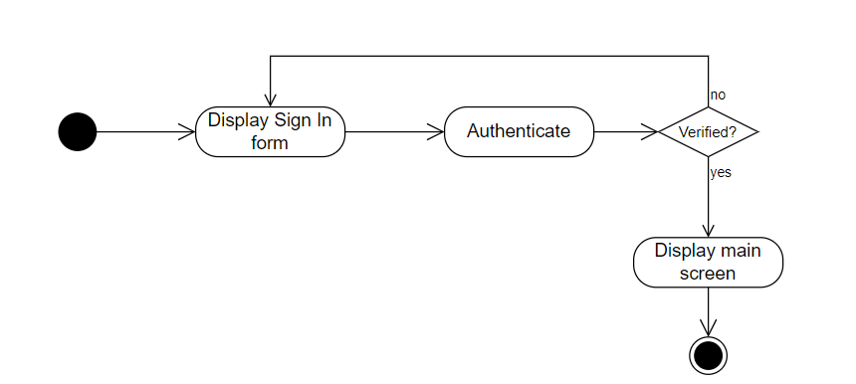Figure 2.1.5.1 Activity diagram Sign in

2.1.5.2 Create orders

|  |  |  |
| --- | --- | --- |
| No. | Activity statement | Action |
| 1 | The staff chooses the Create New Order function. | Create new orders |
| 2 | The system requires the staff to confirm to create a new order | Display menu |
| 3 | The staff does not confirm the creation of a new order. | Display main screen |

Table 2.1.5.2 System actions for activity Create orders

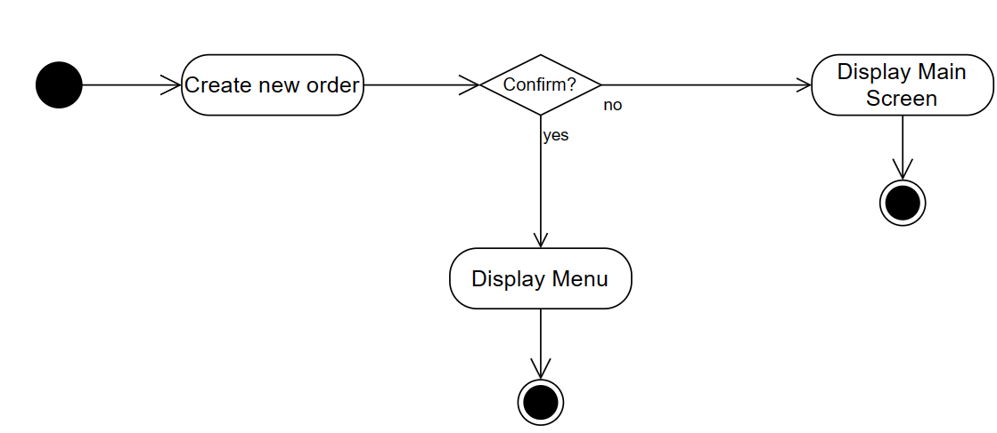Figure 2.1.5.2 Activity diagram Create orders

2.1.5.3 Take orders

|  |  |  |
| --- | --- | --- |
| No. | Activity statement | Action |
| 1 | The staff adds/ removes food items | Add items  Remove items |
| 2 | The system asks the staff to confirm to place an order (information about food items, quantities, and notes) | Note  Send order to the kitchen  Check conditions |
| 3 | The staff chooses the Order function without any items selected | Display menu |

Table 2.1.5.3 System actions for activity Take orders

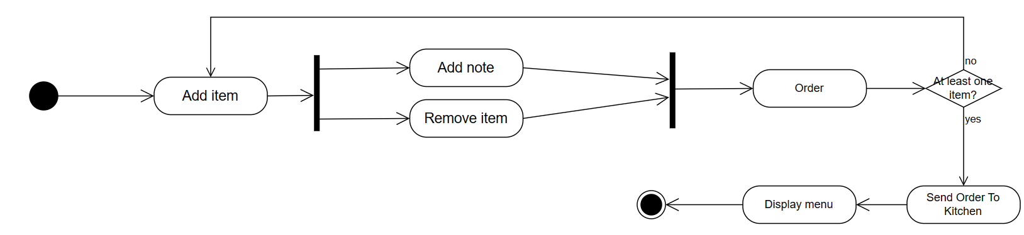

Figure 2.1.5.3 Activity diagram Take orders

2.1.5.4 Close orders

|  |  |  |
| --- | --- | --- |
| No. | Activity statement | Action |
| 1 | The staff chooses the Close Order function. | Close orders |
| 2 | The staff confirms to close that order, the system then sends an electronic invoice to the email address of the customer who has registered as a member and returns to the staff main screen | Send e-invoice  Store e-invoice  Display main screen |
| 3 | The staff does not confirm to close the order. The system displays the menu | Display menu |

Table 2.1.5.4 System actions for activity Close orders

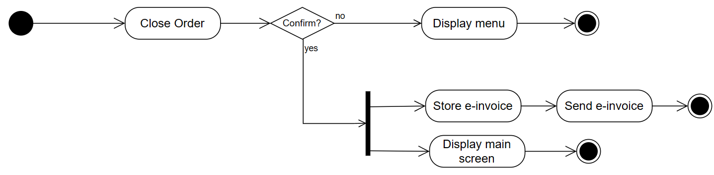

Figure 2.1.5.4 Activity diagram Close orders

2.1.5.5 View total invoices

|  |  |  |
| --- | --- | --- |
| No. | Activity statement | Action |
| 1 | The manager chooses the View Invoices function. | View this shift  Display options (During this shift, By time) |
| 2 | The manager chooses the During this shift function | Get invoices  Calculate total invoices  Display invoices |

Table 2.1.5.5 System actions for activity View total invoices

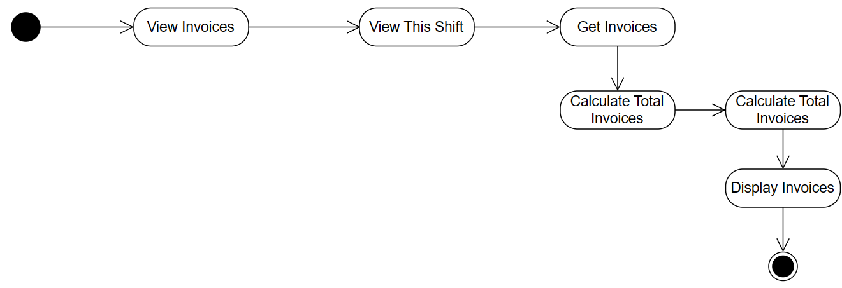

Figure 2.1.5.5 Activity diagram View total invoices

2.1.5.6 View invoices history

|  |  |  |
| --- | --- | --- |
| No. | Activity statement | Action |
| 1 | The manager chooses the View Invoices function. | View by time |
| 2 | The manager chooses the By Time function. | Get invoices  Calculate total invoices  Display invoices |
| 3 | The system displays the total number of invoices by time. | Calculate total invoices |

Table 2.1.5.6 System actions for activity View invoices history

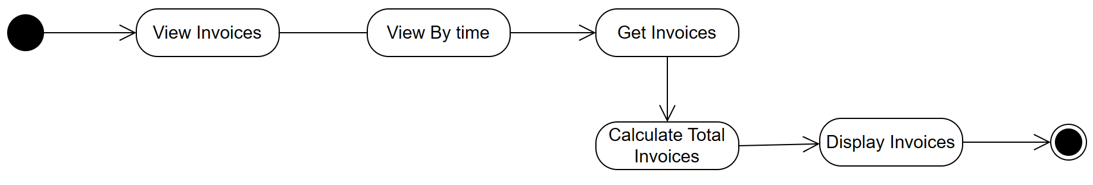

Figure 2.1.5.6 Activity diagram View invoices history

2.1.5.7 Account authentication

|  |  |  |
| --- | --- | --- |
| No. | Activity statement | Action |
| 1 | The customer (the member) is requested to enter email and the password (default: validation code). | Display sign in form  Authenticate |
| 2 | The customer who is not a member needs to enter a personal email. The system sends the validation code to that email. The customer enters the code that was sent to the form. Then choose Sign Up to become a member of the restaurant. The system displays a success notification and displays the menu. | Display sign up form  Send validation code  Authenticate |
| 3 | The customer chooses Sign Up function before providing all mandatory information. | Display sign up form |

Table 2.1.5.7 System actions for activity Account authentication

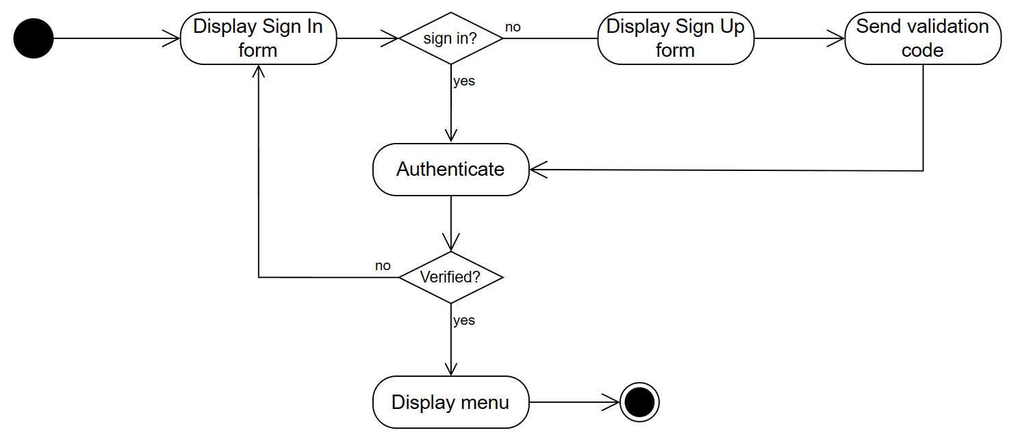

Figure 2.1.5.7 Activity diagram Account authentication

2.1.5.8 Read orders

|  |  |  |
| --- | --- | --- |
| No. | Activity statement | Action |
| 1 | The system sends the customer’s order (including food items, quantities, and notes). | Get customer orders |

Table 2.1.5.8 System actions for activity Read orders

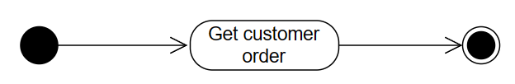

Figure 2.1.5.8 Activity diagram Read orders

2.1.5.8 Mark orders as completed

|  |  |  |
| --- | --- | --- |
| No. | Activity statement | Action |
| 1 | The chef chooses the Complete Order function | Set orders completed |
| 2 | The system sends a notification on the screen (customer/ waitress/ manager) | Send notifications |

Table 2.1.5.9 System actions for activity Mark order as completed

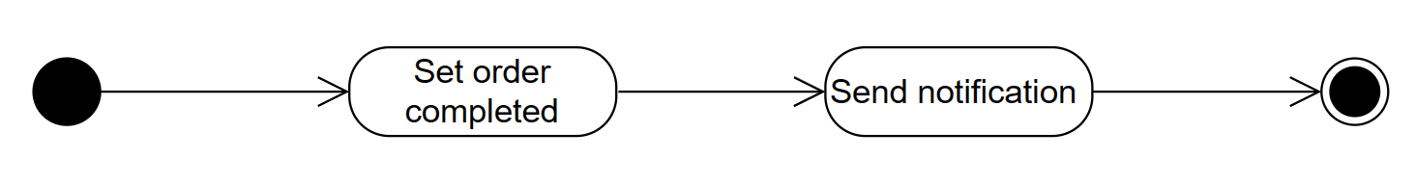

Figure 2.1.5.9 Activity diagram Mark order as completed

2.1.5.9 Manage menu

|  |  |  |
| --- | --- | --- |
| No. | Activity statement | Action |
| 1 | The chef enables an item. | Enable items |
| 2 | The chef disables an item | Disable items |

Table 2.1.5.10 System actions for activity Manage menu

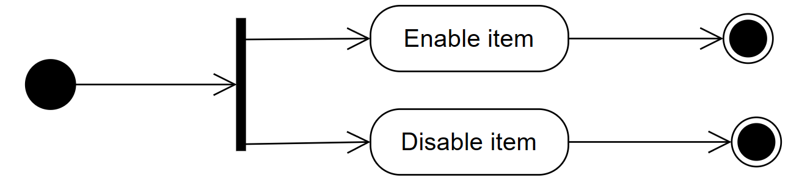

Figure 2.1.5.10 Activity diagram Manage menu

2.1.6 Class diagram

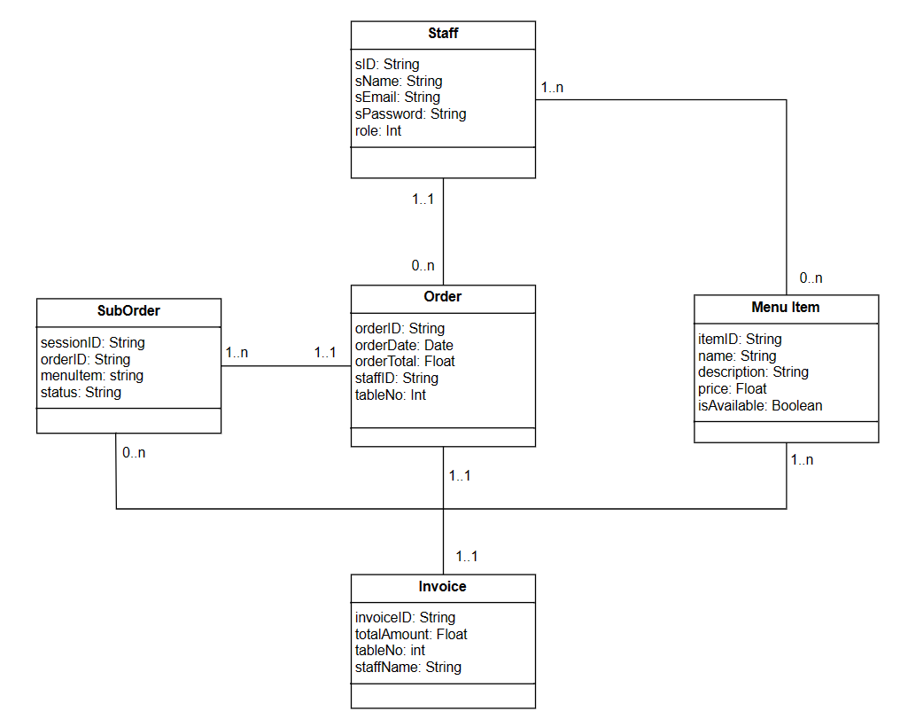

Figure 2.1.6 Class Diagram for Customer Order Management Subsystem

2.2 System design

2.2.1 Entity Relationship Diagram

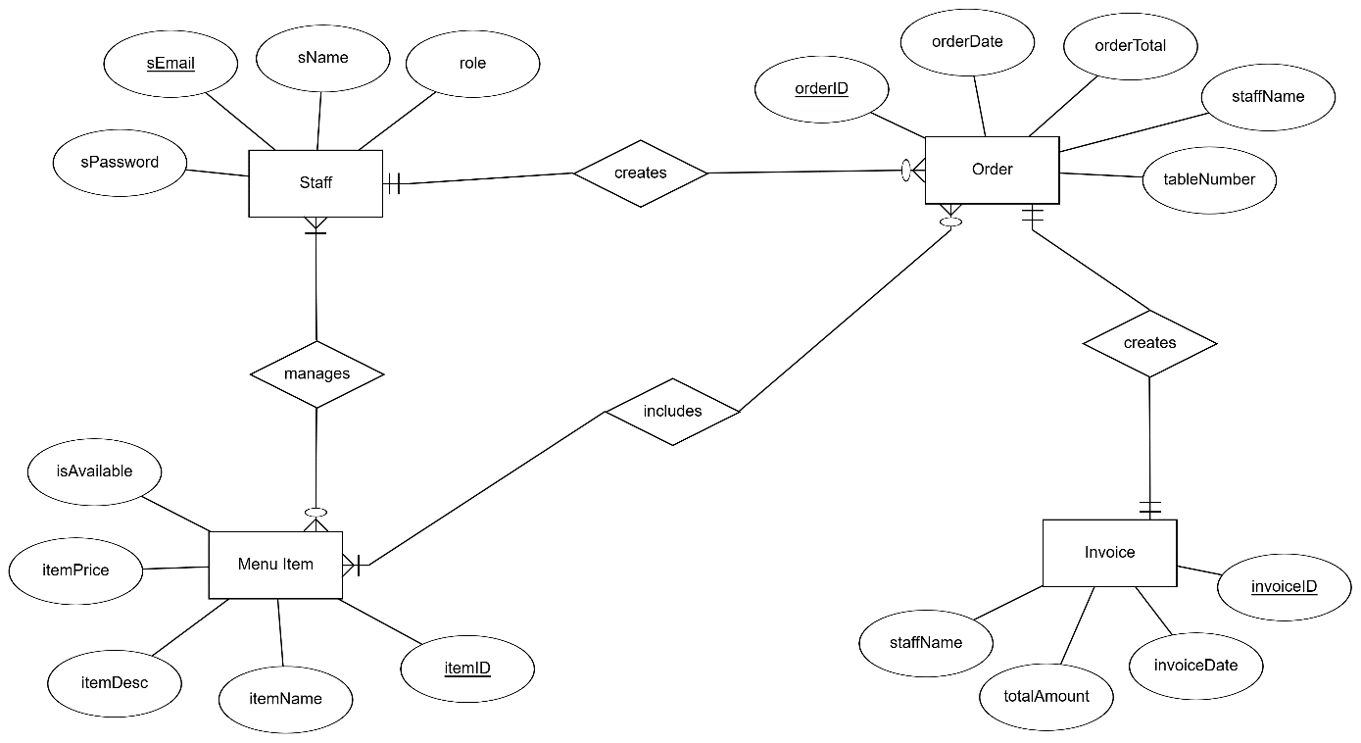

Figure 2.2.1 Entity Relationship Diagram for Customer Order Management Subsystem

2.2.2 Services functionalities

|  |  |
| --- | --- |
| Service | Functionalities |
| Authenticate Service | - Staff authentication.  - Managing access permission. |
| Order service | - Create an order.  - Take an order.  - Notifying Kitchen service for new orders.  - Managing SubOrder and linking them to orders. |
| Kitchen service | - Receiving notifications of new orders from Order service.  - Managing the status of SubOrders (preparing, completed). |
| Menu service | - Managing the availability of menu items. |
| Invoice service | - Generating and managing invoices for orders. |

Table 2.2.2 System services and functionalities

2.2.3 APIs

|  |  |  |  |  |
| --- | --- | --- | --- | --- |
| **Service** | **API** | **Description** | **Input** | **Output** |
| Authenticate service | Sign in | Authenticate staff by checking login credentials. | Staff ID, Password | Status |
| Order service | Create new orders | Create a new order when a customer comes | Staff ID, Table Number | Order |
|  | Record items | Record menu items | Item ID, Order ID | SubOrder |
| Kitchen service | Mark orders | Mark SubOrder as completed preparation. | Session ID | SubOrder Status |
| Invoice service | Create invoices | Generate invoices | Order | Invoice |
|  | Get invoices | View invoices | Time | List of invoices |
| Menu service | Manage menu | Manage menu items | ItemID | Status |

Table 2.2.3 APIs for Customer Order Management Subsystem

2.2.4 Databases

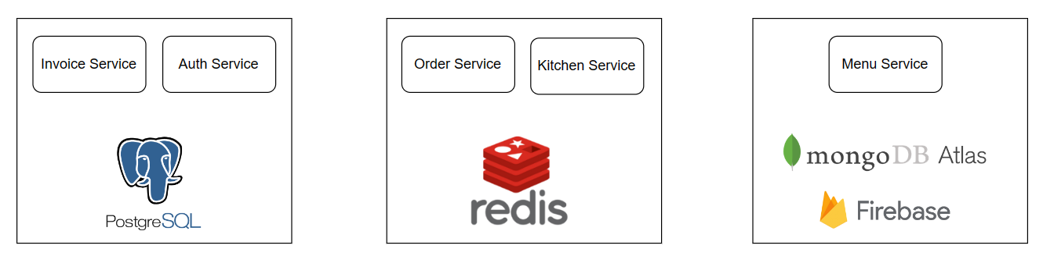

Figure 2.2.4 Databases for services

CHAPTER 3 – IMPLEMENTATION

# CHAPTER 4 – EPLOYMENT

# CHAPTER 5 – CONCLUSION

# REFERENCES

**Vietnamese**

**English**