VIETNAM GENERAL CONFEDERATION OF LABOUR

**TON DUC THANG UNIVERSITY**

**FACULTY OF INFORMATION TECHNOLOGY**



**NGUYỄN ĐÌNH VIỆT HOÀNG – 522H0120**

**NGUYỄN ĐỖ GIA HÒA – 520H0633**

**RETRIEVING THE TIME FROM THE PHOTO OF A CLOCK**

**FINAL REPORT**

**INTRODUCTION TO**

**DIGITAL IMAGE PROCESSING**

**HO CHI MINH CITY, YEAR 2024**

VIETNAM GENERAL CONFEDERATION OF LABOUR

**TON DUC THANG UNIVERSITY**

**FACULTY OF INFORMATION TECHNOLOGY**



**NGUYỄN ĐÌNH VIỆT HOÀNG – 522H0120**

**NGUYỄN ĐỖ GIA HÒA – 520H0633**

**RETRIEVING THE TIME FROM THE PHOTO OF A CLOCK**

**FINAL REPORT**

**INTRODUCTION TO**

**DIGITAL IMAGE PROCESSING**

Instructor

**Mr. Trịnh Hùng Cường**

**HO CHI MINH CITY, YEAR 2024**

**ACKNOWLEDGEMENT**

We sincerely thank Mr. Trịnh Hùng Cường for teaching us the Introduction to Digital Image Processing course with great enthusiasm. We want to express our deep appreciation for the dedication and professional knowledge that you shared with us. Through your classes, we gained a better understanding of the fundamental aspects of the Introduction to Digital Image Processing, thanks to your detailed explanations and practical applications. You helped us grasp the knowledge and apply it effectively. Finally, we extend our heartfelt gratitude to Mr. Trịnh Hùng Cường for your commitment and invaluable support throughout our learning journey in this course. The skills and knowledge we acquired will continue to impact our future development. We sincerely thank you and wish your health, success, and happiness.

*Ho Chi Minh City, June 4, 2024*

*Authors:*

*Nguyễn Đình Việt Hoàng*

*Nguyễn Đỗ Gia Hòa*

**DECLARATION OF AUTHORSHIP**

Our group assures that this is our own report and was guided by Mr. Trịnh Hùng Cường. The research content and results in this report are honest and have not been published in any form before. The figures in the tables used for analysis, comments, and evaluations were collected by the authors from various sources clearly stated in the reference section.

Additionally, the report includes some comments, evaluations, and data from other authors and organizations, all of which are cited and noted for their origin.

**If any fraud is detected, we fully take responsibility for the content of our final report for the second semester of the 2023-2024 academic year.** Ton Duc Thang University is not involved in any copyright or intellectual property violations that we may cause during the process (if any).

*Ho Chi Minh City, June 4, 2024*

*Authors:*

*Nguyễn Đình Việt Hoàng*

*Nguyễn Đỗ Gia Hòa*

**RETRIEVING THE TIME**

**FROM THE PHOTO OF A CLOCK**

**ABSTRACT**

This study presents a comprehensive method for retrieving the time from photos of analog clocks using image processing techniques. The approach involves several key steps: image preprocessing, clock detection, hand detection, time calculation, and visualization.

In image preprocessing, the images are resized to a standard size, converted to HSV color space, inverted, and enhanced using Contrast Limited Adaptive Histogram Equalization (CLAHE). Otsu's thresholding and Gaussian blur are then applied to prepare the images for feature detection. For clock detection, the Hough Circle Transform is employed to identify the clock face, with a fallback to contour detection if circle detection is unsuccessful. Hand detection is achieved through the Hough Line Transform, with detected lines grouped by angle and proximity to identify the hour, minute, and second hands based on their length and thickness.

The time is calculated by determining the angles of the detected hands relative to the 12 o’clock position and converting these angles into time. Visualization includes drawing rectangular frames around each detected hand and overlaying the calculated time on the image.

Experimental validation involved processing a dataset of 10 images of analog wall clocks with varying designs and times, ensuring non-coinciding hands and time differences of 1-2 hours between photos. The results include processed images with frames around the detected hands and the displayed time in HH:MM:SS format. The effectiveness of the method is demonstrated through these output images, showcasing the accurate detection and time retrieval capabilities of the proposed approach.

**INSTRUCTOR RUBRIC**

Supervisor’s Name: ……………………………………………………………..............

Comments: ……………………………………………………………………………...

Total Score Based on Rubric Evaluation: ………………………………………………

*Ho Chi Minh City, date … month … year …*

*Supervisor*

*(sign and write your full name)*

**TABLE OF CONTENTS**

LIST OF FIGURES ix

CHAPTER 1. SOLVING METHODS 1

CHAPTER 2. EXPERIMENTAL STEPS AND RESULTS 3

REFERENCES 24

# LIST OF FIGURES

Figure 1.1: The first input image 4

Figure 1.2: The second input image 5

Figure 1.3: The third input image 6

Figure 1.4: The fourth input image 7

Figure 1.5: The fifth input image 8

Figure 1.6: The sixth input image 9

Figure 1.7: The seventh input image 10

Figure 1.8: The eighth input image 11

Figure 1.9: The nineth input image 12

Figure 1.10: The tenth input image 13

Figure 2.1: The first output image 14

Figure 2.2: The second output image 15

Figure 2.3: The third output image 16

Figure 2.4: The fourth output image 17

Figure 2.5: The fifth output image 18

Figure 2.6: The sixth output image 19

Figure 2.7: The seventh output image 20

Figure 2.8: The eighth output image 21

Figure 2.9: The nineth output image 22

Figure 2.10: The tenth output image 23

CHAPTER 1. SOLVING METHODS

1. **Image Preprocessing**:
   * **Resizing**: Resize the images to a standard size to ensure consistent processing.
   * **Color Conversion**: Convert images to HSV color space and invert them.
   * **Contrast Enhancement**: Apply CLAHE to enhance contrast in the images.
   * **Thresholding and Blurring**: Apply Otsu's thresholding and Gaussian blur to prepare the image for feature detection.
2. **Clock Detection**:
   * **Circle Detection**: Use the Hough Circle Transform to detect the clock face.
   * **Contour Detection**: If circle detection fails, fallback to contour detection to find the largest contour (assumed to be the clock face).
3. **Hand Detection**:
   * **Line Detection**: Use the Hough Line Transform to detect lines (potential clock hands).
   * **Grouping Lines**: Group detected lines by angle and proximity.
   * **Identify Hands**: Determine which lines correspond to the hour, minute, and second hands based on their length and thickness.
4. **Time Calculation**:
   * **Angle Calculation**: Calculate the angles of the detected hands relative to the vertical (12 o’clock) position.
   * **Time Conversion**: Convert these angles into time (HH:MM:SS).
5. **Visualization**:
   * **Draw Rectangles**: Draw rectangular frames around each detected hand.
   * **Display Time**: Overlay the calculated time on the image.

CHAPTER 2. EXPERIMENTAL STEPS AND RESULTS

1. **Experimental Steps:**
   * Step 1: Prepare the dataset:
     + Collect at least 10 photos containing analog wall clocks with varying designs and times.
     + Ensure the clock hands are not coinciding and times differ by 1-2 hours between photos.
   * Step 2: Setup the environment:
     + Install necessary libraries (e.g., OpenCV, NumPy).
     + Create folders input for input images and output for processed images.
   * Step 3: Run the code:
     + Execute the provided code on the dataset.
     + The code will process each image, detect the clock hands, determine the time, draw frames, and save the results in the output folder, which will be automatically created if it does not already exist.

Here are 10 input images:

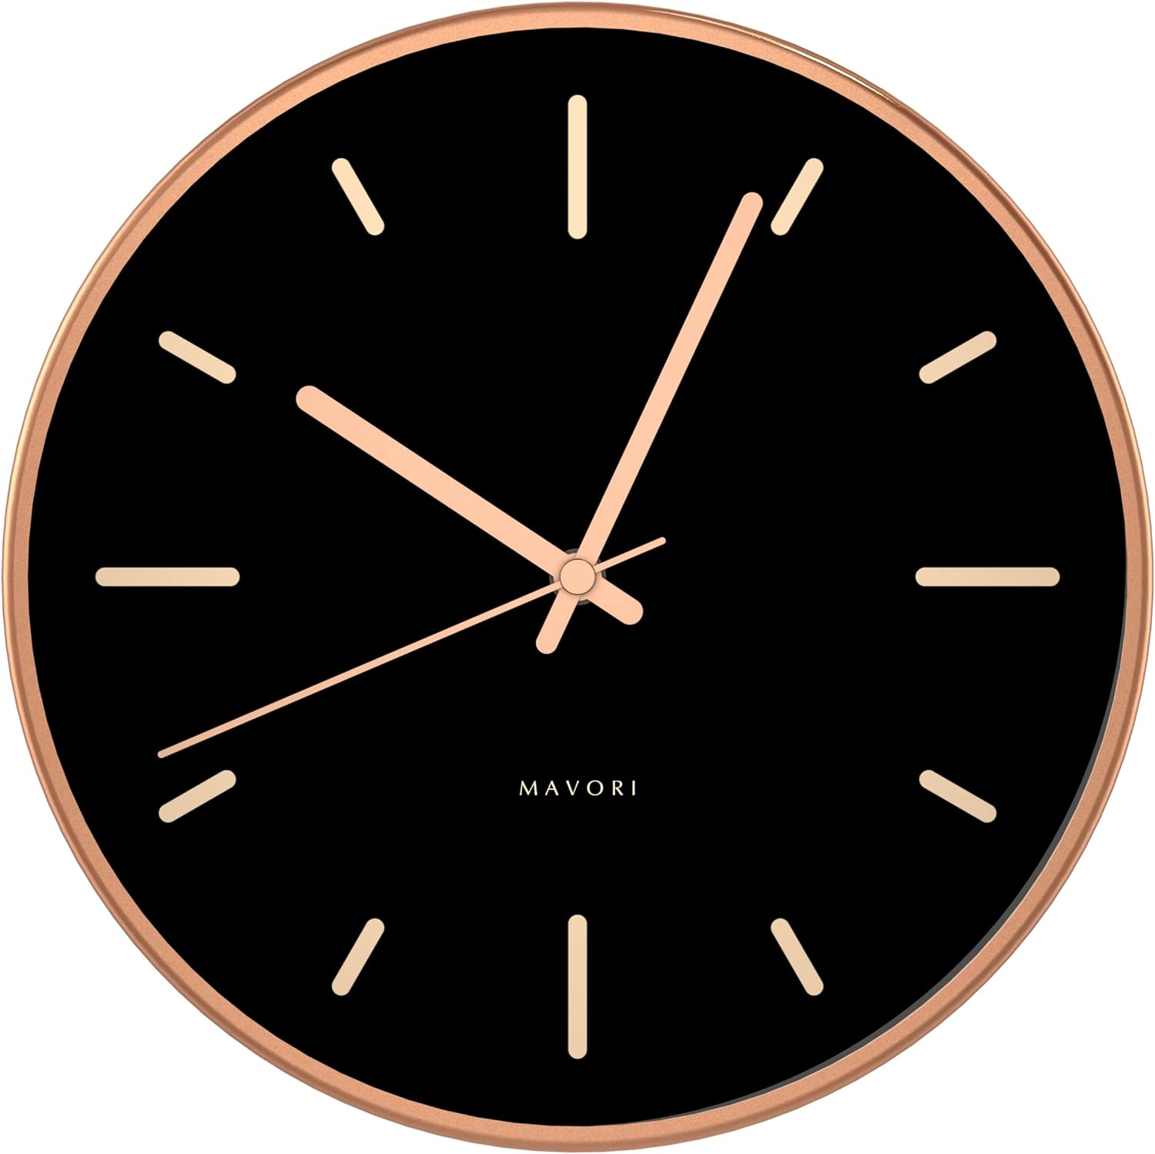

##### Figure 1.1: The first input image

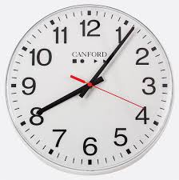

##### Figure 1.2: The second input image

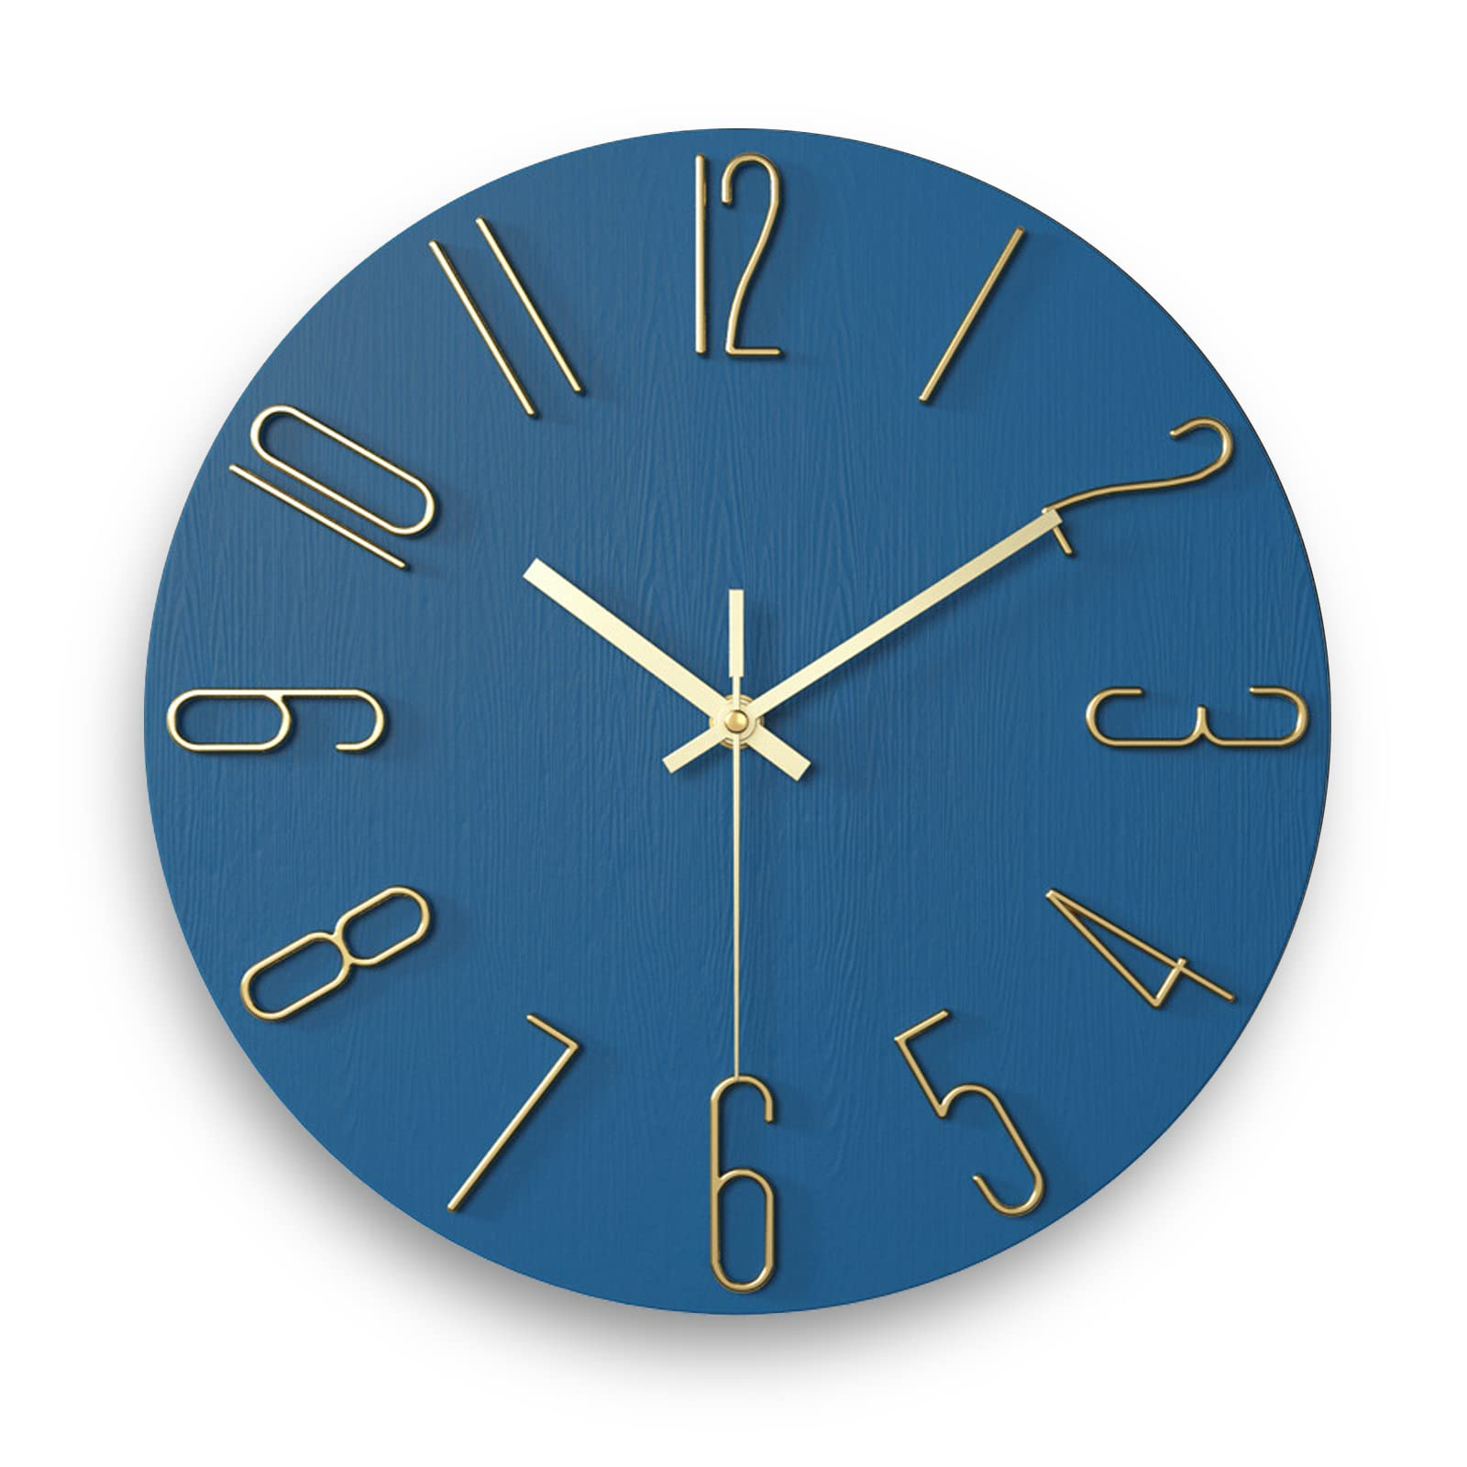

##### Figure 1.3: The third input image

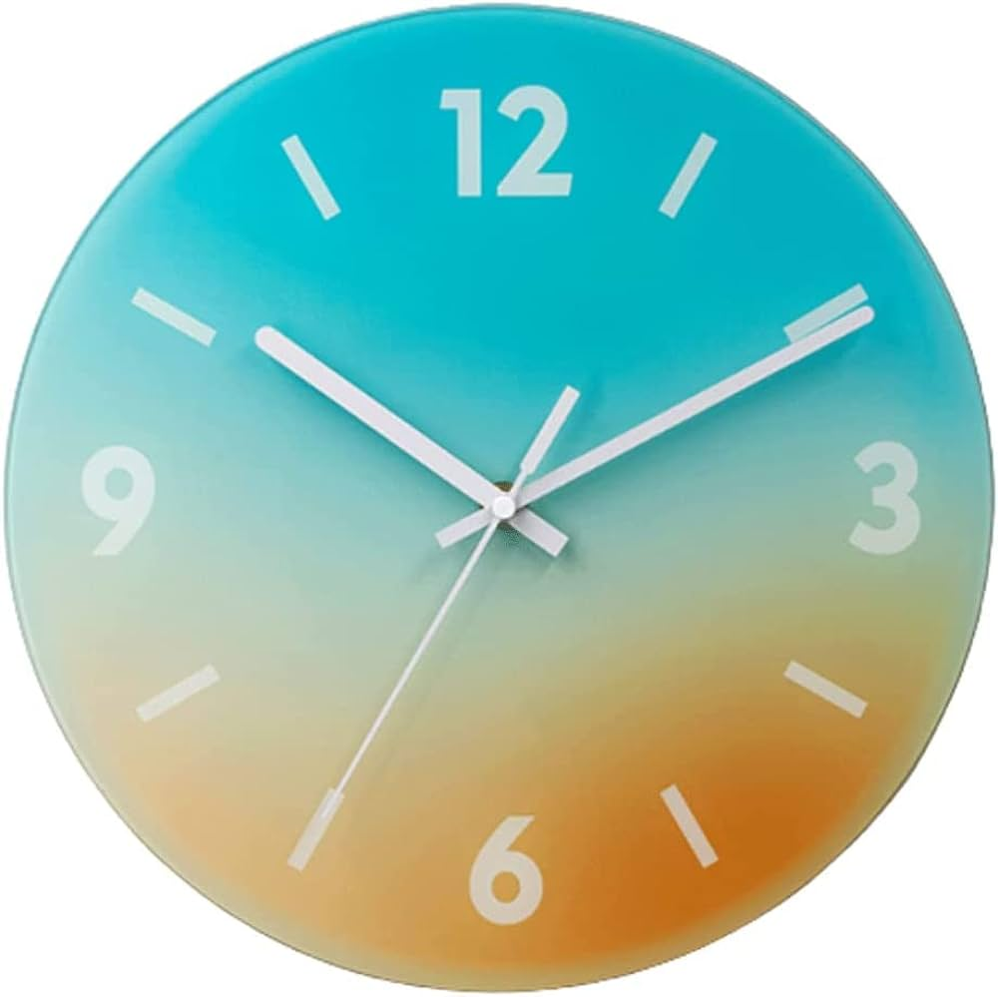

##### Figure 1.4: The fourth input image

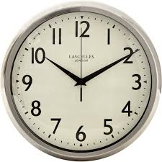

##### Figure 1.5: The fifth input image

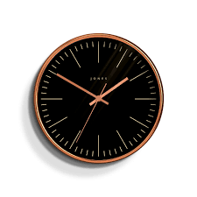

##### Figure 1.6: The sixth input image

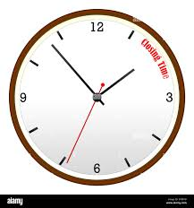

##### Figure 1.7: The seventh input image

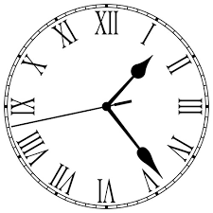

##### Figure 1.8: The eighth input image

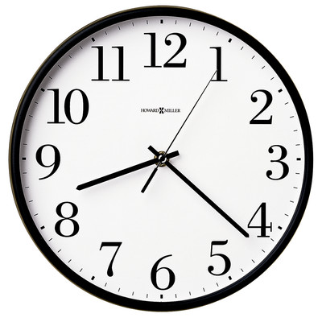

##### Figure 1.9: The nineth input image

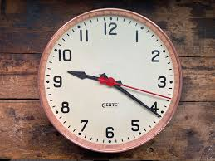

##### Figure 1.10: The tenth input image

1. **Results:**
   * The output includes:
     + Processed Images: Each image will have rectangular frames drawn around the hour, minute, and second hands, labeled accordingly.
     + Time Display: Each image will display the calculated time in the format HH:MM:SS.

Here are 10 output images generated by running the code:

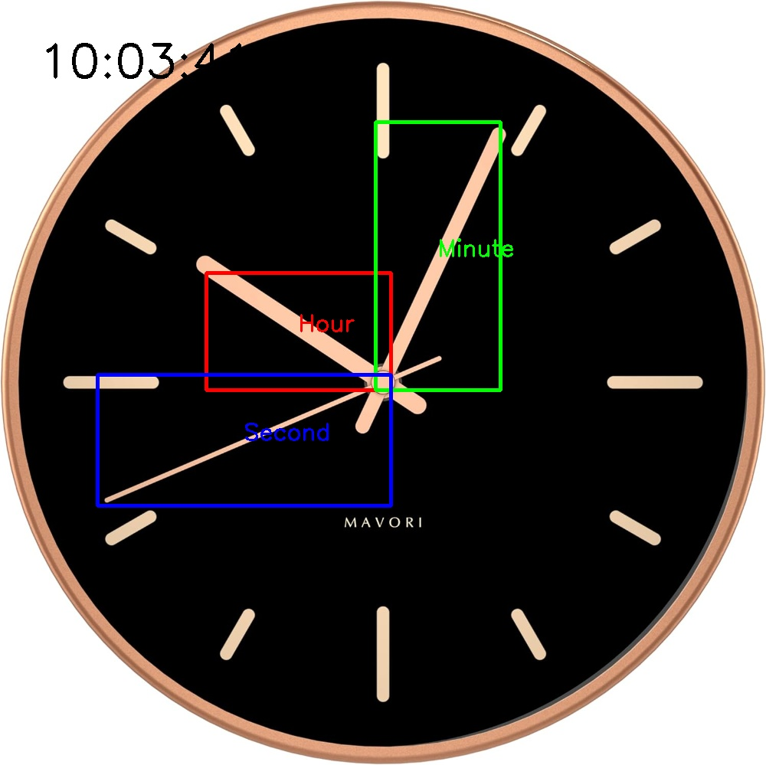

##### Figure 2.1: The first output image

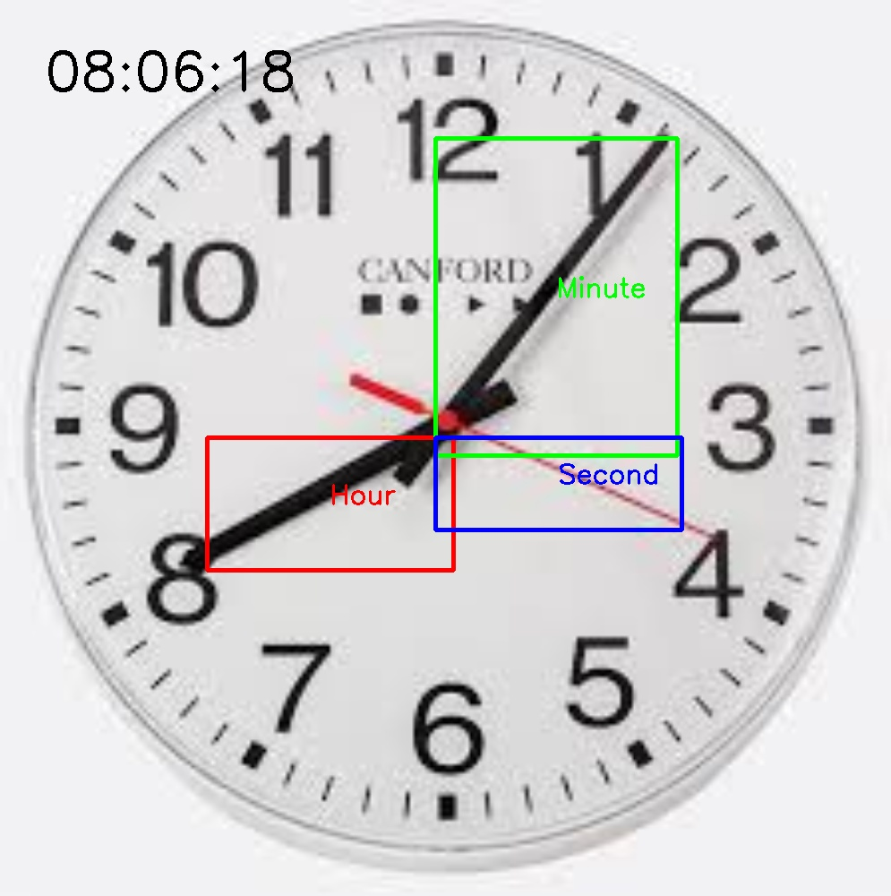

##### Figure 2.2: The second output image

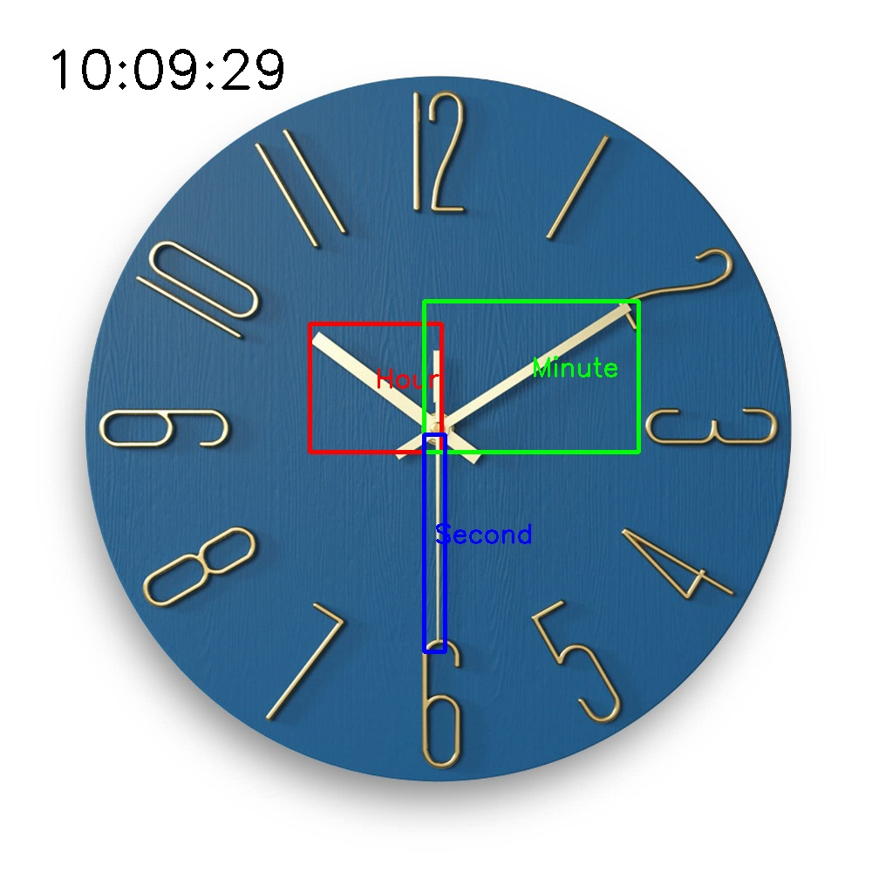

##### Figure 2.3: The third output image

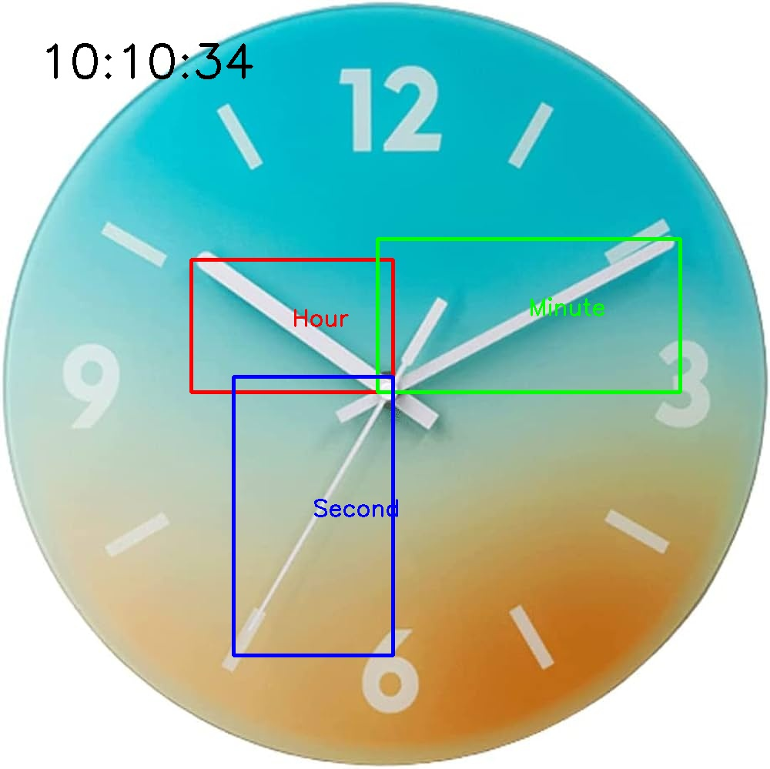

##### Figure 2.4: The fourth output image

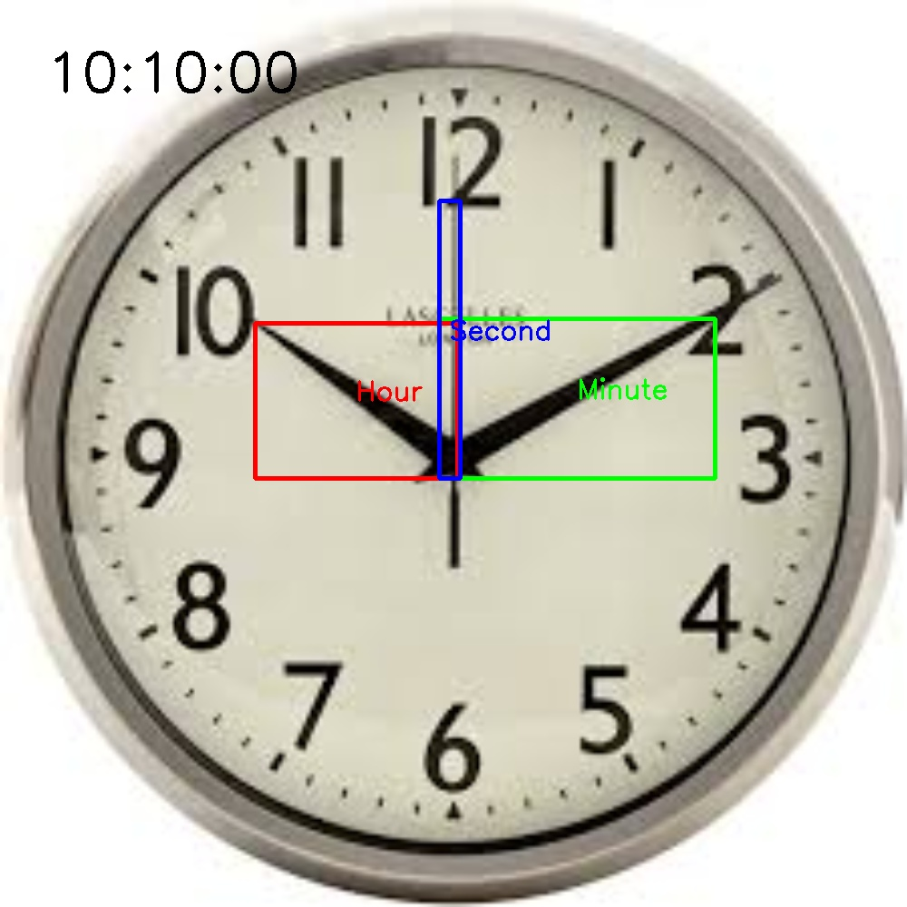

##### Figure 2.5: The fifth output image

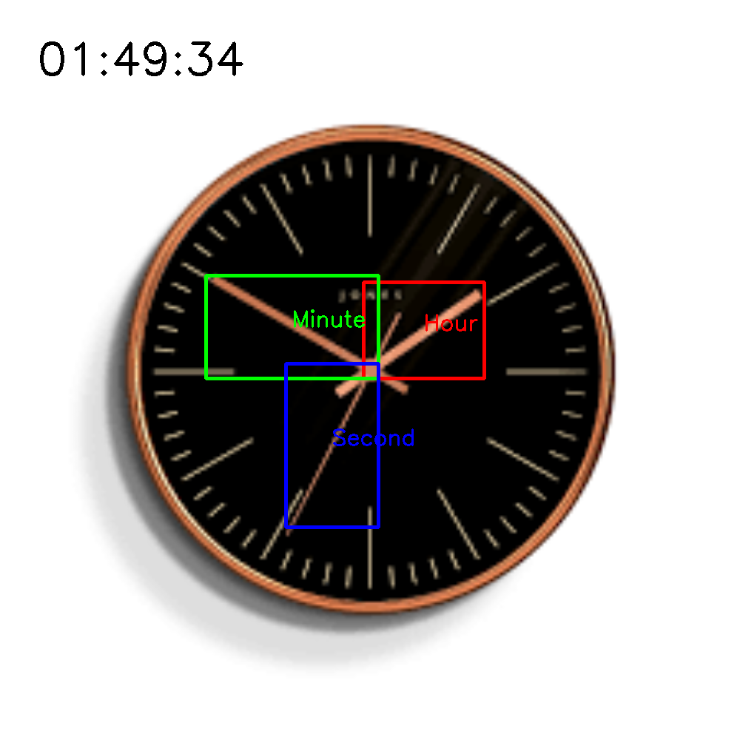

##### Figure 2.6: The sixth output image

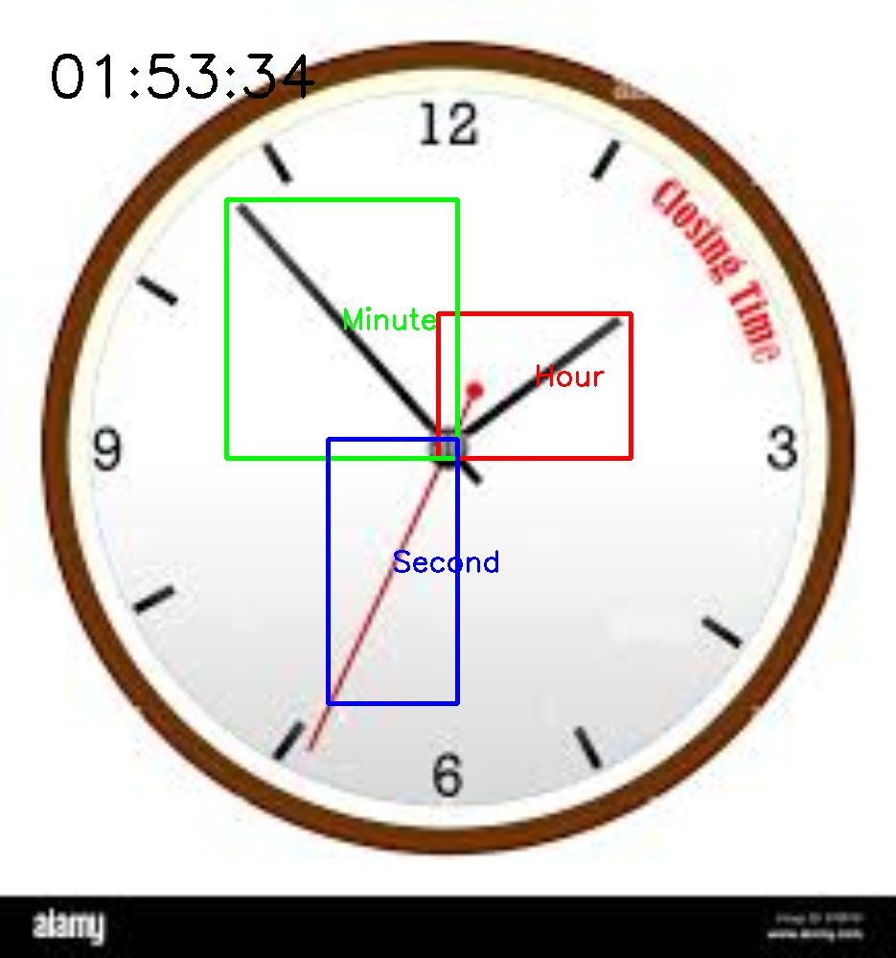

##### Figure 2.7: The seventh output image

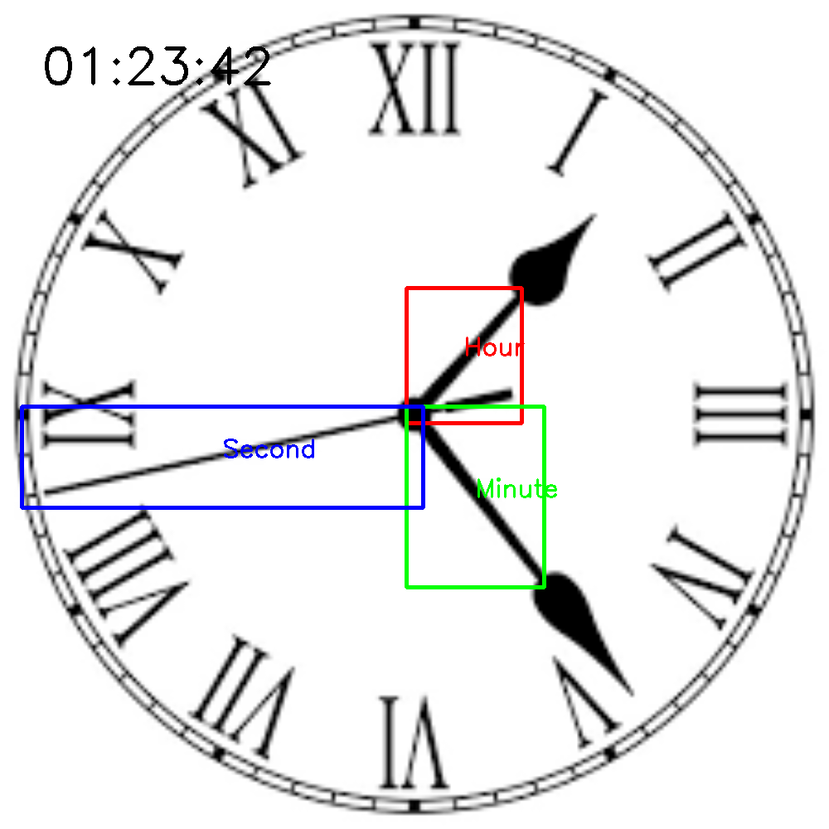

##### Figure 2.8: The eighth output image

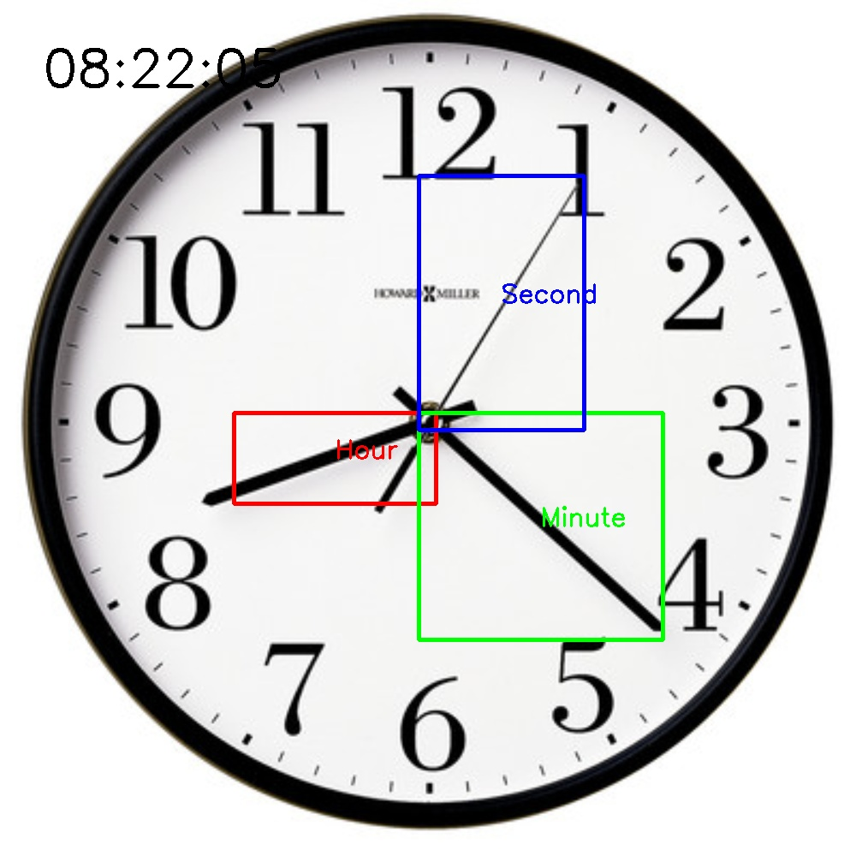

##### Figure 2.9: The nineth output image

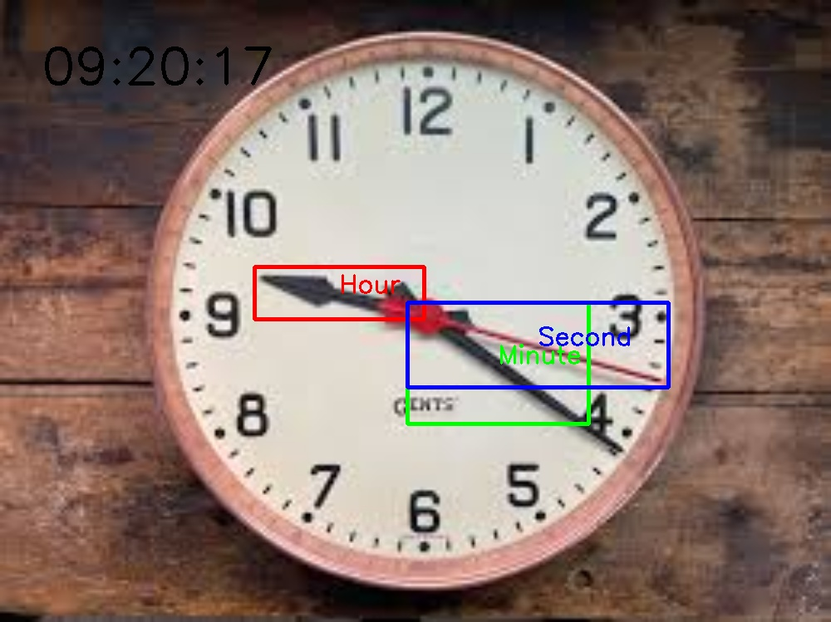

##### Figure 2.10: The tenth output image

# REFERENCES

[1] R. C. Gonzalez and R. E. Woods, Digital Image Processing, 4th ed. Upper Saddle River, NJ, USA: Pearson, 2018.

[2] G. Bradski and A. Kaehler, Learning OpenCV: Computer Vision with the OpenCV Library, 1st ed. Sebastopol, CA, USA: O'Reilly Media, 2008.

[3] J. Canny, "A Computational Approach to Edge Detection," IEEE Transactions on Pattern Analysis and Machine Intelligence, vol. PAMI-8, no. 6, pp. 679-698, Nov. 1986.

[4] P. Viola and M. Jones, "Rapid Object Detection using a Boosted Cascade of Simple Features," in Proc. 2001 IEEE Computer Society Conference on Computer Vision and Pattern Recognition (CVPR 2001), Kauai, HI, USA, 2001, pp. I-511-I-518.

[5] D. G. Lowe, "Distinctive Image Features from Scale-Invariant Keypoints," International Journal of Computer Vision, vol. 60, no. 2, pp. 91-110, Nov. 2004.

[6] N. Dalal and B. Triggs, "Histograms of Oriented Gradients for Human Detection," in Proc. 2005 IEEE Computer Society Conference on Computer Vision and Pattern Recognition (CVPR 2005), San Diego, CA, USA, 2005, pp. 886-893.

[7] T. Ojala, M. Pietikäinen, and T. Mäenpää, "Multiresolution Gray-Scale and Rotation Invariant Texture Classification with Local Binary Patterns," IEEE Transactions on Pattern Analysis and Machine Intelligence, vol. 24, no. 7, pp. 971-987, July 2002.

[8] N. Otsu, "A Threshold Selection Method from Gray-Level Histograms," IEEE Transactions on Systems, Man, and Cybernetics, vol. 9, no. 1, pp. 62-66, Jan. 1979.

[9] R. M. Haralick, K. Shanmugam, and I. Dinstein, "Textural Features for Image Classification," IEEE Transactions on Systems, Man, and Cybernetics, vol. SMC-3, no. 6, pp. 610-621, Nov. 1973.

[10] C. Tomasi and R. Manduchi, "Bilateral Filtering for Gray and Color Images," in Proc. 1998 IEEE International Conference on Computer Vision (ICCV 1998), Bombay, India, 1998, pp. 839-846.