1. **COMPARE DEEP LEARNING AND TRADITIONAL MACHINE LEARNING**

Deep Learning (DL) and Traditional Machine Learning (ML) are both branches of artificial intelligence (AI), but they differ in characteristics and methods. Below are the key features of Deep Learning and a comparison between Deep Learning and Traditional Machine Learning.

* + **Key Features of Deep Learning**
    1. **Multi-Layered Neural Networks:**
* Utilizes neural networks with many layers (deep neural networks), often including tens or hundreds of layers.
* These layers learn increasingly abstract and complex data representations.
  + 1. **Automated Feature Extraction:**
* Ability to automatically extract features from raw data without human intervention.
* Particularly useful in fields like image recognition, natural language processing, and audio.
  + 1. **Scalability:**
* Effective when working with large datasets.
* Performance improves with more data and computational resources.
  + 1. **High Computational Power Requirement:**
* Requires significant computational resources, often using GPUs (Graphics Processing Units) or TPUs (Tensor Processing Units) to speed up processing.
  + 1. **End-to-End Learning:**
* Capable of learning directly from input to output, minimizing the need for preprocessing and feature extraction steps.
  + 1. **Complex Model Structures:**
* Uses complex models like CNNs (Convolutional Neural Networks) for image processing and RNNs (Recurrent Neural Networks) for sequential data.
  + **Comparison Between Deep Learning and Traditional Machine Learning**

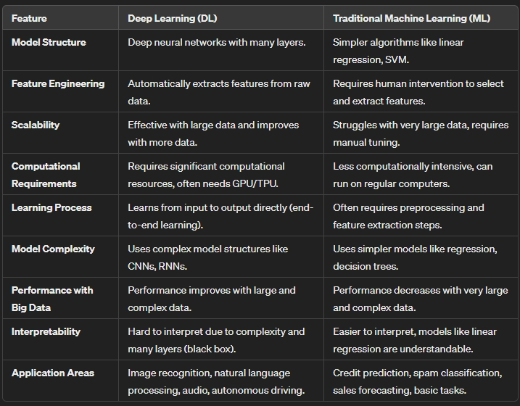

**-> Summary:**

**- Deep Learning** is a powerful choice for complex problems that require automatic feature extraction, especially when large data and computational resources are available. However, it requires significant resources and is more complex in terms of model structure and result interpretation.

**- Traditional Machine Learning** remains useful for simpler problems, with smaller datasets, and when clear interpretation of model decisions is needed.

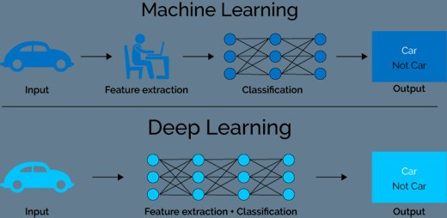

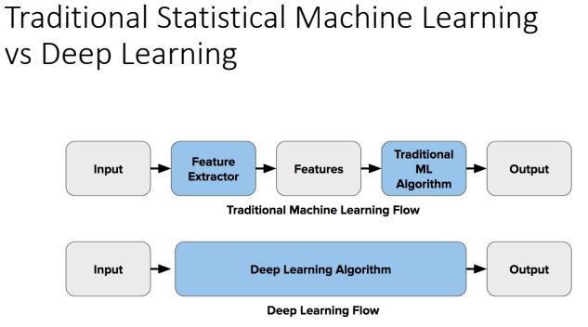

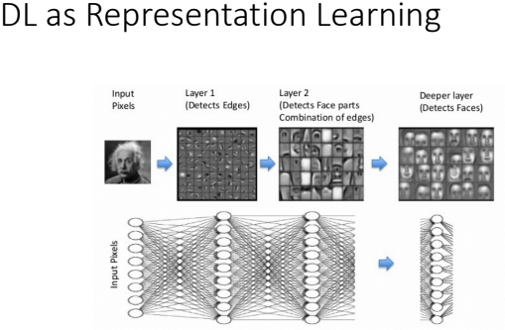

1. **THE REASON WHY DEEP LEARNING IS GOOD FOR CNN AND LSTM**

Deep Learning is particularly well-suited for Convolutional Neural Networks (CNNs) and Long Short-Term Memory networks (LSTMs) due to its ability to automatically learn hierarchical features and capture complex patterns in data. Here’s why Deep Learning excels in these areas:

**Convolutional Neural Networks (CNNs)**

**1/ Hierarchical Feature Learning:**

* **Automatic Feature Extraction:** CNNs automatically learn to extract spatial hierarchies of features from input images. Early layers capture simple patterns such as edges and textures, while deeper layers capture more complex structures such as shapes and objects.
* **Reduced Need for Manual Feature Engineering:** Unlike traditional methods, CNNs do not require hand-crafted features. This reduces the workload on data scientists and allows the model to learn optimal features directly from the data.

**2/ Spatial Invariance:**

* **Translation Invariance:** Through the use of convolutional layers, pooling layers, and weight sharing, CNNs can recognize objects in images regardless of their position. This makes them highly effective for tasks like image classification and object detection.

**3/ Parameter Efficiency:**

* **Weight Sharing:** CNNs use the same filter (kernel) across different parts of the input, which reduces the number of parameters compared to fully connected networks, making the model more efficient and less prone to overfitting.

**4/ Deep Architectures:**

* **Multiple Layers:** CNNs can have many layers, allowing them to learn a wide range of features at different levels of abstraction. This deep architecture enables the network to model complex relationships in the data.

**Long Short-Term Memory Networks (LSTMs)**

**1/ Sequential Data Handling:**

* **Temporal Dependencies:** LSTMs are designed to handle sequential data and capture long-term dependencies. This makes them ideal for tasks where the order of data points matters, such as time series forecasting, speech recognition, and natural language processing.

**2/ Overcoming the Vanishing Gradient Problem:**

* **Memory Cells and Gates:** LSTMs have a unique architecture with memory cells and gating mechanisms (input gate, forget gate, output gate) that allow them to maintain and update information over long sequences. This helps in preserving gradients during backpropagation, addressing the vanishing gradient problem common in traditional RNNs (Recurrent Neural Networks).

**3/ Learning Long-Term Dependencies:**

* **Effective at Capturing Context:** LSTMs can learn dependencies over long sequences, making them effective at understanding context in tasks like language modeling, machine translation, and video analysis.

**4/ Flexibility:**

* **Versatile Applications:** LSTMs can be applied to various sequential data types, including text, speech, and even video, making them a versatile tool for a wide range of applications.

1. **COMPARE STRUCTURED DATA AND UNSTRUCTURED DATA**

*I/ Structured Data*

1. Definition:

* Format: Structured data is highly organized and formatted in a way that is easily searchable and analyzable. It is often stored in tabular form, such as databases or spreadsheets.
* Schema: It follows a predefined schema, meaning the data is organized into rows and columns with specific data types assigned to each column (e.g., integer, string, date).

2. Examples:

* Databases: Relational databases like SQL databases.
* Spreadsheets: Excel files or CSV (Comma Separated Values) files.
* ERP Systems: Data from Enterprise Resource Planning systems.

3. Ease of Analysis:

* Querying: Structured data can be easily queried using SQL or other query languages.
* Storage: It is typically stored in data warehouses, making it straightforward to retrieve and analyze.
* Processing: Data processing tools and techniques (e.g., data mining, machine learning algorithms) are well-established for structured data.

4. Uses:

* Business Intelligence: Reporting and dashboarding for sales, finance, and operations.
* Data Analytics: Statistical analysis, machine learning on numeric and categorical data.

*II/ Unstructured Data*

1. Definition:

* Format: Unstructured data does not have a predefined data model or schema. It includes a wide variety of formats such as text, images, audio, and video.
* Organization: It is not organized in a tabular format and often requires significant preprocessing before analysis.

2. Examples:

* Text Data: Emails, social media posts, documents.
* Multimedia: Images, audio recordings, videos.
* Web Content: Web pages, blog posts.

3. Ease of Analysis:

* Complexity: Analyzing unstructured data is more complex and requires advanced techniques such as natural language processing (NLP) for text analysis and computer vision for image and video analysis.
* Storage: Often stored in data lakes or NoSQL databases, which are designed to handle large volumes of unstructured data.
* Processing: Requires specialized tools and frameworks (e.g., Hadoop, Spark) and techniques (e.g., deep learning, machine learning) to process and analyze.

4. Uses:

* Sentiment Analysis: Understanding customer sentiments from social media and reviews.
* Content Recommendation: Recommending products or content based on user preferences and behaviors.
* Multimedia Analysis: Face recognition in images and videos, speech-to-text conversion in audio files.

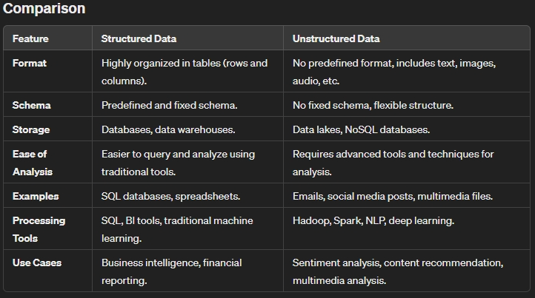

* **Summary:**
* **Structured Data** is easy to organize, store, and analyze due to its predefined schema and tabular format. It is ideal for traditional data processing and analysis tasks.
* **Unstructured Data** is more flexible and encompasses a wide variety of formats but is more challenging to process and analyze. It requires advanced techniques and tools to extract meaningful information.

1. **HISTORY OF DEEP LEARNING**

The history of Deep Learning (DL) is a fascinating journey that spans several decades, marked by periods of intense innovation, setbacks, and significant breakthroughs. Here’s an overview of the key milestones in the development of Deep Learning:

Early Foundations (1940s-1960s)

1943: Warren McCulloch and Walter Pitts proposed the first mathematical model of a neuron, known as the McCulloch-Pitts neuron, laying the groundwork for neural networks.

1950s: The development of the first artificial neural network concepts, including the Perceptron, introduced by Frank Rosenblatt in 1958. The Perceptron was capable of learning and making simple decisions based on input data.

Neural Networks and the AI Winter (1970s-1980s)

1960s-1970s: Early enthusiasm for neural networks faced challenges due to computational limitations and theoretical issues. The XOR problem, which a single-layer Perceptron couldn’t solve, highlighted the need for multi-layer networks.

1980s:

* Backpropagation Algorithm: The rediscovery and popularization of the backpropagation algorithm by Geoffrey Hinton, David Rumelhart, and Ronald Williams in 1986 was a major breakthrough. This algorithm allowed multi-layer neural networks to be trained more effectively.
* Neural Network Renaissance: Renewed interest in neural networks led to the exploration of deeper architectures, although computational power was still a limiting factor.

Emergence of Deep Learning (1990s-2000s)

1990s: Development of more sophisticated neural network architectures and learning algorithms. Yann LeCun’s work on Convolutional Neural Networks (CNNs) demonstrated their effectiveness in image recognition tasks.

2000s:

* Recurrent Neural Networks (RNNs): Sepp Hochreiter and Jürgen Schmidhuber introduced Long Short-Term Memory (LSTM) networks in 1997, solving some issues with traditional RNNs and enabling better performance on sequential data.
* Computational Advances: Improvements in hardware, particularly GPUs, made training deeper networks feasible.

Deep Learning Breakthroughs (2010s)

2010s:

* AlexNet: In 2012, Alex Krizhevsky, Ilya Sutskever, and Geoffrey Hinton’s AlexNet won the ImageNet Large Scale Visual Recognition Challenge (ILSVRC) by a significant margin. This success highlighted the power of deep CNNs and GPUs.
* DeepMind and AlphaGo: In 2014, Google DeepMind demonstrated deep learning’s potential with the development of AlphaGo, which defeated a professional human Go player in 2015.
* Generative Models: The development of Generative Adversarial Networks (GANs) by Ian Goodfellow and colleagues in 2014 opened new possibilities in generating realistic data.

Recent Advances (2020s)

2020s:

* Transformers and NLP: The transformer architecture, introduced by Vaswani et al. in 2017, revolutionized natural language processing (NLP). Models like BERT (2018) and GPT-3 (2020) demonstrated unprecedented capabilities in language understanding and generation.
* Wide Adoption: Deep learning is now widely used in various fields, including healthcare, autonomous driving, finance, and entertainment. It has become integral to technologies like virtual assistants, recommendation systems, and image and speech recognition.

1. **DEEP LEARNING SHOULD USE GPU THAN CPU**

Deep Learning requires the use of GPUs (Graphics Processing Units) for handling large datasets and high computational tasks due to the following reasons:

**Parallel Processing Capabilities**

* **Massive Parallelism:** GPUs are designed with thousands of cores that can perform many operations simultaneously. This architecture is well-suited for the parallel nature of deep learning tasks, such as matrix multiplications, which are fundamental to neural network training and inference.
* **Efficiency in Handling Large-Scale Data:** Deep learning models, particularly deep neural networks, involve large-scale data and extensive computations. GPUs can process multiple data points concurrently, significantly speeding up the training process.

**High Computational Power**

* **Complex Calculations:** Training deep learning models involves complex mathematical operations that need to be performed repeatedly across large datasets. GPUs excel at handling these computations more efficiently than CPUs (Central Processing Units).
* **Faster Training:** The enhanced computational power of GPUs allows for faster training of deep learning models. This is crucial when dealing with large datasets and deep networks, where training on a CPU would be prohibitively slow.

**Memory Bandwidth**

* **High Memory Bandwidth:** GPUs offer higher memory bandwidth compared to CPUs. This allows them to handle large volumes of data quickly, which is essential for deep learning tasks that require rapid data access and manipulation.
* **Efficient Data Handling:** With higher memory bandwidth, GPUs can more effectively manage the data transfer between the GPU memory and the processing cores, reducing bottlenecks and improving overall training speed.

**Specialized Hardware and Optimizations**

* **Tensor Cores:** Modern GPUs, such as NVIDIA's Volta and Ampere architectures, include Tensor Cores specifically designed to accelerate deep learning workloads. These cores perform operations like matrix multiplications much faster than general-purpose cores.
* **Optimization Libraries:** There are numerous libraries and frameworks optimized for GPU usage, such as CUDA (Compute Unified Device Architecture), cuDNN (CUDA Deep Neural Network library), and TensorFlow, which leverage GPU capabilities to accelerate deep learning tasks.

**Scalability**

* **Distributed Training:** GPUs enable efficient distributed training across multiple devices. Deep learning frameworks support multi-GPU configurations, allowing large models to be split across several GPUs, further speeding up the training process.
* **Handling Larger Models:** With GPUs, it’s possible to train larger models that might not fit into the memory of a single CPU. This scalability is crucial for developing state-of-the-art models in areas like natural language processing and computer vision.

**Energy Efficiency**

* **Power Consumption:** Although GPUs consume significant power, their ability to perform many operations in parallel means they can complete tasks faster than CPUs. This can lead to lower overall energy consumption for large training tasks.

**Practical Examples**

* **Image Processing:** Training Convolutional Neural Networks (CNNs) for image recognition tasks involves a high number of matrix operations, which GPUs handle efficiently.
* **Natural Language Processing:** Models like Transformers, which power state-of-the-art NLP tasks, require substantial computational resources to process and generate language data. GPUs are essential for managing these tasks within a reasonable timeframe.
* **Reinforcement Learning:** Training agents in complex environments, such as those used by DeepMind's AlphaGo, requires extensive simulations and computations that are best handled by GPUs.