VIETNAM GENERAL CONFEDERATION OF LABOUR

**TON DUC THANG UNIVERSITY**

**FACULTY OF INFORMATION TECHNOLOGY**



**TRUONG TRI PHONG - 522H0167**

**VO HOANG TAN - 522H0089**

**DO DUY TAN - 522H0012**

**NGUYEN DINH VIET HOANG - 522H0120**

**ASSIGNMENT REPORT**

**MANAGEMENT OF**

**INFORMATION SYSTEMS**

**HO CHI MINH CITY, YEAR 2024**

VIETNAM GENERAL CONFEDERATION OF LABOUR

**TON DUC THANG UNIVERSITY**

**FACULTY OF INFORMATION TECHNOLOGY**



**TRUONG TRI PHONG - 522H0167**

**VO HOANG TAN - 522H0089**

**DO DUY TAN - 522H0012**

**NGUYEN DINH VIET HOANG - 522H0120**

**ASSIGNMENT REPORT**

**MANAGEMENT OF**

**INFORMATION SYSTEMS**

Advised by

**MsC. HO THI THANH TUYEN**

**HO CHI MINH CITY, YEAR 2024**

**DECLARATION OF AUTHORSHIP**

We hereby declare that this thesis was carried out by ourselves under the guidance and supervision of MsC. Ho Thi Thanh Tuyen; and that the work and the results contained in it are original and have not been submitted anywhere for any previous purposes. The data and figures presented in this thesis are for analysis, comments, and evaluations from various resources by our own work and have been duly acknowledged in the reference part.

In addition, other comments, reviews and data used by other authors, and organizations have been acknowledged, and explicitly cited.

We will take full responsibility for any fraud detected in my thesis. Ton Duc Thang University is unrelated to any copyright infringement caused on my work (if any).

*Ho Chi Minh City, October 30, 2024*

*Authors:*

*Truong Tri Phong*

*Vo Hoang Tan*

*Do Duy Tan*

*Nguyen Dinh Viet Hoang*

**TABLE OF CONTENTS**

TASK 1: PORTERS’ STRATEGIES FOR COMPETITIVE ADVANTAGE 1

a) Which competitive business strategy best describes this enterprise? Explain why. (You should demonstrate understanding of Porter’s Strategies for Competitive Advantage) 1

b) Pick one competitive business strategy from Porter’s Strategies for Competitive Advantage. (Use a different strategy from the one that you discussed in Task 1a). Explain how a competitor could use this strategy in an effort to disrupt Lisa’s business. 1

TASK 2: PORTER’S VALUE CHAIN MODEL 3

a) Which two primary activities of the Value Chain are most important to DMM? Why are they so important? 3

b) Briefly explain one business process that DMM would perform for each value chain activity identified. 3

TASK 3: DATA 4

a) Define transactional data and its Data model 4

b) Identify two examples of transactional data and explain how these transactional data are relevant to DMM’s needs. (Your examples must be clearly linked to the case details.) 4

TASK 4: BUSINESS FUNCTION 5

a) Choose ONE business function and explain how data from the website could be used to support it. Explain your answer with an example from the case. 5

b) Identify two specific examples of IS-generated reports that would be useful for this purpose. (Briefly explain what the reports might show and why these would be useful in the case of DMM.) 5

REFERENCES 6

# TASK 1: PORTERS’ STRATEGIES FOR COMPETITIVE ADVANTAGE

a) Which competitive business strategy best describes this enterprise? Explain why. (You should demonstrate understanding of Porter’s Strategies for Competitive Advantage)

**+ Strategy:** Product Differentiation.

**+ Reason:** DMM employs a Differentiation Strategy by focusing on delivering a premium motorbike rental experience for tourists in Vietnam. This is achieved through high-quality motorbikes, reliable after-sales service, and 24/7 customer support, creating a seamless, high-quality customer experience. These elements distinguish DMM in the competitive tourism market, especially among middle- to high-income tourists who prioritize quality and safety. The integrated systems enhance DMM’s value proposition, building a trustworthy and unique brand that resonates with customers seeking reliability and a memorable experience​.

b) Pick one competitive business strategy from Porter’s Strategies for Competitive Advantage. (Use a different strategy from the one that you discussed in Task 1a). Explain how a competitor could use this strategy in an effort to disrupt Lisa’s business.

**+ Competitor's Strategy:** Cost Leadership

**+ Explanation:** A competitor could leverage a Cost Leadership strategy to offer a more budget-friendly alternative to DMM by focusing on lower prices rather than premium services. By adopting streamlined operations and reducing add-on services, a competitor can attract price-sensitive customers with minimal service options. This approach would appeal to budget-conscious tourists, potentially drawing business away from DMM. By offering basic, low-cost rentals, competitors might erode DMM's market share among

customers less concerned with high-quality service, challenging DMM’s premium positioning in the market.

# TASK 2: PORTER’S VALUE CHAIN MODEL

a) Which two primary activities of the Value Chain are most important to DMM? Why are they so important?

**+ Primary Activities:** Inbound Logistics and Customer Service.

**+ Reason:**

* Inbound Logistics: Inbound Logistics involves receiving, managing, and preparing motorbikes before they are available for rental. This activity is crucial for ensuring that the fleet is reliable, safe, and ready for customers at any time.
* Customer Service: Customer Service covers interactions from the booking stage through to post-rental support, including emergency assistance. It is essential for creating a positive experience and building a strong, reliable brand reputation.

b) Briefly explain one business process that DMM would perform for each value chain activity identified.

Inbound Logistics:



Customer Service:



# TASK 3: DATA

a) Define transactional data and its Data model

**+ Definition:** Transaction data includes information recorded during rentals, such as customer details, rental time, bike type, and payment information. This data helps track rentals, manage fleet availability, process payments, and forecast demand, providing insights to improve efficiency and customer service.

**+ Data Model:** The model includes tables for customer data, bike information, and transaction history to manage detailed information about each transaction and support analysis for business strategies.

- Example: Customer table, rental table, payment table, feedback table,…

b) Identify two examples of transactional data and explain how these transactional data are relevant to DMM’s needs. (Your examples must be clearly linked to the case details.)

**+ Customer Personal Information (name, address, phone number, email):** Helps verify and contact customers when necessary, ensuring safety and personalized service.

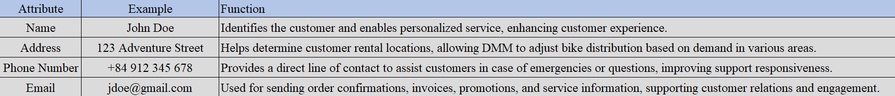

**+ Customer Feedback and Ratings:** This feedback helps DMM monitor satisfaction levels, highlight positive experiences on the website for credibility, and quickly address any issues flagged by negative feedback, supporting ongoing service improvements.

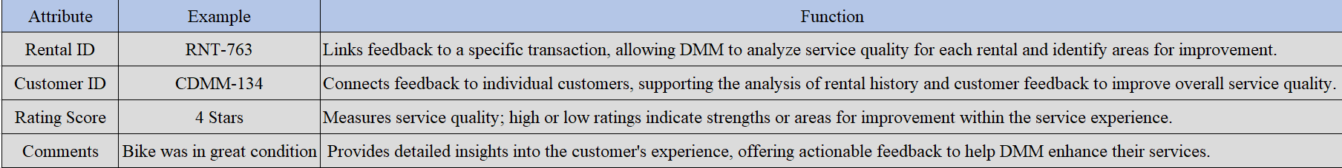

# TASK 4: BUSINESS FUNCTION

a) Choose ONE business function and explain how data from the website could be used to support it. Explain your answer with an example from the case.

**+ Function:** Marketing.

**+ Using Website Data:** The website is a key tool for collecting and analyzing customer data, which is essential for effective marketing strategies. By tracking website interactions, DMM can gain insights into customer preferences, rental patterns, and demographics.

**Example:** Data on rental locations helps identify the most popular areas, optimizing advertising campaigns targeting specific areas and boosting revenue effectively.

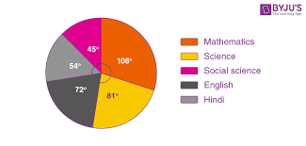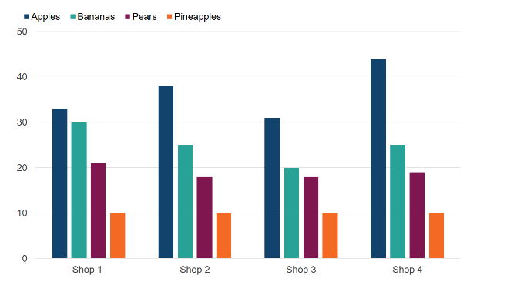

b) Identify two specific examples of IS-generated reports that would be useful for this purpose. (Briefly explain what the reports might show and why these would be useful in the case of DMM.)

**+ Booking Trend Report:** Analyzes booking volume by day/week/month to identify peak tourist seasons, helping plan advertising and adjust resources effectively.

+ **Customer Service Evaluation Report:** Compiles customer feedback on services, helping DMM improve services to meet customer needs and increase satisfaction.

# REFERENCES

Porter, M. E. (1985). *Competitive Advantage: Creating and Sustaining Superior Performance*. Free Press.

Laudon, K. C., & Laudon, J. P. (2020). *Management Information Systems: Managing the Digital Firm* (16th ed.). Pearson.

Kotler, P., & Keller, K. L. (2016). *Marketing Management* (15th ed.). Pearson.

Chopra, S., & Meindl, P. (2016). *Supply Chain Management: Strategy, Planning, and Operation* (6th ed.). Pearson.

Turban, E., Pollard, C., & Wood, G. (2018). *Information Technology for Management: On-Demand Strategies for Performance, Growth, and Sustainability* (11th ed.). Wiley.