VIETNAM GENERAL CONFEDERATION OF LABOR

**TON DUC THANG UNIVERSITY**

**FACULTY OF INFORMATION TECHNOLOGY**



**STUDENT NAME – STUDENT ID**

**STUDENT NAME – STUDENT ID**

**BUILDING A BOOKS MANAGEMENT AND ORDERING SYSTEM ON THE MERN STACK PLATFORM**

**INFORMATION TECHNOLOGY PROJECT 2**

**SOFTWARE ENGINEERING**

**HO CHI MINH CITY, 2023**

VIETNAM GENERAL CONFEDERATION OF LABOR

**TON DUC THANG UNIVERSITY**

**FACULTY OF INFORMATION TECHNOLOGY**



**STUDENT NAME – STUDENT ID**

**STUDENT NAME – STUDENT ID**

**BUILDING A BOOKS MANAGEMENT AND ORDERING SYSTEM ON THE MERN STACK PLATFORM**

**INFORMATION TECHNOLOGY PROJECT 2**

**SOFTWARE ENGINEERING**

Advised by

**Dr. Trinh Hung Cuong**

**HO CHI MINH CITY, 2023**

**ACKNOWLEDGEMENT**

We would like to express our sincere gratitude to Mr. Trinh Hung Cuong, our instructor and mentor, for his valuable guidance and support throughout the mid-term report of our project on Building a book management and ordering system on the MERN stack platform. He has been very helpful and patient in providing us with constructive feedback and suggestions to improve our work. He has also encouraged us to explore new technologies and techniques to enhance our system's functionality and performance. We have learned a lot from his expertise and experience in web development and software engineering. We are honored and privileged to have him as our teacher and supervisor.

*Ho Chi Minh city, 3rd September 2023.*

*Author*

*(Signature and full name)*

***Cuong***

Ho Quoc Cuong

***Thinh***

Do Minh Thinh

**DECLARATION OF AUTHORSHIP**

We hereby declare that this is our own project and is guided by Mr. Trinh Hung Cuong; The content research and results contained herein are central and have not been published in any form before. The data in the tables for analysis, comments and evaluation are collected by the main author from different sources, which are clearly stated in the reference section.

In addition, the project also uses some comments, assessments as well as data of other authors, other organizations with citations and annotated sources.

**If something wrong happens, We’ll take full responsibility for the content of my project.** Ton Duc Thang University is not related to the infringing rights, the copyrights that We give during the implementation process (if any).

*Ho Chi Minh city, 3rd September 2023*

*Author*

*(Signature and full name)*

***Cuong***

Ho Quoc Cuong

***Thinh***

Do Minh Thinh

**BUILDING A BOOKS MANAGEMENT AND ORDERING SYSTEM ON THE MERN STACK PLATFORM**

**ABSTRACT**

The project

* .

**TABLE OF CONTENT**

LIST OF FIGURES v

LIST OF TABLES vi

ABBREVIATIONS vii

CHAPTER 1. INTRODUCTION 1

1.1 Content 1 1

1.2 Content 2 1

CHAPTER 2. THEORETICAL BASIS 2

2.1 Content 1 2

2.2 Content 2 2

CHAPTER 3. DESIGNING AND IMPLEMENTING 3

3.1 Content 1 3

3.2 Content 2 3

CHAPTER 4. RESULT 3

4.1 Content 1 3

4.2 Content 2 3

CHAPTER 5. CONCLUSION 5

5.1 Conclusion 5

5.2 Potential and Development Direction 5

REFERENCES 6

# LIST OF FIGURES

Figure 4.1: Slider bar of home page 4

# LIST OF TABLES

Bảng 4.1: Thống kê kiểu thực thể trong tập VLSP 2016 3

# ABBREVIATIONS

|  |  |
| --- | --- |
| BERT | Bidirectional Encoder Representations from Transformers |
| GEC | Grammatical Error Correction |
| MERN | MongoDB, express, react, nodejs |
| MLM | Masked Language Model |
| NLP | Natural Language Processing |
| NSP | Next Sentence Prediction |

# INTRODUCTION

## Content 1

In the era ...

Books, …

## Content 2

The main

# THEORETICAL BASIS

## Content 1

In the era ...

Books, …

## Content 2

The main

# DESIGNING AND IMPLEMENTING

## Content 1

In the era ...

Books, …

## Content 2

The main

# RESULT

## Content 1

In the era ...

Books, …

Table 4.1: Summary ...

|  |  |  |
| --- | --- | --- |
| **Label** | **Train** | **Test** |
| **LOC** | 1210 | 1377 |
| **ORG** | 7478 | 274 |
| **PER** | 6230 | 1294 |
| **MISC** | 250 | 47 |
| **Total** | 15168 | 2992 |

## Content 2

The main

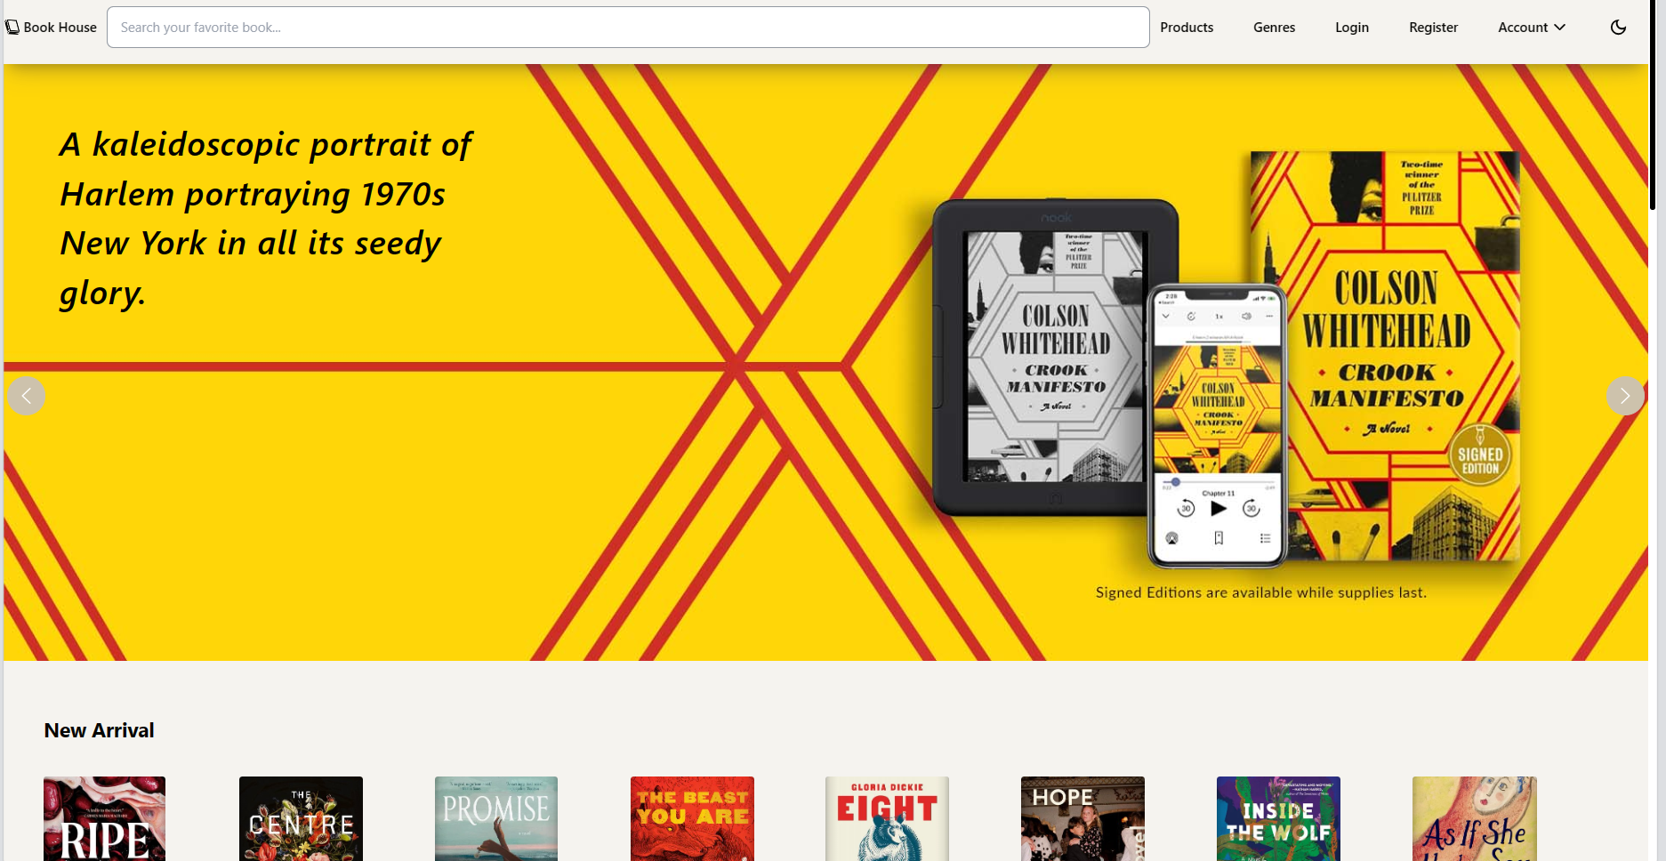

Figure 4.1: Slider bar of home page

# CONCLUSION

## Conclusion

s.

## Potential and Development Direction

s.

# REFERENCES

Akarsh Shrivas, Aniket Pawar, Pratham Mishra, Satish Chadokar. (2023). *E-commerce Website using MERN Stack- IJIRMPS Volume 11, Issue 3.* IJRASET.

Shubham, K. (2021, January 23). *Build an E-Commerce website with MERN Stack .* Retrieved from dev.to: https://dev.to/shubham1710/build-an-e-commerce-website-with-mern-stack-part-1-setting-up-the-project-1l2d