**WEB PROGRAMMING AND APPLICATIONS**

**(503073)**

**WEEK 5**

**Prepared by Mai Van Manh**

**Exercise 1**. Loading data dynamically from server with fetch API (or AJAX)

This exercise involves using the Fetch API (or XMLHttpRequest) to retrieve student data from a web service, displaying the list of students on a predefined interface. Afterward, it requires implementing basic student management features such as adding a new student, deleting a student, or updating a student's status.

* The mandatory requirement for this assignment is to synchronize the data with a backend restful web service. You can easily set up a restful web service by utilizing the provided database.json file in combination with the json-server tool (requires Node.js installed on your computer).
* Once you have the necessary tools installed ([Node.js](https://nodejs.org/en/download/current) and [json-server](https://github.com/typicode/json-server)), you can quickly set up the backend by entering the following command: json-server database.json. This will start the server, and it will be accessible at <http://localhost:3000/students>.
* Next, you will send HTTP requests to the address http://localhost:3000/students using appropriate HTTP methods (GET, POST, PATCH, DELETE) to perform read, add, delete, and update operations on the student data.

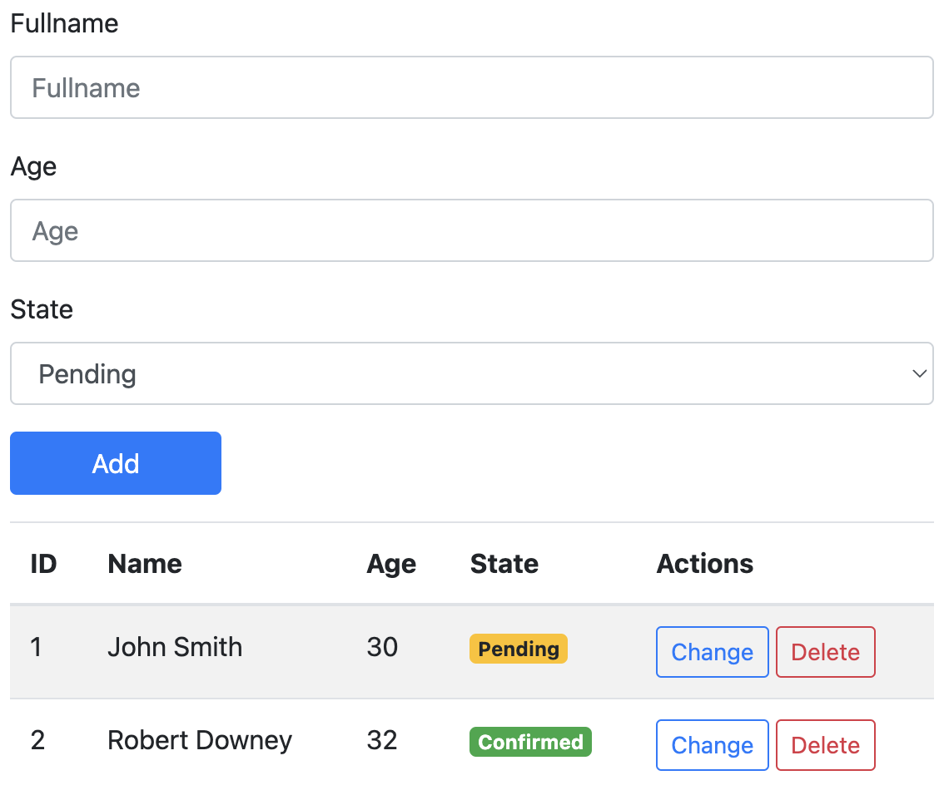

*Expected outcome upon successful data retrieval*

**Exercise 2:** Develop a webpage that displays the password strength.

* The strength status should be instantly updated whenever a user adds or removes a character in the textbox.
* If criteria are met, use a green background for that criteria; if criteria are not met, use a deep red background.

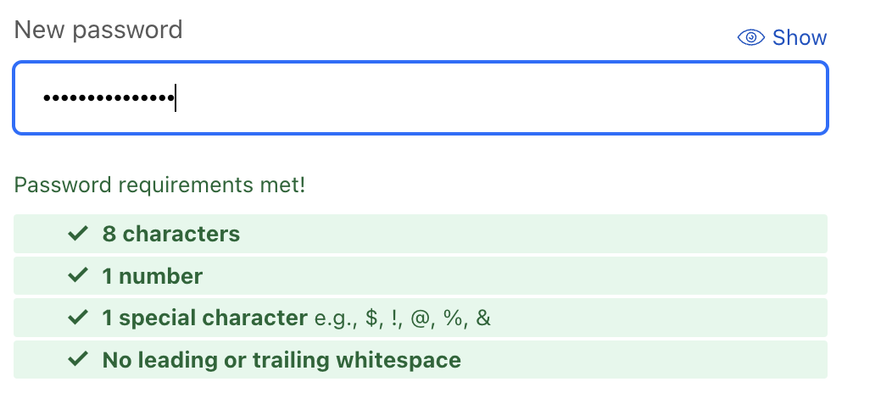

**Exercise 3.** Create a color picker web page

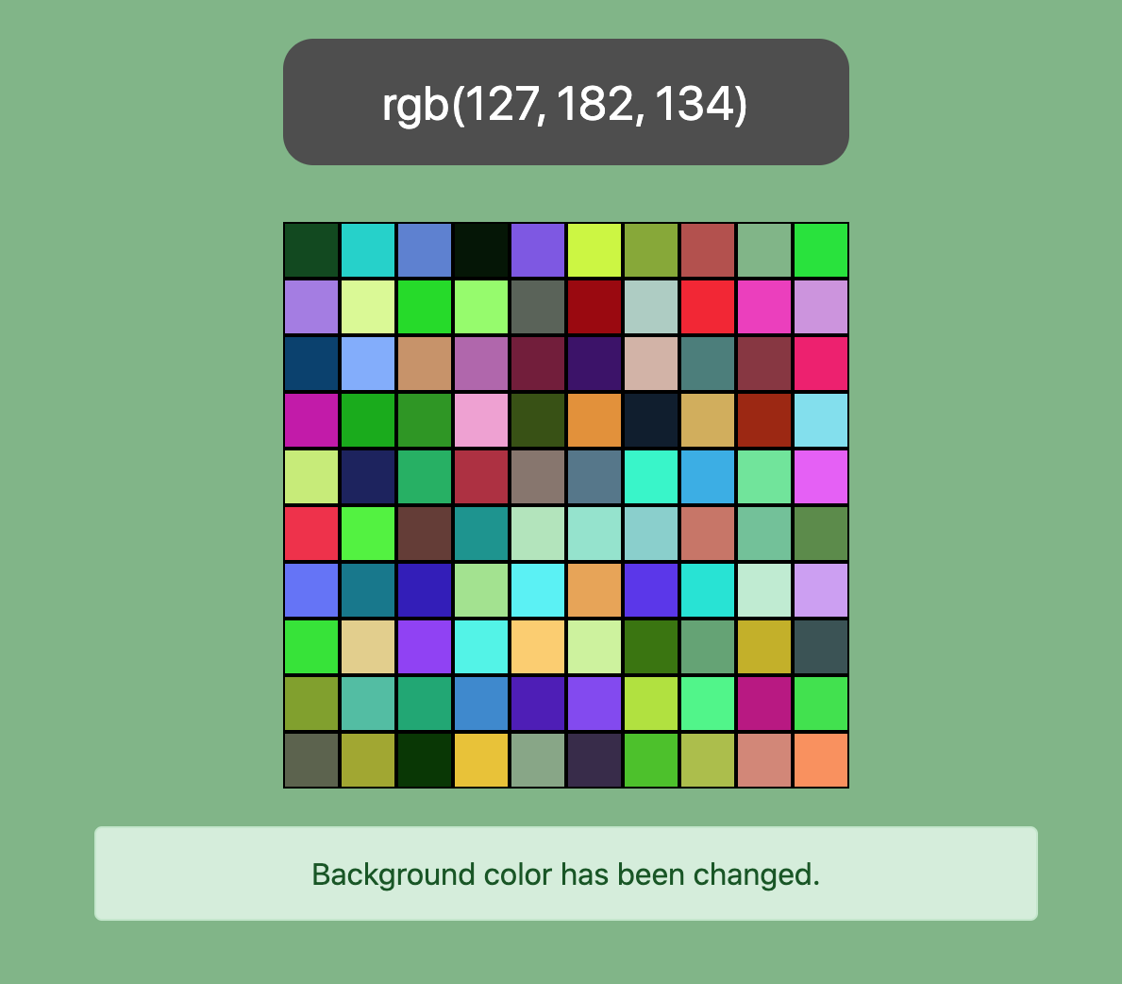

See the video demo (***Color picker.mp4***) to better understand the requirements of this exercise.

Requirements:

* The cells must be generated dynamically by interacting with the Document Object Model (do not hardcoding by HTML).
* The cell colors must be generated randomly and they will be changed every time the page is reloaded. You are free to choose which colors to display.
* When mouse overs the cells, the background color changes temporarily according to the value of the cell and will return to the original color when the mouse is moved out of the color panel.

When you click on a cell, the background color changes to the color of the cell. Messages will show and hide in 3 seconds with face in and fade out effects.

**Exercise 4:** Create a webpage simulating a shopping cart found on e-commerce websites.

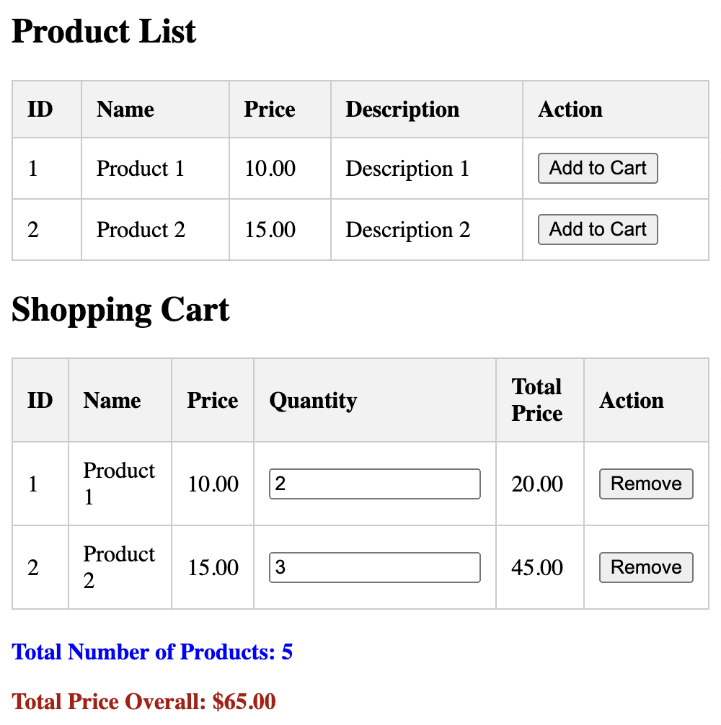

* Upon clicking the "Add to cart" button, the product will be added to the "Shopping Cart" table if not already present or update the quantity if it is.
* When adjusting the quantity of a product in the cart, the total amount will be automatically updated immediately.
* Pressing the "Remove" button will delete the product from the cart list, and the total amount will also be updated accordingly.

**Exercise 5:** Implement a filter feature for a webpage containing a textbox and a table listing products, where adding or removing a character in the textbox filters the product table to display only items matching the entered keyword.

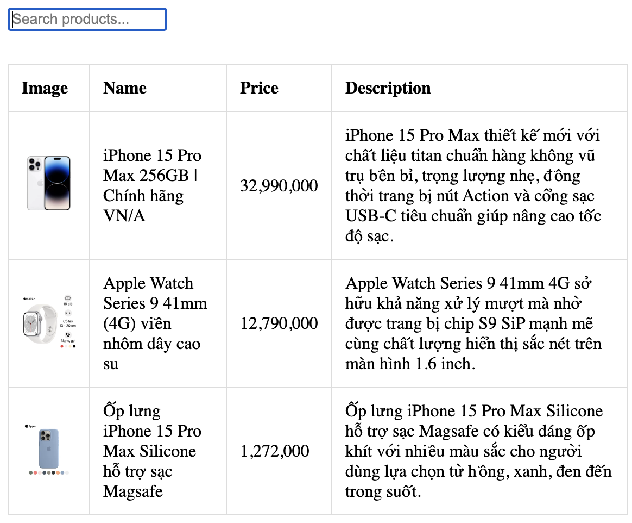

* The entered keyword can be searched in any column of the table (name, price, description), and results will be displayed when the product content contains that keyword.
* For example, entering the keyword "**i**" will display products like **i**Phone, **i**Pad, and **i**Mac because they contain the letter " **i** ". Entering "900" will show products with prices like "32,990,000" or "12,790,000" as they contain the search keyword in their price.
* For example, Even when entering "thiet ke," the product "iPhone 15 Pro Max" in the illustration will be displayed because it contains the phrase "thiết kế" (Vietnamese) in the product description. This feature enhances user experience by dynamically updating the displayed products based on real-time keyword input, facilitating efficient and flexible product searches.

**Exercise 6:** Use the given images to create puzzle games like the following:

|  |  |
| --- | --- |
| ../../../../../../../../../Users/mvmanh/Desktop/Screen%20Shot% | ../../../../../../../../../Users/mvmanh/Desktop/Screen%20Shot% |

See the video demo (***Puzze-example.mp4***) to better understand the requirements of this exercise.

**Requirements**:

* The position of the puzzle pieces is chosen randomly when the page is loaded. Rotation angles (0, 90, 180, 270) of the puzzle pieces are also randomly generated.
* Users can click on the pieces to rotate them (0 🡪 90, 90 🡪 180,…).
* You can only drag pieces into empty box, you can not drop pieces in the none empty box or outside.
* After the user drags the last piece of the puzzle, the web page will display a greeting message if the user has correctly cropped the original photo.