H1: Among people with siblings, does birth order affect MWB? No.
One-Way ANOVA
One-Way ANOVA (Welch's)
 |  | F |  | df1 |  | df2 |  | p
Overall Mental Well-Being |  | 2.63e-7 |  | 1 |  | 76.1 |  | 1.000
Depression Symptoms |  | 0.219 |  | 1 |  | 92.6 |  | 0.641
Generalized Anxiety Symptoms |  | 1.057 |  | 1 |  | 87.9 |  | 0.307

Plots
Overall Mental Well-Being
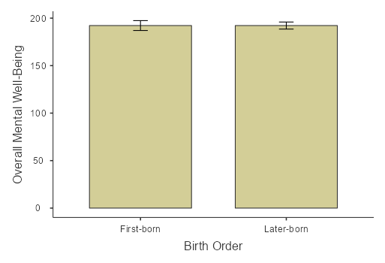
Depression Symptoms
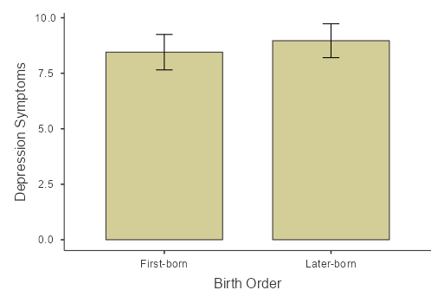
Generalized Anxiety Symptoms
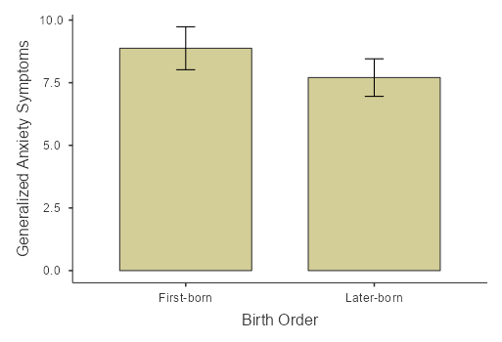

H2: Among immigrants with siblings, does birth order affect MWB? No.
One-Way ANOVA
One-Way ANOVA (Welch's)
 |  | F |  | df1 |  | df2 |  | p
Overall Mental Well-Being |  | 0.11738 |  | 1 |  | 54.7 |  | 0.733
Depression Symptoms |  | 0.00404 |  | 1 |  | 63.1 |  | 0.950
Generalized Anxiety Symptoms |  | 0.56207 |  | 1 |  | 62.8 |  | 0.456

Plots
Overall Mental Well-Being
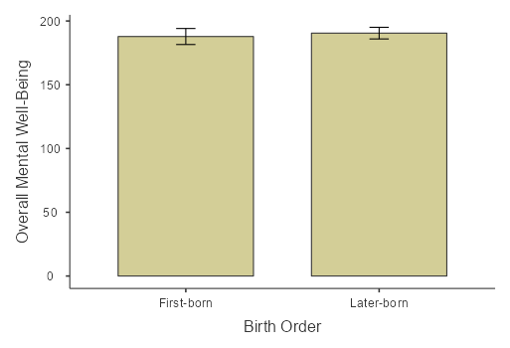
Depression Symptoms
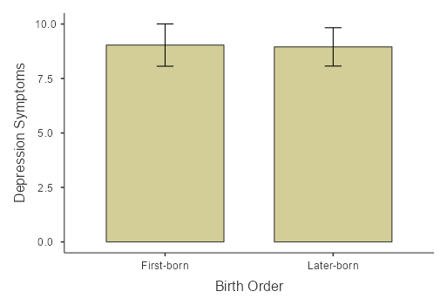
Generalized Anxiety Symptoms
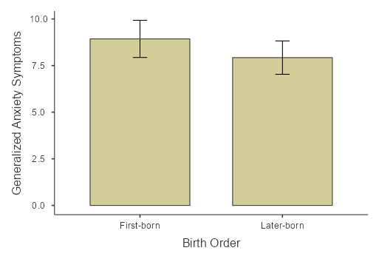

H3: Among people with siblings, is there an interaction between birth order * gender * immigration background? No. But gender main effect:
ANOVA - Overall Mental Well-Being
 |  | Sum of Squares |  | df |  | Mean Square |  | F |  | p
Immigration Background |  | 766.20 |  | 1 |  | 766.20 |  | 0.78097 |  | 0.379
Birth Order |  | 24.06 |  | 1 |  | 24.06 |  | 0.02453 |  | 0.876
Gender |  | 6.89 |  | 1 |  | 6.89 |  | 0.00702 |  | 0.933
Immigration Background ✻ Birth Order |  | 43.01 |  | 1 |  | 43.01 |  | 0.04384 |  | 0.835
Immigration Background ✻ Gender |  | 2.62 |  | 1 |  | 2.62 |  | 0.00267 |  | 0.959
Birth Order ✻ Gender |  | 17.50 |  | 1 |  | 17.50 |  | 0.01784 |  | 0.894
Immigration Background ✻ Birth Order ✻ Gender |  | 178.50 |  | 1 |  | 178.50 |  | 0.18194 |  | 0.671
Residuals |  | 88296.99 |  | 90 |  | 981.08

ANOVA - Depression Symptoms
 |  | Sum of Squares |  | df |  | Mean Square |  | F |  | p
Gender |  | 22.308 |  | 1 |  | 22.308 |  | 0.71399 |  | 0.400
Immigration Background |  | 2.344 |  | 1 |  | 2.344 |  | 0.07503 |  | 0.785
Birth Order |  | 9.465 |  | 1 |  | 9.465 |  | 0.30292 |  | 0.583
Gender ✻ Immigration Background |  | 3.017 |  | 1 |  | 3.017 |  | 0.09656 |  | 0.757
Gender ✻ Birth Order |  | 1.049 |  | 1 |  | 1.049 |  | 0.03359 |  | 0.855
Immigration Background ✻ Birth Order |  | 0.173 |  | 1 |  | 0.173 |  | 0.00555 |  | 0.941
Gender ✻ Immigration Background ✻ Birth Order |  | 59.532 |  | 1 |  | 59.532 |  | 1.90536 |  | 0.171
Residuals |  | 2812.002 |  | 90 |  | 31.244

ANOVA
ANOVA - Generalized Anxiety Symptoms
 |  | Sum of Squares |  | df |  | Mean Square |  | F |  | p
Immigration Background |  | 13.90 |  | 1 |  | 13.90 |  | 0.4528 |  | 0.503
Birth Order |  | 4.88 |  | 1 |  | 4.88 |  | 0.1589 |  | 0.691
Gender |  | 124.08 |  | 1 |  | 124.08 |  | 4.0407 |  | 0.047
Immigration Background ✻ Birth Order |  | 7.46 |  | 1 |  | 7.46 |  | 0.2429 |  | 0.623
Immigration Background ✻ Gender |  | 1.96 |  | 1 |  | 1.96 |  | 0.0639 |  | 0.801
Birth Order ✻ Gender |  | 8.53 |  | 1 |  | 8.53 |  | 0.2779 |  | 0.599
Immigration Background ✻ Birth Order ✻ Gender |  | 3.17 |  | 1 |  | 3.17 |  | 0.1033 |  | 0.749
Residuals |  | 2763.59 |  | 90 |  | 30.71

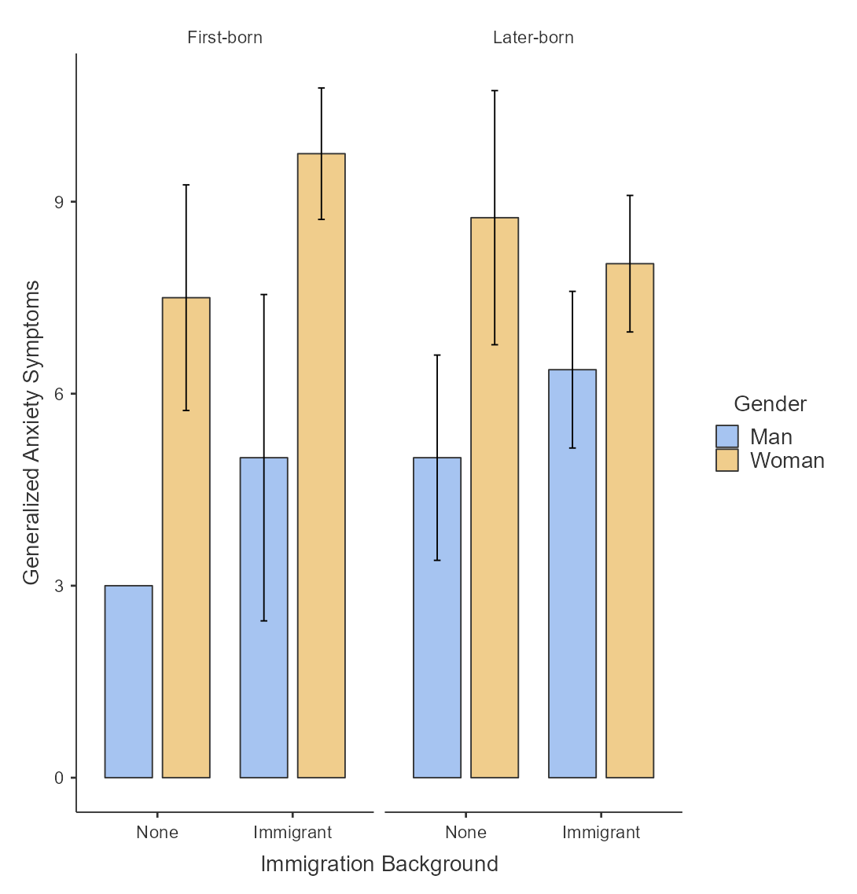

Independent Samples T-Test
 |  |  |  | Statistic |  | df |  | p |  |  |  | Effect Size
Generalized Anxiety Symptoms |  | Welch's t |  | -2.89 |  | 45.7 |  | 0.006 |  | Cohen's d |  | -0.641
Note. Hₐ μ _{Man} ≠ μ _{Woman}

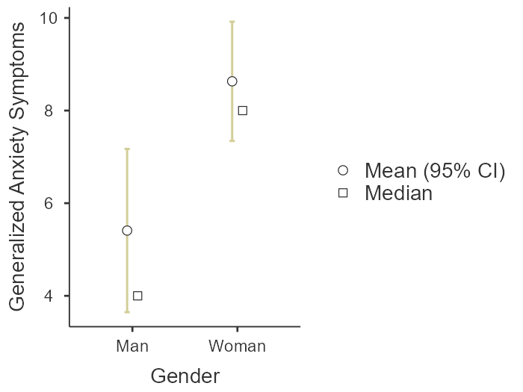

Story Questions:
- What if we look at just women and include only children. Is there a birth order X immigrant background interaction?
No, but we see the immigrant background effect. (See sample with only children and everyone).
- What if we consider 3rd gen to be no immigrant? (people with siblings only)No.
ANOVA - Overall Mental Well-Being
 |  | Sum of Squares |  | df |  | Mean Square |  | F |  | p
Birth Order |  | 7.181 |  | 1 |  | 7.181 |  | 0.00733 |  | 0.932
Gender |  | 37.043 |  | 1 |  | 37.043 |  | 0.03783 |  | 0.846
Alternative Immigration Background |  | 589.697 |  | 1 |  | 589.697 |  | 0.60217 |  | 0.440
Birth Order ✻ Gender |  | 0.305 |  | 1 |  | 0.305 |  | 3.11e-4 |  | 0.986
Birth Order ✻ Alternative Immigration Background |  | 131.525 |  | 1 |  | 131.525 |  | 0.13431 |  | 0.715
Gender ✻ Alternative Immigration Background |  | 2.906 |  | 1 |  | 2.906 |  | 0.00297 |  | 0.957
Birth Order ✻ Gender ✻ Alternative Immigration Background |  | 125.304 |  | 1 |  | 125.304 |  | 0.12795 |  | 0.721
Residuals |  | 88136.100 |  | 90 |  | 979.290

ANOVA - Depression Symptoms
 |  | Sum of Squares |  | df |  | Mean Square |  | F |  | p
Gender |  | 18.70112 |  | 1 |  | 18.70112 |  | 0.6151 |  | 0.435
Birth Order |  | 6.42376 |  | 1 |  | 6.42376 |  | 0.2113 |  | 0.647
Alternative Immigration Background |  | 4.26027 |  | 1 |  | 4.26027 |  | 0.1401 |  | 0.709
Gender ✻ Birth Order |  | 0.00117 |  | 1 |  | 0.00117 |  | 3.84e-5 |  | 0.995
Gender ✻ Alternative Immigration Background |  | 0.43829 |  | 1 |  | 0.43829 |  | 0.0144 |  | 0.905
Birth Order ✻ Alternative Immigration Background |  | 3.48574 |  | 1 |  | 3.48574 |  | 0.1146 |  | 0.736
Gender ✻ Birth Order ✻ Alternative Immigration Background |  | 67.40974 |  | 1 |  | 67.40974 |  | 2.2171 |  | 0.140
Residuals |  | 2736.41332 |  | 90 |  | 30.40459

ANOVA - Generalized Anxiety Symptoms
 |  | Sum of Squares |  | df |  | Mean Square |  | F |  | p
Birth Order |  | 3.45 |  | 1 |  | 3.45 |  | 0.1145 |  | 0.736
Gender |  | 131.90 |  | 1 |  | 131.90 |  | 4.3742 |  | 0.039
Alternative Immigration Background |  | 18.58 |  | 1 |  | 18.58 |  | 0.6160 |  | 0.435
Birth Order ✻ Gender |  | 13.37 |  | 1 |  | 13.37 |  | 0.4434 |  | 0.507
Birth Order ✻ Alternative Immigration Background |  | 12.02 |  | 1 |  | 12.02 |  | 0.3986 |  | 0.529
Gender ✻ Alternative Immigration Background |  | 1.45 |  | 1 |  | 1.45 |  | 0.0481 |  | 0.827
Birth Order ✻ Gender ✻ Alternative Immigration Background |  | 7.87 |  | 1 |  | 7.87 |  | 0.2610 |  | 0.611
Residuals |  | 2713.96 |  | 90 |  | 30.16

My Aim 2: Among everyone, does birth order affect MWB subscores?
Yes, only children have higher Positive Relations with Others than later-borns.
One-Way ANOVA (Welch's)
 |  | F |  | df1 |  | df2 |  | p
Autonomy |  | 0.759 |  | 2 |  | 35.4 |  | 0.476
Environmental Mastery |  | 0.881 |  | 2 |  | 36.0 |  | 0.423
Personal Growth |  | 0.780 |  | 2 |  | 33.2 |  | 0.467
Positive Relations With Others |  | 4.116 |  | 2 |  | 37.0 |  | 0.024
Purpose In Life |  | 0.212 |  | 2 |  | 33.0 |  | 0.810
Self-Acceptance |  | 0.684 |  | 2 |  | 35.1 |  | 0.511

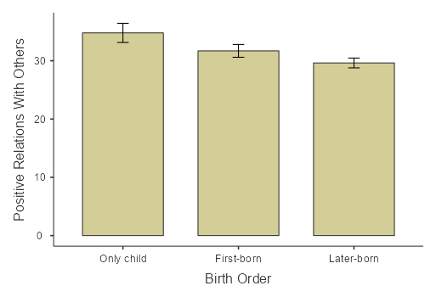

Among everyone, is there an interaction? No, but main effect of immigrant background:
Immigrants have worse MWB.ve
ANOVA
ANOVA - Overall Mental Well-Being
 |  | Sum of Squares |  | df |  | Mean Square |  | F |  | p
Immigration Background |  | 9159 |  | 1 |  | 9159 |  | 9.85 |  | 0.002
Birth Order |  | 4906 |  | 2 |  | 2453 |  | 2.64 |  | 0.076
Immigration Background ✻ Birth Order |  | 4739 |  | 2 |  | 2369 |  | 2.55 |  | 0.083
Residuals |  | 101366 |  | 109 |  | 930

Post Hoc Tests
Post Hoc Comparisons - Immigration Background
Comparison
Immigration Background |  |  |  | Immigration Background |  | Mean Difference |  | SE |  | df |  | t |  | p_{tukey} |  | Cohen's d
None |  | - |  | Immigrant |  | 23.7 |  | 7.54 |  | 109 |  | 3.14 |  | 0.002 |  | 0.776
Note. Comparisons are based on estimated marginal means
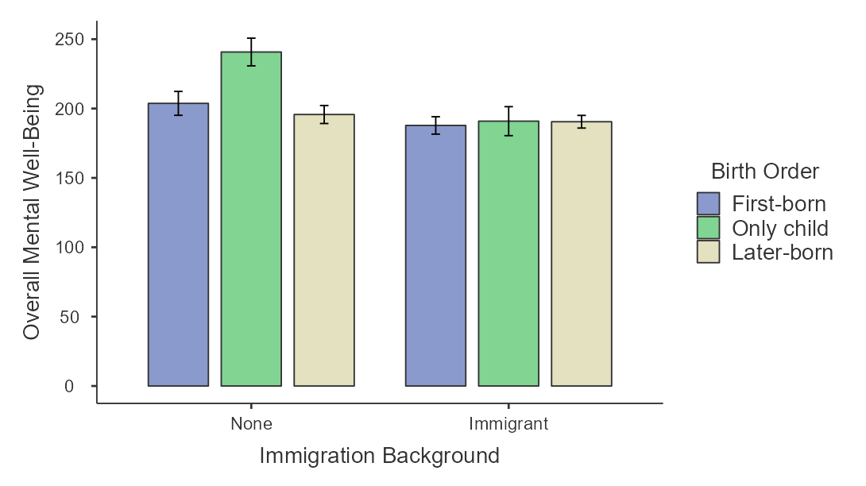
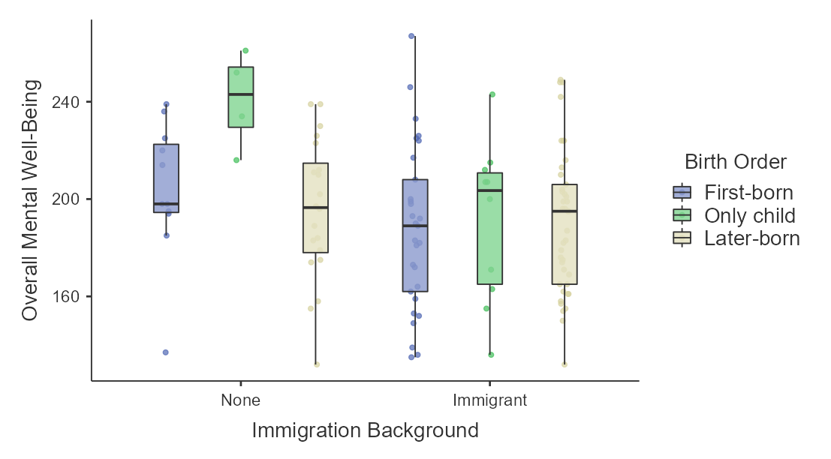
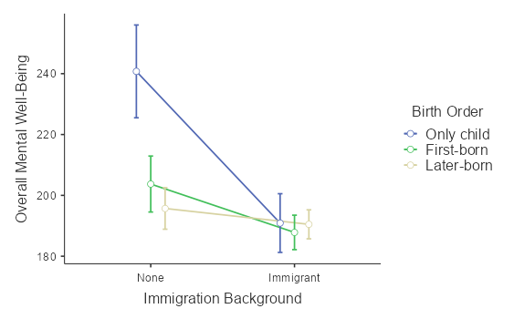

Estimated Marginal Means - Immigration Background ✻ Birth Order
 |  |  |  |  |  |  |  | 95% Confidence Interval
Birth Order |  | Immigration Background |  | Mean |  | SE |  | Lower |  | Upper
First-born |  | None |  | 204 |  | 9.19 |  | 186 |  | 222
 |  | Immigrant |  | 188 |  | 5.66 |  | 177 |  | 199
Only child |  | None |  | 241 |  | 15.25 |  | 211 |  | 271
 |  | Immigrant |  | 191 |  | 9.64 |  | 172 |  | 210
Later-born |  | None |  | 196 |  | 6.82 |  | 182 |  | 209
 |  | Immigrant |  | 190 |  | 4.76 |  | 181 |  | 200

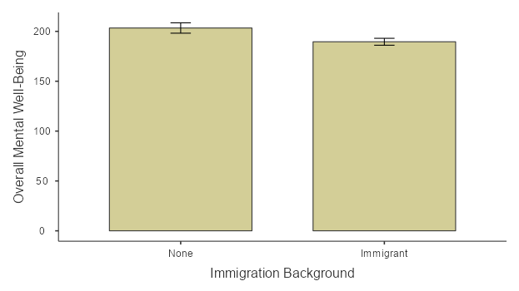
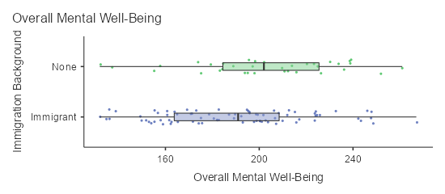

Among everyone, does immigration background affect MWB subscores?
Yes, immigrants have less self-acceptance than non-immigrants.
One-Way ANOVA (Fisher's)
 |  | F |  | df1 |  | df2 |  | p
Autonomy |  | 0.628 |  | 1 |  | 113 |  | 0.430
Environmental Mastery |  | 3.365 |  | 1 |  | 113 |  | 0.069
Personal Growth |  | 1.929 |  | 1 |  | 113 |  | 0.168
Positive Relations With Others |  | 2.804 |  | 1 |  | 113 |  | 0.097
Purpose In Life |  | 2.691 |  | 1 |  | 113 |  | 0.104
Self-Acceptance |  | 5.196 |  | 1 |  | 113 |  | 0.025

Tukey Post-Hoc Test – Self-Acceptance
 |  |  |  | None |  | Immigrant
None |  | Mean difference |  | — |  | 3.67 | *
 |  | p-value |  | — |  | 0.025
Immigrant |  | Mean difference |  |  |  | —
 |  | p-value |  |  |  | —
Note. * p < .05, ** p < .01, *** p < .001

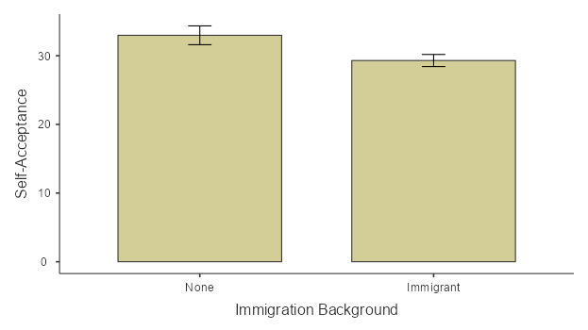

Among None/3rd-gen, does birth order affect MWB?
Only children have less anxiety than later-borns.
One-Way ANOVA (Welch's)
 |  | F |  | df1 |  | df2 |  | p
Overall Mental Well-Being |  | 1.94 |  | 2 |  | 12.9 |  | 0.184
Depression Symptoms |  | 4.51 |  | 2 |  | 15.7 |  | 0.028
Generalized Anxiety Symptoms |  | 6.73 |  | 2 |  | 20.1 |  | 0.006

Plots
Generalized Anxiety Symptoms
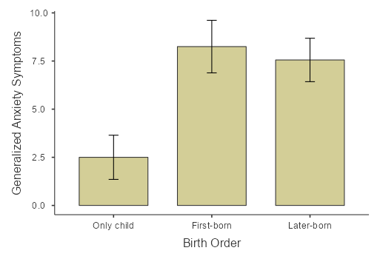
Positive Relations With Others

Among None/3rd-gen, does birth order affect MWB subscores?
Only children have more Positive Relations with Others than later-borns.
One-Way ANOVA (Welch's)
 |  | F |  | df1 |  | df2 |  | p
Autonomy |  | 2.000 |  | 2 |  | 13.5 |  | 0.174
Environmental Mastery |  | 1.542 |  | 2 |  | 14.2 |  | 0.248
Personal Growth |  | 1.428 |  | 2 |  | 12.3 |  | 0.277
Positive Relations With Others |  | 4.194 |  | 2 |  | 14.9 |  | 0.036
Purpose In Life |  | 0.376 |  | 2 |  | 12.8 |  | 0.694
Self-Acceptance |  | 2.458 |  | 2 |  | 18.4 |  | 0.113

