TravelX
Smart Currency Exchange Reservation Platform
Product Requirements Document
Version 1.3
FPT IS Internship Project
Author: Gyeonhui Lee, Jihun Yu, Seohyun Cha, Doohyun KIM, Chaei Shin
July 10, 2026 (Revision 1.3

1. Project Overview

1.1 Background
Travelers going abroad often have to visit multiple currency exchange offices in person to compare rates, and wait in long lines to exchange money. Most exchange offices still operate on a walk-in basis, making it difficult to reserve an exchange amount in advance.
This project aims to provide an online reservation platform that lets travelers compare exchange rates, reserve the currency they want, and pick it up at their chosen branch.

1.2 Goals
Provide a platform where users can complete the following within minutes:
- Compare exchange rates
- Reserve foreign currency
- Select a pickup location
- Receive a reservation confirmation

1.3 Key Differentiators
Redefine the core value as “benchmark-rate exchange comparison (refreshed daily, with branch-level preferential rates updated in real time) + reservation,” and add two AI-assisted features as MVP+: an optimal exchange-timing recommendation and a nearby exchange-shop recommendation, to demonstrate experience with financial domain data analysis and external API integration.
- Daily-updated benchmark-rate comparison, with real-time branch-level preferential rates — integration with external public data APIs
- Online reservation and confirmation issuance — reservation-only stock and concurrency handling
- AI-based optimal exchange timing recommendation — time-series data analysis and batch processing
- AI-based exchange shop recommendation — rule-based scoring evolving into click/conversion-driven weight optimization

2. Target Users

2.1 Primary Users
- Overseas travelers
- Business travelers
- Walk-in exchange customers

2.2 Secondary Users
- Exchange office staff

3. Problem Definition
- It is hard for users to know which exchange office offers the best rate.
- Users must visit a branch in person to exchange currency.
- Popular currencies frequently run out of stock.
- Wait times are unpredictable.

4. Solution
- Daily-updated benchmark-rate lookup, with real-time branch preferential rates
- Compare rates across exchange offices
- Online reservation
- Select pickup date and time
- Reservation confirmation issuance
- AI-based exchange timing recommendation
- AI-based exchange shop recommendation

5. Competitive Service Comparison
TravelX's positioning compared to existing services is as follows.

Service Type | Example | Limitations
Bank app currency exchange reservation | KB Kookmin Bank, Shinhan Bank, etc. | Only offers the bank's own rate; cannot compare with other exchange offices
Airport/city exchange kiosks | Individual exchange office counters | No real-time comparison; requires waiting on site
Travel community exchange rate info | Informally shared via Naver Cafe, etc. | Not real-time; no reservation feature
TravelX (this project) | - | Provides daily-updated rate comparison across multiple exchange offices + online reservation + AI-based timing & shop recommendations, all on one platform

6. MVP Scope

6.1 User Features

Authentication
- Sign in with Google
- Log out

Exchange Rate
- View exchange rates
- Search currency
- Compare rates across exchange offices

Reservation
- Select currency
- Enter amount
- Select pickup location
- Select pickup date/time
- Confirm reservation

Reservation Management
- View reservations (Upcoming / Completed / Cancelled, filterable)
- Cancel reservation (confirmation step required before finalizing)
- View exchange history (Completed / Cancelled transactions, separate from the upcoming list)
- Download receipt (completed reservations only)

Cash Pickup
- Present QR code (single-use) for staff to scan; QR is invalidated immediately upon redemption

Profile
- View profile (name, email — read-only, sourced from Google account)

Notifications
- Reservation completed notification
- Reservation cancelled notification
- Pre-pickup reminder notification
- View notification list
- Mark notifications as read

6.2 Admin Features
- Register new branch (name, address, map coordinates, business hours, contact, supported currencies)
- Edit / deactivate branch
- Set per-branch time-slot reservation capacity (30-minute slots)
- Manage currency inventory
- Approve/manage reservations
- Manage exchange rates
- Manage users
- Dashboard (reservation status, popular currency stats)

6.3 AI Exchange Timing Recommendation
- Compares the current rate to the regression model's predicted value to generate a recommendation

6.4 AI Exchange Shop Recommendation
- Ranks nearby exchange shops by a distance/rate/availability/reservation composite score to help users pick among options.

7. User Flow

7.1 Userflow Admin
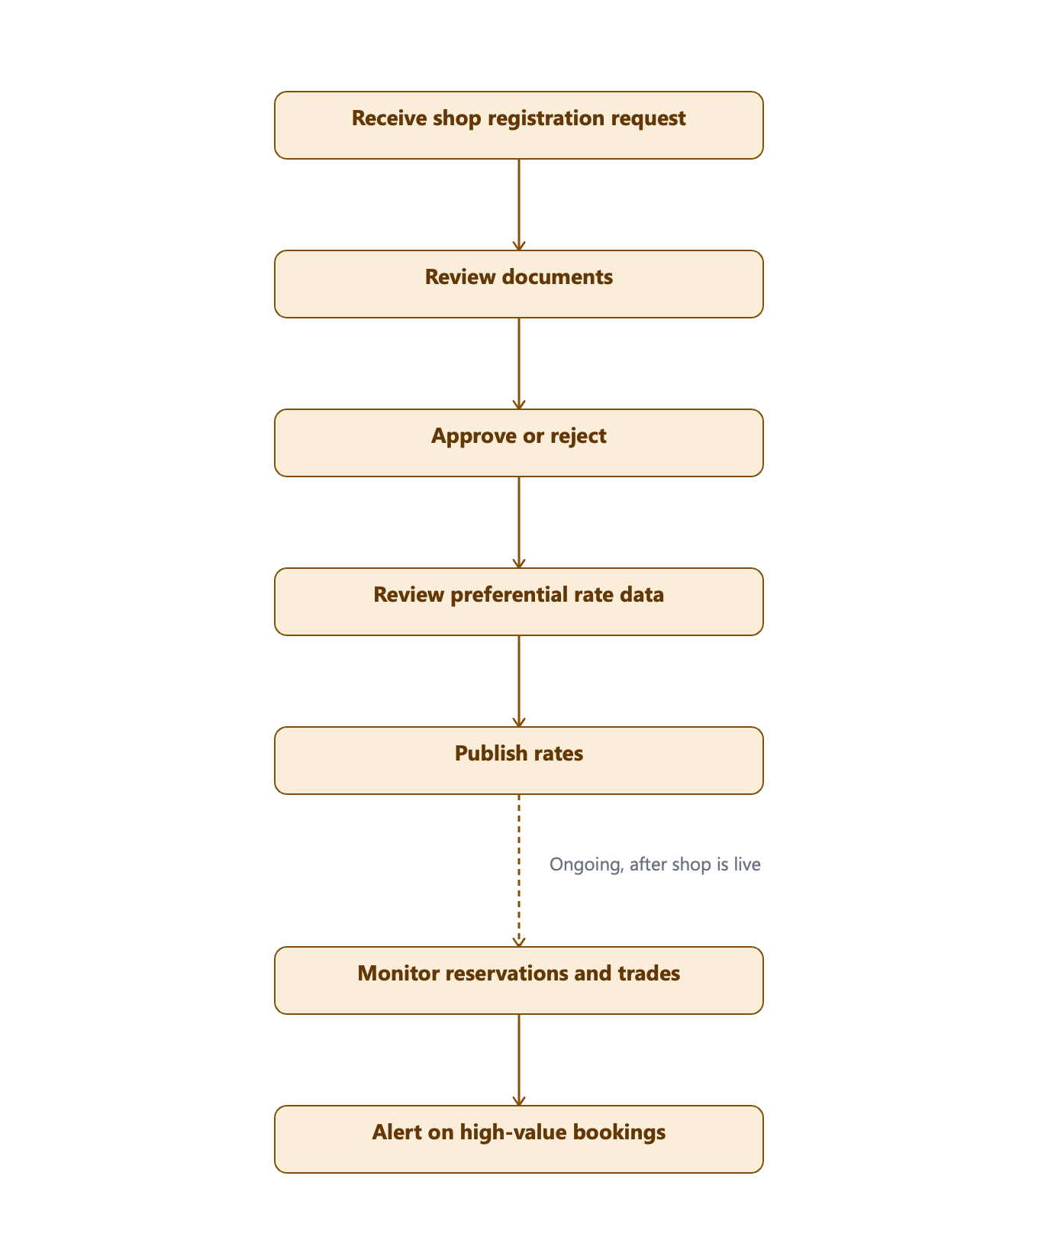

7.2 Userflow Staff

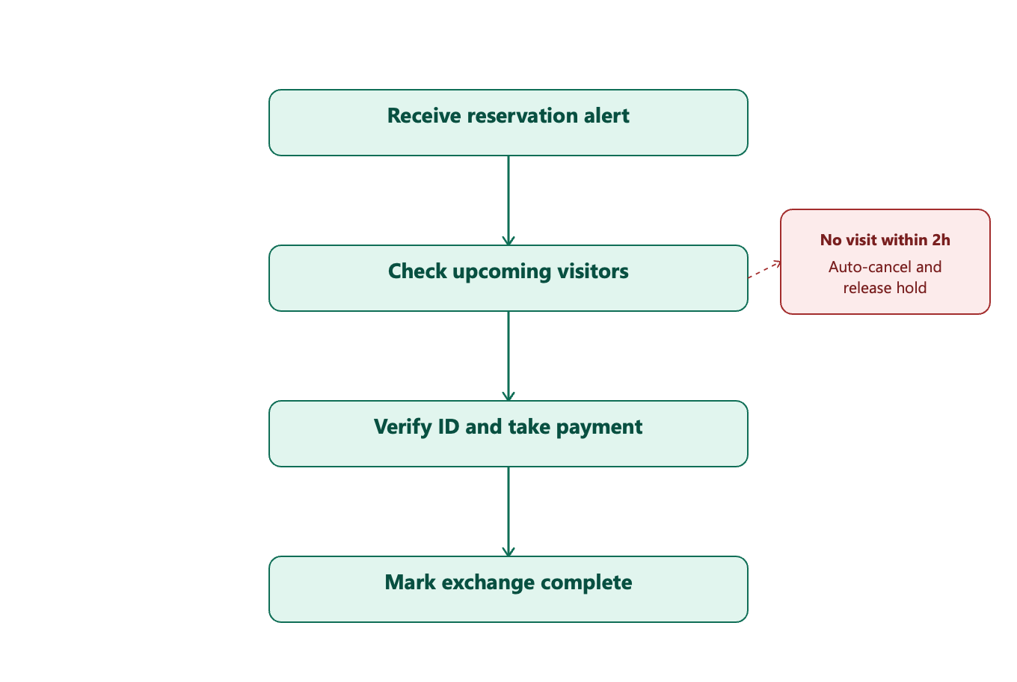

7.3 Userflow Tourist
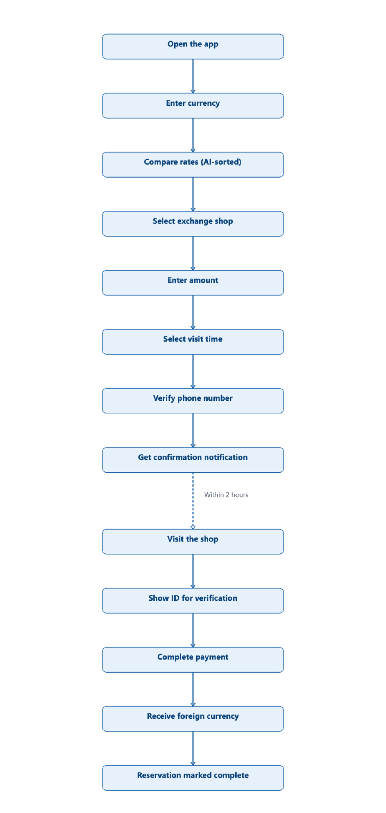

8. Functional Requirements
Feature | Input | Process | Output
Sign In with Google | Google OAuth2 ID token | Verify token with Google; auto-create account on first login or retrieve existing user; issue JWT | User account created/retrieved, session started
Logout | JWT (session) | Invalidate/revoke JWT | Session ended
Currency Search | Currency code or country name | Query currency list; if no input given, return recent searches (per user) and popular currencies (aggregated) | Matching currency list, or recent/popular currency list
Exchange Rate Comparison | Currency, (optional) location | Query benchmark rate + branch preferential rates | Ranked rate comparison list
Reservation | Currency, amount, branch, date/time | Validate reservation-only stock and time-slot capacity, lock rate, hold stock for 2 hours | Reservation created (rate & currency guaranteed)
Cancel Reservation | Reservation ID | Validate ownership & status, release held stock (client must show a confirmation modal before finalizing cancellation) | Reservation cancelled, stock restored
Reservation History | User ID (session) | Query past reservations | Reservation history list
Reservation Confirmation | Reservation ID | Generate reservation number and a unique single-use QR code encoding the reservation ID | Confirmation
Notifications | Reservation status change event | Generate in-app notification | Reservation completed/cancelled/pickup-reminder notification
Rate Management (Admin) | Currency, new benchmark rate | Validate & update rate | Exchange rate updated
Branch Management (Admin) | Branch details (name, address, coordinates, hours, contact, supported currencies, time-slot capacity) | Create/update/deactivate branch | Branch record updated
Reservation Management (Admin) | Reservation ID, action | Approve/modify/cancel reservation | Reservation status updated
User Management (Admin) | User ID, action | View/suspend/update user account | User account updated
AI Exchange Timing Recommendation | Recent N-day rate history | Run regression model, compare prediction to current rate | Now/Wait/Neutral badge
Admin Dashboard | Date range filter | Aggregate reservation & currency stats | Reservation status & popular currency statistics
AI Exchange Shop Recommendation | User location, currency, radius, top_n | Score branches (distance/rate/availability/reservation) & rank | Ranked nearby branch list
Identity Verification (KYC) | Phone number (booking) / ID document (pickup) | Verify phone at reservation, verify ID at pickup | Verified reservation / verified pickup
No-Show Trust Control | User's no-show history | Check 30-day no-show count against thresholds | Reservation limit applied (1 concurrent / 7-day block)
Large-Amount Reservation Limit | Reservation amount | Validate against USD 10,000 threshold | Reservation blocked/flagged if at or above threshold
Branch Rate & Stock Setting | Preferential rate (%), reservation-only stock quantity | Branch submits daily values via admin page | BranchCurrencyRate updated
Cash Pickup | QR code (or reservation number) + presented ID | Decode QR/number → verify reservation status == RESERVED → match presented ID against reservation holder → atomically transition to COMPLETED (reject reuse) | Pickup approved, or rejected (expired / already used / identity mismatch)
Download Receipt | Reservation ID (status == COMPLETED) | Generate receipt from reservation + branch + rate data | Downloadable receipt file

9. Detailed Design of the AI Exchange Timing Recommendation Feature

9.1 Purpose
To help travelers who find it hard to judge whether to exchange currency now or wait, this feature provides a reference recommendation signal based on exchange rate history data.

9.2 Data Sources
- Exchange rate history loaded daily into our own DB
- Exchange rate data collected in batches from external public APIs (e.g., the Korea Eximbank Open API)

9.3 Recommendation Logic — Phase 1
Instead of complex time-series models like ARIMA or LSTM, the design uses a Linear Regression model with moving averages and volatility as features. This offers a step up in modeling capability from a simple moving-average rule model, while remaining a low-risk structure that can be reliably implemented and validated within a month.
- Retrieve exchange rate data for the most recent N days
- Build features: recent moving average and standard deviation, recent rate of change, lagged exchange rate values, etc.
- Using the next day exchange rate as the target, train a linear regression model
- Compare the predicted value with the current rate to produce a "Exchange Now"/"Wait"/"Neutral" signal
- Store the regression coefficients as well, so it is possible to explain which features influenced the signal and by how much.

9.4 Safeguards and Operational Considerations
- Fallback logic: if model prediction fails or input data is abnormal, automatically switch to the existing moving average $±$standard deviation rule-based logic
- Warm-up policy: until at least 14 days of exchange-rate history are available for a currency, suppress the Now/Wait/Neutral badge and display a “Collecting data” state instead.

9.5 Future Enhancements — Phase 2
- Introduce time-series forecasting models
- Refine predictions by combining economic indicators and news sentiment analysis
- Set per-user target exchange rate alert thresholds
- Expand to multiple currency pairs and enhance the automatic model retraining pipeline

9.6 Display and Disclaimer
Display a recommendation badge on the exchange rate comparison screen, with the following disclaimer at the bottom: “This recommendation is not investment advice and is provided for reference only.”
A High Volatility badge is also shown when a currency's recent rate swing exceeds a defined threshold, displayed alongside the Now/Wait/Neutral signal (exact threshold to be confirmed by the team).

10. Non-functional Requirements
Category | Requirement
Response time | Average within 2 seconds
Availability | 99% or higher
Security | JWT authentication (Google OAuth2 login only), role-based authorization
Scalability | REST API, Layered Architecture
Batch stability | Falls back to the latest cached data if the external exchange rate API fails, with retry logic applied
Data consistency | Transaction/lock handling to prevent inventory from being oversold during concurrent reservations

11. System Architecture Overview
The system is based on a 3-tier structure: Frontend (React/TypeScript) → Backend REST API (Spring Boot) → MySQL database, with a separate batch scheduler configured to collect exchange rate history.
- Frontend: React, TypeScript, Tailwind
- Backend: Spring Boot REST API, Spring Security, JPA/QueryDSL
- AI: Python, scikit-learn, PyTorch, pandas
- Scheduler: Spring Scheduler-based exchange rate batch collection (runs daily)
- Database: MySQL
- External integration: public exchange rate data API

12. Database Design (Draft)

User
Field | Description
id | PK
name | Name (from Google profile)
email | Email (from Google profile)
googleId | Google account unique ID (OAuth2 "sub" claim)
role | Role (USER / ADMIN)

Branch
Field | Description
id | PK
name | Branch name
address | Address
phone | Contact number
latitude | Branch latitude
longitude | Branch longitude
businessHours | Business hours
pickupLocationDetail | Detailed pickup location within the branch (floor, booth, etc.), free text
timeSlotCapacity | Maximum concurrent reservations allowed per 30-minute pickup time slot at this branch

Currency
Field | Description
id | PK
code | Currency code (USD, JPY, etc.)
country | Country
buyRate | Buy rate
sellRate | Sell rate
updatedAt | Rate update timestamp
Note: buyRate/sellRate above represent the daily benchmark rate sourced from the external exchange-rate API. Branch-level final rates are derived — see BranchCurrencyRate below.

BranchCurrencyRate
Field | Description
id | PK
branchId | FK → Branch
currencyId | FK → Currency
preferentialRate | Branch preferential rate (%), set by the branch and applied instantly; final rate = benchmark rate × (1 − preferentialRate)
reservationOnlyStock | Quantity the branch allocates for app reservations only (separate from walk-in inventory); reservations are validated and decremented against this field
updatedAt | Last updated timestamp

ExchangeRateHistory
Field | Description
id | PK
currencyId | FK → Currency
rate | Exchange rate at time of recording
recordedAt | Recorded timestamp

Reservation
Field | Description
id | PK
userId | FK → User
currencyId | FK → Currency
branchId | FK → Branch
amount | Reservation amount
pickupDate | Pickup date
pickupTime | Pickup time
status | Reservation status
lockedRate | Exchange rate locked at reservation time (used to compute the amount-from/amount-to shown on confirmation and detail screens)
pickedUpAt | Timestamp when staff completed the QR pickup redemption (nullable)
Note: reservation amount is validated against BranchCurrencyRate.reservationOnlyStock (not total branch inventory) and capped at USD 10,000 equivalent per transaction.

ReservationStatus (Enum)
- RESERVED
- COMPLETED
- CANCELLED
UI label mapping: RESERVED → "Upcoming", COMPLETED → "Completed", CANCELLED → "Cancelled" (aligns §24 and on-screen copy with this enum).

Notification
Field | Description
id | PK
userId | FK → User
type | Notification type
message | Notification content
isRead | Read status
createdAt | Created timestamp

13. Tech Stack
Area | Technology
Frontend | React, TypeScript, Tailwind CSS
Backend | Spring Boot, Spring Security, JPA, QueryDSL
Database | MySQL
AI | Python, scikit-learn, PyTorch, pandas
Infra | Kubernetes, AWS EC2
Batch/Analysis | Spring Scheduler, moving average/standard deviation statistical logic

14. API Specification (Draft)
Method | Endpoint | Description
GET | /currencies | Retrieve full list of currencies/rates
GET | /currencies/{code} | Retrieve details for a specific currency
GET | /currencies/{code}/history | Retrieve exchange rate history
GET | /currencies/{code}/recommendation | Retrieve exchange timing recommendation
GET | /branches | Retrieve branch list
POST | /reservations | Create reservation
GET | /reservations | Retrieve my reservation list
DELETE | /reservations/{id} | Cancel reservation
GET | /admin/reservations | (Admin) Retrieve all reservations
PATCH | /admin/rates | (Admin) Update exchange rates
GET | /admin/dashboard | (New, Admin) Retrieve statistics dashboard
GET | /branches/recommend | (New) Retrieve AI-ranked nearby exchange-shop recommendations (distance/rate/availability/reservation scoring)
PATCH | /branches/{id}/rate | (New, Branch) Update branch preferential rate and reservation-only stock
POST | /auth/verify-phone | (New) Send/confirm phone verification code (KYC stage 1)
GET | /oauth2/authorization/google | Initiate Google OAuth2 sign-in
GET | /auth/google/callback | Google OAuth2 callback — verify token, create/retrieve user, issue JWT
POST | /auth/logout | Invalidate JWT / end session
GET | /reservations/{id} | Retrieve a single reservation's details (includes QR payload)
POST | /branches/{id}/reservations/{reservationId}/redeem | (New, Branch/Staff) Scan QR to verify and redeem a reservation; validates status and atomically transitions RESERVED → COMPLETED
GET | /reservations/{id}/receipt | Download receipt for a completed reservation
POST | /admin/branches | (New, Admin) Register a new branch
PATCH | /admin/branches/{id} | (New, Admin) Edit branch details / deactivate branch
GET | /branches/{id} | Retrieve single branch details (address, hours, rates, badges, map preview)
GET | /notifications | Retrieve my notification list
PATCH | /notifications/read | Mark notification(s) as read
GET | /users/me | Retrieve my profile (name, email)

15. Development Schedule (4-Week Roadmap)
Week | Goal | Detailed Tasks
Week 1 | Design & foundation setup | ERD design, project setup, Google OAuth2 + JWT authentication implementation; apply for exchange-rate API auth key
Week 2 | Core feature implementation | Exchange rate lookup/comparison API, reservation CRUD, branch management; branch preferential-rate & reservation-only-stock management API
Week 3 | Differentiating feature implementation | Notifications, exchange rate history batch collection, AI recommendation logic ; pickup-reminder batch job; AI exchange-shop recommendation scoring service
Week 4 | Finalization & deployment | Admin dashboard, testing, Docker/AWS deployment, documentation

16. Future Features
- Exchange rate alerts (notify when target rate is reached)
- Google Maps-based nearby branch recommendations
- Multi-language support
- Online payment integration
- Digital wallet integration
- Enhanced AI recommendation model (time-series forecasting, news sentiment analysis)
- Evolve exchange-shop recommendation from rule-based scoring to Learning-to-Rank / contextual-bandit models as click and conversion data accumulate
- Partner self-service branch onboarding (application, document review, approval workflow)

17. Sequence Diagrams
These are the exact Mermaid sources for the two core request flows, abstracted to three lanes only — User → Server → Database. Notification writes are folded into the Server→Database step rather than shown as a separate participant. Diagram images are to be inserted separately from the Mermaid source below.

17.1 Exchange Rate Comparison
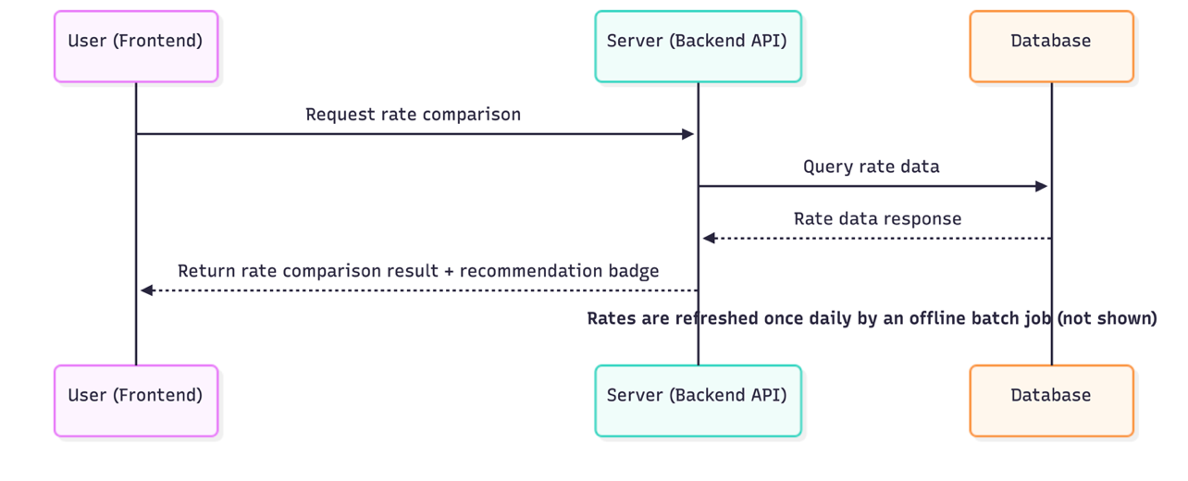

17.2 Currency Exchange Reservation
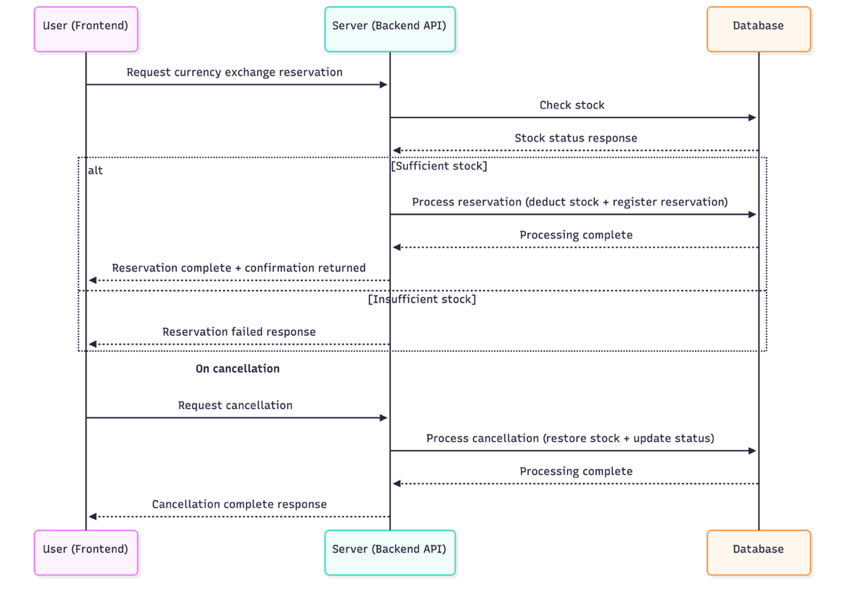

17.3 Cash Pickup / QR Redemption
Unlike §17.1/17.2 (abstracted to three lanes), this flow adds a fourth lane, Staff (Branch App), because redemption is staff-initiated at the pickup counter rather than user-initiated from the app. Diagram image pending — to be rendered from the Mermaid source below and inserted here, matching the style of §17.1/17.2.

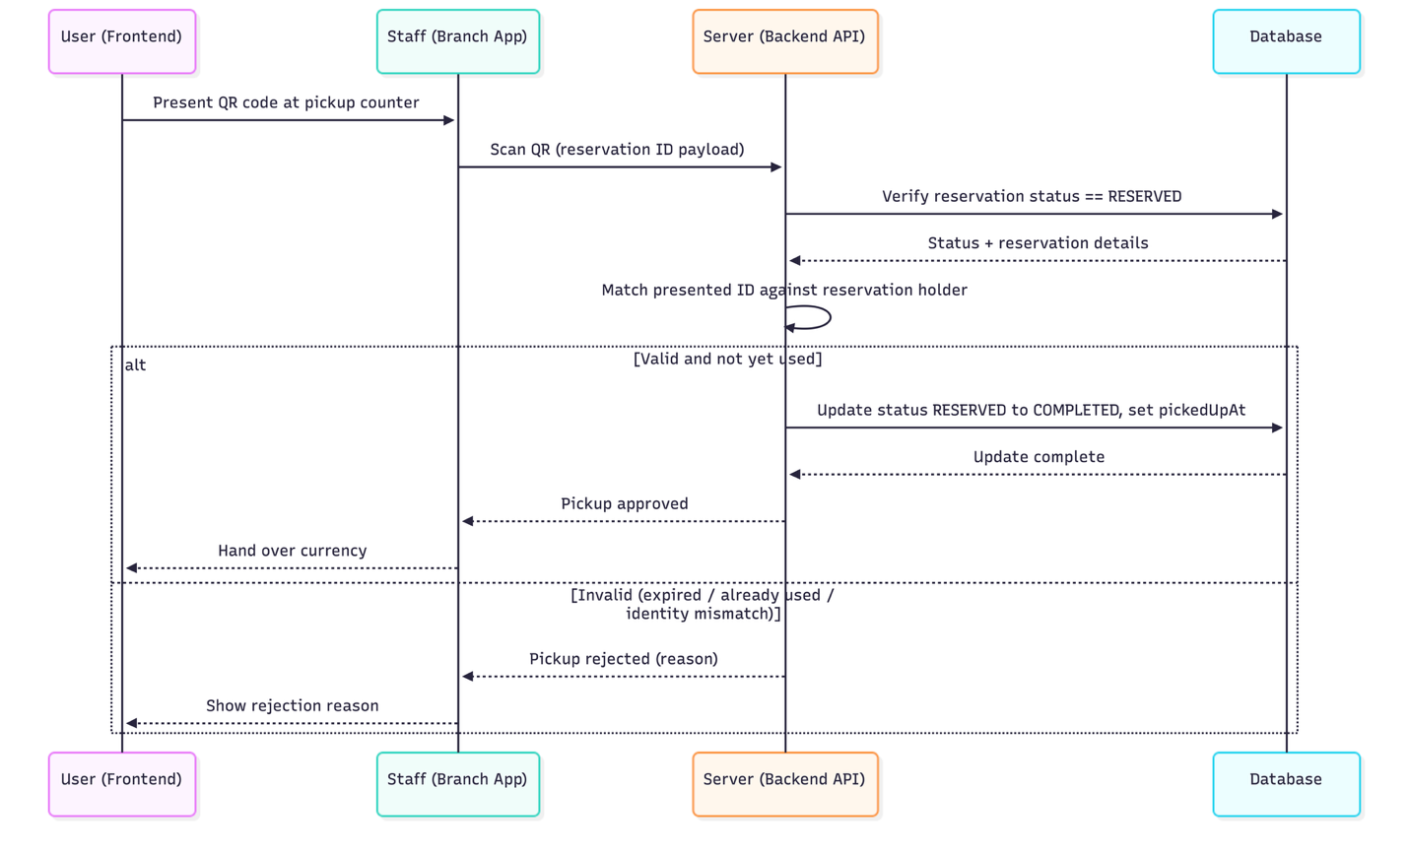

18. Detailed Design of the AI Exchange Shop Recommendation Feature

18.1 Purpose
To help travelers choose among nearby exchange shops when several are available, this feature ranks candidate branches with a composite score based on distance, rate competitiveness, availability, and reservation feasibility. It complements, and is independent from, the exchange-timing recommendation in §9 — this feature ranks shops, not timing.

18.2 Inputs / Outputs
Field | Description
latitude, longitude | User's current location (required)
currency | Desired currency (required)
radius_km | Search radius (optional, default 5 km)
top_n | Maximum number of branches to return (optional, default 10; the Rate Detail screen requests top_n=4)
total_score | Final recommendation score (0–1)
breakdown | Per-factor contribution: distance_score, rate_score, availability_score, reservation_score
is_open_now, reservation_available | Status flags used for UI badges
is_best_rate_nearby | Boolean flag — true if this branch has the lowest sell rate among nearby branches (independent of total_score)

18.3 Scoring Logic — Phase 1 (Rule-based)
score = w1·distance_score + w2·fee_score + w3·availability_score + w4·reservation_score
Initial weights: w1 = 0.35 (distance), w2 = 0.35 (rate/fee competitiveness), w3 = 0.20 (availability), w4 = 0.10 (reservation feasibility). Weights are configurable service-policy values, not hard-coded. Results are sorted by total_score descending, with distance_score as the tiebreaker; the top-scoring branches are highlighted on the map.

18.4 Weight Optimization — Phase 2 (Logistic Regression)
Once click/conversion data accumulates, weights w1–w4 are re-derived by training a logistic-regression model that predicts click likelihood from the four sub-scores as features — the learned coefficients become the new weights, preserving the interpretable rule-based structure. Retraining runs as a periodic batch job (e.g., Spring Scheduler, daily or weekly).

18.5 Considerations
- Selection/position bias: users disproportionately see top-ranked branches; add exposure position as a feature, or apply Inverse Propensity Scoring correction.
- Conversion vs. click: to optimize for actual reservations rather than clicks, switch the training label to conversion, or use a two-stage click × conversion model.
- Phased rollout: launch MVP with rule-based scoring (Phase 1); move to logistic regression once sufficient click/conversion data exists; consider Learning-to-Rank or contextual bandits as usage matures.

18.6 Display and Disclaimer
Recommendation results are displayed as a sorted list with map highlights; the final choice of exchange shop remains with the user. The same disclaimer as §9.6 applies: this is not investment or financial advice and is provided for reference only.

19. Reservation, Cancellation & No-Show Policy

19.1 Reservation Policy
Item | MVP Policy | Rationale
Deposit | None | Minimizes friction and operational overhead
Reservation hold | 2 hours from booking time | Benchmarked against bank internet-exchange practice
Cancellation | Free before visit | No penalty since no deposit is collected
Stock handling | Stock is held at booking time and auto-released on expiry | Prevents wasted inventory
Large-amount reservations | Not supported at or above USD 10,000 | Avoids complex legal/reporting procedures
Minimum exchange amount | 10,000 VND (equivalent) — reservations below this cannot be completed | Prevents trivial/spam reservations (value to be reconfirmed by team)
Time-slot capacity | Configurable per branch, applied in 30-minute pickup-time windows; a full slot becomes unselectable | Prevents pickup-time congestion; keeps counter wait times predictable

19.2 No-Show Risk Controls
No deposit is collected from travelers, to keep the barrier to entry low. Instead, the system protects each branch's opportunity cost through the following controls:
- User trust penalty: a user with a no-show in the last 30 days is limited to 1 concurrent reservation; 3 or more cumulative no-shows blocks new reservations for 7 days.
- Dynamic inventory rotation: a branch/time-slot's reservation-only allocation flexes with its historical no-show rate; if a user neither arrives nor can be reached as the hold nears expiry (e.g., 30 minutes before), the hold is released back to walk-in inventory.

19.3 Time-Slot & Waiting Policy
Reservation pickup times are organized into 30-minute time slots. Each branch sets its own maximum number of concurrent reservations per slot (Branch.timeSlotCapacity, §12). When a slot reaches capacity it is marked unavailable and cannot be selected — the MVP does not offer a waitlist or automatic queue promotion.

20. Exchange Shop Partner Policy

20.1 Reservation-Only Stock Model
Branch staff cannot be relied on to keep app inventory synced with real-time walk-in sales, so TravelX avoids real-time sync entirely. Each morning, a branch sets a reservation-only quantity per currency in the admin page (e.g., 2,000 of the day’s 5,000 USD on hand). Only that quantity is consumed by app bookings; the rest is sold freely walk-in and never touches app stock. Once the reservation-only quantity is exhausted, the app shows that currency/branch as fully booked for the day — an expected "sold out" state, not a bug. Branches can tune this quantity to control how much of their inventory they expose to the app

20.2 Happy-Hour Incentive
Branches may designate specific low-traffic time windows (e.g., weekday mornings) with an extra preferential rate to attract app bookings during slow periods, improving counter utilization.

20.3 Inventory & Demand Analytics Report
Branches receive aggregated reservation-trend data (by day of week, time of day, currency) to help them plan appropriate stock levels and avoid exchange-rate exposure risk from over- or under-stocking.

20.4 Non-Fulfillment Compensation & Shop Penalty Tiers
Situation | User-Facing Response | Branch Penalty
Reservation stock unavailable at pickup (branch’s fault) | Immediate notification + automatic referral to the nearest branch with availability | 1st occurrence: warning notice only
3 cumulative violations | Same as above | Search-ranking demotion
5 cumulative violations | Same as above | Reservation-only stock listing suspended pending re-approval
Compensation is a re-routing guarantee, not a refund, since no deposit was collected. Because penalties directly affect a branch’s visibility in the app, branches that keep the reservation-only stock correctly separated are rewarded with more bookings.

20.5 Why Branches Participate
- Customer-acquisition channel for shops without their own marketing reach
- Demand forecasting from reservation data to plan staffing and inventory
- Controllable inventory-exposure risk — branches expose only as much stock as they choose

21. Legal & Compliance

21.1 Exchange Business Registration
Under Article 8(3) of the Foreign Exchange Transactions Act, operating a currency exchange business requires registration with the relevant Customs office. Registration is not required during this internship/toy-project phase; this PRD notes it as a requirement for any transition to a live commercial service.

21.2 Transaction Limits & Reporting
- ID verification is required for exchanges over KRW 1,000,000.
- Same-day exchanges of USD 10,000-equivalent or more are automatically reported to the National Tax Service; travelers carrying more than USD 10,000 out of the country must declare it to Customs. Violations: up to 5% of the amount for amounts ≤ USD 30,000, or imprisonment up to 1 year / a fine up to KRW 100,000,000 for amounts > USD 30,000.
- MVP applies this by disallowing reservations at or above USD 10,000, with an upfront notice for amounts approaching the threshold.

21.3 KYC / CDD
Exchange businesses are subject to customer due diligence under the Act on Reporting and Using Specified Financial Transaction Information for cash transactions around USD 10,000 conducted without an account (verifying identity, address, and contact information; enhanced due diligence for high-risk customers). TravelX applies a two-stage verification: phone verification at reservation time, and staff ID check at pickup — with an on-screen reminder to bring an ID for larger reservations.

22. Key Performance Indicators (KPI)
Goal: enable travelers to compare and reserve real, trustworthy branch exchange rates without waiting, while giving branches efficient inventory management and maximized offline customer acquisition.
KPI | Definition | Target
Rate-comparison usage rate | Share of all users who use the rate-comparison page | ≥ 60%
Look-to-book conversion | Share of rate-detail views that start the reservation flow | ≥ 20%
Reservation completion rate | Share of started reservations that are confirmed | ≥ 60%
End-to-end funnel completion | Share of app entries that reach final in-branch pickup | ≥ 50%
No-show rate | Share of confirmed reservations cancelled by non-visit | ≤ 30%
Voluntary cancellation rate | Share of no-visit reservations cancelled voluntarily before the 2-hour expiry | ≥ 50%
Branch fulfillment rate | Share of confirmed reservations completed normally with no branch-caused failure | ≥ 98%
Alternate-match success rate | Share of branch-caused failures successfully re-routed to a nearby branch and picked up | ≥ 40%
Average transaction value (ATV) | Average amount per completed reservation | Ongoing monitoring

23. Competitive Landscape (Updated)

23.1 Rate Comparison & Reservation
mibank is the closest direct competitor: it already compares rates across banks and private exchange shops in real time with location-based nearby-branch search, bundled with travel insurance and deposit-rate comparison. User reviews report weak support for shortchanging/counterfeit-note incidents. Because mibank has no reservation or stock-hold feature, TravelX’s differentiator is the compare + reserve combination, not comparison alone.
Travel Wallet is a prepaid FX card with an auto-charge "reserve at target rate" feature, but it settles entirely in-app with no pickup step, so its "reservation" has no expiry or no-show concept — reinforcing the need for TravelX’s own expiry and no-show policy.
Bank internet-exchange offers up to 90% preferential rates, but pickup branch/time availability varies by bank, and the Korea Federation of Banks’ rate-comparison disclosure excludes private exchange shops entirely.
Travel-card fee and re-exchange-fee structures across 4 major products were reviewed as a reference point for reservation-cancellation penalty design.

23.2 AI Recommendation
Coeur16’s AI daily FX-prediction service reports roughly 66–70% directional accuracy at 5 business days out, even at industry-leading maturity — confirming that "90% prediction accuracy" is not a realistic MVP target. §9 and §18 use conversion/click-through KPIs instead of raw prediction accuracy. Existing travel-industry AI features (Hana Tour, Interpark Triple, Chamjoeun Travel) are all assistive recommendation layers, not autonomous decision-makers — consistent with positioning both of TravelX’s AI features as reference/assistive only.

24. Wireframe Requirements (Reference)

Screen/Feature | Required Elements/Description
Home | Currency selector, amount input, entry point to the rate-comparison list
Exchange Comparison | Per-branch rate/distance/hours list, AI-recommendation sort toggle
Reservation | Planned visit-time picker, reservation summary, expiry notice
AI Recommendation | Plain-language reason summary, recommendation ranking display
My Reservations | Reservation status (Upcoming/Completed/Cancelled), countdown to expiry
Staff Confirmation (branch) | Reservation-holder info, ID-check button, payment-complete button; QR-scan action, rejected-state UI (expired / already used / identity mismatch)
Currency Search | Recent searches (hidden if none) and popular currencies shown before input; selecting a currency navigates to Rate Detail
Rate Detail | List of AI-recommended nearby branches, "not investment advice" disclaimer, "Reserve now" entry point
Branch Detail | Address, business hours (today highlighted), rate, "Best rate nearby" badge, map preview, "Reserve now" entry point
Branch Map | Map of registered branches only, pins reflect the selected currency's rates
Reservation Complete | Success confirmation, reservation number, amount/location/date summary, links to Reservation Detail and Home
Reservation Detail | Status badge, QR code view (upcoming only), cancel with confirmation modal, receipt download (completed)
Exchange History | Completed/Cancelled tabs, past transaction list, read-only detail link
My Page / Notifications | Profile card (read-only), menu links (Notifications, My Reservation, Exchange history, Log out); notification list with mark-all-as-read and empty state
Admin Login | ID/Password input fields, Login button (system-issued accounts only, no sign-up)
Admin Dashboard | Today's total users, number of pending reservations, currencies ranking (sorted by volume), recent confirmed reservations list, left sidebar navigation
Exchange Rates | Selected shop location info, base/target currency pairs list, input fields for Buy/Sell rates and Fee percentages, "Save changes" button, left sidebar navigation
Inventory | Selected shop location info, currency list with stock balances, "Low stock" status badges, "Adjust stock" button, left sidebar navigation
Reservations | Search bar, status filter tabs (ALL, Completed, Cancelled, Pending), reservation list with customer details and status badges, pagination, left sidebar navigation
QR Scan | Camera scan area with guide; Scanned reservation details (customer info, transaction details), "Complete" and "Reject" action buttons; Success/Reject status result UI with transaction summary and "Back to list" button, left sidebar navigation
Settings | Shop detail input fields (Name, Latitude/Longitude, Operating hours, Slot reservation limit), pre-filled current values (for modify), "Adjust stock" (Save) button, first-time registration forced redirect, left sidebar navigation

25. Appendix — References
- Korea Eximbank Open API — data.go.kr
- ExchangeRate-API — exchangerate-api.com
- ExchangeRate-API free tier updates once daily and does not include historical data (historical data requires a paid plan); used only as a fallback/secondary rate source.
- Google Maps Platform – Places API (Nearby Search) — reference for a future enhancement of branch-proximity search; not required for the MVP rule-based scoring in §18.

