**Comic Corner Data Structure**

1. **Description:** Comic Corner is a store that sells comic books for young people and those who are young at heart.
2. **Entity Relational Diagram**

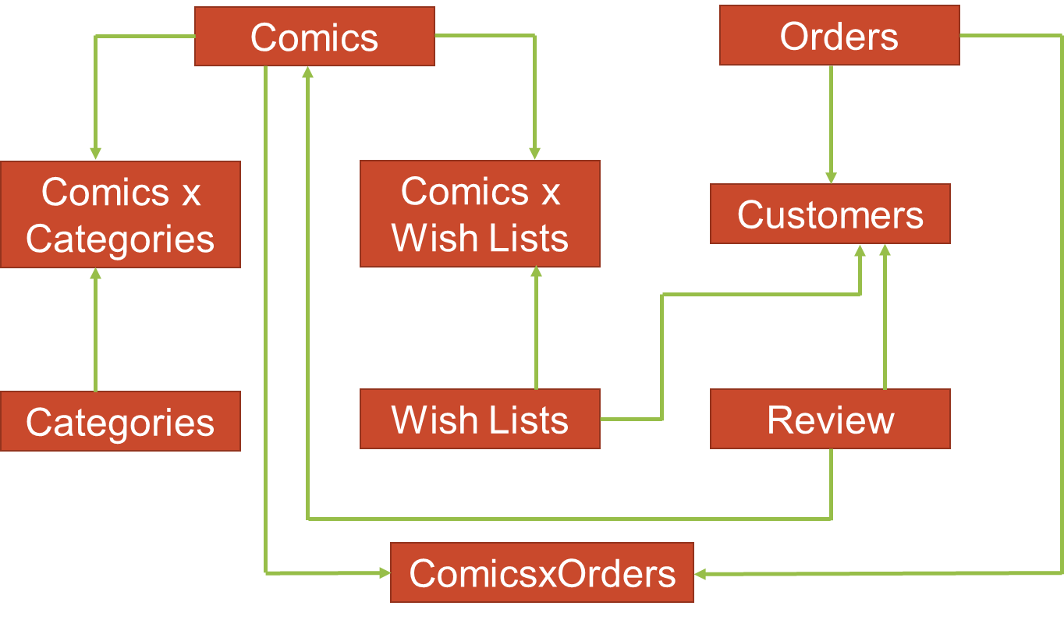

1. **Justification of ERD**

**3.1) Comics and Categories: Many to Many**

A category can have many comics under it. A comic may belong to many categories. For example: the comic named The Killing Joke may lie under DC Comic Category but also belong to a Super Villain Origin Story. That way, users can have more ways to search for the comic they like.

**3.2) Comics and Order: Many to Many**

An order can have many comics as we want our customers to buy more and more. One comic book can appear in many orders if that is a popular one.

**3.3) Comics and Wish List: Many to Many**

Customer may make many wish lists as they like. In there they can put the same comic books as they wish. For example, they can create a Wish List called Birthday present for Sean with the latest issue of Batman in it. If they wish to have the same comic as a present for another friend in another wish list, they should be able to do that too.

**3.4) Reviews and Comics: One to Many**

Under one comic, there will be many reviews from different users. But that reviews could only be seen when you click onto that specific comic.

**3.5) Customers and Orders: One to Many**

Follow the same discussion in 3.2), we wish our customers to buy more and more so they can make many orders as they like. Moreover, for a comic store, one order should usually be under the name of one customer as it is for personal use.

**3.6) Customers and Reviews: One to Many**

One customer can write many reviews under many comic as they like but that review will belong to just him/her only.

**3.7) Customers and Wish Lists: One to Many**

One customer can write many wish lists with different comics in it. And because it is a personal purchase, they are the only one who can view and update that wish list.