**Pet Grooming Entity Relationship Diagram**

Name: **Viet Phuong Tran**

Student No.: **n01400583**

1. Pet to Species: One to Many

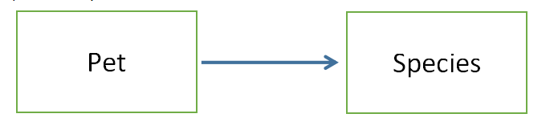

A single pet belong to just one species, but you can have many pets in a specific species.

1. Pet to Owner: One to Many

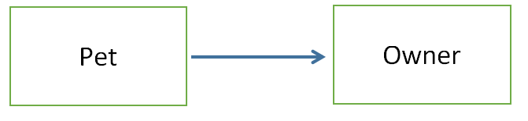

A pet belong to one owner. An owner can have many pets. Although in real life a pet can have multiple owners, for a pet store, it is enough to associate just one owner to the pet. In that way, the invoice will be issued to one person only so we can save time collecting money. We also just need one person to contact when the pet is in store.

1. Pet to Groomer: One to Many

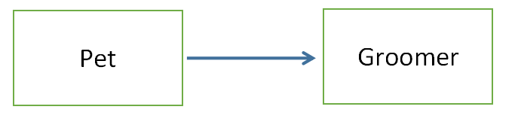

A groomer can groom many pets. A pet can be groomed by only one groomer at a given time. Some customers may want their pet to be taken care of by a familiar hand. This data structure support that needs. Moreover, it is more efficient to have just one groomer take care of the pet from start to finish.

1. Bookings and Services: Many to Many

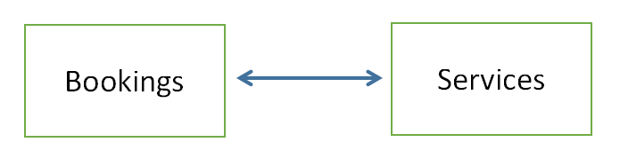

One booking can have many services. One service can appear in many booking. For example, customer may want to give their pet a bath and trim his nail. Other may want to give their pets a manicure service in their booking as well. This data structure will support that type of situation.

1. Bookings to Groomer: One to Many

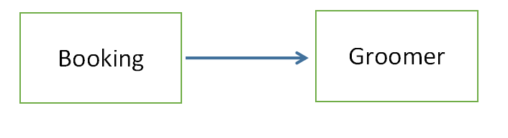

One groomer will take charge of many bookings. One booking belong to just one grommer. Follow the discussion in 3), a groomer will take care of a pet from start to finish so the booking will have only one grommer’s name on it. Moreover, we are not hire a groomer to take care of just one pet, one booking so their name will appear in several orders.

1. Booking to Owner: One to Many

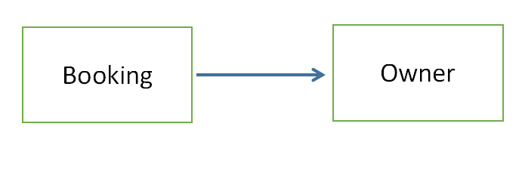

An owner can have many bookings as they have more than one pets. However, a booking may only belong to one owner.

1. Booking to Pet: One to Many

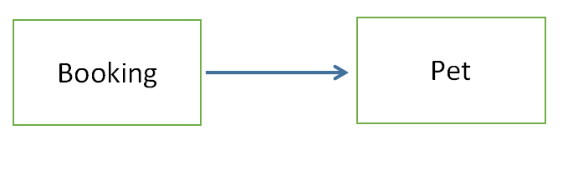

Follow the same logic in 6), a pet can have many bookings as they can enjoy many services in our grooming. However, one booking may only belong to one pet.