GitHub repo: <https://github.com/vietphuvn/ImageFilter>

Deployment command:

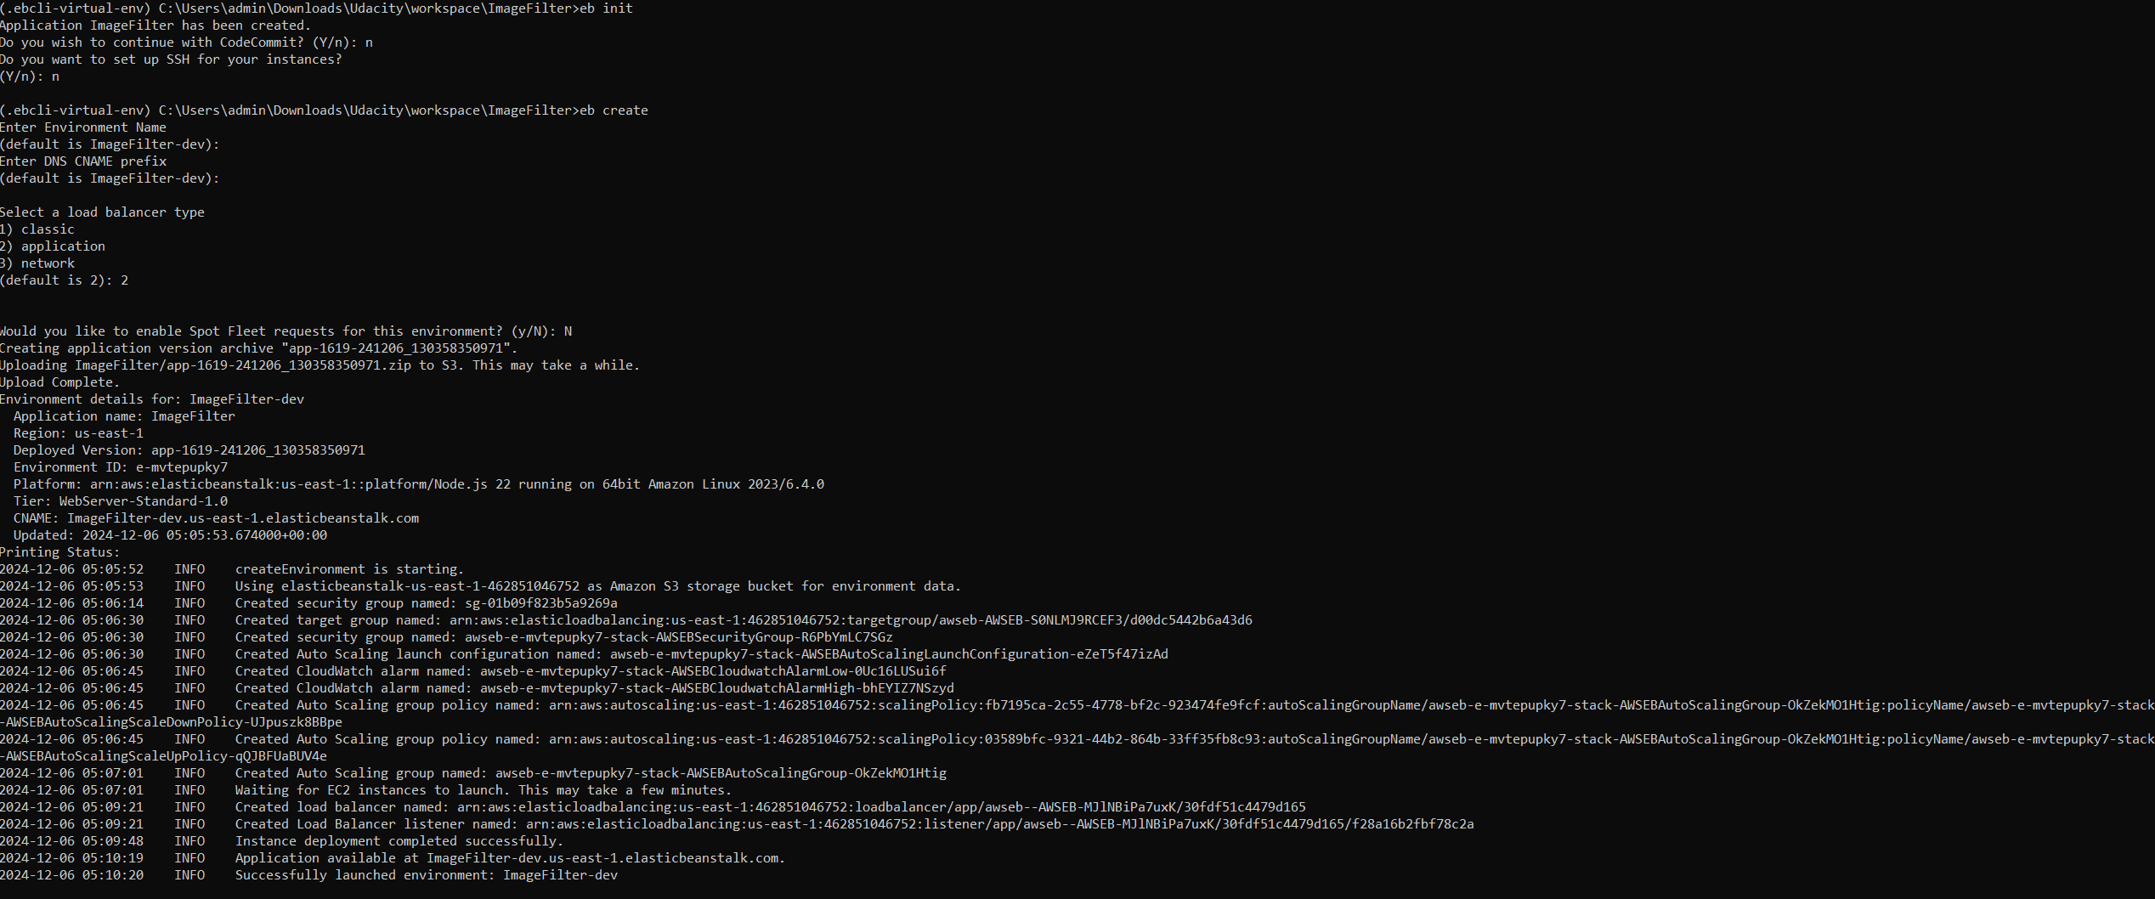

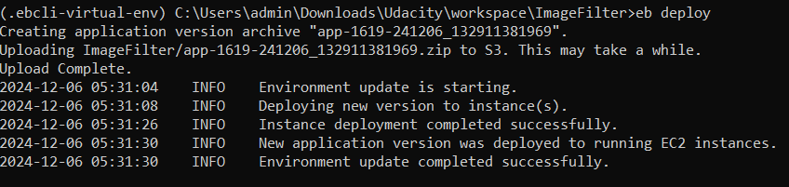

Elastic Beanstalk ENV:

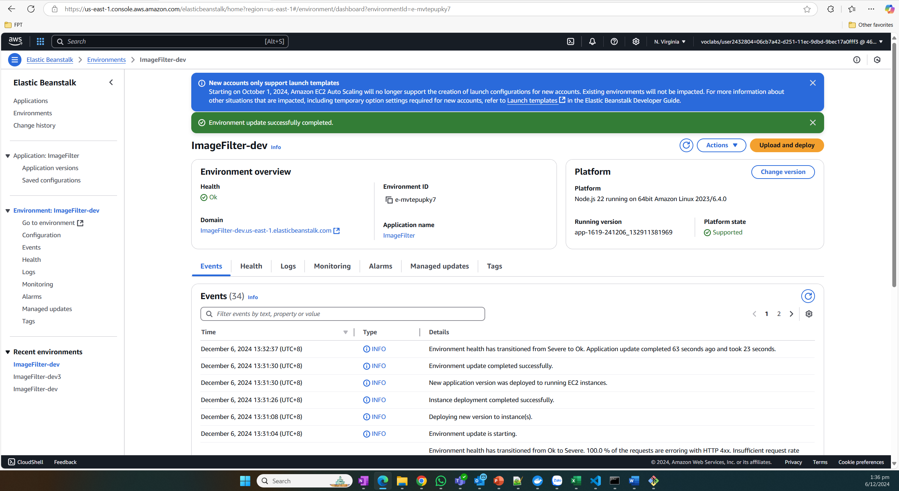

API:

<http://imagefilter-dev.us-east-1.elasticbeanstalk.com/>

<http://imagefilter-dev.us-east-1.elasticbeanstalk.com/filteredimage?image_url=https://upload.wikimedia.org/wikipedia/commons/b/bd/Golden_tabby_and_white_kitten_n01.jpg>