The Battle of Neighborhoods

*Analyzing restaurants in the neighborhood of Toronto*

**1, Introduction:**

* Problem: Analyzing the restaurants in the neighborhood of Toronto.
* Audience: Everyone who wants to open a restaurant in the neighborhood of Toronto, they want to find the best place for opening, locations and distributions of other restaurants in every neighborhood, what type of restaurants are popular among these areas.

**2, Data**

* Foursquare location data: an API from Foursquare helps us to explore restaurants around Toronto such as longitude, latitude, venue, venue category ...
* List of postal codes in Canada from Wikipedia: postal codes of Canada to interact with Foursquare API

**3, Methodology**

* EDA: explore neighborhoods of Toronto and restaurants, find out what is the most popular type of restaurant for every neighborhood
* Cluster: split neighborhoods of Toronto into cluster based on favorite restaurants in every area

**4, Get data, clean data and analyze**

* Scrap data from Wikipedia, clean “Not assigned” data, add Latitude and Longitude
  + We scrap data from Wikipedia via this link: <https://en.wikipedia.org/wiki/List_of_postal_codes_of_Canada:_M>
  + This data consists of all postal code of Canada starting with M letter. So we need to scrap by using BeautifulSoup library, then filter all neighborhood containing “Toronto” to get all postal code of Toronto neighborhoods.
  + We clean data by deleting all “Not assigned” borough, and any neighborhood named “Not assigned” will be replaced by Borough name.

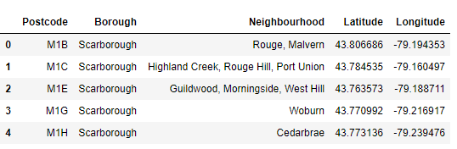

* Then we get restaurants around Toronto by using Foursquare explore API.
  + We use latitude and longitude of neighborhood to get venues in food category of Foursquare explore API.
  + The results consists of all food-related venues such as restaurant, food store… Then we must filter all venue category containing “Restaurant” keyword to get only restaurants.

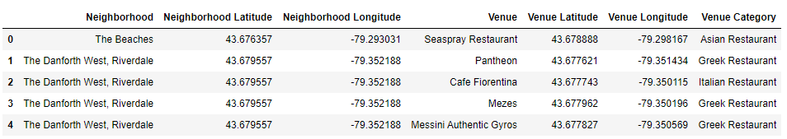

* We draw map of restaurants around Toronto to find the distribution of all restaurants. Clearly, we can see that they are mainly in the center of Toronto.

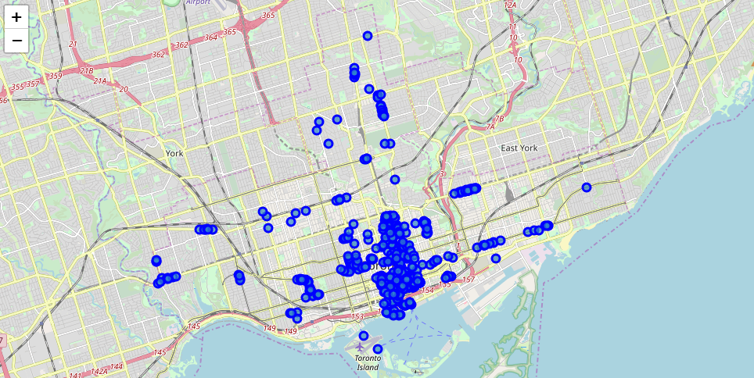

* We get lists of top 10 favorite restaurants in every neighborhood. As we can see, general restaurants and Italian restaurant are the dominants.

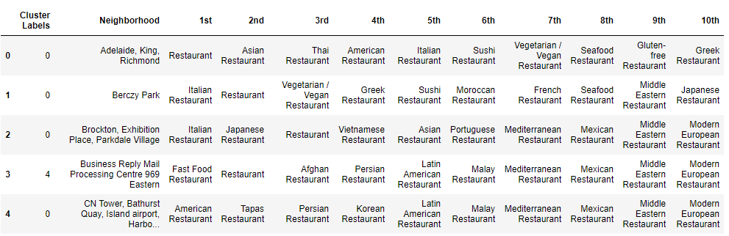

* Next, we cluster neighborhoods by favorite restaurants to find the similar neighborhoods. We create 5 clusters.

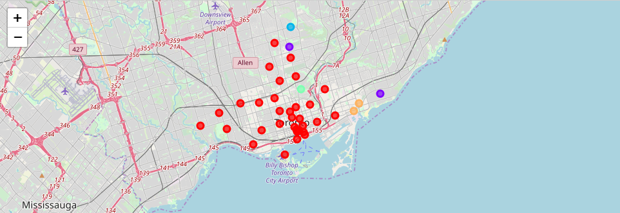

**5, Result and Discussion**

Our analysis shows that general restaurant, Italian, Afghan and Polish seems to be the most popular types of restaurant in Toronto.

We split these neighborhoods into 5 clusters.

* Cluster 0 (84.21%): the most popular cluster, focusing on general, Italian, Sushi and American restaurant
* Cluster 1 (5.26%): Asian, Afghan and Polish
* Cluster 2 (2.63%): Dim Sum, Afghan and Polish
* Cluster 3 (2.63%): Japan, Afghan and Polish
* Cluster 4 (5.27%): Fash Food, Italian, Sushi, Restaurant, Afghan

**6, Conclusion**

* Purpose of this project was to identify which area is suitable for opening a restaurant. By analyzing restaurants around Toronto from Foursquare data, stakeholders can choose an optimal location for the restaurant, and know what type of restaurant is suitable (a general restaurant, Italian restaurant or American restaurant ...)
* Final decission on optimal restaurant location will be made by stakeholders based on specific characteristics of neighborhoods and locations in every recommended zone.