**ĐẠI HỌC KINH TẾ - TÀI CHÍNH TP. HCM**

**KHOA CÔNG NGHỆ THÔNG TIN**



**PROJECT REPORT**

**SOFTWARE TECHNOLOGY**

**TEACHER**

TS. NGUYỄN THỊ THANH TRÚC

**TÊN THÀNH VIÊN**

NGUYỄN VIẾT THANH - 175050001

NGUYỄN THỊ THÚY LINH - 175050278

Contents

**CHƯƠNG I: THE OPENING CHAPTER** 5

**1.1. Project Name:** 5

**1.2. The reason to choose this topic:** 5

**1.3. The purpose of the system:** 5

**1.4. Sources of investigation:** 5

**1.5. Research Methods:** 5

**CHƯƠNG II: SURVEY OF THE SYSTEM AND ESTABLISHING THE PROJECT** 6

**2.1. Investigate library system:** 6

**2.1.1. Preliminary survey of the system:** 6

**2.1.2. Summary of the project:** 6

**2.1.3. Problem:** 7

**2.1.4. Determine customer requirements:** 11

**2.2. Analyze customer requirements:** 11

**2.2.1. Usecase Book:** 12

**2.2.2. Usecase Account:** 13

**2.2.3. Usecase Bill** 13

**2.4. Thiết kế giao diện ban đầu:** 14

**CHƯƠNG III: IMPLEMENTATION OF THE PROJECT** 17

**3.1. Assignment of work:** 17

**3.2. Describe the working process:** 18

**3.2.1. Database design:** 18

**3.2.2. 3-layer model design for the project:** 18

**3.2.3. Stored Procedure:** 20

**CHƯƠNG IV: REFERENCES** 21

**CHƯƠNG V: CONCLUDE** 22

**5.1. Evaluate:** 22

**5.2. Advantages:** 22

**5.3. Disadvantages:** 22

***LỜI NÓI ĐẦU***

It can be said that, in the past 100 years, these are the years of science and technology, human intelligence has constantly been raised to a new level, and scientific achievements have been invented daily and hourly in order to recover. service for future research. Not outside the rhythms of the era, Information Technology also develops like a storm with a series of utilities that are increasingly effective for life. Electronic computers are no longer a luxury item, but increasingly an effective working and entertainment tool for human beings. On the other hand, our country is on the path of industrialization and modernization. Computerization of all branches is an urgent issue. Any profession requires certain requirements, not only is IT applied massively but most importantly, it has to meet the very diverse requirements of the user. In order to do that, building a management software in accordance with the practice is very important and always a challenge for those who make the software.

Today, in the era of global information technology boom, countries around the world are trying to apply information technology to modernize their production and business processes to achieve economic efficiency. Software Engineering is one of the most interesting fields in computer science.

           Currently, with the development of science and technology, especially information technology, computer components are increasing and the cost is getting cheaper. On the other hand, thanks to modern technology, people's lives are getting more and more interesting. Some people always want to have some modern items in their home: computers, televisions, refrigerators, laptops, etc. Businessmen want to meet the needs of customers (fast, convenient and accurate). ) and has just reduced the cost of hiring. Today, computers are born, their management becomes easier, less effort-consuming, time-saving. Our "Library Management" topic will describe a certain part on Book Management in the School Library.

# **CHƯƠNG I: THE OPENING CHAPTER**

## **1.1. Project Name:**

Develop the program "Library Management of the University".

## **1.2. The reason to choose this topic:**

In recent years, the demand for reading is growing a lot. Many libraries have been built, many types of books have been imported to meet the needs of students.

Currently, the library must directly receive and manage a large number of books and students. Therefore, the task of managing, receiving and handling student requests becomes complicated.

Moreover, the management is not only about the quantity of books, but also the need to borrow books, information about existing books and money to buy and borrow books so that it can be met. be in demand and provide a wealth of knowledge to students. But with the current storage and handling by hand, it will take a lot of time and manpower without high efficiency. Therefore, it is necessary to computerize the management form, namely building a software to meet the current needs, unify and achieve the highest efficiency for library management activities.

Due to the above needs, my group decided to choose the topic: "Building the School's Library Management Software".

## **1.3. The purpose of the system:**

Build a library book management software. The goal management software manages library activities, in order to meet the most important needs for students. When applying IT to management, it will reduce the effort and time and help the school to grasp the situation of the library's operations so that decisions can be made quickly. In addition, the system also provides the school with the status of the entire library, through the library's statistical summary.

## **1.4. Sources of investigation:**

Surveying the actual system.

Fieldwork at the library.

Gather information from the library.

Gather information and needs of students.

Consult the parents.

## **1.5. Research Methods:**

In order to make the system construction accurate, complete and close to reality, our group conducted direct surveys at the library, related subjects such as students and parents.

After surveying the system, with the knowledge and programming languages learned in the school, my team decided to choose C # language to implement this program. With outstanding features such as applications running on Windows are very suitable because its programming library is very powerful, diverse and friendly, communicating with other applications easily, ... C # is an option Choose very good for the idea implementation.

# **CHƯƠNG II: SURVEY OF THE SYSTEM AND ESTABLISHING THE PROJECT**

## **2.1. Investigate library system:**

### **2.1.1. Preliminary survey of the system:**

The organizational structure of the current library:

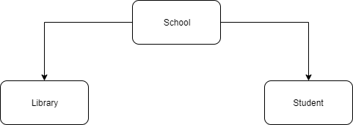

The school: is responsible for direct management of students, the library, all library issues must go through the school and the school reserves the right to decide all information handled in the library.

Library: is responsible for completing the work of making loan repayments, finding books and managing books, receiving students' requests, solving questions and helping students wholeheartedly.

Students: have access to the management system, but have limited functionality, can look up current book information, about to run out and end, view their account status and change passwords.

### **2.1.2. Summary of the project:**

**2.1.2.1. Summary of the activities of the project:**

Library management software:

- Allow users to access the system, view book information, change their passwords.

- Allow the librarian to make a loan slip, pay, or buy, view accurate information and quantities, check student information.

- Allow the school to do everything, change information, username, password and enter books, check library information and enter all kinds of faculties…

**2.1.2.2. Scope of the system used:**

Used for UEF University's economics and finance library.

**2.1.2.3. Main user object:**

School , Library and Student.

### **2.1.3. Problem:**

When students enter the library, the librarian will accept the request and make a loan slip or purchase student documents. Before making a vote, the library must know the requirements of the student, check if the library can meet the needs of the students or not, if not then must refuse, otherwise the loan slip will be made. or pay for students.

Each student when carrying out procedures for borrowing or buying will be assigned a separate bill code, along with information to facilitate the payment, warranty and return documents later. Student information includes: login name, title, sale price, rental price, quantity, purchase date, rental date, and which book information. This information is stored. If students come in for a return or a complaint, the library will retrieve the old bill information, to ensure that no errors have occurred.

In order to provide better knowledge for students while studying at the school, the library also provides additional preferential price list for students. When students return documents, librarians receive information to check old bills and delete them. The status of the account will then be updated for students.

In order to use the program, each student in the school will be provided with an account including a username and a password. When using a decentralized school program, managing the entire program, the librarian's right to access the system only, create a bill, view an account and do everything in the librarian's authority. Student information includes: account code, username, password, rights and status of the account. This information is stored, eliminating students not studying in the school and changing the information as needed.

Analysis chart of library management system:

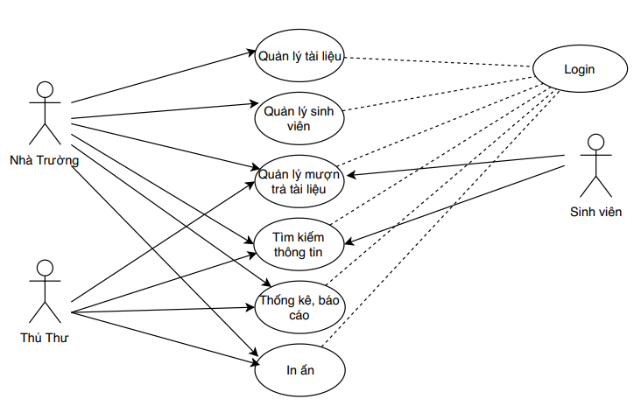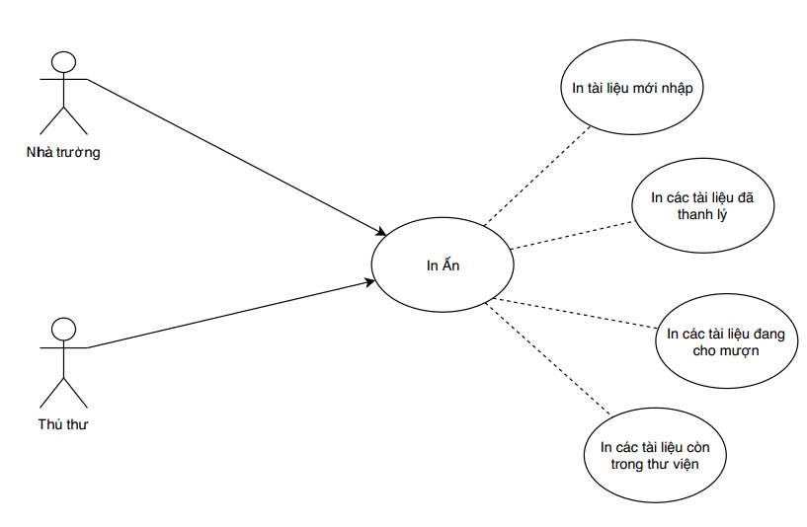

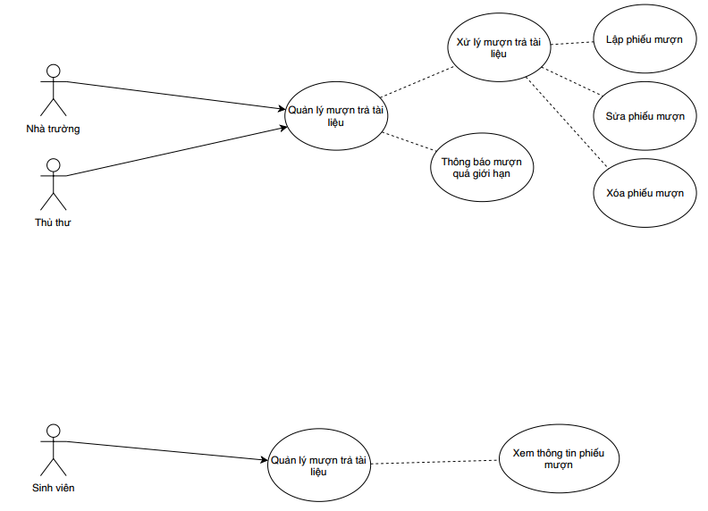

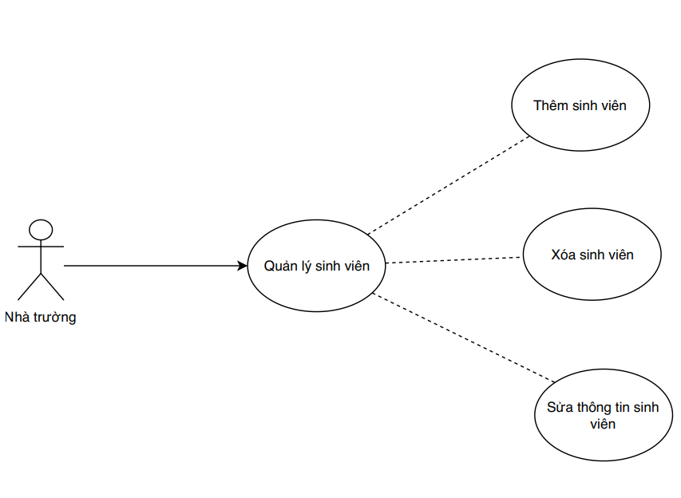

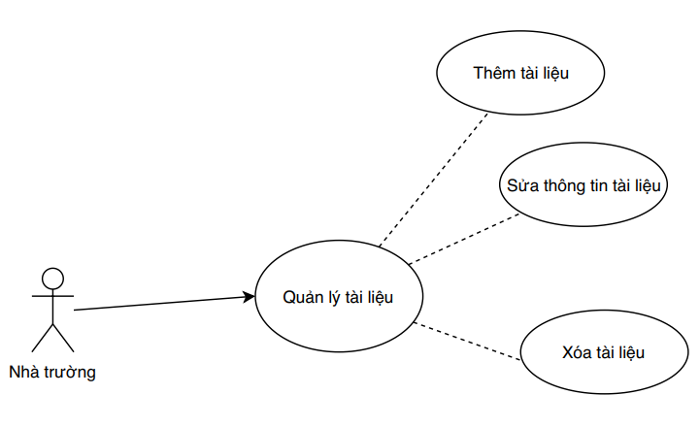 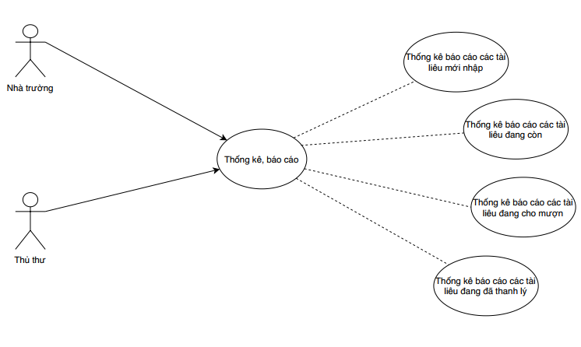

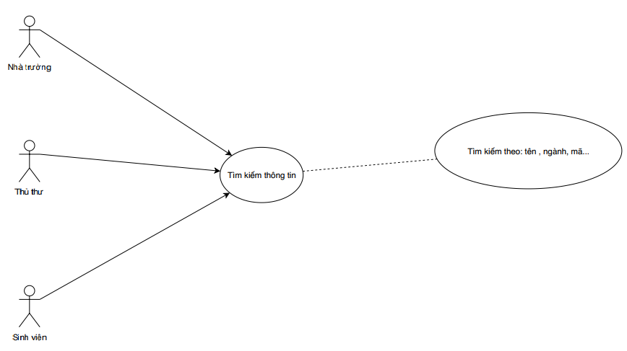

### **2.1.4. Determine customer requirements:**

The Application system should provide the following functions:

**2.1.4.1. Sign In:**

Based and username and password used to provide student powers. If you are a student, you can only use the forms: profile, book (but limited functionality).

**2.1.4.2. Book management:**

Book management: add, delete, edit, search books in the library.

**2.1.4.3. Account management:**

Account management: add, delete, edit, search account in the system.

**2.1.4.4. Bill management:**

Bill management: add, edit, delete, search bill related information

**2.1.4.5. Major management:**

Major management: add, edit, delete, search major

**2.1.4.6. Profile:**

Profile: Edit password , show account information

## **2.2. Analyze customer requirements:**

Usecase of the whole system:

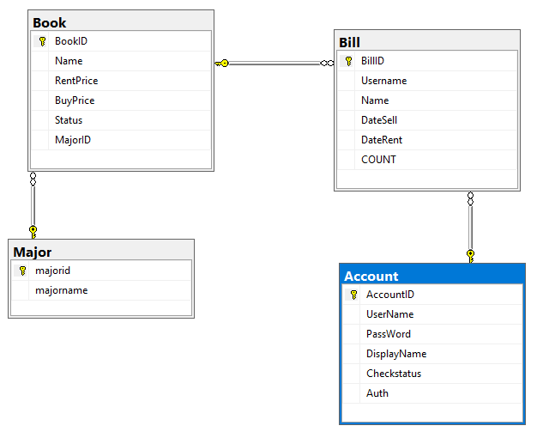

### **2.2.1. Usecase Book:**

Mô tả:

- BookID :Book’s Code.

- Name: Book’s Name.

- RentPrice: Book’s RentPirce.

- BuyPrice: Book’s BuyPrice.

- Status: Book’s Status.

- MajorID: Major’s Code.

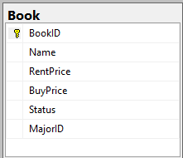

### **2.2.2. Usecase Account:**

Mô tả:

- AccountID: Account’s Code

- Username: Account’s Username

- Password: Account’s Password

- Displayname: Account’s Displayname

- Checkstatus: Account’s Checkstatus

- Auth: Account’s Auth

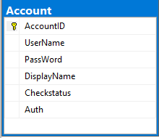

### **2.2.3. Usecase Bill**

Mô tả:

- BillID: Bill’s Code

- Username: Account’s Username

- Name: Book’s Name

- Datesell: Datesell

- Daterent: Daterent

- COUNT: Number book

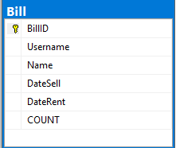

## **2.4. Thiết kế giao diện ban đầu:**

**Form Sign In:**

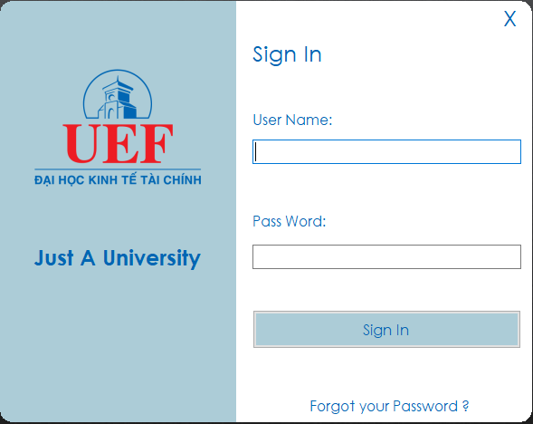

**Form Menu:**

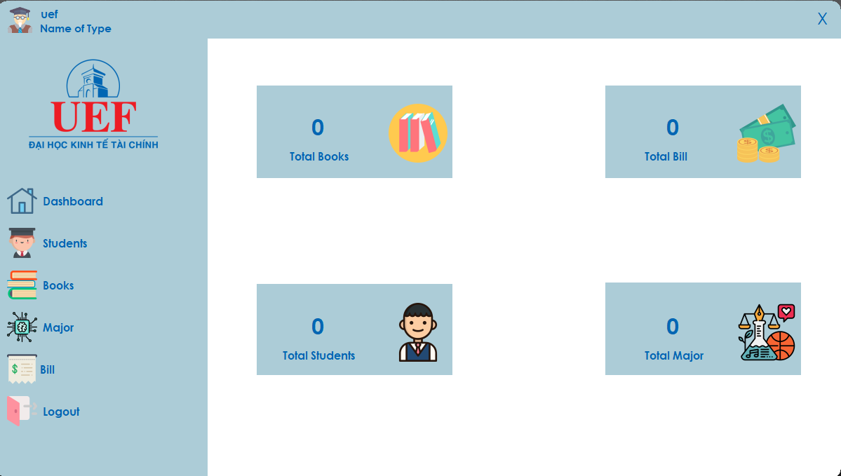

**Form Account:**

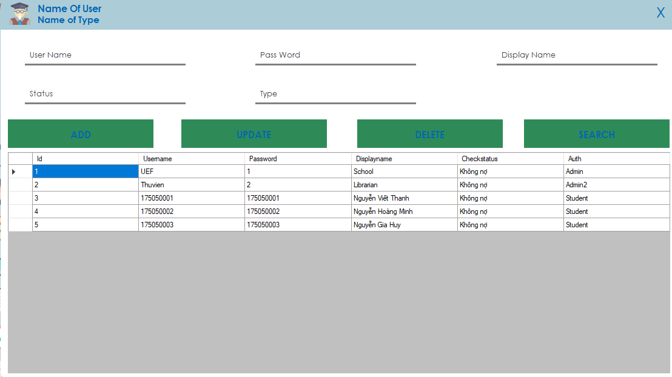

**Form Book:**

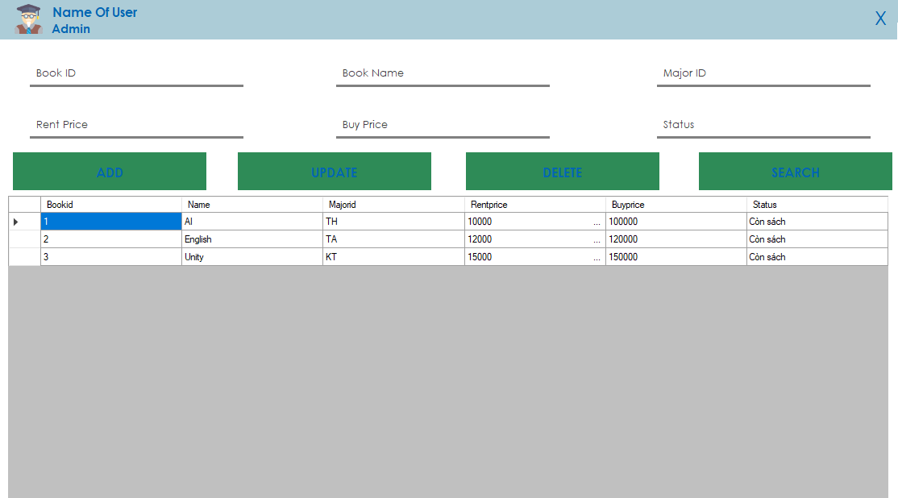

**Form Major:**

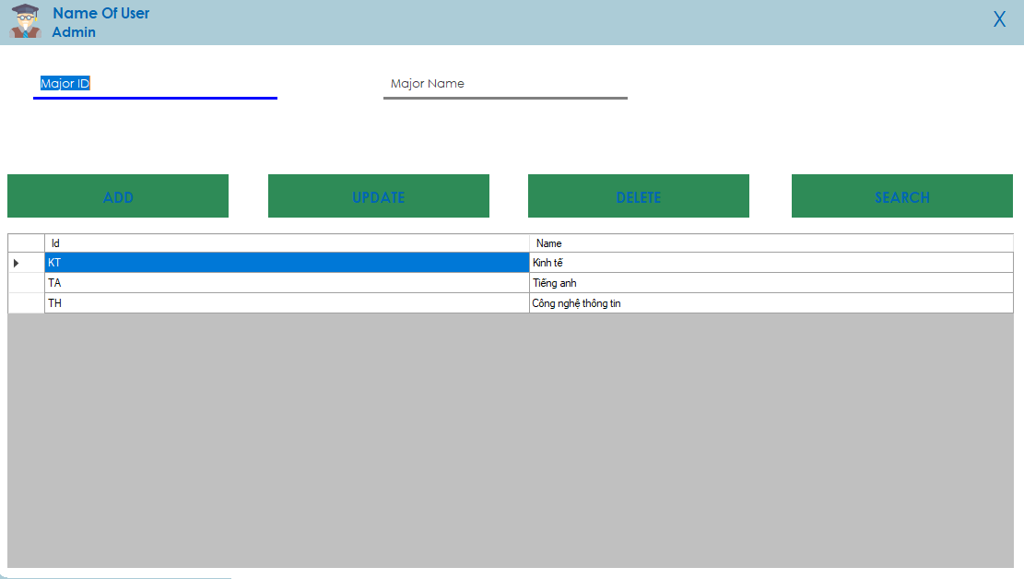

**Form Bill:**

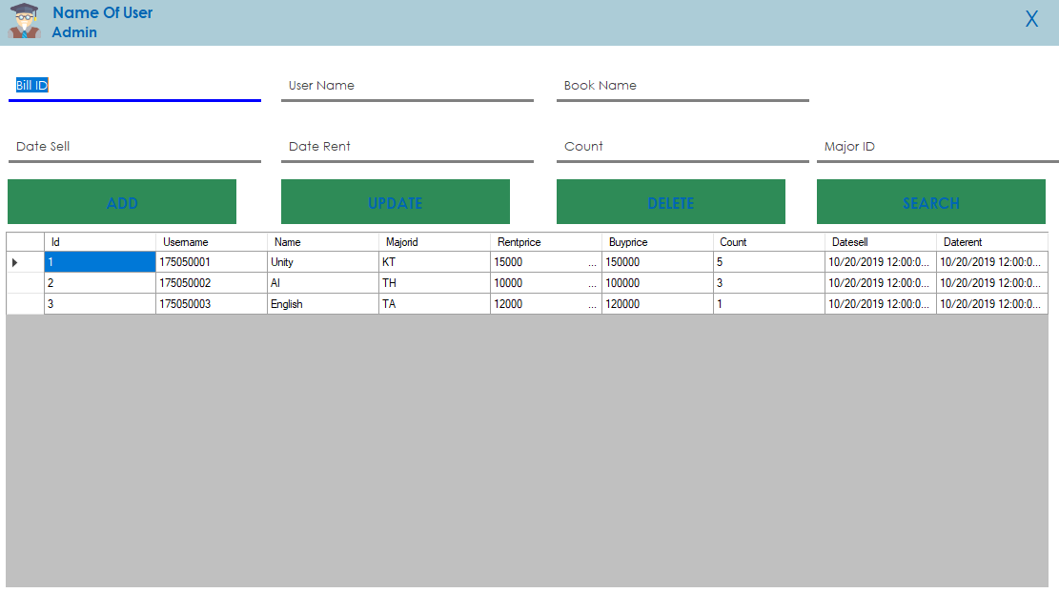

**Form Profile:**

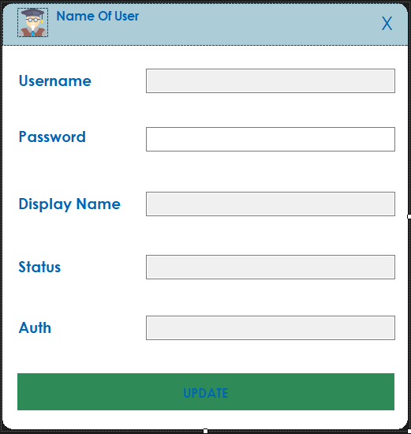

# **CHƯƠNG III: IMPLEMENTATION OF THE PROJECT**

## **3.1. Assignment of work:**

Surveying and designing Database for projects:

* Nguyễn Viết Thanh
* Nguyễn Thị Thúy Linh

Interface design and document lookup:

* Nguyễn Viết Thanh
* Nguyễn Thị Thúy Linh

Program:

- Nguyễn Viết Thanh

- Nguyễn Thị Thúy Linh

## **3.2. Describe the working process:**

### **3.2.1. Database design:**

Major Table:

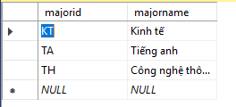

Account Table:

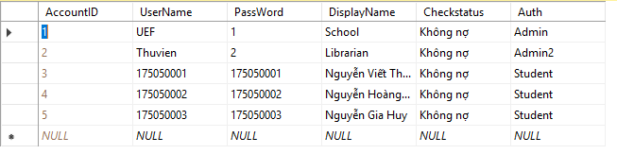

Book Table:

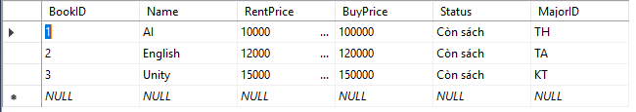

Bill Table:

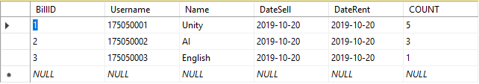

### **3.2.2. 3-layer model design for the project:**

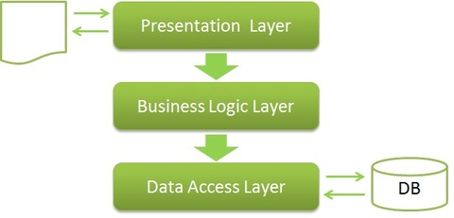

Explain the 3-layer model of the project:

- **GUI Layer**: is the layer that displays the interface and functions for users to use.

- **BUSSINESS (BUS) Layer**: is the layer that validates requests from the GUI layer and accesses on the Data layer to get information and return to the GUI.

- **Data Access Layer(DAL)**: is the layer to access data with the database, only this layer can work with the database.

**DAL_Connect function:**

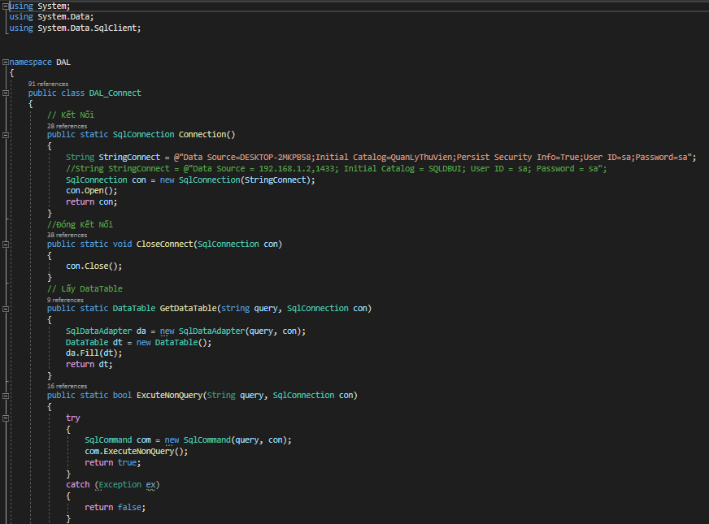

- DTO Layer (not necessary): is a sub-class, defines the tables in the Database of the project, defines its columns as well as to assign data when the query retrieves data.

Mode of operation of the 3-layer Model:

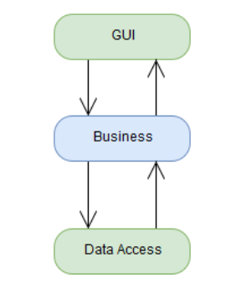

- The GUI links to the **Bussiness Layer** and **DTO.**

- Bussiness Layer links to **Data Access** and **DTO.**

- Data Access only links to **DTO..**

### **3.2.3. Stored Procedure:**

In the process of implementing the project, our team looked up and found the advantages of Store Procedure in Microsoft SQL Server as follows:

**- Dynamic:** allows to adjust the program accordingly: Create Store Procedure only once and store it in Database once, but in the program can call that command with any number of times. Can be specified by someone created and their changes completely independent of the source code of the program.

**- Fast:** capable of parsing and optimizing on the first execution and 1 translated version will be stored in memory for later use.

**- Minimize bandwidth consumption:** with a process using Transact-SQL, there are hundreds of single statements sent at the same time, leading to bandwidth consumption or possibly overload. The Stored Procedure improves this problem by sending in a processing sequence. Also, the stored procedure can parse and optimize the command in the first execution, helping to improve the statement better.

**- Security:** decentralizing user rights to users, granting rights, limiting rights to users even if they are not allowed to directly execute these stored procedures. This will limit and eliminate unlicensed data breaches.

A few examples of Store Procedure statements in group projects:

- Store Procedure of Form Login:

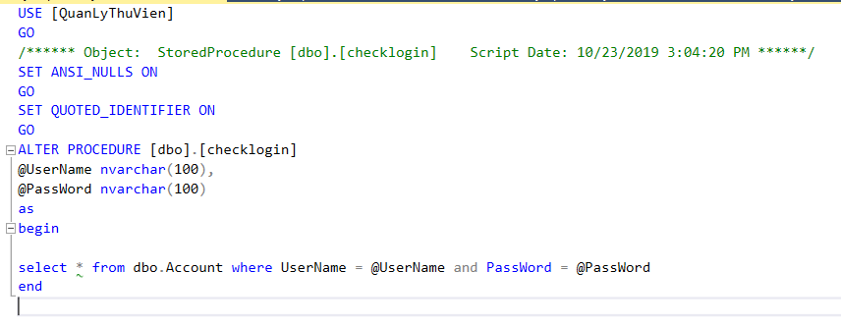

- Store Procedure of Form Book:

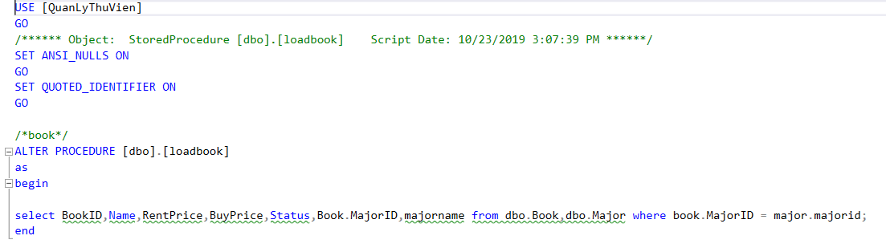

# **CHƯƠNG IV: REFERENCES**

Online References:

- Teamview

 

- www.google.com.vn

- sethphat.com

- [www.wikipedia.org](http://www.wikipedia.org)

- www.w3schools.com

# **CHƯƠNG V: CONCLUDE**

## **5.1. Evaluate:**

In the process of doing this great exercise, due to the limited ability, the topic of my group could not avoid shortcomings. My team considered it to be quite successful in building a library management software for UEF. Initially, there were some difficulties such as: not having the opportunity to sit together to discuss ideas, the level of the group was limited and the number of members was small. But the members worked together to overcome all difficulties and got the job done seriously.

## **5.2. Advantages:**

Simple interface, easy to use

Most can optimize all existing functions of the software

There are clear statistics convenient for management.

## **5.3. Disadvantages:**

The Statistics section has not been made possible due to many errors

Software lacks many functions.