**Discrete Mathematics Final Exam**

1. A

* (1) 1 + 1 = 3 or 1 + 1 = 2 is true because 1 + 1 = 2 is true
* (2) 2 + 2 =4 and 2 + 2 = 1 is false because 2 + 2 = 1 is false

Then (1) 🡪 (2) is false.

1. A

* P 🡪 Q is “If Lucy has an invention, she will get a prize”, (i) is true. Q is necessary for P so (ii) is true.

1. A

* 1 + 1 = 0 or 2 + 2 = 4 is true, then x = 6
* 1 + 1 = 2 and 1 + 2 = 3 then x = 13

1. A

* over 30 🡪 can read newspaper <-> cannot read newspaper 🡪 not over 30.
* Conclusion 1 is logical
* Conclusion 2 is not

1. A

* parrot 🡪 like fruit <-> does not like fruit 🡪 not parrot.(i) is illogical.
* smart 🡪 know french <-> does not know french 🡪 not smart. (ii) is logical.

1. B

|  |  |
| --- | --- |
| q | p |
| 1 | 1 |
| 1 | 0 |
| 0 | 1 |
| 0 | 0 |

1. A

* , or , (i) is true.
* 2x + 3 is odd so (ii) is false.

1. A

* g is a ceiling function, so g(-4.5) = -4.

1. A

* A – B = {2, 3, 4}
* The bit string for A – B is 0011100000

1. A

* A has 3 elements, so AxA has 9 elements. Therefore AxA has 2^9 = 512 subsets.

1. A



1. A

* Following the sequence: 1 < << < < < < 

1. A

* H = 7, f(7) = 10 🡪 K
* E = 4 , f(4) = 7 🡪 H

1. B

* The number of operations is 2n, so the complexity is 

1. D

* Following the sequence: 1 < << < < < < , we have , so .

1. A

* a = -4, b = 3 => a+ b = -1

1. A

*  has no element.

1. A

* b = 6k + 4 = 6k + 3 + 1 => b mod 3 = 1=> ab mod 3 = 2.

1. A

* 104578690 – 58 divided by 101 => 102578690 = 58 (mod 101)

1. A

* S has 5, then 5 + 5 = 10 S. Continue the same.

1. A

* a3 = 3.a2 = 3.3.a1 = 3.3.4 = 36

1. A

* T(4) = 3 + T(3) = 3 + 3 + T(2) = 3 + 3 + 3 + T(1) = 3 + 3 + 3 + 3 = 4.3 = 12

1. A

* 4^3 = 64.

1. A

* 

1. A

* 9.8.7 = 504

1. A

* (6 + 5 + 5 + 4 + 4 + 4 + 3 + 3 + 2 + 2 + 2 + 1 + 1)/2 = 21

1. A

* 2.6 = 12

1. A

* f(16) = 2f(8) + 3 = 2(2f(4) + 3) + 3 = 4f(4) + 9 = 4(2f(2) + 3) + 9 = 8f(2) + 21 = 8(2f(1) + 3) + 21 = 125

1. A

* (i) 5 + 4 + 3 + 2 + 2 + 0 = 16 (graphic)
* (ii) 6 + 5 + 4 + 3 + 2 + 1 = 21 (not a graphic)

1. A

* a) has more than two odd - degree vertices
* b) has all even – degree vertices

1. A

* Try to find out b) has a hamilton circuit

1. A

* has two odd vertices so (i) is true
* (ii) is true based on trying

1. A

* 

1. A

* 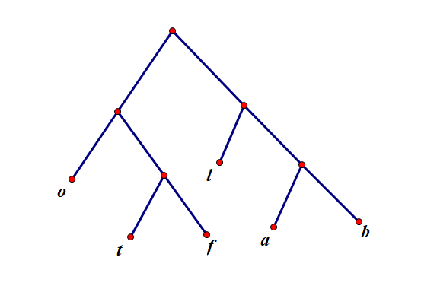 f t b a o l
* 1 1 1 1 2 2
* The average number of bits:



1. A

* (i) Code of ‘d’ is prefix of code of ‘c’, so (i) is not prefix code.
* (ii) None of the code is prefix of other codes

1. A

* + - * 2 3 5 / * 2 3 3 = + - 6 5 / 6 3 = + - 6 5 2 = + 1 2 = 3

1. A

* 110 | 00 | 01 = d a b

1. A

* A spanning tree can not have a cycle.

1. A

* 12 – (8 – 1) = 5

1. A

* n = i + l = mi + 1 => 5i + 1 = i + 45 => i = 11.

1. 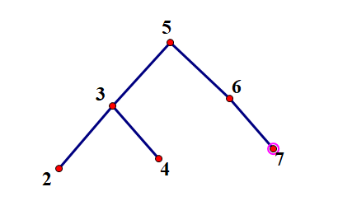A

1. D

* 5 4 + 6 3 / 7 - * = 9 6 3 / 7 - * = 9 2 7 - * = 9 (-5) * = -45

1. A

* e = n – 1 = 2.12 + 1 – 1 = 24

1. A

* Cannot remove any vertices to make the graph disconnected.

1. B

* Each vertex connect with an edge, so the length of Hamilton circuit is equal to the number of vertices (8).

1. C

* 

1. A

* 21 + 15 = 36 is divisible by 9 => 21 = -15 (mod 9)

1. A

* 

1. A

* ab / gcd(a, b) = 700 / 10 = 70

1. D

* It is not raining and the soccer game will not be held.