**OSG – LAB 2**

* Name: Ngô Việt Tiến
* Student code: SE161204
* Class: SE1605

1. **The manipulating of some commands in Fedora terminal**
2. **su:**

* Function: run a command with substitute user and group id.
* Syntax: **su [options] [-] [username [arguments]]**
* Example: switch user “viettien1602” to “nvtien”, and to root.

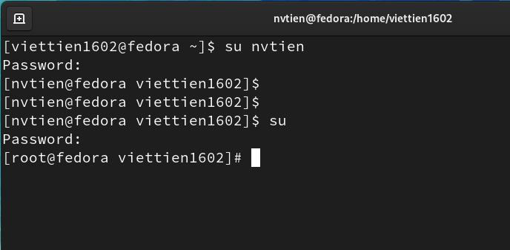

1. **env:**

* Function: run a program with modified environment.
* Syntax: **env [options] … [=] [name = value] … [command [arg] …]**
* Example:

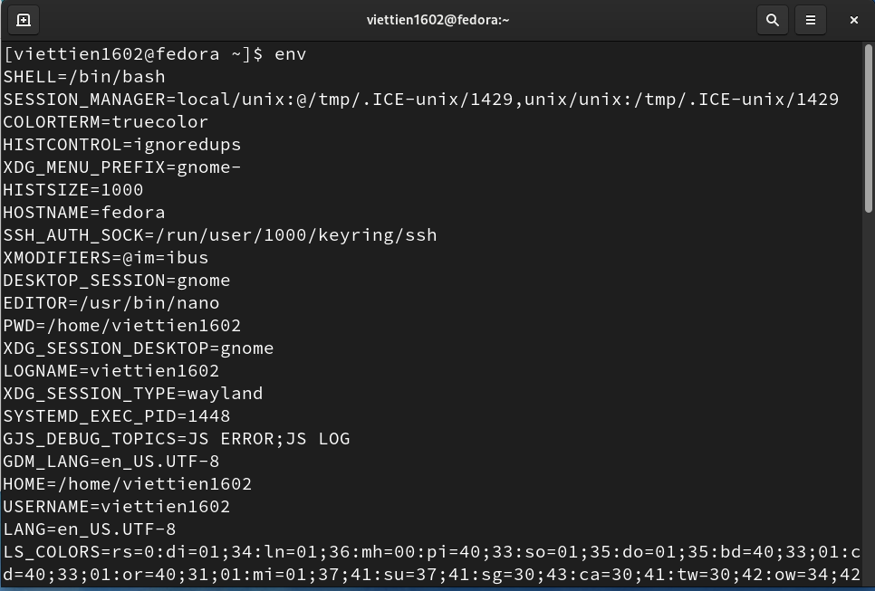

1. **mkdir:**

* Function: make directories.
* Syntax: **mkdir [option]… directories …**
* Example: create directory “tien1” at home.

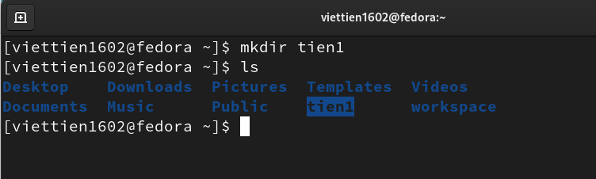

1. **cp:**

* Function: copy files and directories.
* Syntax: **+ cp [option] … [-t] source dest**

**+ cp [option] … source … directories**

**+ cp [option] … -t directories source …**

* Example: create a file name “tien” and copy it to directory “tien1”.

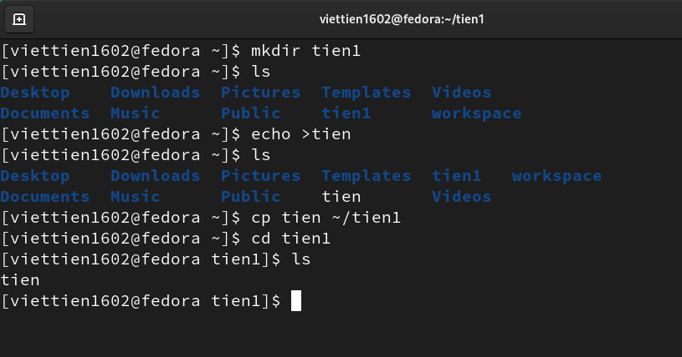

1. **mv:**

* Function: move (rename) files.
* Syntax: + **mv [option] … [-t] source dest**

+ **mv [option] … source … directories**

+ **mv [option] … -t directories source …**

* Example:

+ Rename file “tien” to “demo”.

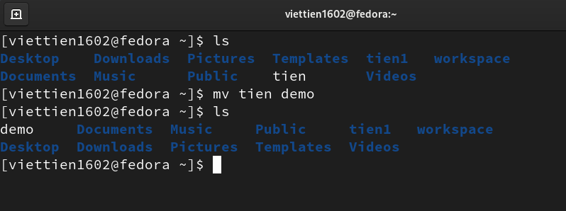

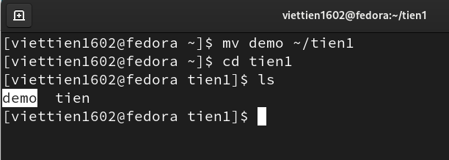+ Move file “demo” to directory “tien1”.

1. **rmdir:**

* Function: remove empty directorie.
* Syntax: **rmdir [option] … directories…**
* Example: create empty directory “tien2” and then remove it.

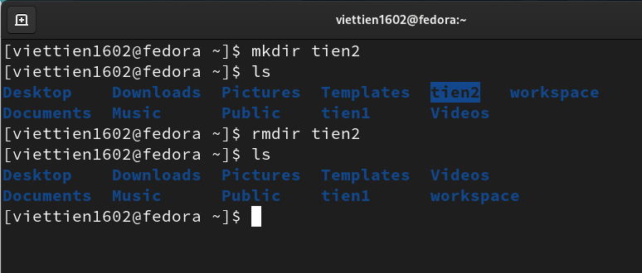

1. **cat:**

* Function: concatenate files and print on the standard output.
* Syntax: **cat [option] … [file] …**
* Example: write “hello world” to the file “demo” and print that text on the command line.

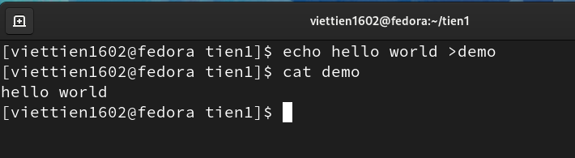

1. **ln:**

* Function: make links between files.
* Syntax: + **ln [option] … [-t] target link_name**

+ **ln [option] … target**

+ **ln [option] … target … directories**

+ **ln [option] … -t directories target …**

* 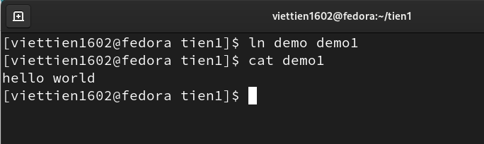Example: make a hard link between an existed file “demo” with a new file “demo1”.

1. **rm:**

* Function: remove files or directories.
* Syntax: **rm [option] … [file] …**
* Example: remove file “tien” in directory “tien1”.

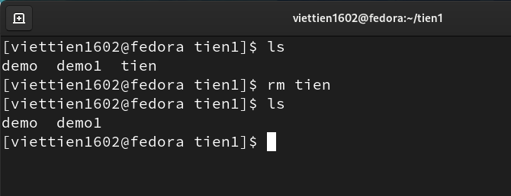

1. **chown:**

* Function: change file owner and group.
* Syntax: + **chown [option] … [owner] [ : [group] ] file …**

+ **chown [option] … --reference = RFILE file …**

* Example: change owner of the file “demo”.

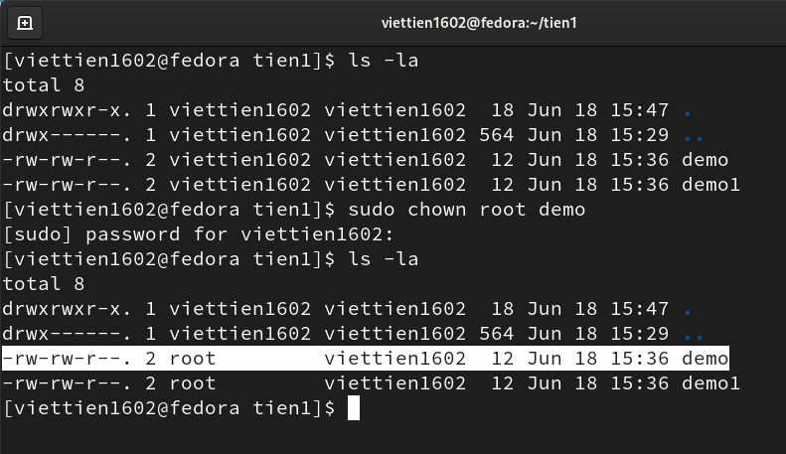

1. **chgrp:**

* Function: change group ownership.
* Syntax: + **chgrp [option] … group file …**

+ **chgrp [option] … --reference = RFILE file …**

* Example: change group ownership of the file “demo”.

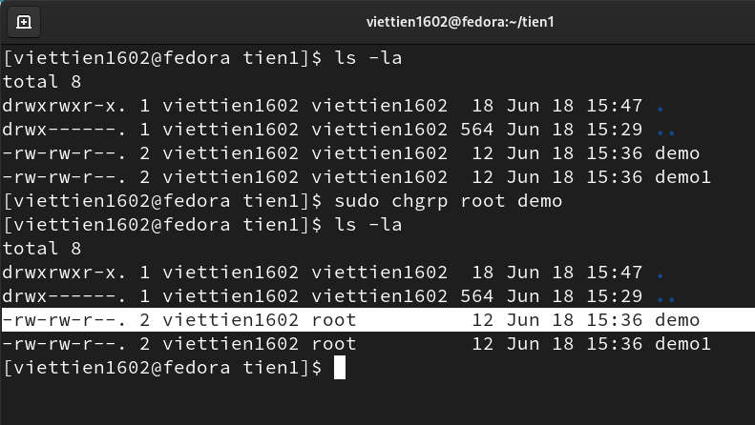

1. **chmod:**

* Function: change file mode bits.
* Syntax: + **chmod [option] … mode [ , [mode] ] … file …**

+ **chmod [option] … octal – mode file …**

+ **chmod [option] … --reference = RFILE file …**

* Example: change mode of user to read/write/execute of the file “demo”.

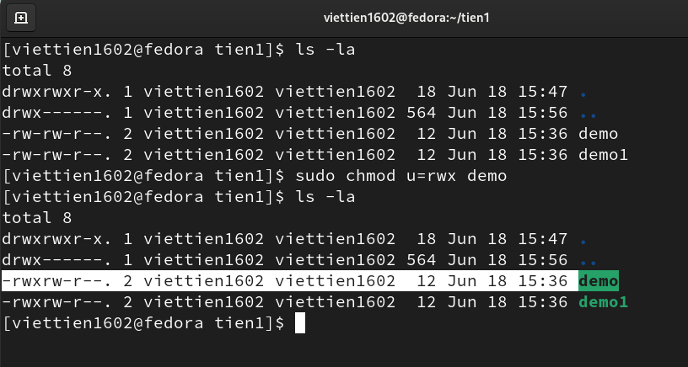

1. **find:**

* Function: search for files in a directory hierarchy.
* Syntax: **find [-h] [-l] [-p] [- d debugopts] [-Olevel] [starting – point … ] [expression]**
* Example:

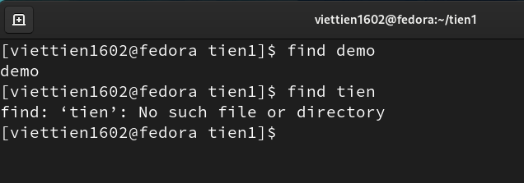

1. **df:**

* Function: report file system disk space usage.
* Syntax: **df [option] … [file] …**
* Example:

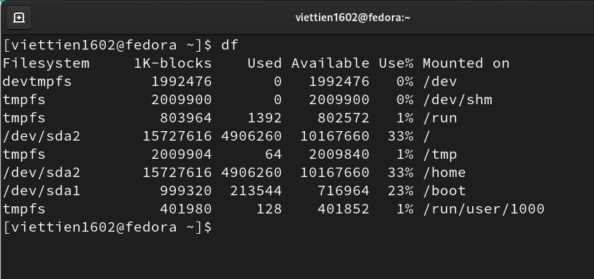

1. **ps:**

* Function: report a snapshot of a current processes.
* Syntax: **ps [option]**
* Example:

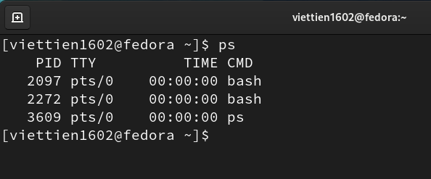

1. **top:**

* Function: display Linux processes.
* Example:

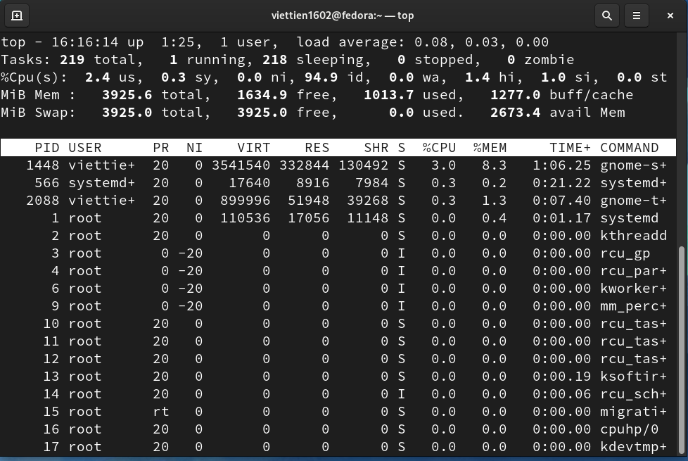

1. **jobs:**

* Function: show jobs that are waiting to be executed.
* Syntax: **+ jobs [lnprs] [jobspec ...]**

**+ jobs -x command [args]**

1. **kill:**

* Function: terminate a process.
* Syntax: + **kill [ -s signal | -p ] [ -a ] [ -- ] pid ...**

+ **kill -l [ signal ]**

* 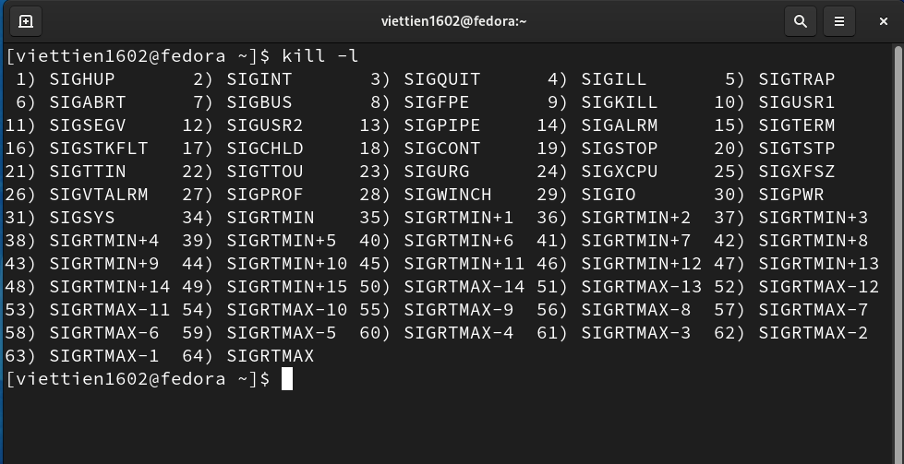Example:

1. **Files that are done at tutorial in file management**

* **Create a directory: mkdir**

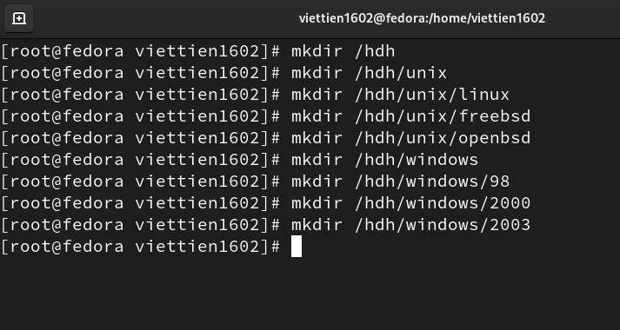

* **View the directory or file: ls or ll**
* *View the hdh directory:*

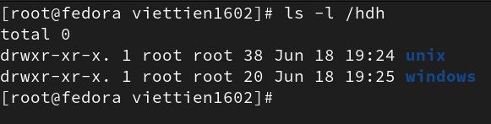

* 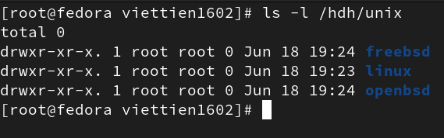View the unix directory:

* View the windows directory:

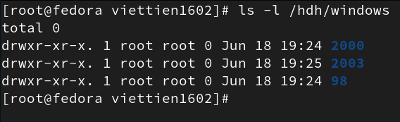

* **Create a file:**

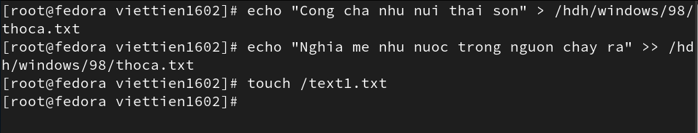

* **View the file content:**

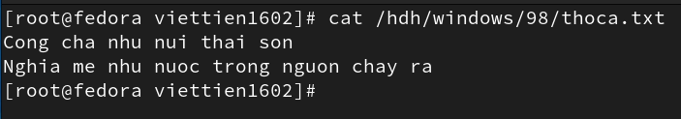

* **Copy a file / directory: cp**

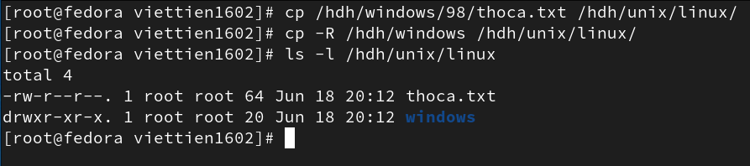

* **Move objects: mv**

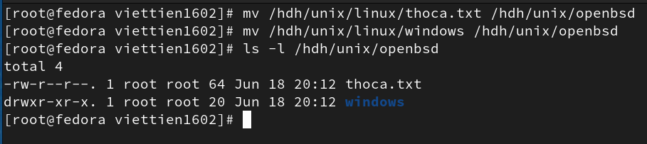

* 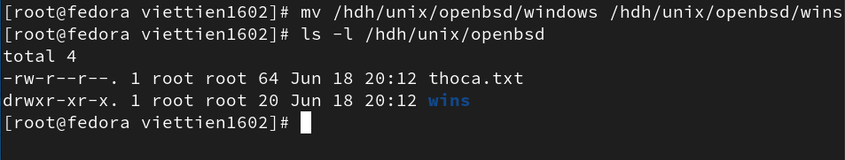**Rename: mv**
* **Delete a file/ directory: rm**

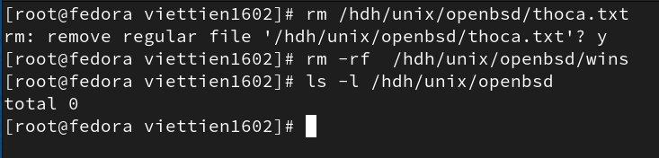

* **Delete the empty directory: rmdir**

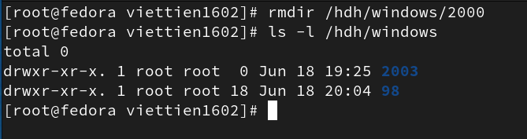

* **Change the directory: cd**

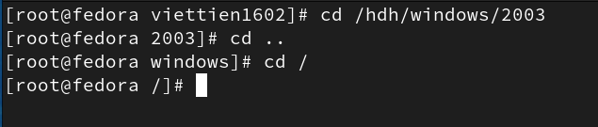

* **View the current directory: pwd**

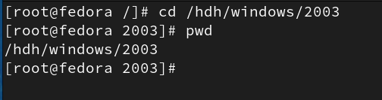

* 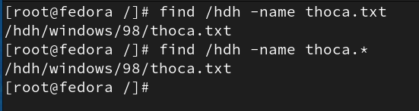**Searching: find, grep, whereis, which**
* **Zip or unzip: gzip/ gunzip, zip/unzip, tar**
* *Using gzip/gunzip:*
* 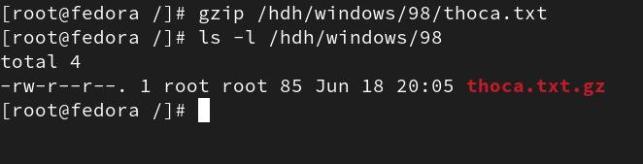Zip the thoca.txt file:
* Unzip:

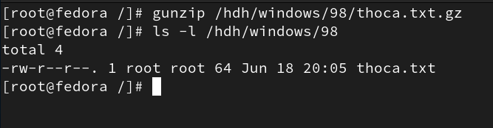

* *Using tar:*
* Zip the thoca.txt file to the .tar extension:

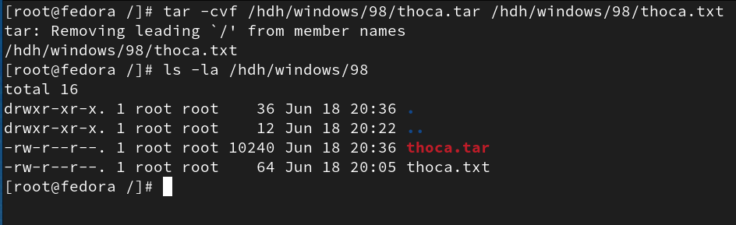

* Zip the thoca.txt file to the .tar.gz extension:

