**OSG – LAB 3**

* Name: Ngô Việt Tiến
* Student code: SE161204
* Class: SE1605

1. **The manipulating of some commands**
2. **vmstat:**

* Function: Report virtual memory statistics.
* Syntax: **vmstat [options] [delay [count]]**
* 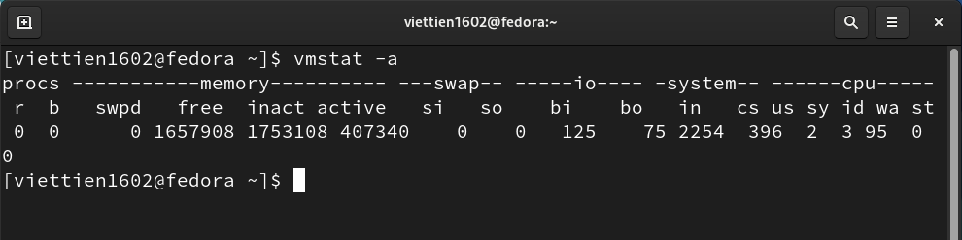Example:

1. **pstree-np:**

* Function: display a tree of processes.
* Syntax: **pstree [options]**
* Example:

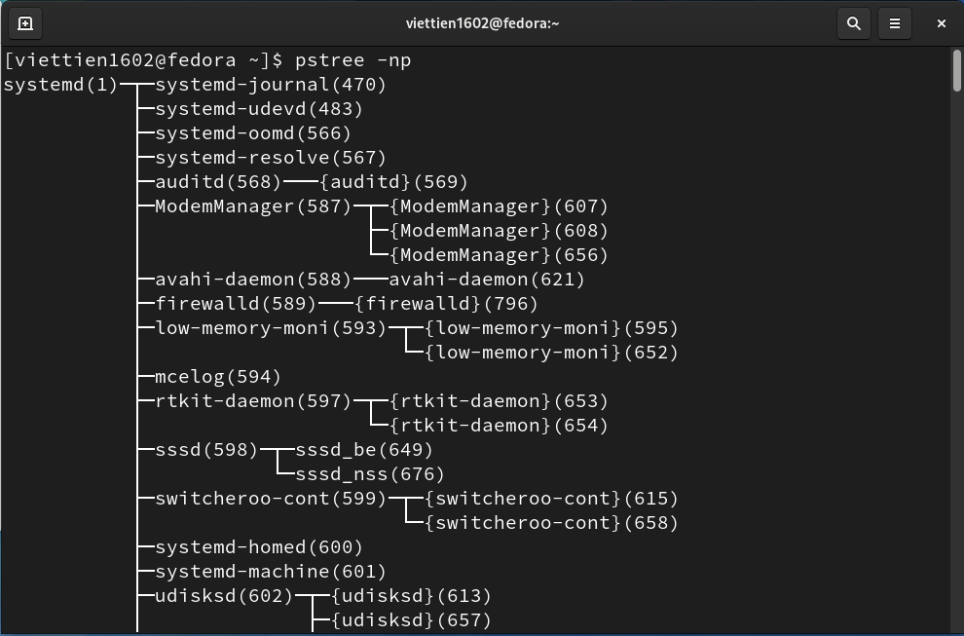

1. **pgrep <option> <parameter>:**

* Function: list process following name, properties, …
* Syntax: **pgrep [option] pattern**
* Example:

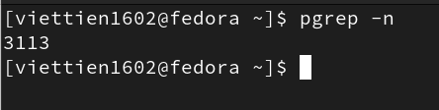

1. **pkill:**

* Function: send signals to processes based on name and other attributes.
* Syntax: **pkill [option] pattern**
* 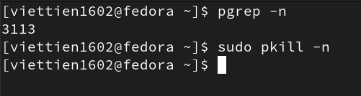Example:

1. **uptime:**

* Function: tell how long the system has been running.
* Syntax: uptime [options]
* Excample:

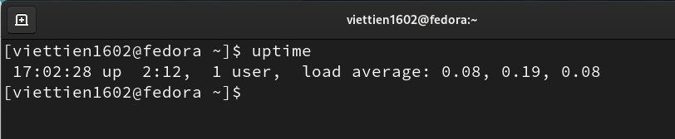

1. **free:**

* Function: Display amount of free and used memory in the system.
* Syntax: free [options]
* Example:

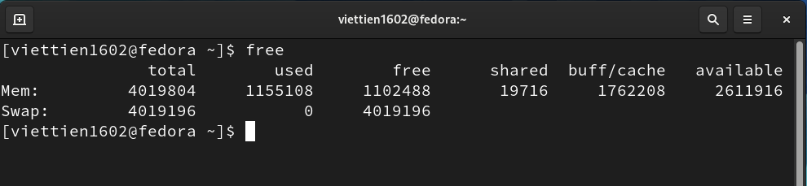

1. **Editor program vi:**
2. Create file “tien”:

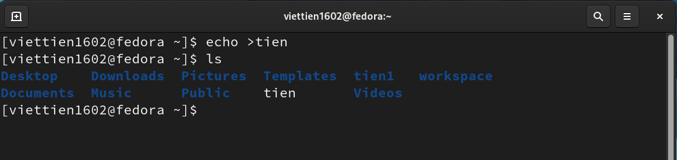

1. Using vi to write to file “tien”:

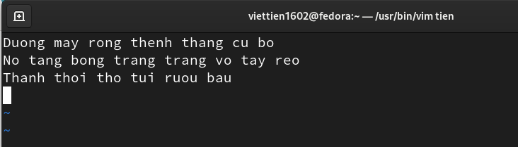

1. Show the text of file “tien” after saving:

