|  |  |
| --- | --- |
|  | **MINISTRY OF EDUCATION AND TRAINING** |

|  |
| --- |
| **FPT UNIVERSITY** |

Time and Attendance System

Software Design Description

Project code: FUTAS

Document code: FUTAS-SDD

Hà Nội, January, 2013

Record of change

*A: Added , M : Modified, D : Deleted

|  |  |  |  |  |
| --- | --- | --- | --- | --- |
| Effective Date | Changed Items | A, M, D | Change Description | New Version |
| 18th February 2013 | Create new | A | First Created | 1.0 |
| 5th March 2013 | Edit | M | Update content | 1.1 |
|  |  |  |  |  |
|  |  |  |  |  |
|  |  |  |  |  |
|  |  |  |  |  |
|  |  |  |  |  |
|  |  |  |  |  |
|  |  |  |  |  |
|  |  |  |  |  |
|  |  |  |  |  |
|  |  |  |  |  |
|  |  |  |  |  |
|  |  |  |  |  |
|  |  |  |  |  |
|  |  |  |  |  |
|  |  |  |  |  |
|  |  |  |  |  |
|  |  |  |  |  |
|  |  |  |  |  |
|  |  |  |  |  |

Table of content

**4.1. Design Overview**

**4.2. System Architectural Design**

4.2.1. Choice of System Architecture

4.2.2. Discussion of Alternative Design

4.2.3. Description of System Interface

**4.3. Class Diagram**

4.3.1. Report

4.3.2. Salary & Man-day

4.3.3. Shift

4.3.4. Employee & Group

4.4. Sequence Diagram

4.4.1. Report

4.4.2. Salary & Man-day

4.4.3. Shift

4.4.4. Employee & Group

**4.5. User Interface Design**

**4.6. Database Design or Data Structure**

4.6.1. Table detail

4.6.2. Design diagram of database

**4.1. Design Overview**

* FUTAS contains many clients and a server. Clients here are reader in office. A client includes reading head and stripe card. Server here stored all client transaction, information scanned card, database.
* Client connect to server via Ethernet only
* Client connect to client via Ethernet only
* Client connect to server
* Server always starts and listens to the connection
* Validate the client connect
* Create a thread for process connection

**4.2. System Architecture Design**

**4.2.1 Choice of System Architecture**

* FUTAS uses client-server model, data centered architecture

**4.2.2 Discussion of Alternative Designs**

1. Server

* Why using C#

The general rule is to always use the highest level language that provides satisfactory performance and stability.

C# defines an extensive set of standard libraries that implement critical functionality that other language library does not even mention.

C# is distributed in forms that are processor architecture and operating system independent. For high end commercial closed source software, this is a major advantage. Most leading edge technology companies would rather die than let their customer look at the source code.

C# is an elegant, simple, type-safe, objected-oriented language that allows enterprise programmer to build a breadth of applications.

C# also gives you the capability of building durable system-level components by virtue if the following features:

* Full COM/Platform support for existing code integration.
* Robustness through garbage collection and type safety.
* Security provided through intrinsic code trust mechanisms.
* Full support of extensible metadata concept.
* You can also interoperate with other languages, across platforms, with legacy data, by virtue of the following features.
* XML support for Web-based component interaction.
* Versioning to provide ease of administration and deployment.
* TCP Server Demo

In this tutorial I’m going to show you how to build a threaded TCP server with C#. If you have ever worked with Window’s sockets, you know how difficult this can sometimes be. However, thanks to the .NET framework, making one is a lot easier than it used to be.

Let’s just see some code. Below is the basic setup for our TCP server class.

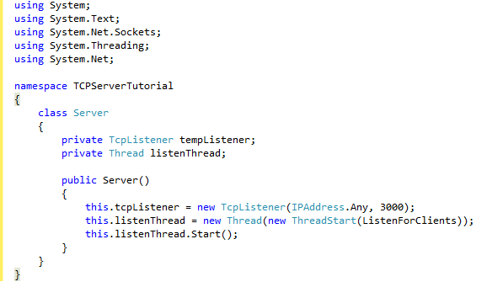

Figure 4.1 TCP server

1. Data

The data centered software architecture is characterized by a centralized data store which is shared by all surrounding software component. Here I show you connect data

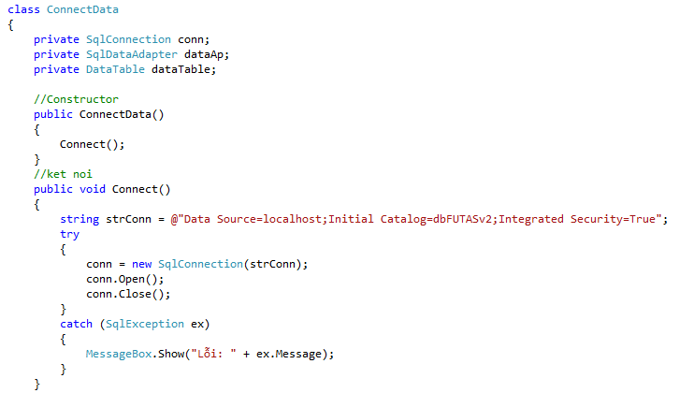

Figure 4.2 Connect data

**4.2.3 Description of System Interface**

1. Data flow

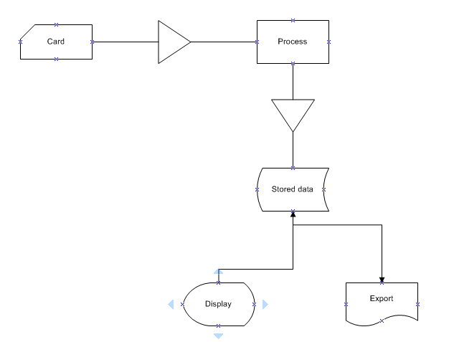

Figure 4.3 Data flow

1. Modules

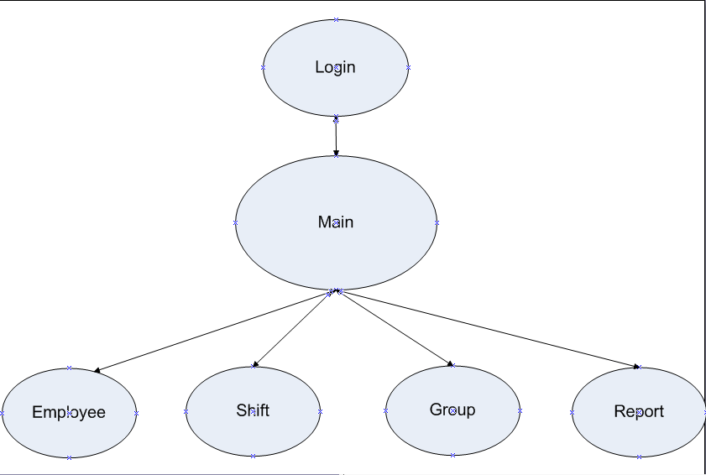

Figure 4.4 Modules

* FUTAS include 4 main module :
* Employee management
* Shift management
* Group management
* Report management

1. Use Case Diagram

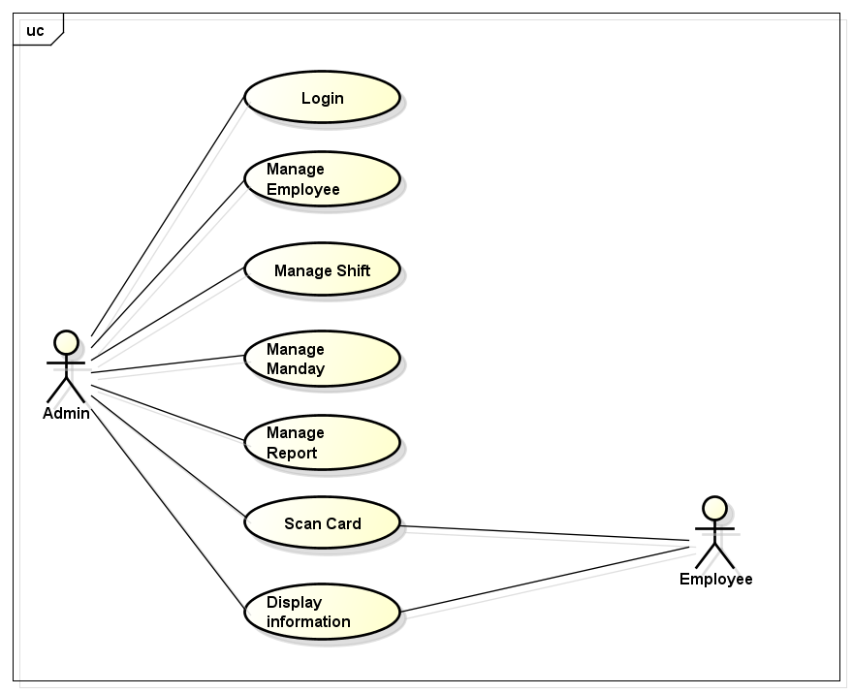

Figure 4.5 Use Case Diagram

* FUTAS is used by only administrator. Another employees want to view something have to contact to administrator

**4.3. Class Diagram**

**4.3.1. Report**

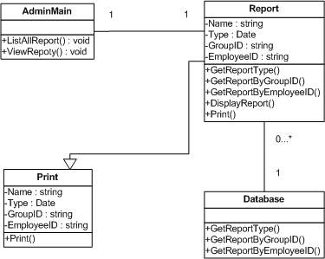

Figure 4.6 Report Class Diagram

**4.3.2. Salary & Man-day**

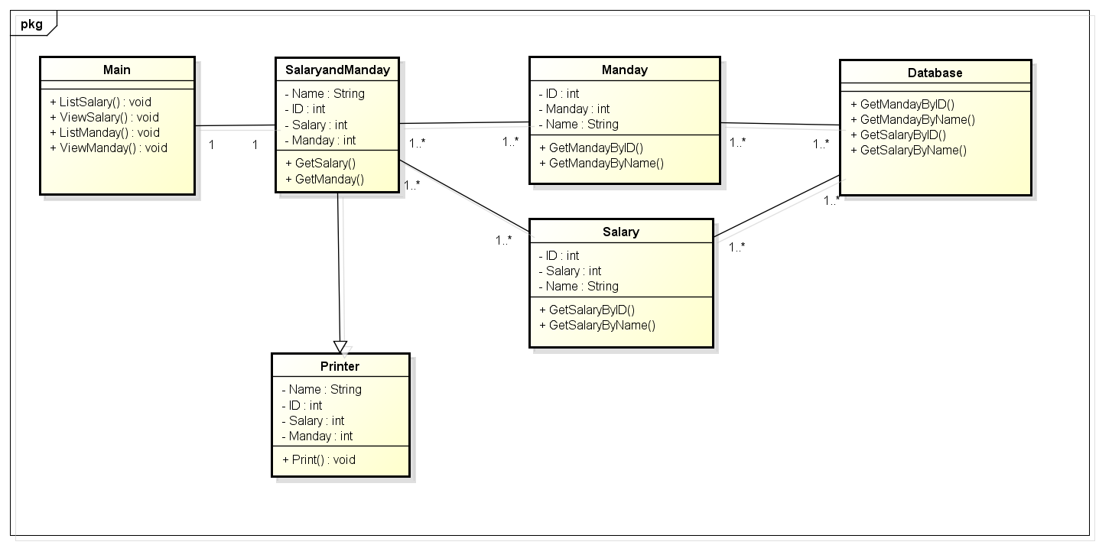

Figure 4.7 Salary & Man-day Class Diagram

**4.3.3. Shifts**

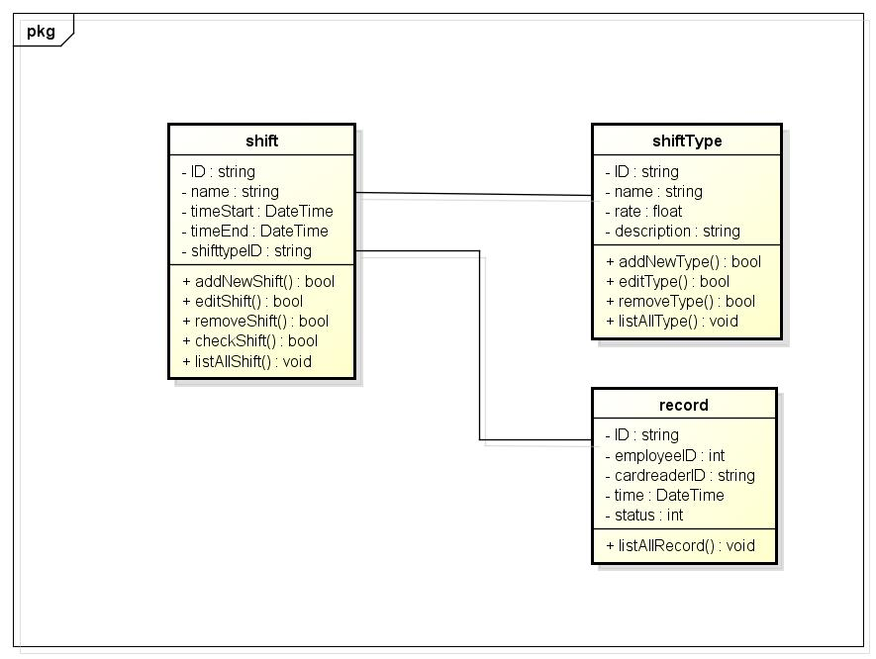

Figure 4.8 Shift Class Diagram

**4.3.4. Employee & Group**

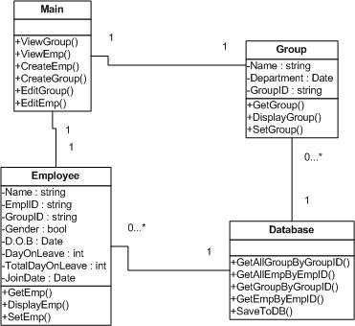

Figure 4.9 Employees & Group Class Diagram

**4.4. Sequence Diagram**

**4.4.1. Report**

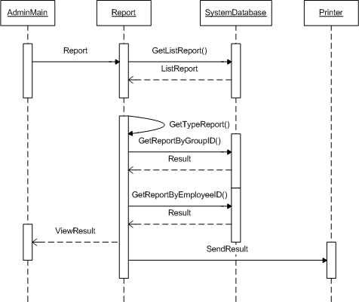

Figure 4.10 Report Sequence Diagram

**4.4.2. Salary & Man-day**

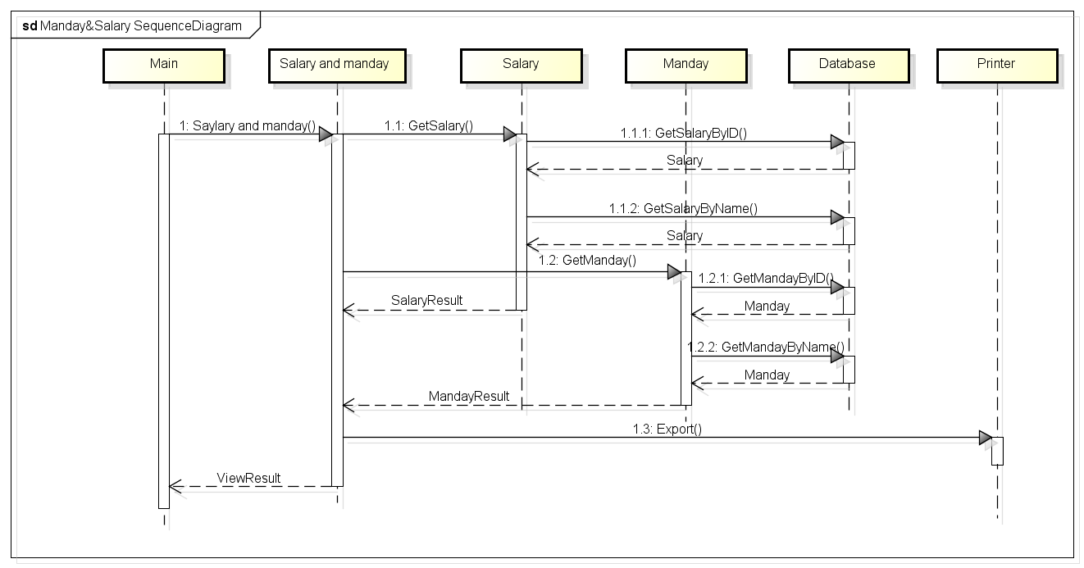

Figure 4.11 Salary & Man-day Sequence Diagram

**4.4.3. Shifts**

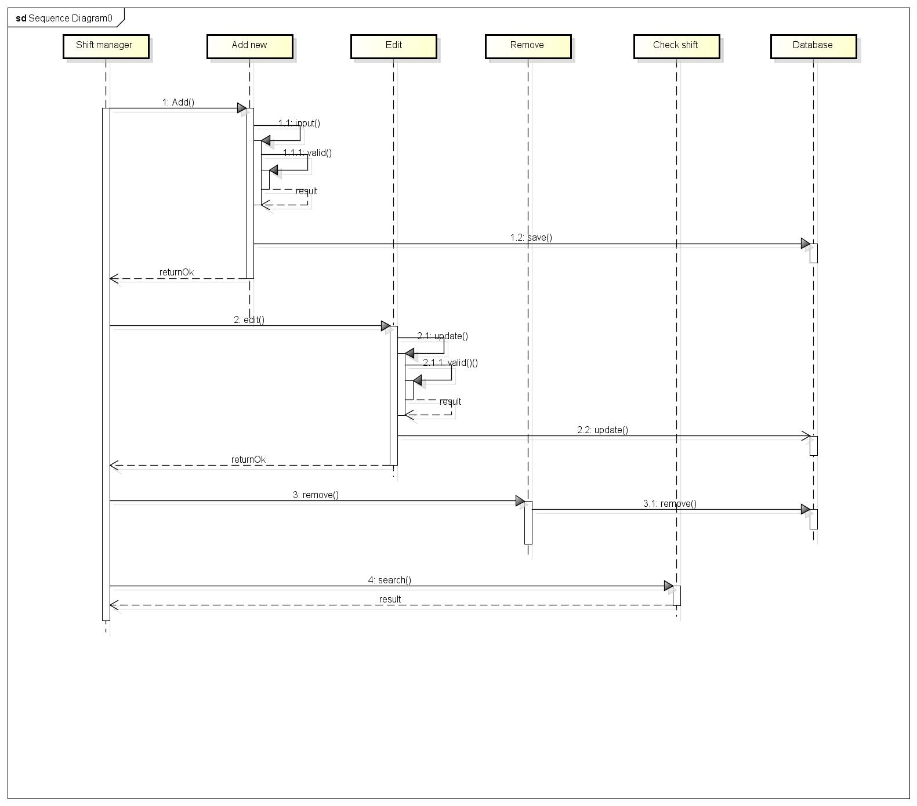

Figure 4.12 Shift Sequence Diagram

**4.4.4. Employee & Group**

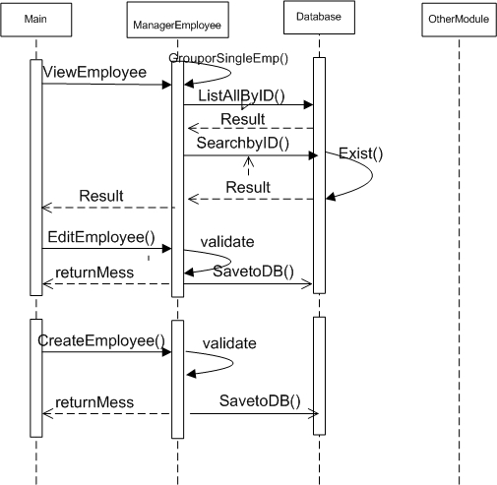

Figure 4.13 Employees & Group Sequence Diagram

**4.5. User interface design**

1. **Login**

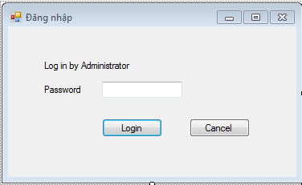4.14 Login Screen

* System login only by administrator
* Password is encoded, default and unchangeable

1. **Main menu**

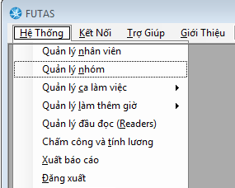

Figure 4.15 Main Menu Screen

* On top menu, FUTAS include:
* Menu : Click and select module
* Help : Click and view guidance
* About

|  |  |
| --- | --- |
| Quản lý nhân viên | Link to employee management |
| Quản lý phòng ban | Link to group management |
| Quản lý ca làm việc | Link to shift management |
| Quản lý làm ngoài giờ | Link to OT management |
| Chấm công và tính lương | Link to man-day & salary management |
| Xuất báo cáo | Link to report management |
| Đăng xuất | Logout system |

1. **Employee Management**

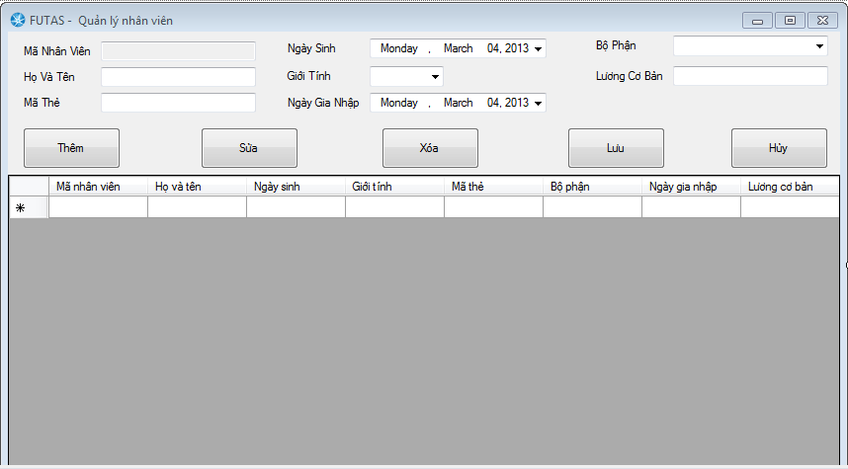

Figure 4.16 Employee Management Screen

|  |  |
| --- | --- |
| Mã Nhân Viên | ID of an employee(automatically increase) |
| Họ Và Tên | Enter full name of an employee to textbox |
| Mã Thẻ | Enter code of a card to textbox |
| Ngày sinh | Select birthday of employee above |
| Giới tính | Select gender of employee above |
| Ngày gia nhập | Select join date of employee above |
| Bộ phận | Select group employee will join |
| Lương cơ bản | Enter base salary of employee above |
| Thêm | Click button add to add new employee to database |
| Sửa | Click button edit to edit employee selected in database |
| Xóa | Click button delete to remove employee selected in database |
| Lưu | Click button save to save employee edited in database |
| Hủy | Click button cancel to cancel activity |

1. **Group Management**

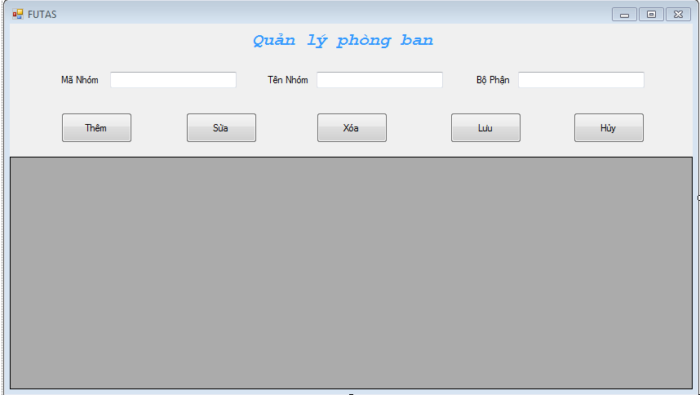

Figure 4.17 Group Management Screen

|  |  |
| --- | --- |
| Mã Nhóm | ID of group (automatically increase) |
| Tên Nhóm | Enter name of group in textbox |
| Bộ Phận | Enter department of group in textbox |
| Thêm | Click add button to add new group to database |
| Sửa | Click edit button to edit group selected to database |
| Xóa | Click delete button to delete group selected in database |
| Lưu | Click save button to save group edited in database |
| Hủy | Click cancel button to cancel activity |

1. **Shift Management**

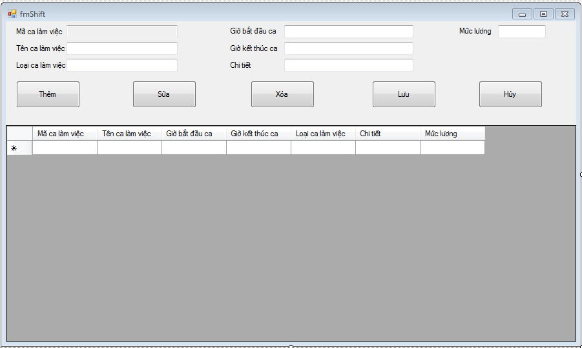

Figure 4.18 Shift Management Screen

|  |  |
| --- | --- |
| Mã ca làm việc | ID of a shift (automatically increase) |
| Tên ca làm việc | Enter name of shift in textbox |
| Loại ca làm việc | Enter type of shift in textbox |
| Giờ bắt đầu ca | Enter time start of shift above in textbox |
| Giờ kết thúc ca | Enter time end of shift above in textbox |
| Chi tiết | Enter detail of shift above in textbox |
| Mức lương | Enter salary level of shift above in textbox |
| Thêm | Click add button to add new shift to database |
| Sửa | Click edit button to edit selected shift in database |
| Xóa | Click delete button to delete selected shift in database |
| Lưu | Click save button to save edited shift in database |
| Hủy | Click cancel button to cancel activity |

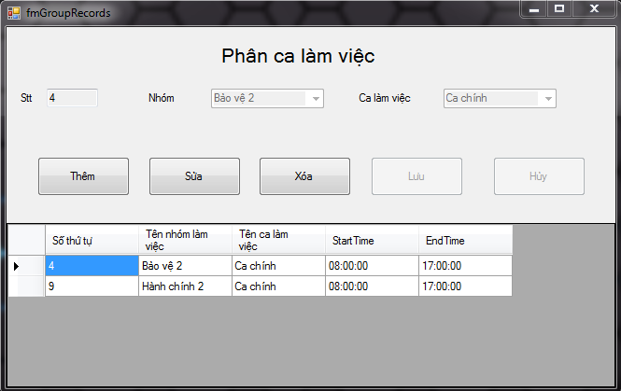

Figure 4.19 Shift Distribution Management Screen

|  |  |
| --- | --- |
| Stt | List |
| Nhóm | Select group |
| Ca làm việc | Select shift |
| Thêm | Click add button to distribute group to a shift |
| Sửa | Click edit button to edit selected group in a shift |
| Xóa | Click delete button to remove selected group in a shift |
| Lưu | Click save button to save edited group in a shift |
| Hủy | Click cancel button to cancel activity |

1. **Overtime Management**

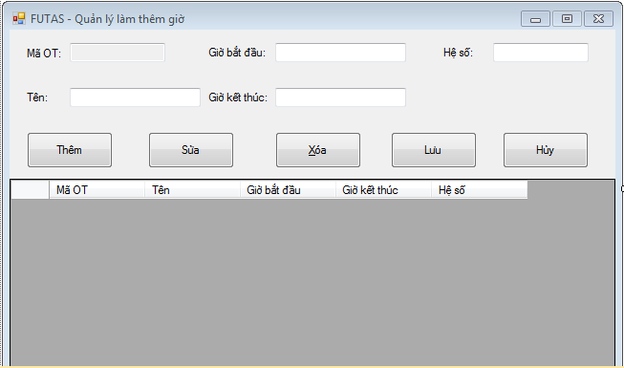

Figure 4.19 Overtime Management Screen

|  |  |
| --- | --- |
| Mã OT | ID of an Overtime shift(automatically increase) |
| Giờ bắt đầu | Start time of an Overtime shift |
| Hệ số | Multiplier factor |
| Tên | Name of an Overtime shift |
| Giờ kết thúc | End time of an Overtime shift |
| Thêm | Click add button to add Overtime shift to database |
| Sửa | Click edit button to edit selected Overtime shift in database |
| Xóa | Click delete button to delete selected Overtime shift in database |
| Lưu | Click save button to save edited Overtime shift in database |
| Hủy | Click cancel button to cancel activity |

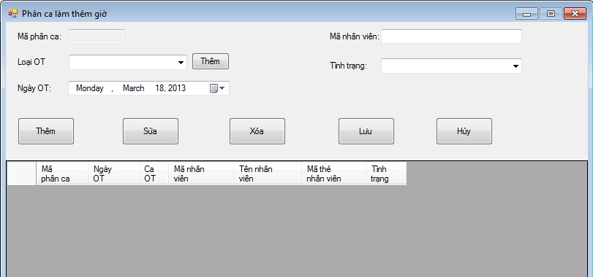

Figure 4.20 Overtime Distribution Screen

|  |  |
| --- | --- |
| Mã phân ca | ID of an Overtime shift |
| Loại OT | Select type of an Overtime shift |
| Ngày OT | Select day registered of an Overtime shift |
| Mã nhân viên | Enter ID of an employee |
| Tình trạng | Status of an Overtime shift |
| Thêm | Click add button to distribute employee in an Overtime shift |
| Sửa | Click edit button to edit distributed employee in an Overtime shift |
| Xóa | Click delete button to delete distributed employee in an Overtime shift |
| Lưu | Click save button to save edited employee in an Overtime shift |
| Hủy | Click cancel button to cancel activity |

1. **Readers Management**

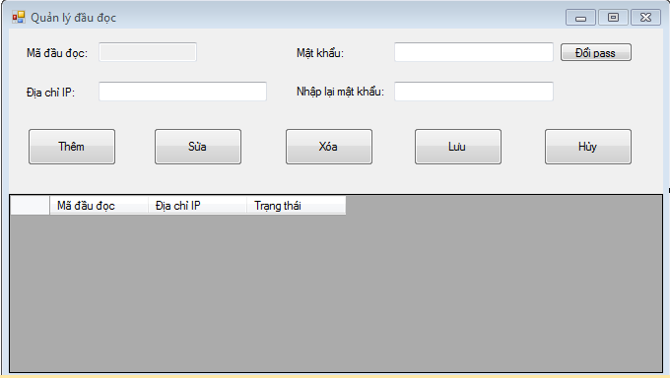

Figure 4.21 Reader Management Screen

|  |  |
| --- | --- |
| Mã đầu đọc | ID of a reader |
| Mật khẩu | Password of a reader |
| Đổi pass | Click button change pass to change password of a reader |
| Địa chỉ IP | IP address of a reader |
| Nhập lại mật khẩu | Confirm password was type above |
| Thêm | Click button add to add reader to database |
| Sửa | Click button edit to edit selected reader in database |
| Xóa | Click button delete to delete selected reader in database |
| Lưu | Click button save to save edited reader in database |
| Hủy | Click button cancel to cancel activity |

1. **Report Management**

**4.6. Database design**

**4.6.1. Table Detail**

* Employee
  + ID(Primary key)
  + NAME
  + DOB
  + JOINT DATE
  + GROUP ID
  + CARD ID
  + DAY ON LEAVE
  + TOTAL DAY ON LEAVE
  + BASE SALARY
  + GENDER
* GROUP
  + GROUP ID(Primary key)
  + NAME
  + DEPARTMENT
* SHIFT
  + SHIFT ID(Primary key)
  + NAME
  + TIME START
  + TIME END
  + SHIFT TYPE
  + RATE
  + DESCRIPTION
* Group Record
  + ID(Primary key)
  + GID
  + Shift ID
* RECORD
  + ID(Primary key)
  + EMPLOYEE ID
  + READER ID
  + CARD ID
  + TIME
  + STATUS (ONTIME/ LATE)
* READER
  + CARD READER ID(Primary key)
  + USER
  + PASS
  + IP
* OVERTIME
* OVERTIME ID(Primary key)
* NAME
* RATE
* OVERTIME DISTRIBUTION
* OVERTIME DISTRIBUTION ID(Primary key)
* START TIME
* END TIME
* EMPLOYEE ID
* OVERTIME ID

**4.6.2. Design diagram of database**

