First put the permission to the manifest file, in my app there are three permissions that the app need so I put

-READ_CONTACTS for the selectContact Intent

-CALL_PHONE to call that contact and

-READ_EXTERNAL_STOREAGE to access the gallery

# Select a Contact and Call

The selectContact function will hmm… select a contact. And make sure to Overide the onAvtivityResult function like on the common intent android guide.

# Send Email

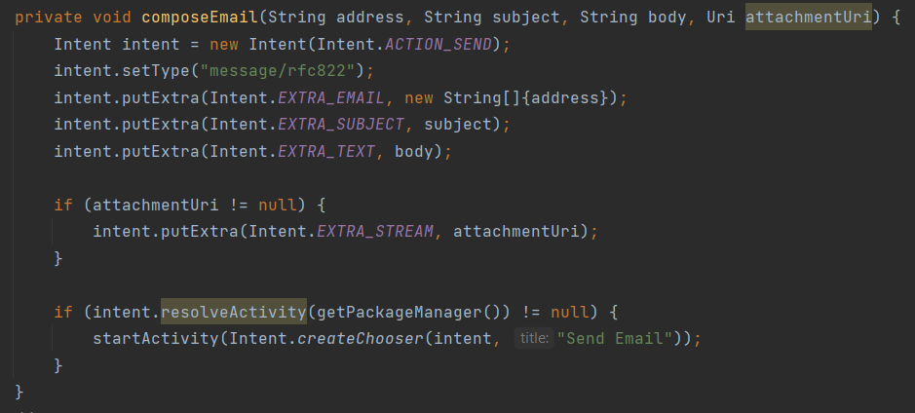

Send Email is pretty simple and doesn’t require to overide the onActivityResult().

# Access gallery

To have overide the onActivityResult()



And these are some pictures about my app

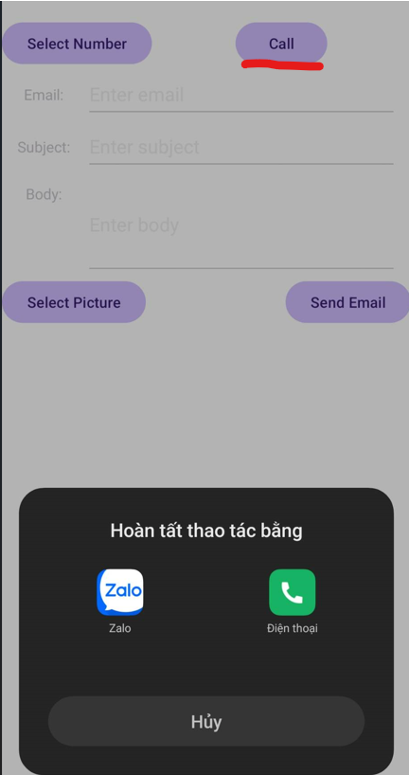 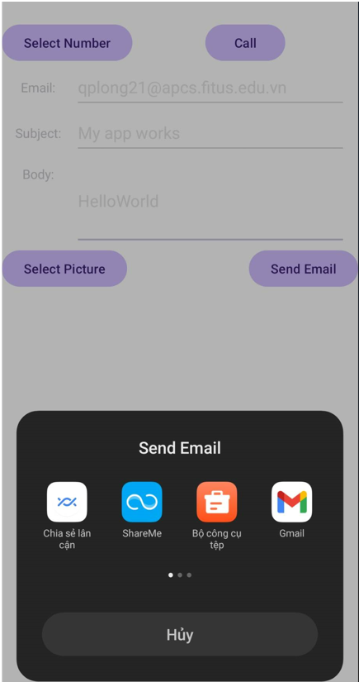

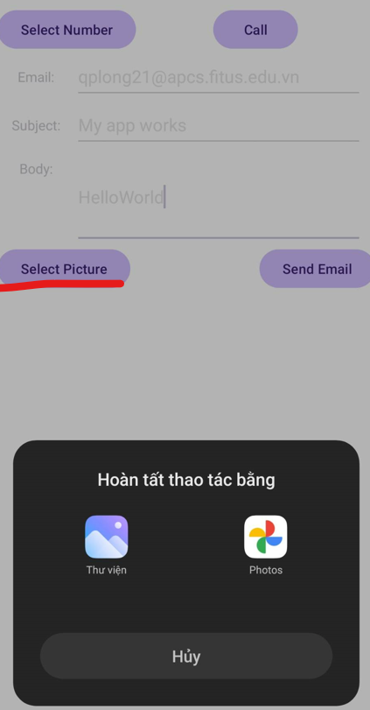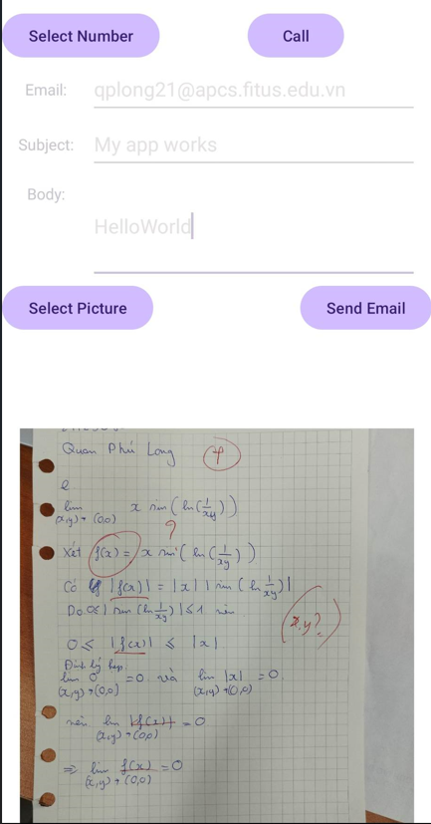

21125080 Quan Phú Long