[ APPLICATION NOTE #178 ]

USB HID Implementation in Smart-UPSTM
By Daniel Cohen & Manuel J. Palomino

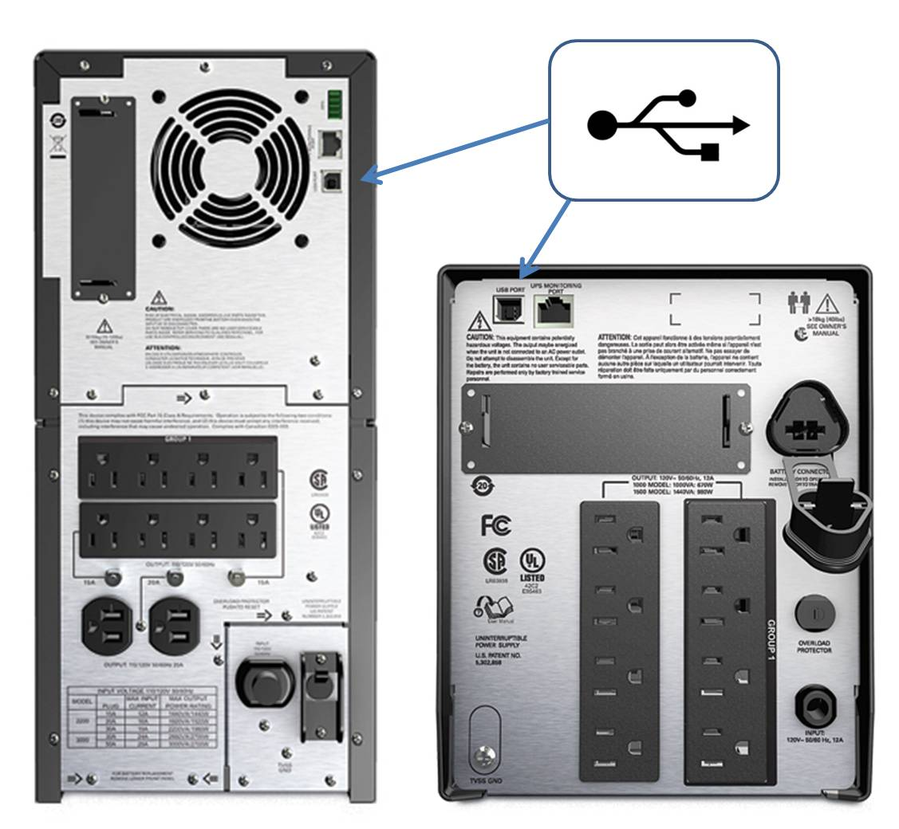
Project at a glance
Project Type
Manage the behaviour of the Smart-UPS and its outlets through a custom application making use of USB connectivity, standard USB usages and the instructions presented here.

Products Supported
APC Smart-UPS models SRT, SMT, SMX and SMC.

Additional Equipment Required
USB cable (Type A to B) rated for USB 2.0 (generally included with Smart-UPS)

Recommended References

USB HID Implementation in SMART-UPS

Schneider Electric’s APC Smart-UPS provide access to controls and configuration parameters through various mechanisms. USB is one of the most popular methods of connecting and controlling the UPS. Its ubiquity in workstations and its standardized protocols make USB a key feature of the Smart-UPS.

The USB ports on the Smart-UPS implement the USB HID defined elements of the power devices sub-class. This document describes the elements that are implemented within the Smart-UPS devices.

Table of Contents

1 Introduction and scope of this document 3
2 Physical Layer of Communication 3
2.1 Usages in the descriptor 3
2.1.1 iProduct 3
2.1.2 iManufacturer 3
2.1.3 iSerialNumber 3
2.2 Collection(Power Summary) – 84:04 4
2.2.1 iProduct – 84:FE 4
2.2.2 iSerialNumber – 84:FF 4
2.2.3 iManufacturer – 84:FD 4
2.2.4 iOEMInformation – 85:8F 4
2.2.5 uDeviceChemistry – 85:89 4
2.2.6 Rechargeable – 85:8B 4
2.2.7 CapacityMode – 85:2C 4
2.2.8 RemainingTimeLimit – 85:2A 5
2.2.9 ManufacturerDate – 85:85 5
2.2.10 ConfigVoltage – 84:40 5
2.2.11 Voltage – 84:30 5
2.2.12 RemainingCapacity – 85:66 5
2.2.13 RunTimeToEmpty – 85:68 5
2.2.14 DesignCapacity – 85:83 5
2.2.15 FullChargeCapacity – 85:67 5
2.2.16 WarningCapacityLimit – 85:8C 5
2.2.17 CapacityGranularity1 – 85:8D 5
2.2.18 CapacityGranularity2 – 85:8E 5
2.2.19 RemainingCapacityLimit – 85:29 5
2.2.20 DelayBeforeShutdown – 84:57 5
2.2.21 DelayBeforeReboot – 84:55 5
2.2.22 AudibleAlarmControl – 84:5A 5
2.3 Collection(Present Status) 84:02 5
2.3.1 Charging – 85:44 6
2.3.2 Discharging - 85:45 6
2.3.3 ACPresent - 85:D0 6
2.3.4 BatteryPresent - 85:D1 6
2.3.5 BelowRemainingCapacityLimit - 85:42 6
2.3.6 ShutdownRequested - 84:68 6
2.3.7 ShutDownImminent - 84:69 6
2.3.8 RemainingTimeLimitExpired - 85:43 6
2.3.9 CommunicationsLost - 84:73 6
2.3.10 NeedsReplacement - 85:4B 6
2.3.11 Overload - 84:65 6
2.3.12 VoltageNotRegulated - 85:DB 6
3 Interrupt Reporting on USB 7
3.1 Interrupt Described Polling rate 7
3.2 Interrupt Data Reporting 7
3.2.1 “Legacy UPS”(SUA) 7
3.2.2 “Next Gen UPS” Smart-UPS (SMT, SMX, SMC, SRT) 7
4 Appendix A: Reference – Sample USB Data 8

Introduction and scope of this document

This document describes the USB HID usages that are supported by Smart-UPS. This document describes the implementation that is used in the SRT, SMT, SMX & SMC product families. Future products are expected to support this same set of data.

Physical Layer of Communication

Usages in the descriptor
Although they do not show in a HID browser, the USB descriptor contains several usages even if the device is not a power device (UPS). These sections describe the values that should be populated in these strings.

iProduct
The iProduct string indicated here is ONLY supported in SRT, SMT, SMX, SMC models (SUA have a different format for the string).
<MODEL_STR><space>”FW:”<FW_VERSION_STR><space>/<space>”ID-“<APC Product Identifier>

Delimiter | Description
<MODEL_STRING> | The textual representation of the Model Name (e.g. Smart-UPS)
<space> | Hex 0x20 (Space character)
<FW_VERSION_STR> | The version of the firmware, e.g. UPS 05.2
<APC Product ID> | This is an identifier used to determine the firmware family implemented in the product.

Table 1 – iProduct String description

iManufacturer
This string is hard-coded.

iSerialNumber
This will match identically the string used by APC internally to identify the unit..

iProduct – 84:FE
Returns String Index 1 and the Unicode string representing the SKU String. This returns the same value as the descriptor as described in section 2.1.1.

iSerialNumber – 84:FF
Returns String Index 2 and the Unicode string representing the SerialNumber_STR. This returns the same value as the descriptor as described in section 2.1.1 and 2.1.3.

iName – 84:01

APCLightsAndBeeperTest– FF86:72
When written 1, will set will execute the lights and beeper test.

APCFirmwareRevision – FF86:42
Returns the firmware revision string.

ManufacturerDate – 85:85
Converted from -> UPSSystem.ManufacturerData.Date, The manufacture date can be calculated by [(year-1980) * 512] + [month * 32 ]+ day
Day (0…4) 5 bit binary value 1-31 (corresponds to date)
Month (5...8) 4 bit binary value 1-12 (corresponds to month number)
Year (9…15) 7 bit binary value 0-127 (corresponds to year biased by 1980)

AudibleAlarmControl – 84:5A

Collection(Power Summary) – 84:04
Power Summary Collection – Endpoint 0 is the standard interface for Get/Set Feature, endpoint 1 are interrupt usages.

Usage ID | Get / Set Feature | Interrupt
iProduct – 84:FE | X
iSerialNumber – 84:FF | X
iManufacturer – 84:FD | X
iOEMInformation – 85:8F | X
uDeviceChemistry – 85:89 | X
Rechargeable – 85:8B | X
CapacityMode – 85:2C | X
RemainingTimeLimit – 85:2A | X | X
ManufacturerDate – 85:85 | X
ConfigVoltage – 84:40 | X
Voltage – 84:30 | X
RemainingCapacity – 85:66 | X | X
RunTimeToEmpty – 85:68 | X | X
DesignCapacity – 85:83 | X
FullChargeCapacity – 85:67 | X
WarningCapacityLimit – 85:8C | X
CapacityGranularity1 – 85:8D | X
CapacityGranularity2 – 85:8E | X
RemainingCapacityLimit – 85:29 | X
DelayBeforeShutdown – 84:57 | X
DelayBeforeReboot – 84:55 | X
AudibleAlarmControl – 84:5A | X | X

Table 2 – Power Summary Collection usages

iProduct – 84:FE
Returns String Index 1 and the Unicode string representing the SKU_STR. The format of this string should be identical to iProduct as described in section 2.1.1.

iSerialNumber – 84:FF
Returns String Index 2 and the Unicode string representing the SerialNumber_STR. The format of this string should be identical to iSerialNumber as described in section 2.1.3

iManufacturer – 84:FD
Returns String Index 3 and the Unicode string as defined in section 2.1.2.

iOEMInformation – 85:8F
Returns String Index 3 and the Unicode string “American Power Conversion”

uDeviceChemistry – 85:89
Returns String Index 4 and the Unicode string “PbAc”

Rechargeable – 85:8B
Returns constant ‘1’

CapacityMode – 85:2C
Returns constant ‘2’

RemainingTimeLimit – 85:2A
This correlates to the microlink usage LowRuntimeWarningSetting. When runtime is below this number the alarm will sound and BelowRemainingCapacityLimit - 85:42 will be set.

ManufacturerDate – 85:85
This is the representation of the UPS manufacture date (UPSSystem.ManufacturerData.Date) The manufacture date can be calculated by [(year-1980) * 512] + [month * 32 ]+ day
Day (0…4) 5 bit binary value 1-31 (corresponds to date)
Month (5...8) 4 bit binary value 1-12 (corresponds to month number)
Year (9…15) 7 bit binary value 0-127 (corresponds to year biased by 1980)

ConfigVoltage – 84:40
Returns the “nominal” DC battery voltage in centiVolts, e.g., '2400' indicating 24V system.

Voltage – 84:30
Returns the DC battery voltage in centiVolts e.g., '2400' indicating 24V

RemainingCapacity – 85:66
Remaining battery capacity as a percent of full capacity (decimal number). This represents the state of charge of the battery.

RunTimeToEmpty – 85:68
Estimated run time in seconds (decimal number)

DesignCapacity – 85:83
Constant '100%'

FullChargeCapacity – 85:67
Constant '100%'

WarningCapacityLimit – 85:8C
Valid Range 0 – 100. When the Remaining capacity is lower than this threshold BelowRemainingCapacityLimit - 85:42 will be set.

CapacityGranularity1 – 85:8D
Constant '1%', Battery capacity granularity between low and warning

CapacityGranularity2 – 85:8E
Constant '1%', Battery capacity granularity between warning and full

RemainingCapacityLimit – 85:29
Valid Range 0 - 100 %

DelayBeforeShutdown – 84:57
Number of seconds before unit output is turned off.
When written the UPS turn off in the number of seconds specified. Writing a -1 will abort all turn off sequences in progress. When written the UPS output will remain off when the shutdown period has completed.

DelayBeforeReboot – 84:55
Number of seconds unit would remain in Shutdown before Wake up. "-1" if not counting.
When written the UPS will obey the TurnOffCountdownSetting, then remain off for the time specified in the write, before restarting. The UPS will not turn back on unless AC is present. A -1 write will cancel the timer and remain in the off state. A -1 written while the output is on will have no affect, the output will still turn off.

AudibleAlarmControl – 84:5A
1 = Disabled; 2 = Enabled; 3 = Muted

Collection(Present Status) 84:02
– Endpoint 0 is the standard interface for Get/Set Feature, endpoint 1 are interrupt usages.

Usage ID | Endpoints
Charging – 85:44 | 0,1
Discharging - 85:45 | 0,1
ACPresent - 85:D0 | 0,1
BatteryPresent - 85:D1 | 0,1
BelowRemainingCapacityLimit - 85:42 | 0,1
ShutdownRequested - 84:68 | 0,1
ShutDownImminent - 84:69 | 0,1
RemainingTimeLimitExpired - 85:43 | 0,1
CommunicationsLost - 84:73 | 0,1
NeedsReplacement - 85:4B | 0,1
Overload - 84:65 | 0,1
VoltageNotRegulated - 85:DB | 0,1

Table 3 – Present Status Collection Summary

Charging – 85:44
The unit is charging the battery.

Discharging - 85:45
The battery is discharging.

ACPresent - 85:D0
AC is present on the input.

BatteryPresent - 85:D1
A battery is present in the system.

BelowRemainingCapacityLimit - 85:42
This bit should be set ONLY when the UPS is operating on battery, and the StateOfCharge of the UPS is less than RemainingCapacityLimit. Code should use the micro-link usages for comparison.

ShutdownRequested - 84:68
This bit should be set whenever the MOG (or last SOG) has an off delay timer that is not 0xFFFF. (a shutdown is in progress).

ShutDownImminent - 84:69
This bit is set whenever ShutdownRequested (84:68) is set OR RemainingTimeLimitExpired – (85:43).

RemainingTimeLimitExpired - 85:43
The RunTimeToEmpty – (85:68) is below the threshold RemainingTimeLimit – (85:2A).

CommunicationsLost - 84:73

NeedsReplacement - 85:4B

Overload - 84:65

VoltageNotRegulated - 85:DB

Interrupt Reporting on USB

Interrupt Described Polling rate
In the USB descriptor a polling rate is specified. This determines the maximum communication rate on the interrupt endpoints. During normal operation the descriptor should identify the interrupt rate as 10ms.

Interrupt Data Reporting

“Legacy UPS”(SUA)
The USB micro engine in (SUA) Smart-UPS generated interrupts for ALL the indicated usages listed above every 12 seconds. It also generated interrupt reports as follows:
UPS State Change – PresentStatus was reported.
UPS-Link Asynch written – All interrupt usages reported.

“Next Gen UPS” Smart-UPS (SMT, SMX, SMC, SRT)
The USB engine will send:

When UPS Status Changes
The value of PresentStatus will be monitored for changes in the USB logic, when changing the following usages will be reported via interrupt.
- PresentStatus (PowerSummary)
- RunTimeToEmpty
- Capacity

RunTimeToEmpty changes by > 30 seconds
Whenever the last reported runtime to empty value varies by more than 30 seconds from the present value. The 30-second timer is reset whenever a get feature on this usage is performed OR the interrupt is sent. The following usages will be reported via interrupt: (Note: logic will prevent interrupts faster than 15 seconds update)
- PresentStatus (PowerSummary)
- RunTimeToEmpty
- Capacity

Whenever a setting changes
Whenever any one of these settings changes all the settings are reported via interrupt.
- LowBatteryWarning
- AlarmSetting

Appendix A: Reference – Sample USB Data

Typical UPS USB support:

