REPUBLIC OF THE PHILIPPINES
City Government of Vigan
Province of Ilocos Sur

vigan SCHOLARSHIP management system

System Documentation & Standard Operating Procedure
Academic Year 2026

Version 1.0 | April 2026
Prepared by: Management Information Sytem | City Government of Vigan

DOCUMENT CONTROL

FIELD | DETAILS
Document Title | Vigan Scholarship Management System – System Documentation & SOP
Document Number | VSMS-DOC-2026-001
Version | 1.0
Prepared By | Scholarship Office, City Government of Vigan
Date Issued | April 2026
Review Cycle | Annual or upon system update
Classification | Official – For Internal and Public Guidance

SECTION 1: SYSTEM OVERVIEW

1.1 Purpose
The Vigan Scholarship Management System (VSMS) is a formal and transparent digital application system developed by the City Government of Vigan, Province of Ilocos Sur. It is designed to facilitate the end-to-end management of scholarship applications for qualified students seeking financial support from the City Government of Vigan.

This documentation provides a comprehensive reference for all stakeholders, applicants, parents/guardians, and scholarship office administrators, covering the system's functional components, user interfaces, and operational procedures.

1.2 System Objectives
- Digitize and streamline the scholarship application process to eliminate paper-based inefficiencies.
- Provide applicants with real-time status tracking and in-portal notifications.
- Ensure a transparent, fair, and audit-ready evaluation pipeline for administrators.
- Reduce processing time through structured multi-stage review workflows.
- Maintain an accessible and secure record of all scholarship applicants and scholars.

1.3 System Scope
The HCSP covers the following functional areas:
- Public-facing landing page with scholarship information, benefits, and application process overview.
- Applicant account registration and email verification.
- Multi-step online scholarship application form with document upload.
- Administrator portal for application review, eligibility screening, exam/interview scheduling, COR review, and scholar management.
- In-portal notification system for applicants.

1.4 System Statistics (Academic Year 2026)

METRIC | VALUE
Total Scholarship Funds Awarded | PHP 2.4 Million+
Active Scholars (Currently Enrolled) | 882+
Partner Schools Across Ilocos Sur | 12
Academic Completion Success Rate | 94%

SECTION 2: PUBLIC-FACING PORTAL (LANDING PAGE)

2.1 Landing Page – Hero Section
The landing page is the primary public entry point of the HCSP. It is accessible to all visitors without authentication and serves as the official information hub for the scholarship program.
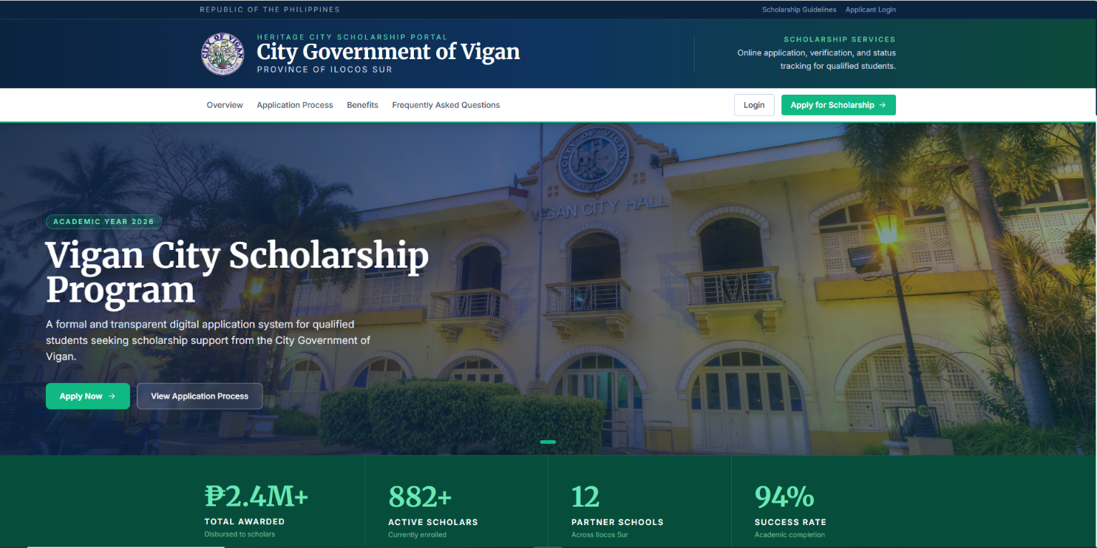

2.1.1 Interface Components
- Top bar: Displays 'Republic of the Philippines' branding with links to Scholarship Guidelines and Applicant Login.
- Navigation bar: Contains four menu items — Overview, Application Process, Benefits, and Frequently Asked Questions — along with Login and Apply for Scholarship call-to-action buttons.
- Hero banner: Features Vigan City Hall as the background image with Academic Year 2026 badge, the program title 'Vigan City Scholarship Program,' a descriptive tagline, and two action buttons: Apply Now and View Application Process.
- Statistics strip: Displays four key program metrics — Total Awarded (PHP 2.4M+), Active Scholars (882+), Partner Schools (12), and Success Rate (94%).

2.2 Scholarship Benefits Section
The Benefits section presents the three primary forms of support offered to accepted scholars under the program.

Benefit | Description | Target Beneficiary
Full Tuition Coverage | Qualified scholars receive full tuition support so they can focus on academic performance and completion. | All accepted scholars
Monthly Stipend | Financial assistance for transportation, school materials, and daily study needs. | Enrolled scholars
Mentorship & Support | Guidance and program support throughout the scholar's academic stay in partner institutions. | Scholars in partner schools

2.3 Application Process Overview (Six Steps)
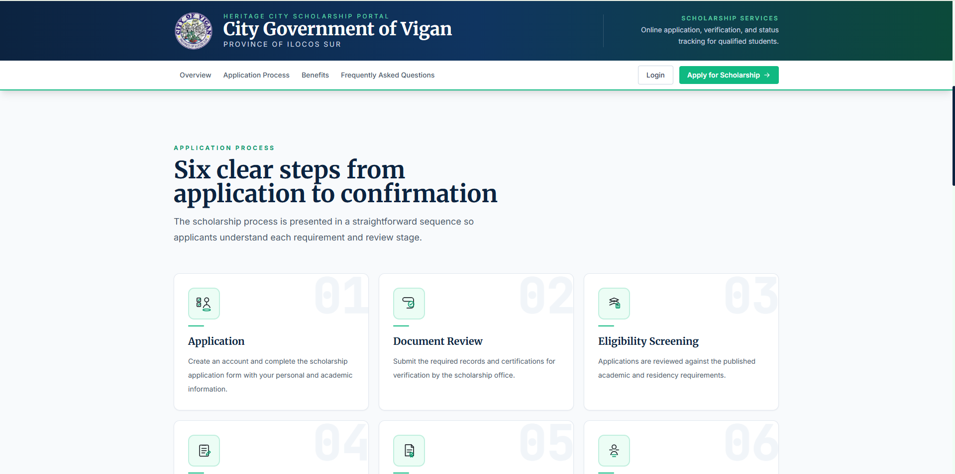
The landing page displays a six-step visual guide that explains the scholarship process from application to confirmation. This section is informational and does not require login.

Step 01 | Application  The applicant creates an account and completes the scholarship application form with personal and academic information.

Step 02 | Document Review  The applicant submits the required records and certifications for verification by the scholarship office.

Step 03 | Eligibility Screening  Applications are reviewed by administrators against published academic and residency requirements.

Step 04 | Exam / Interview  Qualified applicants are scheduled for an examination or interview as part of the selection process.

Step 05 | Final Evaluation  The scholarship committee conducts a final review based on all submitted documents and assessment results.

Step 06 | Confirmation  Accepted applicants are officially notified and onboarded as scholars with access to program benefits.

2.4 FAQ Section
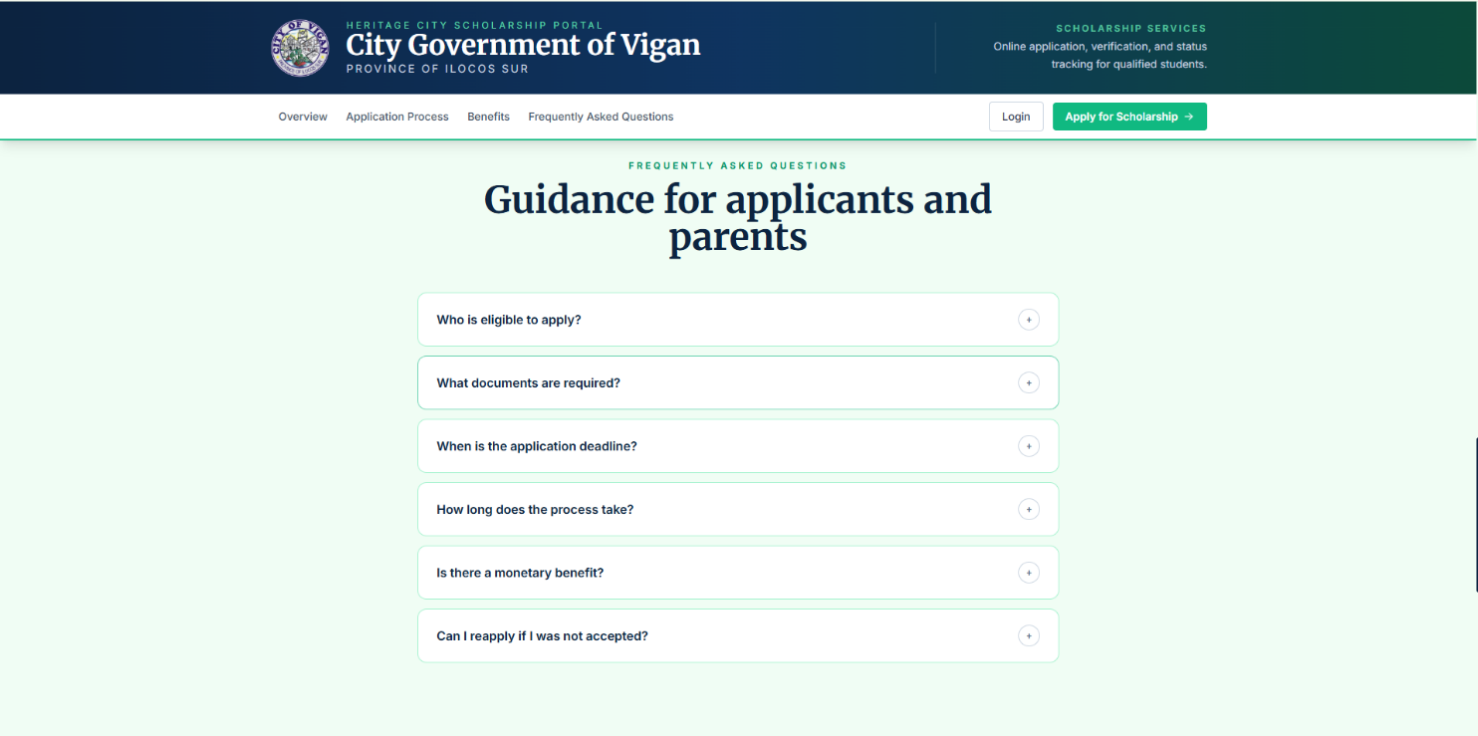
The Frequently Asked Questions (FAQ) section is a collapsible accordion panel accessible from the navigation bar. It provides guidance for applicants and parents. The following questions are currently listed:

- Who is eligible to apply?
- What documents are required?
- When is the application deadline?
- How long does the process take?
- Is there a monetary benefit?
- Can I reapply if I was not accepted?

2.5 Footer Section
The footer section contains a final call-to-action banner (Begin Your Scholarship Application) with two primary buttons: Create Applicant Account and Sign In to Existing Account. Below the banner, the footer displays portal links (Login, Apply for Scholarship) and information links (Application Process, FAQ). Copyright notice reads: '© 2026 City Government of Vigan. All rights reserved.'
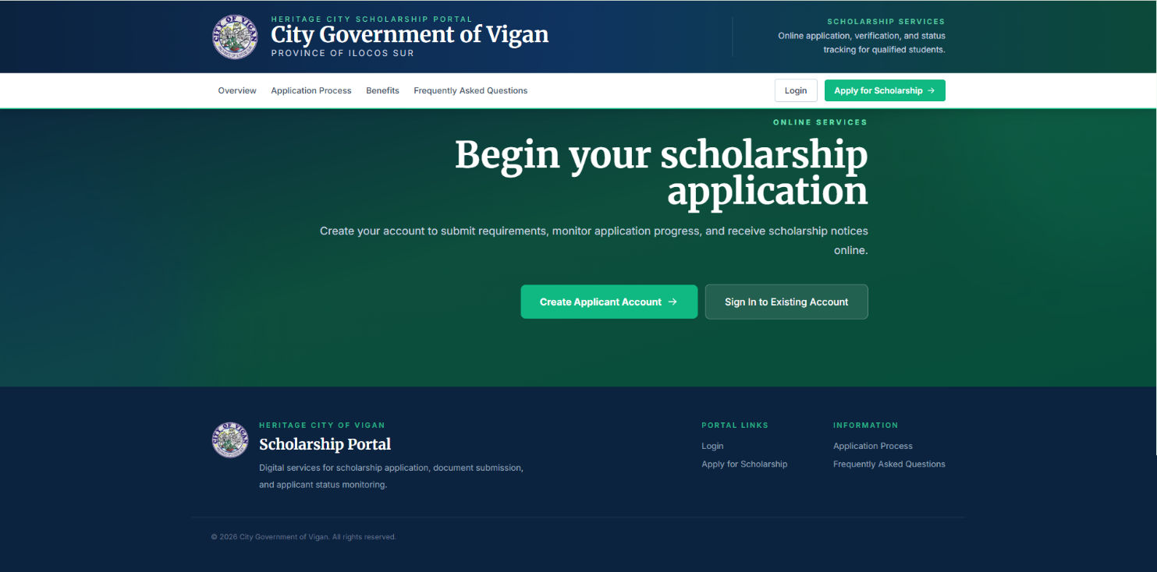

SECTION 3: USER AUTHENTICATION

3.1 Account Registration
New applicants must create an account before submitting a scholarship application. The registration page is split into two panels: the left panel displays the City Government of Vigan branding with the portal description and scholarship office details; the right panel contains the registration form.
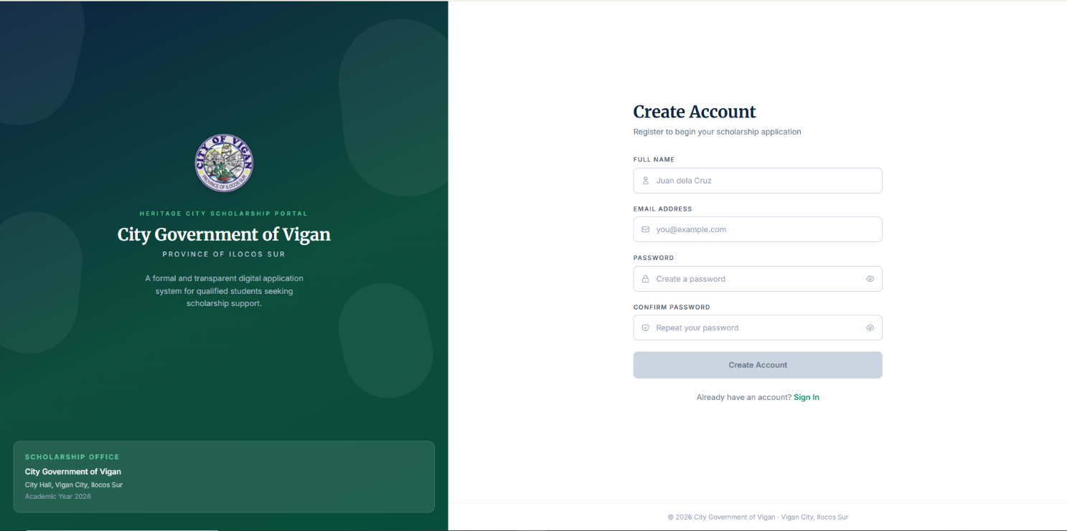

3.1.1 Registration Form Fields
FIELD | DESCRIPTION
Full Name | Required. Applicant's complete legal name (e.g., Juan dela Cruz).
Email Address | Required. Must be a valid, active email. Used for all portal communications.
Password | Required. Applicant sets a unique password for portal access.
Confirm Password | Required. Must match the password field to prevent entry errors.

3.1.2 Post-Registration: Email Verification
Upon successful registration, the system automatically sends a confirmation email to the registered email address with the subject: 'Confirm Your Scholarship Portal Email.' The email requires the applicant to verify their email address before logging in for the first time.

EMAIL VERIFICATION REQUIREMENTS
• The applicant must click the 'Confirm Email Address' button in the verification email.
• The confirmation link expires in 24 hours from the time of registration.
• Email confirmation protects the applicant account and ensures that scholarship notices, requirement reminders, and status updates are sent to the correct inbox.
• Accounts that are not verified within 24 hours may require re-registration.

3.2 Login
Registered and verified applicants access the portal through the Login page. The login page features the same split-panel layout as registration.
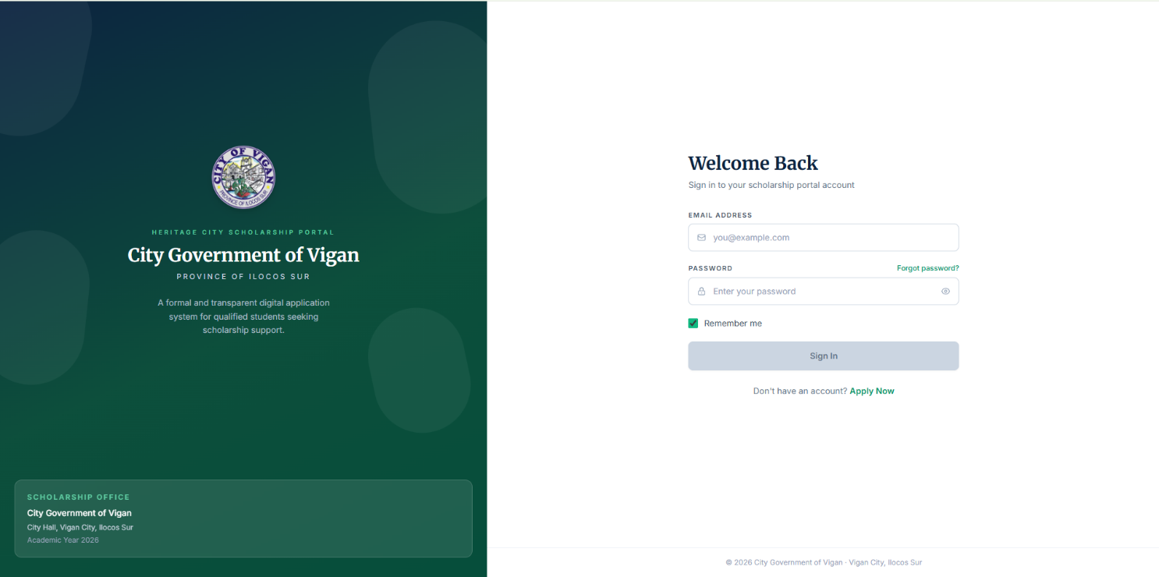

3.2.1 Login Form Fields
FIELD | DESCRIPTION
Email Address | The email address used during registration.
Password | The password set during account creation.
Remember Me | Optional checkbox. Keeps the session active across browser sessions.
Forgot Password? | Link to initiate a password reset via email.

IMPORTANT NOTE
• Unverified accounts will not be able to log in. Applicants must complete email verification first.
• Applicants who do not have an account may click 'Apply Now' on the login page to navigate to the registration form.
• The scholarship office (City Hall, Vigan City, Ilocos Sur) manages all account-related issues.

SECTION 4: APPLICANT PORTAL

4.1 Applicant Dashboard
After a successful login, the applicant is directed to the Scholarship Applicant Portal. The portal is a private, authenticated workspace where the applicant manages their scholarship application. The navigation bar contains the following sections: Dashboard, Apply, Status, Notifications, and COR.
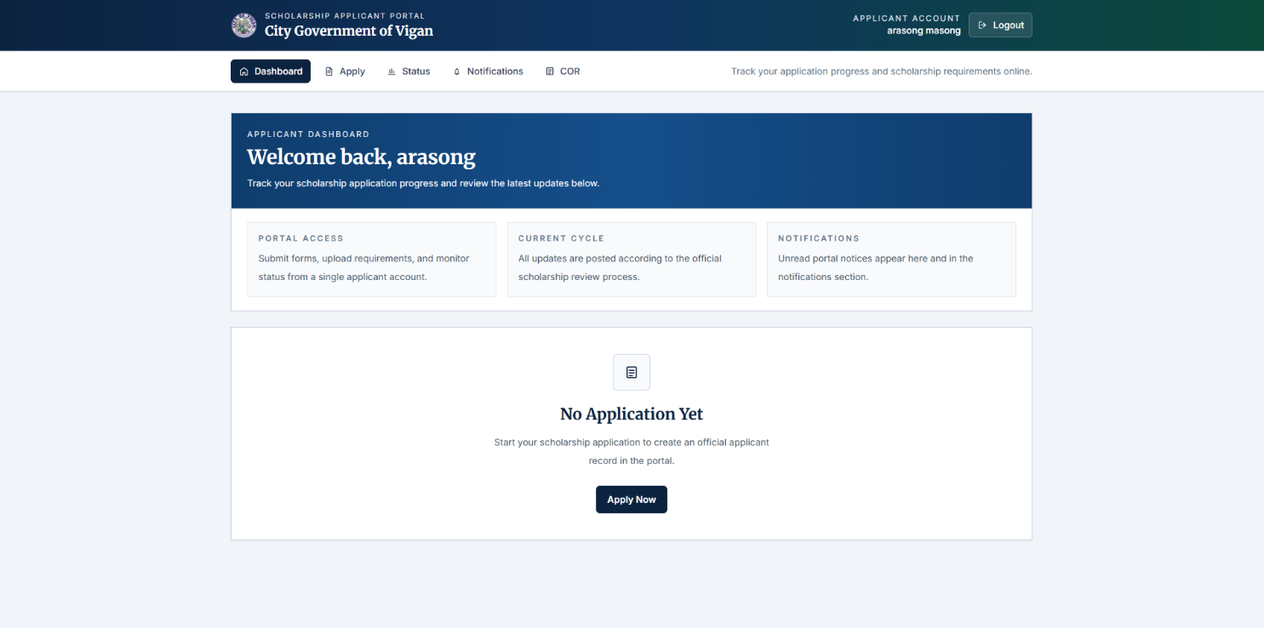

4.1.1 Dashboard Summary Cards
CARD | DESCRIPTION
Portal Access | Confirms the applicant can submit forms, upload requirements, and monitor status from a single account.
Current Cycle | Informs the applicant that all updates are posted according to the official scholarship review process.
Notifications | Displays unread portal notices. Mirrors the Notifications section tab.

If no application has been submitted yet, the dashboard center displays a 'No Application Yet' state with an Apply Now button to begin the application. Once an application is submitted, this area updates to display the application status and progress.

4.2 Application Form (Multi-Step Wizard)
The scholarship application is divided into a four-step wizard. Each step must be completed before proceeding to the next. A progress indicator at the top of the form shows the current step and completion status.
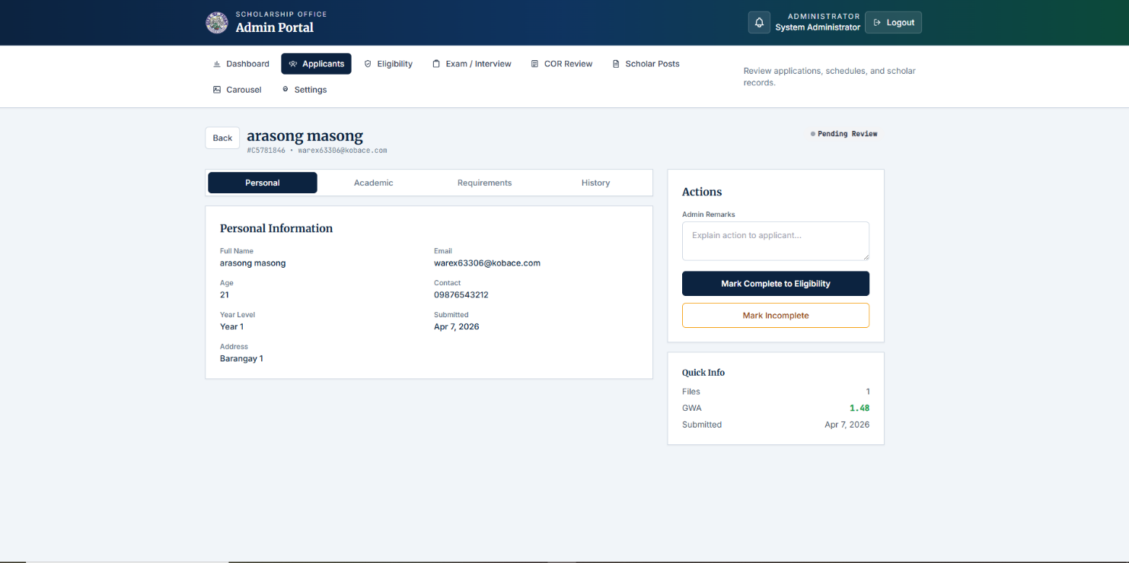

Step 1: Personal Information
The applicant fills in their personal details. All fields marked with an asterisk (*) are required.

FIELD | DESCRIPTION / REQUIREMENT
Full Name * | Applicant's complete legal name as it appears on official documents.
Age * | Applicant's current age in years.
Contact Number * | Valid Philippine mobile number (e.g., 09XXXXXXXXX).
Complete Address * | Full barangay and city/municipality address.
School / University * | Name of the college or university the applicant is enrolled in or applying to.
Course / Program * | Full name of the degree program (e.g., Bachelor of Science in Computer Science).
Year Level * | Dropdown selection: Year 1, Year 2, Year 3, or Year 4.
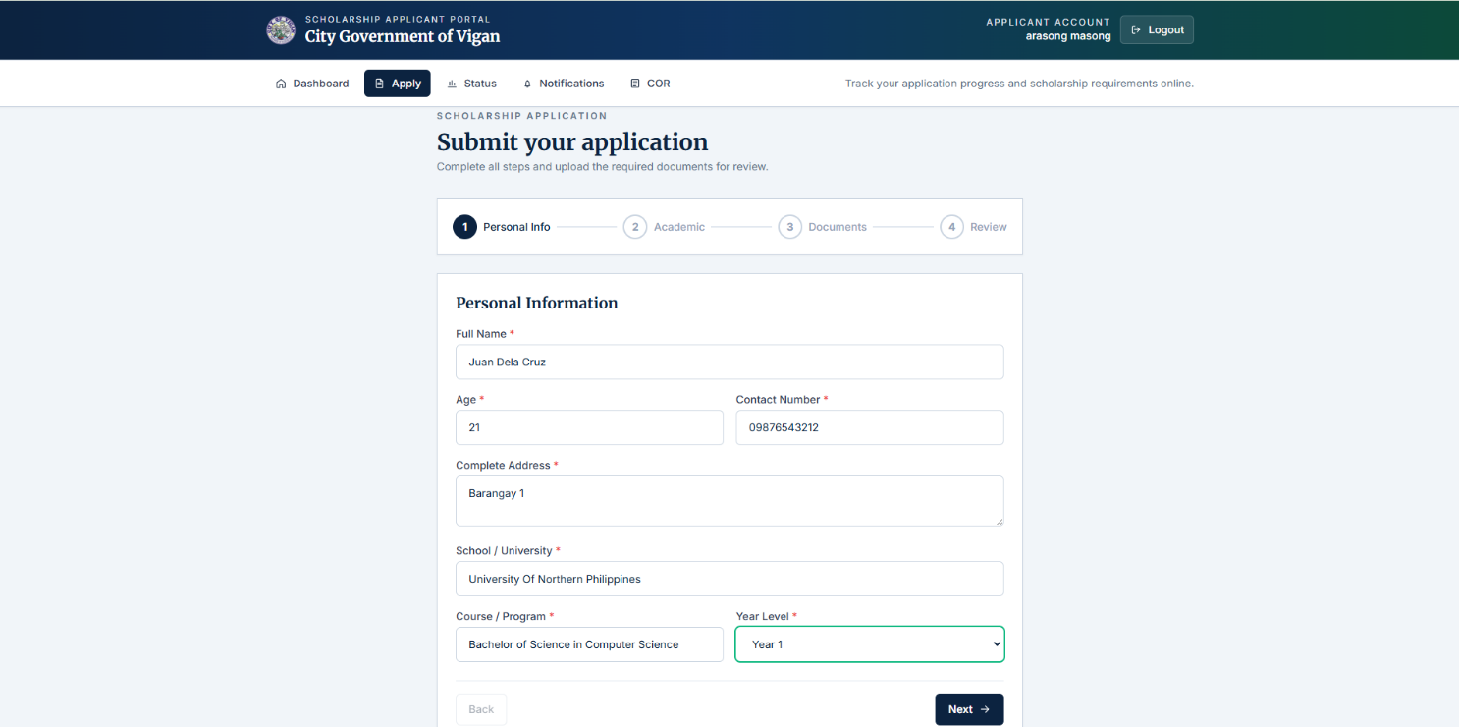

Step 2: Academic Records
The applicant submits their academic performance data.

FIELD | DESCRIPTION / REQUIREMENT
General Weighted Average (GWA) * | Entered on a 1.0–5.0 scale where 1.0 = Excellent. Minimum GWA of 2.0 (85% equivalent) is required.
Academic Achievements (Optional) | Free text field for honors, awards, or recognitions.

GWA ELIGIBILITY REQUIREMENT
Applicants must have a minimum GWA of 2.0 (85% equivalent) to qualify for eligibility screening.
Applications with GWA lower than 2.0 will not proceed past the eligibility review stage.
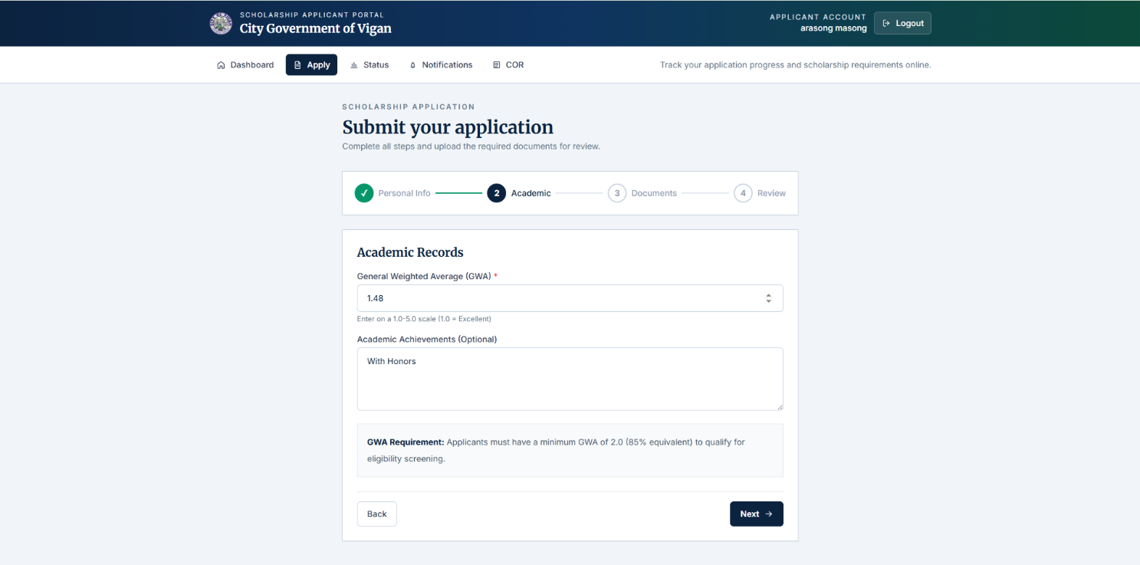

Step 3: Document Upload
The applicant uploads all required supporting documents. Files must be in PDF, JPG, or PNG format, with a maximum size of 5MB per file.

Required Documents:
- Personal Letter of Application addressed to the City Mayor.
- Certificate of Residency from the Punong Barangay (certifying bona fide residency for at least one [1] year with no derogatory records).
- Form 138 (General Average of at least 83% with no grade lower than 80% for the 1st and 2nd Semester).
- Certification from the High School Principal that the applicant is eligible for college education and is of Good Moral Character.
- Result of College Admission Test (CAT).
- Passport-size picture with printed name.
- Affidavit executed by a parent or legal guardian certifying that combined annual income is less than PHP 84,204.00 and the family does not own real estate property with fair value exceeding PHP 250,000.00.
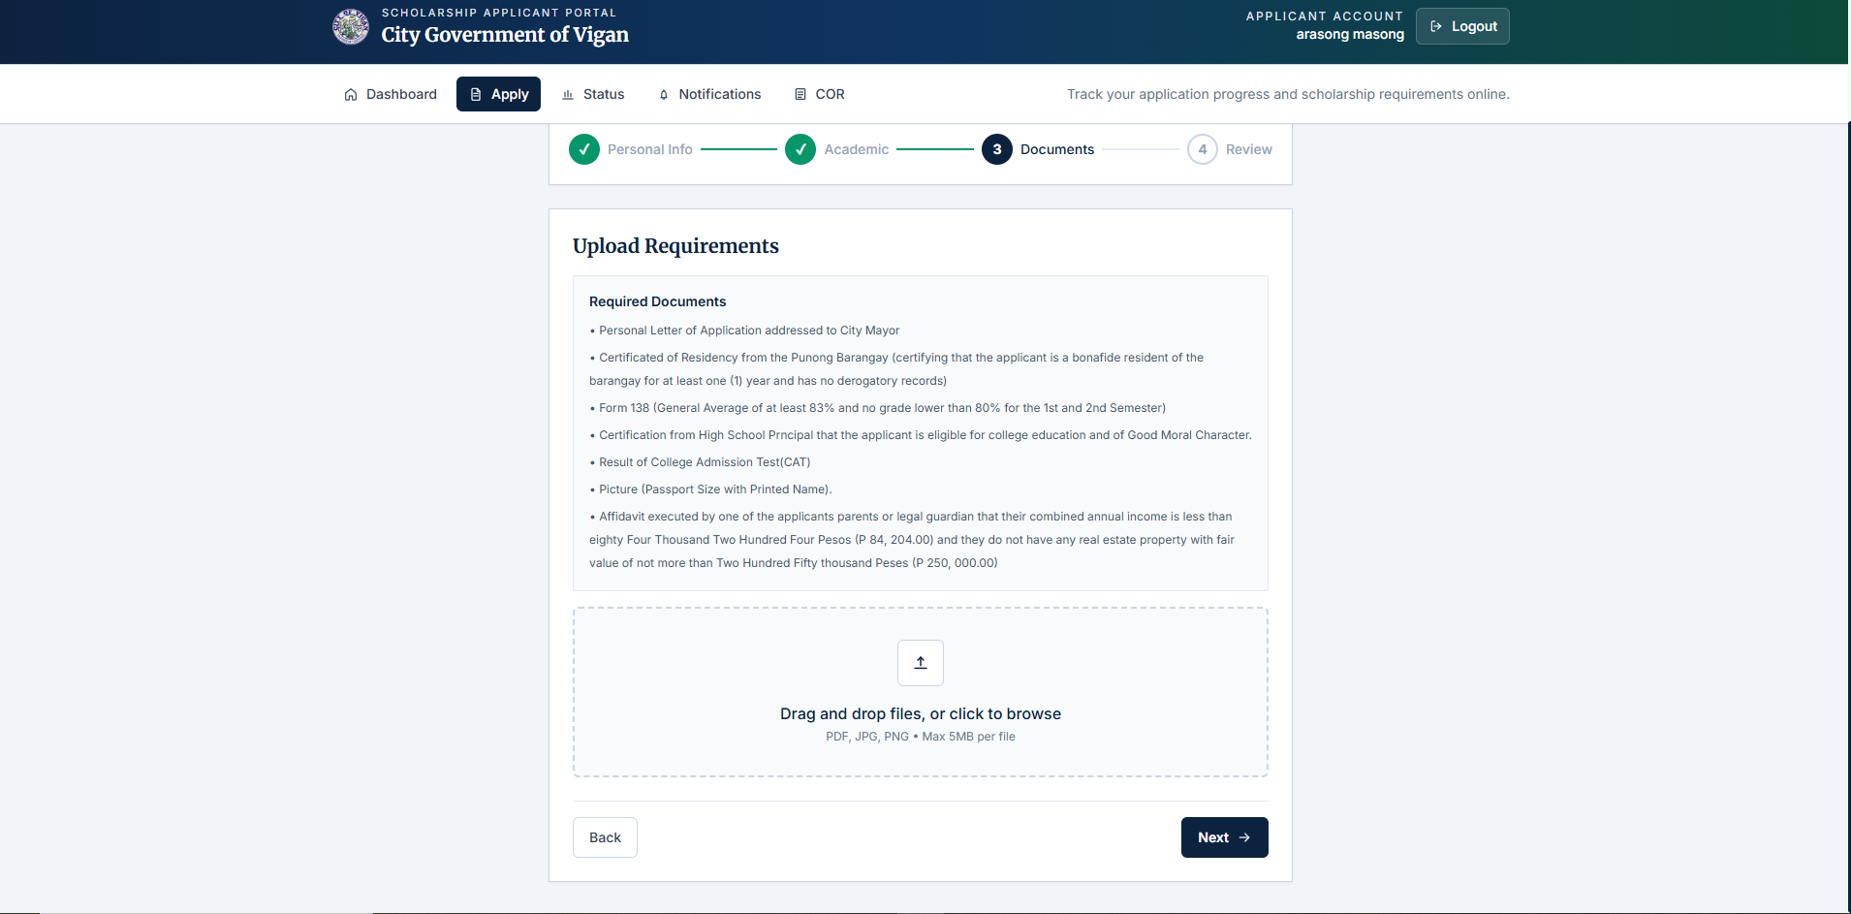

Step 4: Review and Submit
The final step displays a summary of all information entered across the previous three steps for the applicant's review before official submission.

SECTION REVIEWED | CONTENTS DISPLAYED
Personal Information | Full Name, Age, Contact, Year Level, Address
Academic | School, Course, GWA
Documents | File name(s) of uploaded documents

SUBMISSION DECLARATION
By clicking 'Submit Application', the applicant confirms that all submitted information is true and accurate.
Falsification of any document is grounds for immediate disqualification from the scholarship program.
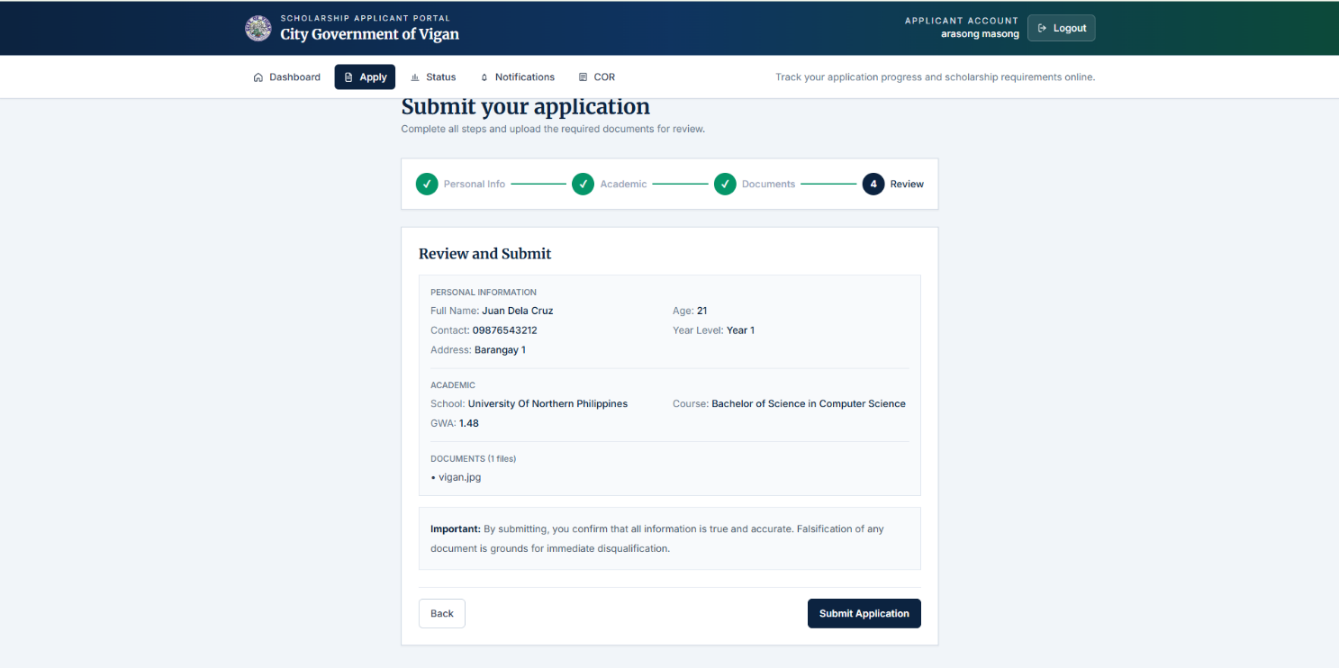

4.3 Notifications
The Notifications tab displays all system messages sent to the applicant's account. Notifications are categorized as All, Unread, and Read. Upon submission, the applicant receives an 'Application Submitted' notification containing their Reference ID (e.g., Reference ID: C5781846). This reference ID can be used for tracking and communication with the scholarship office.
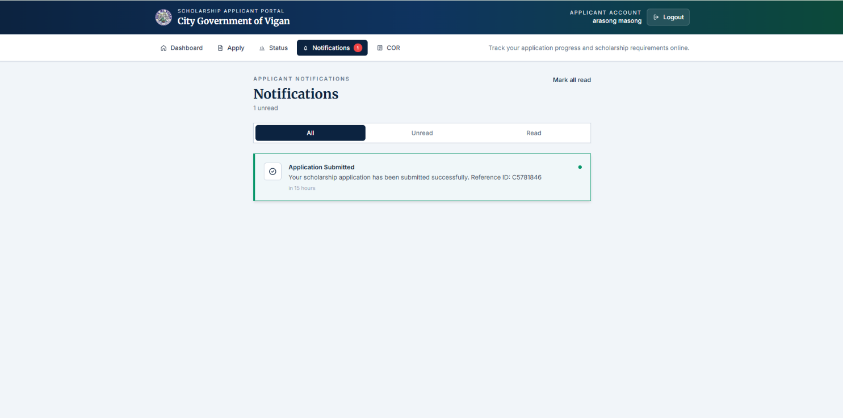

SECTION 5: ADMINISTRATOR PORTAL

5.1 Admin Portal Overview
The Administrator Portal (Admin Portal) is a restricted interface accessible only to authorized scholarship office personnel. It provides comprehensive tools for managing the scholarship pipeline from application intake through scholar confirmation.

5.1.1 Admin Navigation Menu
MENU ITEM | FUNCTION
Dashboard | Overview of all application statistics, urgent actions, and quick links.
Applicants | Full queue of submitted applications with search, filter, and review functions.
Eligibility | Manage eligibility screening decisions for applicants who passed document review.
Exam / Interview | Schedule and manage examination or interview stages for qualified applicants.
COR Review | Review Certificate of Registration submissions from active scholars.
Scholar Posts | Manage official communications and posts directed to scholars.
Carousel | Manage homepage banner/carousel content.
Settings | System configuration options.

5.2 Admin Dashboard
The Admin Dashboard provides a real-time operational overview of the scholarship management workload.

5.2.1 Summary Metric Cards
METRIC CARD | DESCRIPTION
Total Applications | Count of all applications received in the current cycle.
Pending Review | Count of applications awaiting administrator action.
Approved | Count of applications that have passed all review stages.
Accepted Scholars | Count of finalized and onboarded scholars.

5.2.2 Additional Dashboard Panels
- Applications by Status: A visual breakdown (chart or list) of applications grouped by their current workflow status.
- Urgent Actions: Highlights items requiring immediate administrator attention.
- Quick Links: Direct navigation buttons to Eligibility, Exam/Interview, COR Review, Scholar Posts, and All Applicants.
- Recent Activity: Log of the most recent administrative actions taken in the portal.

5.3 Applicant Review
The Applicants section displays all submitted applications in a sortable, filterable queue. Administrators can search by name, email, or school and filter by application status.

5.3.1 Application Queue Columns
COLUMN | DESCRIPTION
Name | Applicant's full name and registered email address.
School | School name and course/program.
GWA | Applicant's submitted General Weighted Average.
Status | Current status badge (e.g., Pending Review, Exam/Interview, Approved).
Submitted | Date the application was submitted.
Action | Review link that opens the full applicant profile.

5.4 Individual Applicant Review
Clicking Review on any applicant opens their full profile in a dedicated detail view. The profile is organized into four tabs: Personal, Academic, Requirements, and History.

5.4.1 Actions Panel (Right Sidebar)
ACTION | DESCRIPTION
Admin Remarks | Free-text field for the administrator to record notes or feedback for the applicant.
Mark Complete to Eligibility | Advances the application to the Eligibility Screening stage.
Mark Incomplete | Returns the application with a note, indicating missing or deficient documents.

5.4.2 Quick Info Panel
- Files: Number of documents uploaded by the applicant.
- GWA: Submitted general weighted average.
- Submitted: Date the application was officially submitted.

SECTION 6: APPLICATION STATUS WORKFLOW

6.1 Application Status Definitions
STATUS | MEANING
Pending Review | Application has been submitted and is awaiting initial review by the scholarship office.
Incomplete | Administrator has flagged the application due to missing or deficient documents. Applicant must resubmit.
Eligibility Screening | Application has passed the initial document review and is being evaluated against eligibility criteria.
Exam / Interview | Applicant has passed eligibility screening and is scheduled for examination or interview.
Approved | Applicant has passed all evaluation stages and is officially approved as a scholar.
Rejected | Applicant did not meet the scholarship requirements at one or more evaluation stages.

6.2 Workflow Diagram (Narrative)
The application progresses through the following sequential stages:

1. Applicant submits application via the portal (Status: Pending Review).
2. Administrator reviews documents. If complete → Mark Complete to Eligibility. If incomplete → Mark Incomplete (applicant is notified).
3. Eligibility screening is performed. Academic (GWA) and residency requirements are checked.
4. Qualified applicants are scheduled for Exam / Interview.
5. Final evaluation by the scholarship committee based on all criteria.
6. Final decision is recorded: Approved (scholar onboarded) or Rejected (applicant notified).

SECTION 7: STANDARD OPERATING PROCEDURE (SOP)
Document Number: HCSP-SOP-2026-001 | Effective: April 2026 | Review: Annual

This Standard Operating Procedure defines the step-by-step responsibilities of applicants and scholarship office administrators for each stage of the Heritage City Scholarship Portal workflow.

SOP-01: Applicant Account Registration

Step | Action | Details / Expected Outcome | Responsible
1 | Access Portal | Navigate to the Heritage City Scholarship Portal landing page via a web browser. | Applicant
2 | Click Apply | Click 'Apply for Scholarship' or 'Create Applicant Account' button. | Applicant
3 | Fill Form | Enter Full Name, Email Address, Password, and Confirm Password in the registration form. | Applicant
4 | Submit | Click 'Create Account'. System creates an unverified account record. | Applicant / System
5 | Check Email | Open the registered email inbox and locate the email with subject 'Confirm Your Scholarship Portal Email'. | Applicant
6 | Verify Email | Click 'Confirm Email Address' button. Link expires in 24 hours. Account is now active. | Applicant / System

SOP-02: Applicant Login

Step | Action | Details / Expected Outcome | Responsible
1 | Access Login | Navigate to the Login page from the portal header or footer. | Applicant
2 | Enter Credentials | Input registered Email Address and Password. | Applicant
3 | Sign In | Click 'Sign In'. System authenticates credentials and redirects to the Applicant Dashboard. | Applicant / System
4 | Verify Access | Confirm the dashboard displays the applicant's name and portal sections (Apply, Status, Notifications, COR). | Applicant

SOP-03: Scholarship Application Submission

Step | Action | Details / Expected Outcome | Responsible
1 | Navigate to Apply | From the Applicant Dashboard, click 'Apply Now' or the 'Apply' tab in the navigation bar. | Applicant
2 | Step 1 – Personal Info | Complete all required fields: Full Name, Age, Contact Number, Address, School, Course, and Year Level. Click Next. | Applicant
3 | Step 2 – Academic | Enter GWA (must be 2.0 or better on a 1.0–5.0 scale). Add optional academic achievements. Click Next. | Applicant
4 | Step 3 – Documents | Upload all required documents (PDF, JPG, or PNG; max 5MB each). Verify all files are listed. Click Next. | Applicant
5 | Step 4 – Review | Review the complete summary of all information and uploaded files for accuracy. | Applicant
6 | Submit | Click 'Submit Application'. System records the submission and assigns a Reference ID. | Applicant / System
7 | Confirm Notification | Check the Notifications tab for the 'Application Submitted' confirmation message with the Reference ID. | Applicant

SOP-04: Administrator – Initial Application Review

Step | Action | Details / Expected Outcome | Responsible
1 | Log In | Access the Admin Portal and log in with authorized administrator credentials. | Administrator
2 | Open Applicants | Navigate to the 'Applicants' section from the admin navigation bar. | Administrator
3 | Locate Application | Search or filter to locate the applicant. Review status, GWA, and submission date. | Administrator
4 | Open Profile | Click 'Review →' to open the applicant's full profile. | Administrator
5 | Review Tabs | Review all four tabs: Personal, Academic, Requirements, and History. | Administrator
6 | Decision – Complete | If all documents are in order, click 'Mark Complete to Eligibility'. Application advances to Eligibility Screening. | Administrator / System
7 | Decision – Incomplete | If documents are missing or deficient, add Admin Remarks and click 'Mark Incomplete'. Applicant is notified via their portal. | Administrator / System

SOP-05: Administrator – Eligibility Screening

Step | Action | Details / Expected Outcome | Responsible
1 | Navigate to Eligibility | From the Admin Portal, click 'Eligibility' in the navigation bar. | Administrator
2 | Review GWA | Confirm the applicant's GWA meets the minimum requirement of 2.0 (85% equivalent). | Administrator
3 | Verify Residency | Check the Certificate of Residency confirming at least 1 year of bona fide residency. | Administrator
4 | Check Income Affidavit | Verify the affidavit confirms combined annual income below PHP 84,204 and no real property exceeding PHP 250,000 in value. | Administrator
5 | Record Decision | Mark the applicant as Eligible (advance to Exam/Interview) or Ineligible (record reason in remarks). | Administrator / System

SOP-06: Administrator – Exam / Interview Scheduling

Step | Action | Details / Expected Outcome | Responsible
1 | Navigate to Exam/Interview | From the Admin Portal, click 'Exam / Interview' in the navigation bar. | Administrator
2 | Identify Qualifiers | Review the list of applicants with 'Exam / Interview' status. | Administrator
3 | Schedule | Set the examination or interview date, time, and venue for each applicant or batch. | Administrator
4 | Notify Applicant | The system sends a portal notification to the applicant with the exam/interview details. | System
5 | Conduct Assessment | Administer the examination or interview on the scheduled date. | Administrator
6 | Record Results | Enter assessment results into the system and update application status accordingly. | Administrator / System

SOP-07: Final Approval and Scholar Onboarding

Step | Action | Details / Expected Outcome | Responsible
1 | Final Committee Review | Scholarship committee reviews all evaluation data (documents, GWA, exam results) for each applicant. | Administrator / Committee
2 | Approve Scholar | For applicants meeting all criteria, update status to 'Approved' in the system. | Administrator / System
3 | Notify Applicant | System sends portal notification and/or official communication confirming scholarship award. | System
4 | Reject Application | For applicants who do not qualify, update status to 'Rejected' and record remarks for the applicant's reference. | Administrator / System
5 | Onboard Scholar | Approved scholars are added to the Scholar Posts and COR Review system for ongoing management. | Administrator

SECTION 8: DOCUMENT REQUIREMENTS CHECKLIST
The following checklist is provided as a reference for applicants preparing their documents before beginning the online application.

# | DOCUMENT | FORMAT ACCEPTED | MAX SIZE
1 | Personal Letter of Application (addressed to City Mayor) | PDF, JPG, PNG | 5MB
2 | Certificate of Residency from Punong Barangay (min. 1 year residency, no derogatory records) | PDF, JPG, PNG | 5MB
3 | Form 138 (Gen. Average ≥83%; no grade <80% in 1st and 2nd Semester) | PDF, JPG, PNG | 5MB
4 | High School Principal Certification (eligible for college; Good Moral Character) | PDF, JPG, PNG | 5MB
5 | Result of College Admission Test (CAT) | PDF, JPG, PNG | 5MB
6 | Passport-size Picture (with printed name) | JPG, PNG | 5MB
7 | Income Affidavit (combined income <PHP 84,204; no real estate >PHP 250,000 fair value) | PDF, JPG, PNG | 5MB

SECTION 9: GLOSSARY OF TERMS

TERM | DEFINITION
HCSP | Heritage City Scholarship Portal – the official digital scholarship management system of the City Government of Vigan.
GWA | General Weighted Average – the academic performance metric used to determine scholarship eligibility.
CAT | College Admission Test – an entrance examination result required as part of the document submission.
COR | Certificate of Registration – official enrollment document from the scholar's school, required for ongoing scholar verification.
Punong Barangay | The elected head of a barangay (village), authorized to issue residency certifications.
Reference ID | A unique application identifier (e.g., C5781846) assigned upon successful application submission.
DXA | Document XML Array – a unit of measurement used internally in Word documents (1440 DXA = 1 inch).
Admin Portal | The restricted administrator interface used by the scholarship office to review, process, and manage applications.

DOCUMENT APPROVAL

This document has been prepared, reviewed, and approved by authorized personnel of the Scholarship Office, City Government of Vigan.

PREPARED BY | REVIEWED BY | APPROVED BY
Signature over Printed Name  Date: _______________ | Signature over Printed Name  Date: _______________ | Signature over Printed Name  Date: _______________

