KPR INSTITUTE OF ENGINEERING AND TECHNOLOGY
(Autonomous), Coimbatore – 641 407 · Department of CSE
U21CSP12 – JavaScript Frameworks
ASSIGNMENT – II
Detail
Name | Vigasvel R
Roll Number | 24CS241
Year / Semester | III / V – B.E. CSE
Academic Year | 2026 – 2027
Issue / Submission Date | 15-10-2026 / 31-10-2026
GitHub Repository | https://github.com/______________________

Questions Answered
Q.No | Task | Application | Stack | CO | Marks
Q1 | Student Management System using MERN Stack | StudentHub | MERN | CO3 | 8
Q2 (Task 2) | Task management application for students | TaskPilot | MERN | CO5 | 16
Q3 (Task 2) | Appointment booking application | MediSlot | MEAN | CO4 | 16

Technologies
MongoDB + Mongoose (database), Express.js + Node.js (REST API), React 18 with Vite (MERN – Q1, Q2), Angular 20 with Reactive Forms (MEAN – Q3). Each app follows Browser → React/Angular → REST/JSON → Express → Mongoose → MongoDB. Complete source code and run steps are in the GitHub repository / zip.
Signature of the Student Signature of the Course In-charge

Q1 – StudentHub – Student Management System
Task: Develop a Student Management System using MERN Stack: React form to enter student details, REST APIs with Express.js and Node.js, student records stored in MongoDB, add / view / update / delete operations.
Stack: React 18 (Vite) + Axios · Node.js + Express.js · MongoDB (vigasvel_studenthub)

Requirements and Implementation
Requirement | Implementation
React form to enter student details | StudentModal.jsx – modal form with text, radio, select, range slider and checkbox inputs
REST APIs using Express.js and Node.js | routes/student.routes.js with validation middleware and central error handler
Store student records in MongoDB | models/student.model.js – Mongoose schema incl. attendance and virtual "eligible" field
Add, view, update and delete operations | Add / Edit in the modal, View with search & filters + dashboard, Delete with confirmation

Database
Collection fields: regNo (String), fullName (String), gender (String), email (String), department / section (String), attendance (Number), guardianName / guardianPhone (String), hosteller (Boolean), eligible (virtual).

REST API
Method | Endpoint | Purpose
GET | /api/students | List students (query: q, department, section, shortage=true)
GET | /api/students/stats | Dashboard numbers: total, average attendance, shortage, by department
GET | /api/students/:id | Get one student
POST | /api/students | Add a student (validation middleware, 422 / 409 errors)
PUT | /api/students/:id | Update a student
DELETE | /api/students/:id | Delete a student

Output
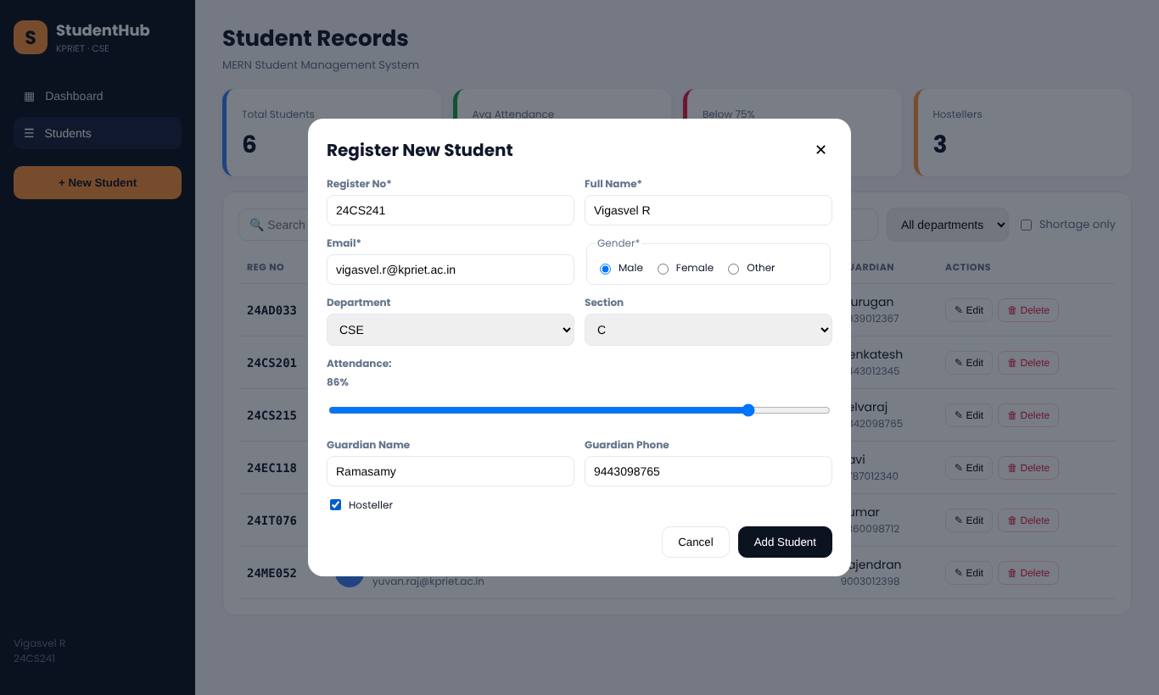  Fig. 1: CREATE – React form (modal) to enter student details | 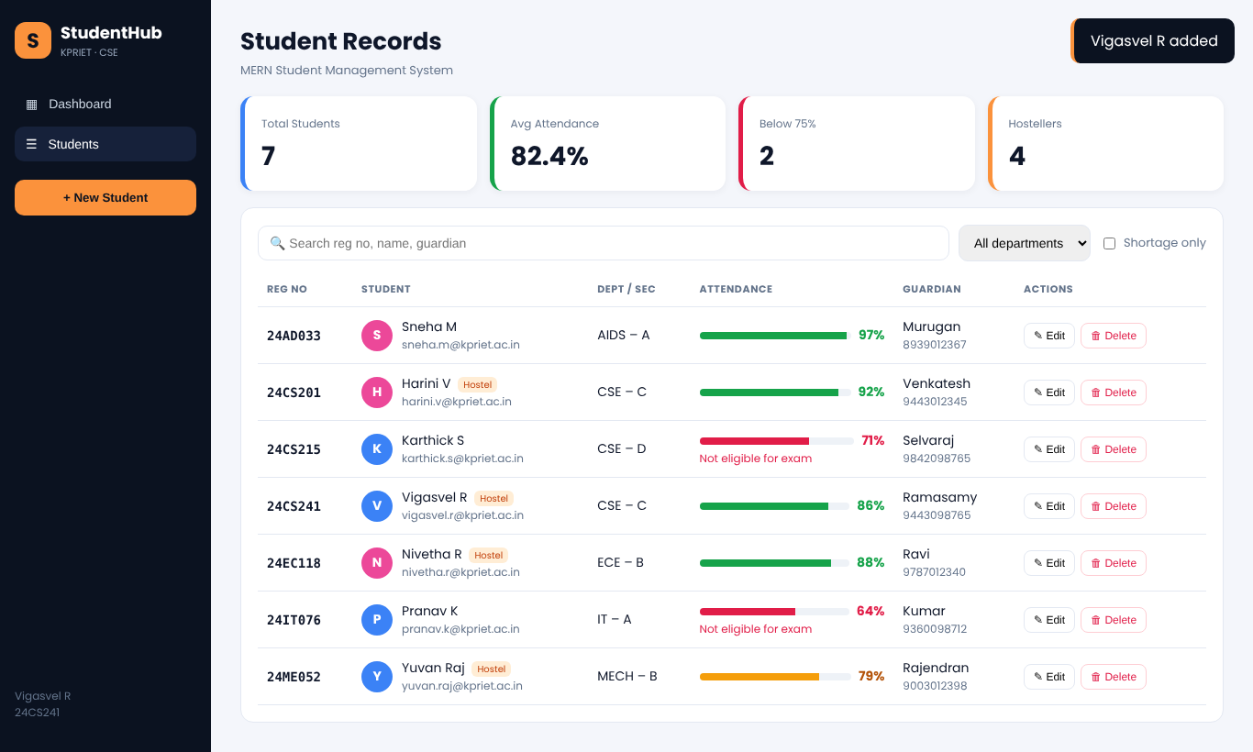  Fig. 2: New student added
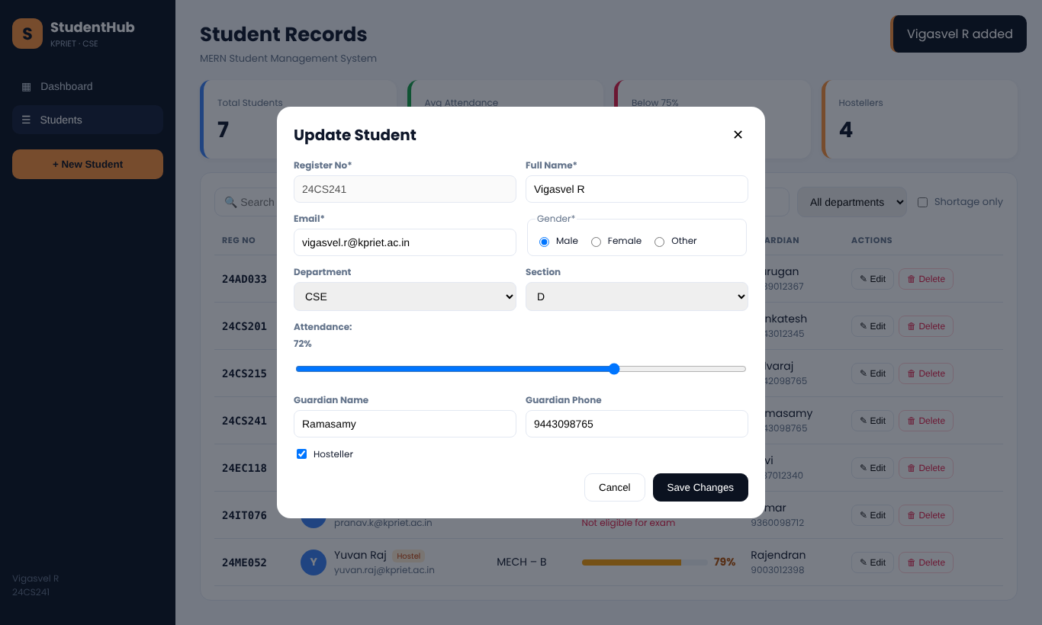  Fig. 3: UPDATE – editing attendance and section | 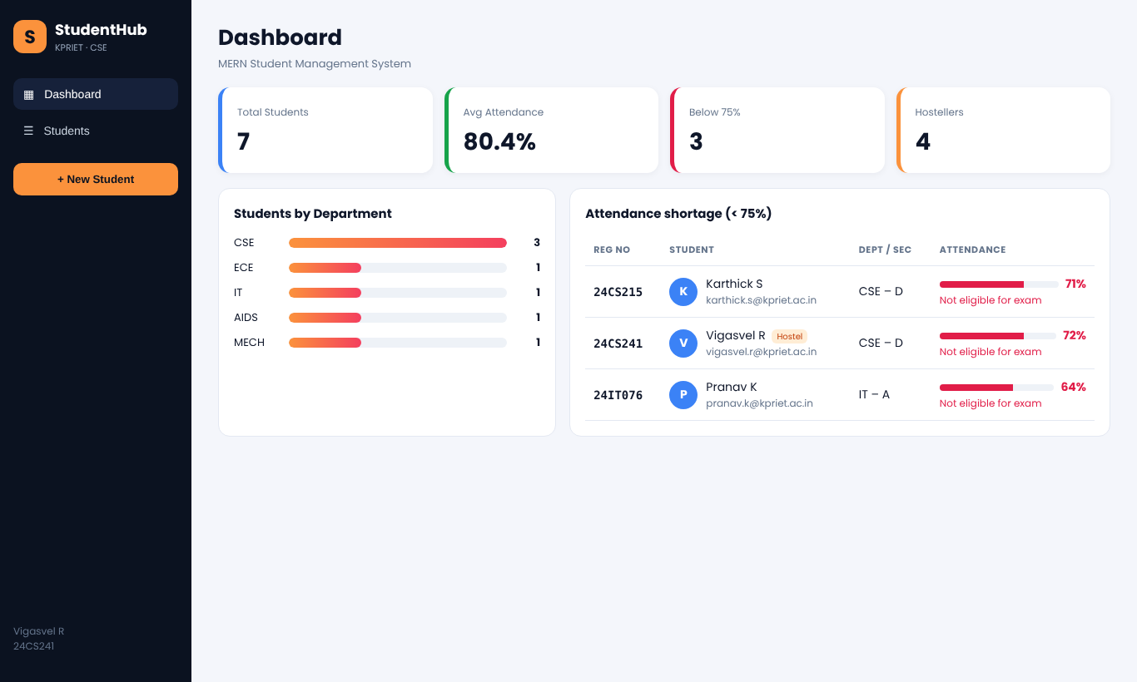  Fig. 4: Dashboard with statistics
Result: The application was implemented and all required operations were tested successfully.

Q2 (Task 2) – TaskPilot – Student Task Manager
Task: Build a task management application for students: add, edit and delete tasks, set task priority and completion status, use React Hooks to manage the interface, store tasks in MongoDB through a Node.js backend.
Stack: React 18 (Vite) + Axios – Hooks: useState, useEffect, useReducer, useMemo, useCallback, useRef, custom useTasks · Node.js + Express.js · MongoDB (vigasvel_taskpilot)

Requirements and Implementation
Requirement | Implementation
Add, edit and delete tasks | TaskForm.jsx for add/edit, Delete button on each card, POST / PUT / DELETE /api/tasks
Set task priority and completion status | Priority Low/Medium/High selector; status Pending / In Progress / Completed via board and checkbox
Use React Hooks to manage the interface | useState, useEffect, useReducer, useMemo, useCallback, useRef and custom hook useTasks()
Store tasks in MongoDB through a Node.js backend | Express API on port 5012 with Mongoose model task.model.js

Database
Collection fields: title (String), description (String), subject (String), priority (String), status (String), dueDate (Date), completedAt (Date).

REST API
Method | Endpoint | Purpose
GET | /api/tasks | List tasks sorted by priority then due date (query: status, priority, subject, q)
GET | /api/tasks/subjects | Distinct subjects
POST | /api/tasks | Add a task
PUT | /api/tasks/:id | Edit a task
PATCH | /api/tasks/:id/status | Change completion status
DELETE | /api/tasks/:id | Delete a task
DELETE | /api/tasks?status=Completed | Clear all completed tasks

Output
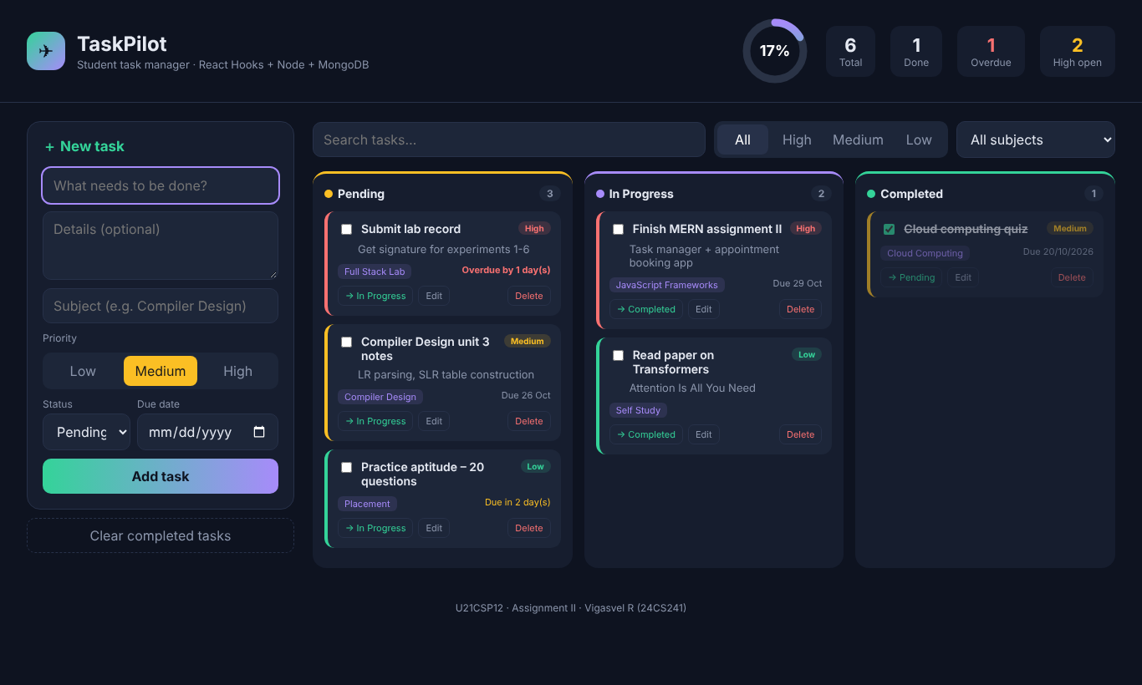  Fig. 5: Task board – tasks loaded from MongoDB | 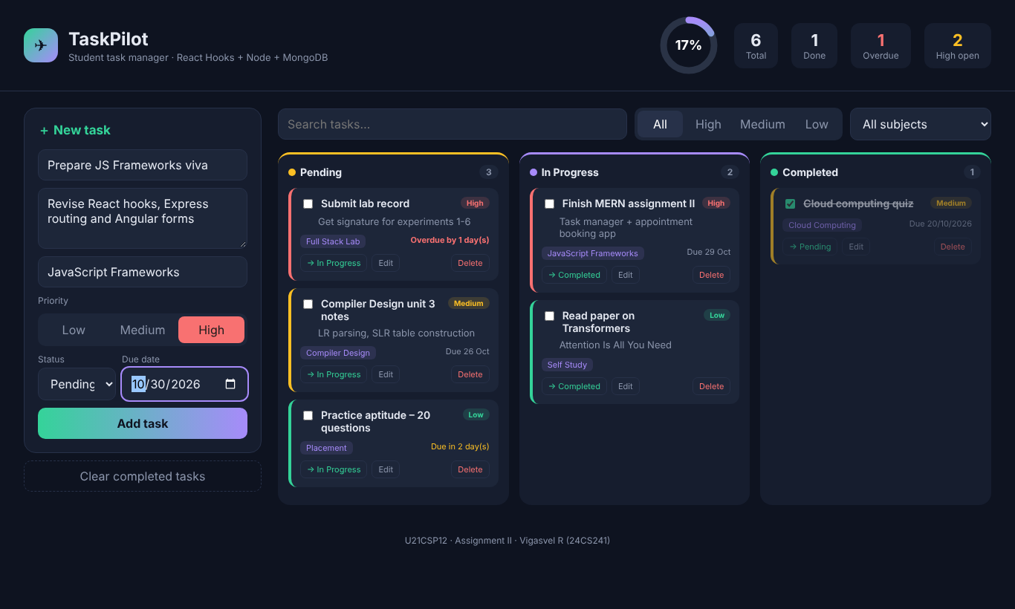  Fig. 6: ADD – new task with High priority and due date
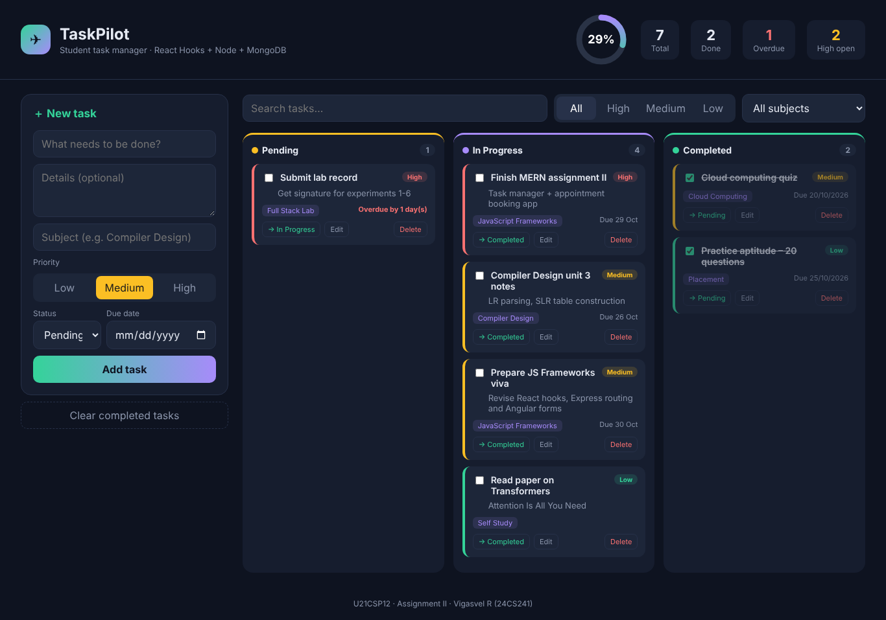  Fig. 7: Completion status changed (moved / ticked) | 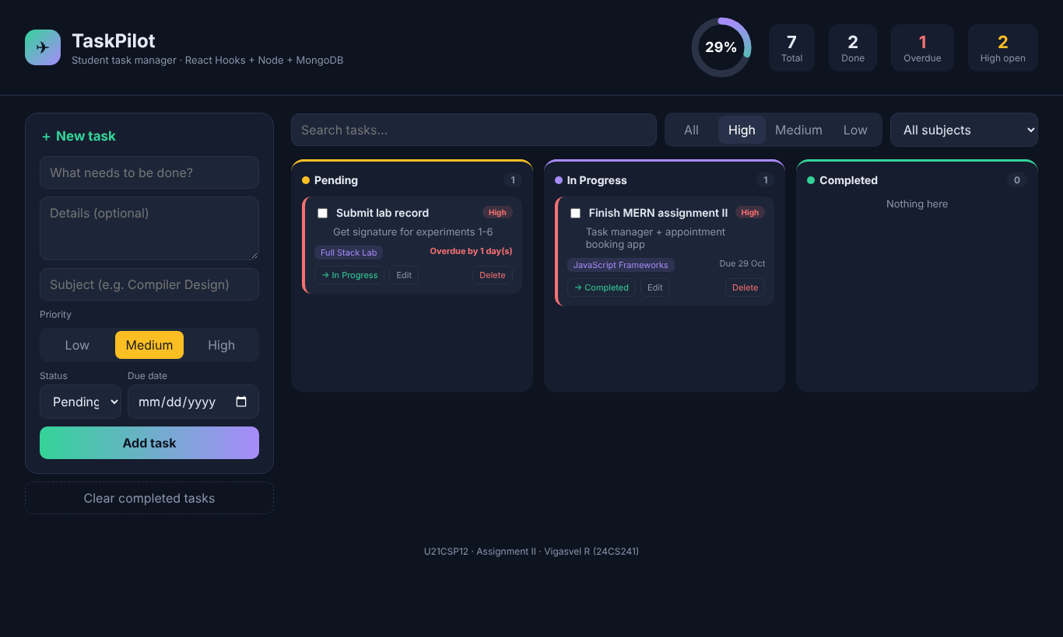  Fig. 8: Filter by priority = High
Result: The application was implemented and all required operations were tested successfully.

Q3 (Task 2) – MediSlot – Appointment Booking (MEAN)
Task: Design an appointment booking application: create Angular forms for patient registration, display doctors and their available appointment slots, develop REST APIs for appointment management, store patient and appointment records in MongoDB.
Stack: Angular 20 (standalone components, Router, Reactive Forms, signals) · Node.js + Express.js · MongoDB (vigasvel_medislot)

Requirements and Implementation
Requirement | Implementation
Angular forms for patient registration | PatientRegister page – Reactive Form with required, min/max, pattern, email and consent validators
Display doctors and their available slots | BookAppointment page – doctor cards by specialization and per-date slot chips (free / booked)
REST APIs for appointment management | POST / GET / PATCH / DELETE /api/appointments plus doctors and patients APIs
Store patient and appointment records in MongoDB | Patient, Doctor and Appointment collections; auto Patient ID and daily token number

Database
Doctor: name, specialization, qualification, experience, room, fee, days[], slots[] | Patient: patientId (auto MS-1001…), name, age, gender, phone, email, bloodGroup, address | Appointment: patient (ref), doctor (ref), date, time, reason, status Booked / Cancelled / Completed, token

REST API
Method | Endpoint | Purpose
GET | /api/doctors | List doctors (query: specialization)
GET | /api/doctors/:id/slots?date= | Slots for a date with available / booked flags
POST | /api/patients | Register a patient (generates Patient ID)
GET | /api/patients/:patientId | Find a patient
POST | /api/appointments | Book a slot (blocks double booking – 409)
GET | /api/appointments | List (query: patientId, date, status)
PATCH | /api/appointments/:id/status | Cancel or complete an appointment
DELETE | /api/appointments/:id | Delete an appointment

Output
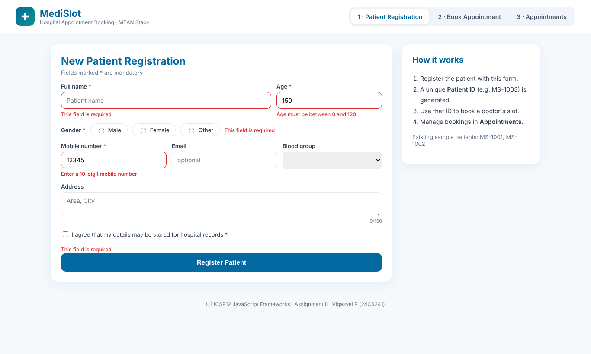  Fig. 9: Angular form validation – patient registration | 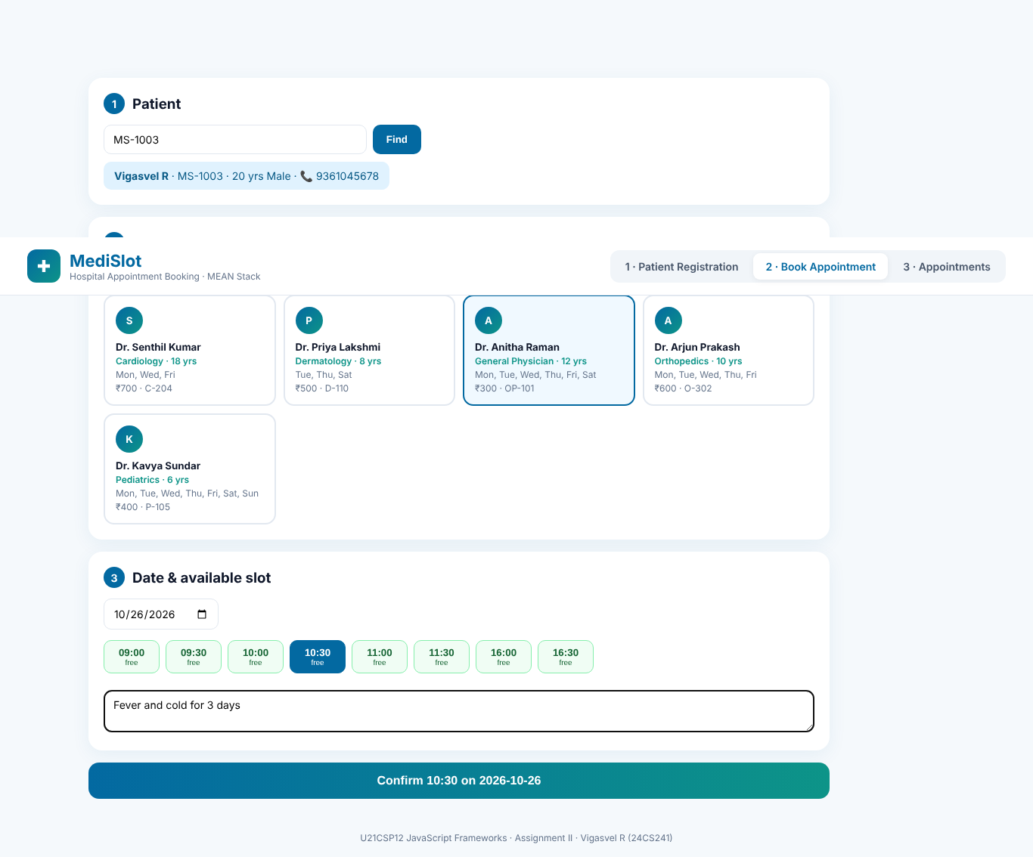  Fig. 10: Doctors and available slots for the chosen date
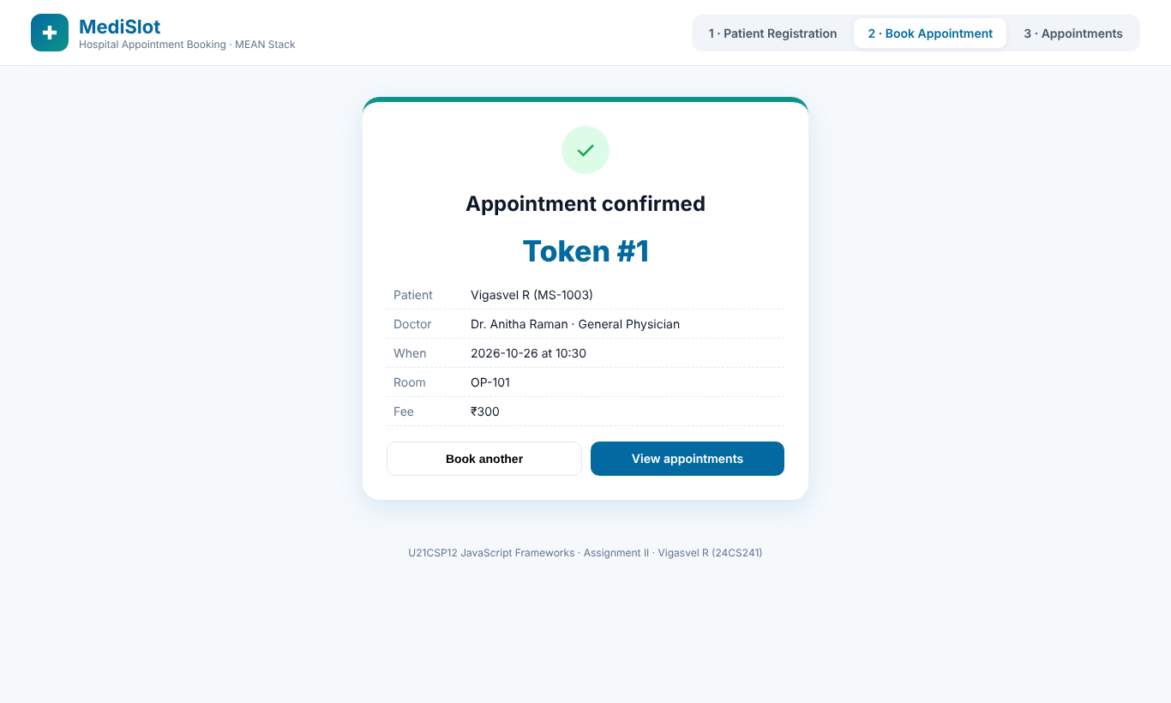  Fig. 11: Appointment confirmed with token number | 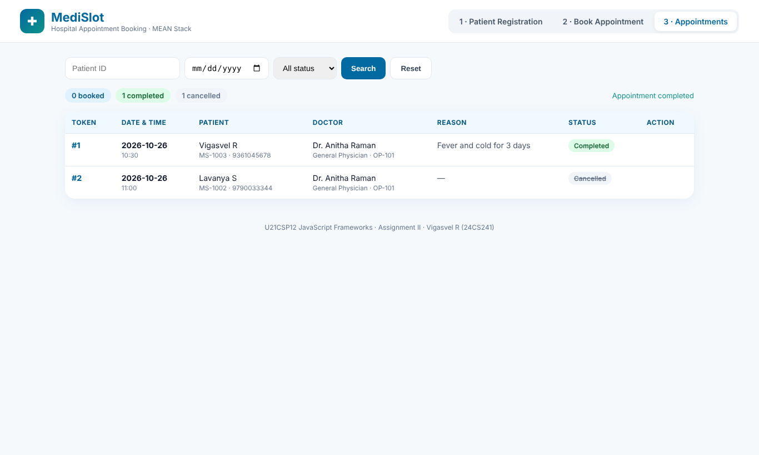  Fig. 12: Appointments completed / cancelled
Result: The application was implemented and all required operations were tested successfully.
Conclusion: All three questions were implemented as working MERN/MEAN applications using React Hooks, Angular forms and services, Express REST APIs and MongoDB.

