**GOOGLE CLOUD PROJECT - TEXT SUMMARIZER**

**For GDSC – Sri Sivasubramaniya Nadar College of Engineering by Vignesh S.M, Varsha Yeshwanth, Rosan D.**

**Facilitator -Arjun Mukesh,**

**GDSC SSN Lead - Vignesh Balaji.**

**PROBLEM STATEMENT:**

Providing a detailed, concise summary of long lines of text can be a cumbersome process, especially as the number of words in our sample increases. Furthermore, it becomes difficult to recontextualise large tracts of text into a summary efficiently and clearly.

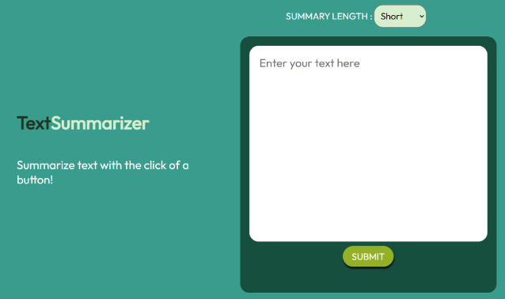**PROPOSED SOLUTION:**

**GitHub project repository -** [**here**](https://github.com/vigbav36/summarizer)

The following project, deployed on Google Cloud Platform, solves both problems through a web application that provides a thorough, succinct summary of a given input text. The project enables the user to upload a sample text/image and choose the length of the summary. The simpleT5 model was used for summarization and the web application uses flask. The finished application was then deployed on to google cloud via compute engine.

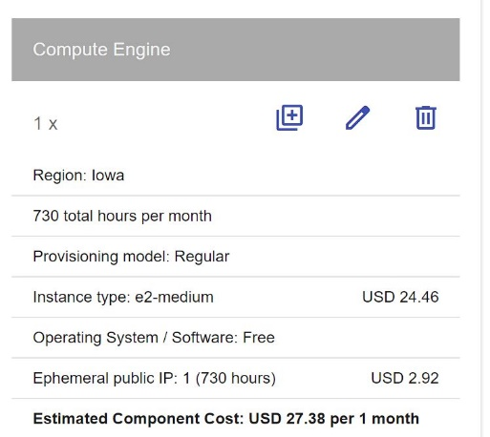

**CLOUD SERVICES USED**:

Google Compute Engine was used to host the flask application. A VM Instance was created and accordingly set up for the deployment of our application. The model.pkl file which is the pickle file of the model is stored in cloud bucket . This makes it easier to store different versions of the model and save the burden of sharing such a large file .The pickle file in this cloud bucket is used in the application. Finally, the application was made to run in the localhost of the virtual machine and accordingly deployed. The application can now be viewed in the browser.

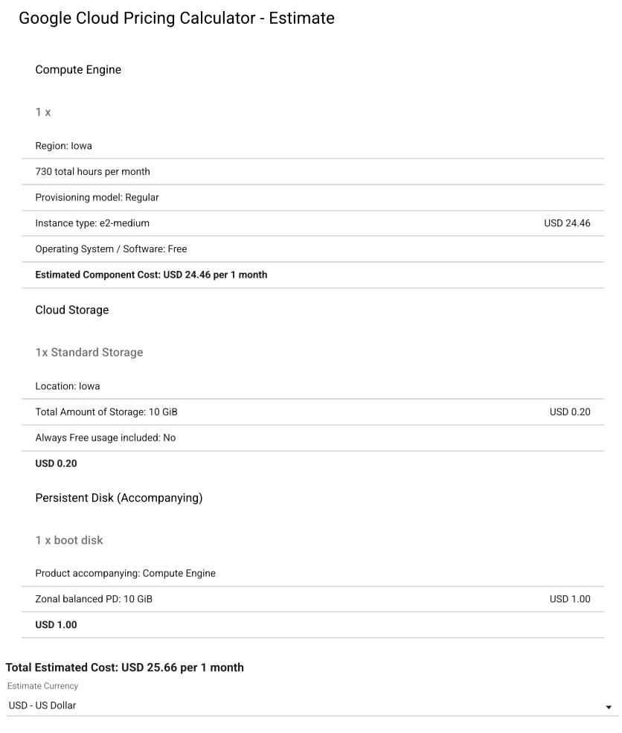**BILLING BREAKDOWN**:

The billing breakdown on the services used is given as:

**WEBSITE LINK**

http://104.154.69.229/