Subwindow Permutation Analysis

coupled with PLS-LDA

(SPA)

Version 1.0

Advisor: Professor Yi-Zeng Liang, yizeng_liang@263.net
Coder: Hong-Dong Li, lhdcsu@gmail.com
Date: Mar. 12, 2010.

Copyright & License
The SPA software is supplied subject to version 2 of the “GNU General Public License”. See the GNU General Public License for more details. SPA can be freely available to all non-commercial users. It can redistributed and/or modified under the terms of the GNU.

Platform
The current version is coded and tested in MATLAB 7.6.0 in Window Operating Systems. If any questions about running this software, please feel free to contact us.

Research Center of Modernization of Chinese Medicines
College of Chemistry and Chemical Engineering
Central South University, Changsha 410083, P.R. China

1 Main functions
ID | File | Descriptions
1 | Plslda.m | Main program for building a PLS-LDA model.
2 | plsldaval.m | Make predictions using PLS-LDA model
3 | plsldcv.m | K-fold cross validation for choosing the number of latent variables
4 | plsldamccv.m | Monte Carlo Cross Validation for choosing the number of latent variables
5 | plsldardcv.m | Repeated Double Cross Validation for choosing the number of latent variables
6 | plotplslda.m | Plot the results obtained from spa.m
7 | spa.m | Conduct variable selection using SPA
8 | plotspa.m | Plot the distribution of normal and permutation prediction errors of a given variable resulting from spa.m

2 Data

This dataset contains raw profiles of 21 metabolites measured on 45 control and 45 T2DM patients. The metabolites are analyzed by GC/MS instrument. If you want to use this data in your study, please cite the following article:

[1] B.-B, Tan,Y.Z. Liang et al . et al. Identification of free fatty acids profiling of type 2 diabetes mellitus and exploring possible biomarkers by GC-MS coupled with chemometrics. Metabolomics. doi: 10.1007/s11306-009-0189-8

In addition, the data is also investigated in the study:

[2] Hong-Dong Li, Mao-Mao Zeng, Bin-Bin Tan, Yi-Zeng Liang et al, Recipe for revealing informative metabolites based on model population analysis, metabolomics, doi:10.1007/s11306-010-0213-z.

3 Usage:
Please type help filename in the MATLAB prompt window for detailed information. For example:

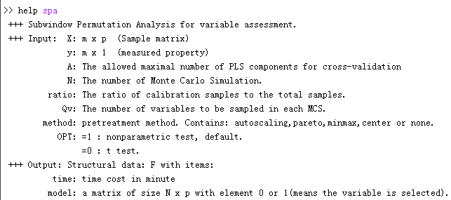

4 Example script:
Along with the software, there is an example script, with filename example_spa.m, which shows how to run SPA program to identify the informative variables of a given dataset. Just run this program, and you will see how SPA works.
5 Reference：
- Hong-Dong Li, Mao-Mao Zeng, Bin-Bin Tan, Yi-Zeng Liang et al, Recipe for revealing informative metabolites based on model population analysis, metabolomics, doi:10.1007/s11306-010-0213-z.

