**PROJECT-2**

Kamal Hemanth Chimakurthi

UTA ID: 1002030186

Suvij Cheemakurthi

UTA ID: 1002030008

Department of Data Science, University of Texas at Arlington

2228-CSE-5330-005: Database Systems

Dr. Ranjan Dash

November 11, 2022

**PROJECT-2**

**Overview:**

This Project-2 is going to work in a team of 2 students 1)Kamal Hemanth Chimakurthi (1002030186) and 2)Suvij Cheemakurthi (1002030008). This report consists of ER diagram, Relational schema diagram, Create database and tables commands.

**Objective:**

Our objective in this project is to design an ER diagram and Relational database schema diagram and to create and implement a database for keeping track of members, the books, the catalog, and the borrowing activity of a university library.

**ER Diagram Assumptions:**

1)The first assumptions which we made were **Members** so a separate relation was created with SSN as primary key followed by other attributes such as Name, Email, Address, Mobile_num(single user can have multiple mobile numbers) and Is_professor (In form of YES or NO. if YES then they are ), Membership_startdate, Membership_expiredate.

2)The second assumption was made about the **Library_Staff** which has attributes Staff_ID as a primary key and Name,Type(Library staff)

3)Next assumption was made about the **Books,** staff will maintain the book catalog with Title, Volume_no, Edition, Category(Such as action,drama,general..etc), price of the book, AuthNam, Publisher_ID and the ISBN(international standard book number) as primary key which will be unique for each book,Published_year.

4)Every book will have a **Publisher**  with Publisher_ID (unique for every publisher) and Name.

5)The university library system keeps track of the staff using an **Authentication** with Staff_ID (unique for every user) and the password.

6)Staff can also generate reports for every transaction. So the next assumption was made about the **Reports** with following attributes ISBN, Rep_no as primary key, Issues_date, SSN, Return_date,Due_date.

**ER Diagram:**

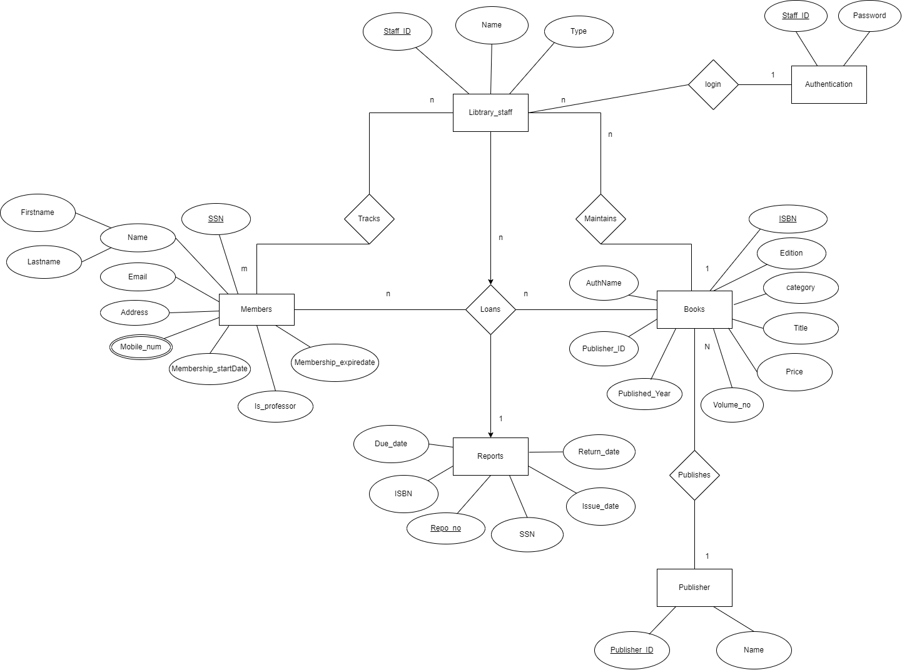

**Relationships between entities:**

1)1 member can reserve N number of books but one book can be reserved by only one member so the relationship is 1:N

2)A publisher may Publish multiple books, but a book is only released by one publisher. So the relationship is 1:N

3)Multiple staff members can log in using the authentication so the relationship is 1:N

4)The staff monitors readers. It is a M:N connection.

5)The staff keeps several reports so the relationship is 1:N

6)The staff maintains several books. So the relationship is 1:N

**Relational Diagram:**

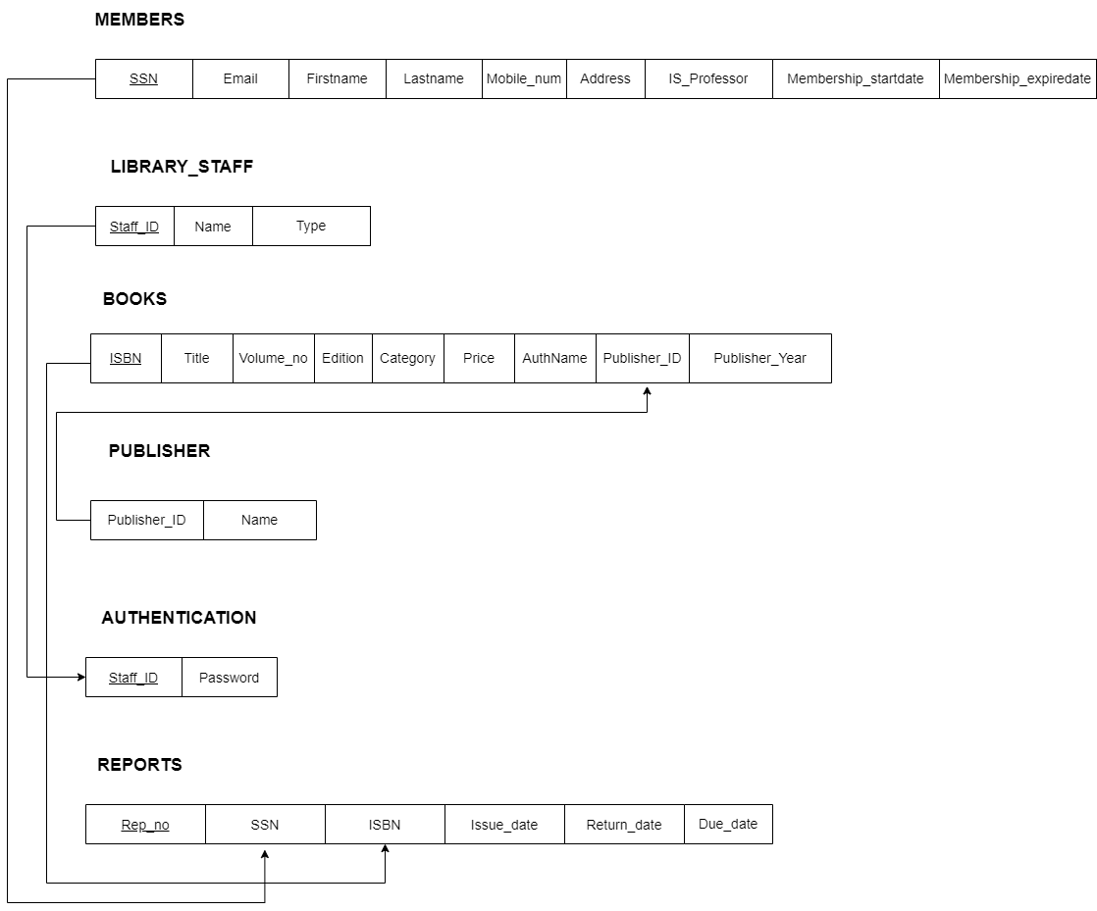

**RELATIONAL DIAGRAM KEY REFERENCES:**

1)Books have a foreign key references from Publisher because every book has an publisher to publish it so Books table have Publisher_ID as foreign key references from Publisher table

2)Authentication table has Staff_ID as foreign key reference from Staff Tables since we are using the staff_ID as login_ID for the Authentication

3)Reports tables have SSN and ISBN as foreign key reference from Members And Books because we maintain logs for every book transaction, So we use SSN from Members table and ISBN from Books table as foreign key for Reports Table.

**Table Creation Commands:**

create table Members(

SSN bigint NOT null primary key,

FirstName char(20),

Lastname char(20),

Email varchar(50),

Address varchar(100),

Mobile_num varchar(20),

Membership_startdate date,

Membership_expiredate date,

Is_professor varchar(3) check(Is_professor in ('Yes','No'))

) ;

create table Library_staff (

Staff_ID varchar(10) primary key,

Name varchar(30),

Type varchar(30)

);

create table Authentication (

Staff_ID varchar(10) primary key,

Password char(30),

FOREIGN KEY(Staff_ID) REFERENCES Library_staff (Staff_ID)

);

Create table Publisher (

Publisher_ID varchar(10) primary key,

Name varchar(50);

);

create table Books (

ISBN varchar(20) primary key,

Title Varchar(50),

Volume_No int,

Edition varchar(30),

Category varchar(20),

Price varchar(20),

AuthName varchar(20),

Publisher_ID varchar(10),

Published_year year,

foreign key(Publisher_ID) references Publisher(Publisher_ID)

);

create table REPORTS (

Rep_no int primary key,

SSN bigint NOT null,

ISBN varchar(20),

Issue_date varchar(30),

Return_date varchar(30),

Due_date varchar(30),

foreign key(SSN) references Members(SSN),

foreign key(ISBN) references Books(ISBN)

);