John Ahrens

Lucio Mondavi

Vignesh Venkataraman

Richie Tran

**Project 4: PEM Fuel Cell Analysis**

Team: Uno

ME 140

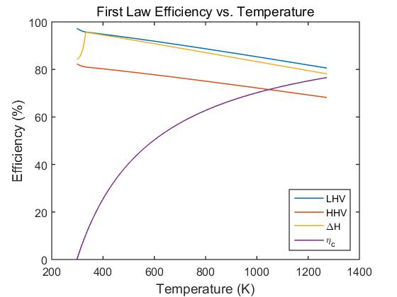

**Figure 1:** First law efficiency vs. Temperature

Maximum first-law efficiency was calculated using LHV, HHV, and actual deltaH. These three efficiencies were compared to the Carnot efficiency curve.

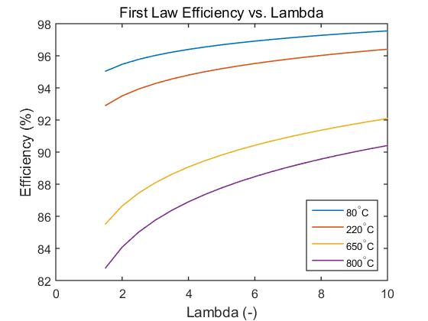

**Figure 2:** First law efficiency vs. Equivalence Ratio (Lambda)

Maximum first-law efficiency was calculated using LHV and a set pressure, while varying lambda. Efficiency was calculated using four different temperatures, representative of temperatures achieved in four different types of fuel cells.

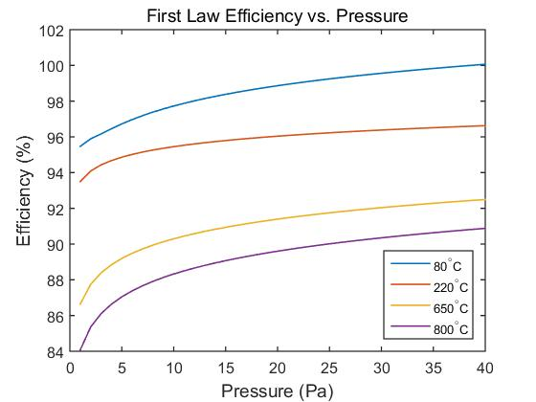

**Figure 3:** First law efficiency vs. Pressure

Maximum first-law efficiency was calculated using LHV and a set lambda, while varying pressure. Efficiency was calculated using four different temperatures, representative of temperatures achieved in four different types of fuel cells.

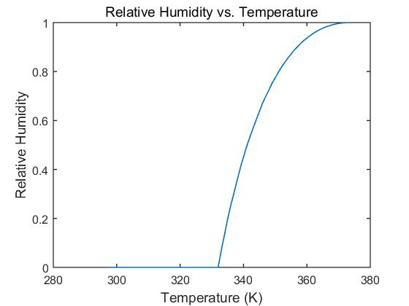

**Figure 4:** First law efficiency vs. Temperature

Relative humidity represents the amount of water vapor in the air divided by the maximum amount of water vapor the air can hold.

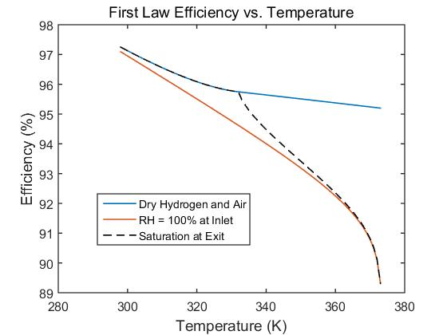

**Figure 5:** First law efficiency vs. Temperature

Maximum first-law efficiency was plotted against temperature using three different relative humidity conditions.

**Personal Reflections**

John Ahrens

1. Time Spent:

Part 1) 4

Part 2) 5

Part 3) 6

Part 4) 1

Total Time: 15 hours

1. Opinions:

This assignment illustrated how efficiency is calculated different for different thermal systems. In addition, I learned how first-law efficiency varies with multiple parameters. Along this vane, I have a much better grasp on the concept of saturated pressure and how different components within mixtures interact.

1. What’s still unclear:

I am still unclear on how second-law efficiency is different from first-law efficiency. Further, while I understand enthalpy’s relation to work and thus efficiency, I do not have a solid intuition for why gibbs can be used to calculated work.

Lucio Mondavi

1. Time Spent:

Part 1) 5

Part 2) 7

Part 3) 3

Part 4)

Total Time: 16 hours

1. Opinions:

Part one was useful in showing us how accurately the LHV approximates efficiency in relation to calculated delta H values.  Part two was useful in discovering how fuel cells behave in different operating conditions.  Part three helped us to understand saturation pressure and how humidity affects the fuel cell. Part four was generally easy, but the final plot tied together some of the concepts explored in other parts.  I don’t think there were any sections of the assignment that were redundant or not useful.

1. What’s still unclear:

We have found the thermodynamic behavior of fuel cells.  I would like to learn more about the actual functionality and operation of fuel cells.  Are there engineering limitations that reduce the actual efficiency of fuel cells?

Viggy Venkataraman

1. Time Spent:

Part 1) 4

Part 2) 5

Part 3) 6

Part 4) 1

Total Time: 15 hours

1. Opinions:

This assignment illustrated how efficiency is calculated different for different thermal systems. In addition, I learned how first-law efficiency varies with multiple parameters. Along this vane, I have a much better grasp on the concept of saturated pressure and how different components within mixtures interact.

1. What’s still unclear:

I am still unclear on how second-law efficiency is different from first-law efficiency. Further, while I understand enthalpy’s relation to work and thus efficiency, I do not have a solid intuition for why gibbs can be used to calculated work.

Ritchie Tran

1. Time Spent:

Part 1) 4

Part 2) 5

Part 3) 6

Part 4) 1

Total Time: 15 hours

1. Opinions:

This assignment illustrated how efficiency is calculated different for different thermal systems. In addition, I learned how first-law efficiency varies with multiple parameters. Along this vane, I have a much better grasp on the concept of saturated pressure and how different components within mixtures interact.

1. What’s still unclear:

I am still unclear on how second-law efficiency is different from first-law efficiency. Further, while I understand enthalpy’s relation to work and thus efficiency, I do not have a solid intuition for why gibbs can be used to calculated work.