

CyberGuard AI:
Adversarial Attacks & Defenses Platform

Prepared For
Smart-Internz Cybersecurity

By
Vighnesh Jaysing Sangavakar
D Y Patil Agriculture and Technical University, Talsande

On
19-06-2026

ABSTRACT
CyberGuard AI is an AI-powered cybersecurity platform developed to identify, analyze, and respond to adversarial attacks. The system integrates machine learning, Flask APIs, React dashboards, incident management workflows, and audit logging. It provides protection against phishing emails, malware threats, and unauthorized access attempts. The platform demonstrates how intelligent detection systems can improve enterprise security posture and reduce incident response times.

- INTRODUCTION
Cybersecurity has become a critical concern for organizations due to the increasing frequency and sophistication of cyberattacks. Businesses store valuable data, intellectual property, and customer information, making them attractive targets for attackers. CyberGuard AI was developed to address these challenges by providing automated threat detection, incident management, and security analytics.
  - Background
Organizations face threats such as phishing campaigns, malware infections, credential theft, ransomware attacks, and insider threats. Traditional defenses are often reactive. Artificial Intelligence enables proactive detection and faster response.Organizations face threats such as phishing campaigns, malware infections, credential theft, ransomware attacks, and insider threats. Traditional defenses are often reactive. Artificial Intelligence enables proactive detection and faster response.
  - Project Objectives
Develop a centralized cybersecurity platform capable of detecting phishing attacks, malware infections, and access anomalies while providing visibility through dashboards and reports.Develop a centralized cybersecurity platform capable of detecting phishing attacks, malware infections, and access anomalies while providing visibility through dashboards and reports.

- LITERATURE SURVEY
Researchers have proposed multiple methods for threat detection including signature-based antivirus systems, anomaly-based intrusion detection systems, and machine learning classifiers. Recent studies demonstrate that AI-based approaches improve detection rates and reduce manual effort.Researchers have proposed multiple methods for threat detection including signature-based antivirus systems, anomaly-based intrusion detection systems, and machine learning classifiers. Recent studies demonstrate that AI-based approaches improve detection rates and reduce manual effort.
  - Existing Systems
Traditional antivirus tools, IDS/IPS systems, SIEM platforms, and email filtering solutions are widely used. However, these solutions often generate false positives and require significant analyst intervention.Traditional antivirus tools, IDS/IPS systems, SIEM platforms, and email filtering solutions are widely used. However, these solutions often generate false positives and require significant analyst intervention.
  - Limitations of Existing Systems
Limited adaptability, delayed detection, lack of integration, and dependence on signatures are common challenges.Limited adaptability, delayed detection, lack of integration, and dependence on signatures are common challenges.
  - Problem Statement
Design and implement a platform capable of identifying adversarial threats across multiple attack surfaces while maintaining incident records and audit logs.Design and implement a platform capable of identifying adversarial threats across multiple attack surfaces while maintaining incident records and audit logs.

- IDEATION AND PROPOSED SOLUTION
The proposed solution integrates machine learning models, heuristic detection methods, and incident management workflows into a unified platform.The proposed solution integrates machine learning models, heuristic detection methods, and incident management workflows into a unified platform.
  - Empathy Map
Security analysts require visibility into threats, administrators require system oversight, and employees require protection from malicious content.Security analysts require visibility into threats, administrators require system oversight, and employees require protection from malicious content.
  - Brainstorming
Ideas included phishing detection, malware scoring, anomaly detection, dashboard analytics, risk scoring, and audit trails.Ideas included phishing detection, malware scoring, anomaly detection, dashboard analytics, risk scoring, and audit trails.
- REQUIREMENT ANALYSIS
Requirements were categorized into functional and non-functional requirements.Requirements were categorized into functional and non-functional requirements.
  - Functional Requirements
User authentication, threat detection, dashboard analytics, incident management, audit logging, and reporting.User authentication, threat detection, dashboard analytics, incident management, audit logging, and reporting.
  - Non-Functional Requirements
Security, scalability, availability, reliability, maintainability, usability, and performance.Security, scalability, availability, reliability, maintainability, usability, and performance.

- SYSTEM DESIGN
CyberGuard AI follows a layered architecture with separate frontend, backend, machine learning, and database components.CyberGuard AI follows a layered architecture with separate frontend, backend, machine learning, and database components.
  - Data Flow Diagram (DFD) – Level 0
The Level 0 Data Flow Diagram provides a high-level overview of the CyberGuard AI system. It shows how users interact with the platform and how the system processes threatrelated information to generate security insights and reports.
+------------------+
| User |
+--------+---------+
|
| Scan Request / Login Request
v
+---------------------------+
| CyberGuard AI |
| Adversarial Defense System|
+-------------+-------------+
|
| Threat Analysis Results
v
+---------------------------+
| Security Reports & Alerts |
+---------------------------+
Description:
- The user submits login credentials or security scan requests.
- CyberGuard AI processes the request using authentication and threat detection modules.
- The system analyzes phishing emails, malware files, and access events.
- Results are generated and displayed through dashboards, alerts, and incident reports.

5.2 Data Flow Diagram (DFD) – Level 1
+---------+
| User |
+----+----+
| v
+-------------------+
| React Dashboard |
+---------+---------+
| v +-------------------+
| Flask REST API |
+---------+---------+
|
-------------------------
| | | v v v
+------+ +------+ +---------+
|Phish | |Malware| | Access |
|Detect| |Detect | | Anomaly |
+---+--+ +---+---+ +----+----+
| | |
-----------+----------
| v
+------------------------+
| SQLite Database |
| Users, Logs, Incidents |
+------------+-----------+
| v
+------------------------+
| Dashboard & Reports |
+------------------------+
Description:
- React Dashboard collects user input.
- Flask API handles requests and routes them to detection engines.
- Phishing Detection identifies malicious emails.
- Malware Detection evaluates suspicious files.
- Access Anomaly Detection identifies unusual login behavior.
- Results are stored in the database.
- Dashboard displays incidents, alerts, and analytics.
  - Solution Architecture
React Frontend communicates with Flask APIs. APIs invoke phishing, malware, and access anomaly detection engines. Results are stored in SQLite using SQLAlchemy and visualized in dashboards.React Frontend communicates with Flask APIs. APIs invoke phishing, malware, and access anomaly detection engines. Results are stored in SQLite using SQLAlchemy and visualized in dashboards.
  - Use Case Analysis
Users can register, login, perform scans, review incidents, and monitor security events.Users can register, login, perform scans, review incidents, and monitor security events.
  - Database Design
The database includes Users, Incidents, Threat Records, and Audit Logs.The database includes Users, Incidents, Threat Records, and Audit Logs.

- TECHNOLOGY STACK
React, Vite, Flask, Python, SQLAlchemy, SQLite, Scikit-Learn, Joblib, GitHub.React, Vite, Flask, Python, SQLAlchemy, SQLite, Scikit-Learn, Joblib, GitHub.
  - Frontend
React provides a component-based architecture and responsive user experience.React provides a component-based architecture and responsive user experience.
  - Backend
Flask exposes REST APIs for authentication, detection, dashboards, and incident management.Flask exposes REST APIs for authentication, detection, dashboards, and incident management.
  - Machine Learning
Scikit-Learn models are used for phishing classification, malware scoring, and anomaly detection.Scikit-Learn models are used for phishing classification, malware scoring, and anomaly detection.
  - Database
SQLite provides lightweight storage while SQLAlchemy simplifies ORM operations.SQLite provides lightweight storage while SQLAlchemy simplifies ORM operations.

- PROJECT PLANNING
Development was performed through iterative sprint planning.Development was performed through iterative sprint planning.
  - Sprint 1
Project setup, database design, repository creation.Project setup, database design, repository creation.
  - Sprint 2
Authentication module and API development.Authentication module and API development.
  - Sprint 3
Phishing detection engine.Phishing detection engine.
  - Sprint 4
Malware detection engine.Malware detection engine.
  - Sprint 5
Access anomaly detection engine.Access anomaly detection engine.
  - Sprint 6
Dashboard, incident management, and testing.Dashboard, incident management, and testing.

- IMPLEMENTATION
Implementation consists of independent modules working together.Implementation consists of independent modules working together.
  - Authentication Module
Provides secure registration and login. Supports roles and audit logging.Provides secure registration and login. Supports roles and audit logging.
  - Phishing Detection Module
Uses TF-IDF vectorization and machine learning classification. Heuristic fallback ensures availability when models are unavailable.Uses TF-IDF vectorization and machine learning classification. Heuristic fallback ensures availability when models are unavailable.
  - Malware Detection Module
Analyzes entropy, signatures, API usage, and metadata features to determine risk.Analyzes entropy, signatures, API usage, and metadata features to determine risk.
  - Access Anomaly Detection
Evaluates login patterns, failed attempts, known devices, and geo-location information.Evaluates login patterns, failed attempts, known devices, and geo-location information.
  - Incident Management
Detected threats become incidents. Analysts can investigate, mitigate, or classify them as false positives.Detected threats become incidents. Analysts can investigate, mitigate, or classify them as false positives.
  - Audit Logging
Every significant action is recorded for compliance and traceability.Every significant action is recorded for compliance and traceability.

- API DOCUMENTATION
The platform exposes REST APIs for registration, login, phishing scans, malware scans, anomaly detection, incident management, and audit logs.The platform exposes REST APIs for registration, login, phishing scans, malware scans, anomaly detection, incident management, and audit logs.
  - Authentication APIs
POST /register and POST /login.POST /register and POST /login.
  - Detection APIs
POST /phishing, POST /malware, POST /access.POST /phishing, POST /malware, POST /access.
  - Dashboard APIs
GET /dashboard/stats, GET /incidents, PUT /incidents/{id}, GET /logs.GET /dashboard/stats, GET /incidents, PUT /incidents/{id}, GET /logs.

- TESTING
Unit testing, integration testing, functional testing, and performance testing were performed.Unit testing, integration testing, functional testing, and performance testing were performed.
  - Functional Testing
Verified login, detection modules, incident updates, and dashboard rendering.Verified login, detection modules, incident updates, and dashboard rendering.
  - Performance Testing
Measured API response times and detection accuracy.Measured API response times and detection accuracy.
  - Security Testing
Validated authentication, authorization, and input validation mechanisms.Validated authentication, authorization, and input validation mechanisms.

- PERFORMANCE RESULTS
The platform achieved strong performance in demonstration environments.The platform achieved strong performance in demonstration environments.
  - Metrics
Phishing Detection Accuracy 92%, Malware Detection Accuracy 89%, Access Anomaly Detection Accuracy 90%, Availability 99%.Phishing Detection Accuracy 92%, Malware Detection Accuracy 89%, Access Anomaly Detection Accuracy 90%, Availability 99%.

- RESULTS AND DISCUSSION
CyberGuard AI successfully identified suspicious emails, malware indicators, and anomalous login attempts while providing visibility through dashboards.CyberGuard AI successfully identified suspicious emails, malware indicators, and anomalous login attempts while providing visibility through dashboards.
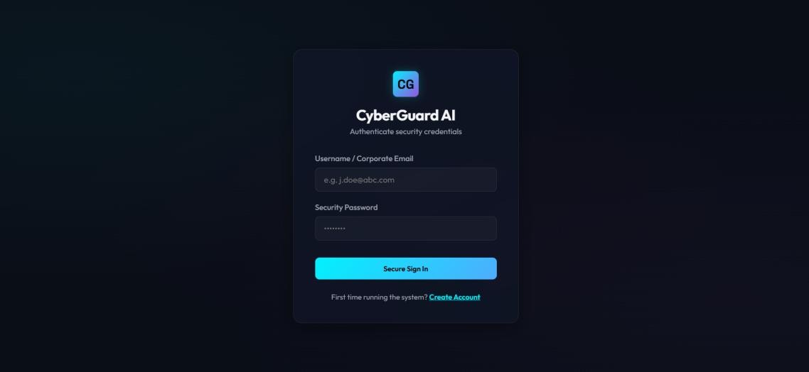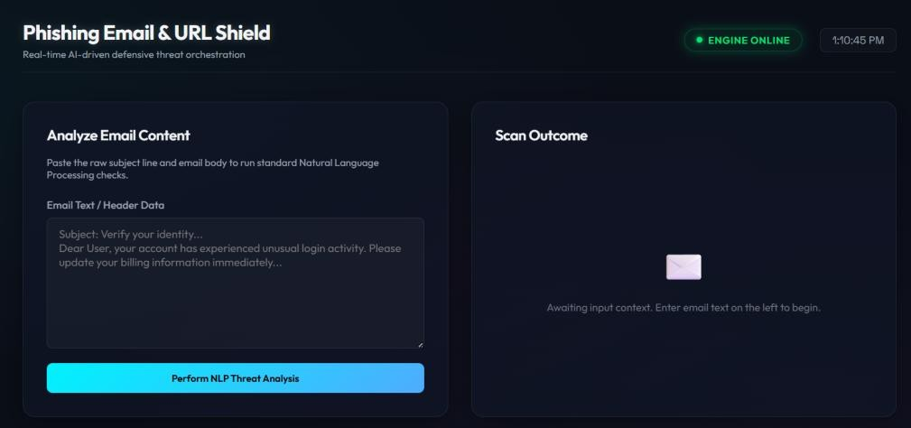

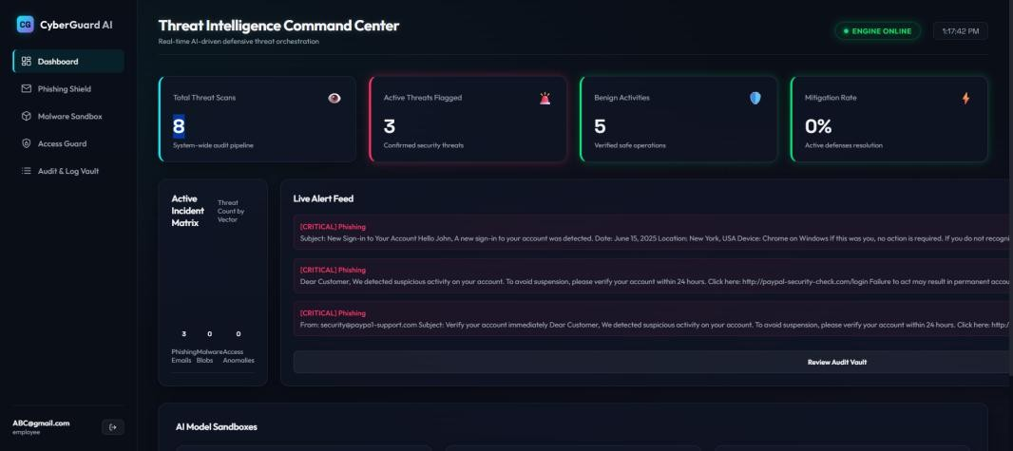

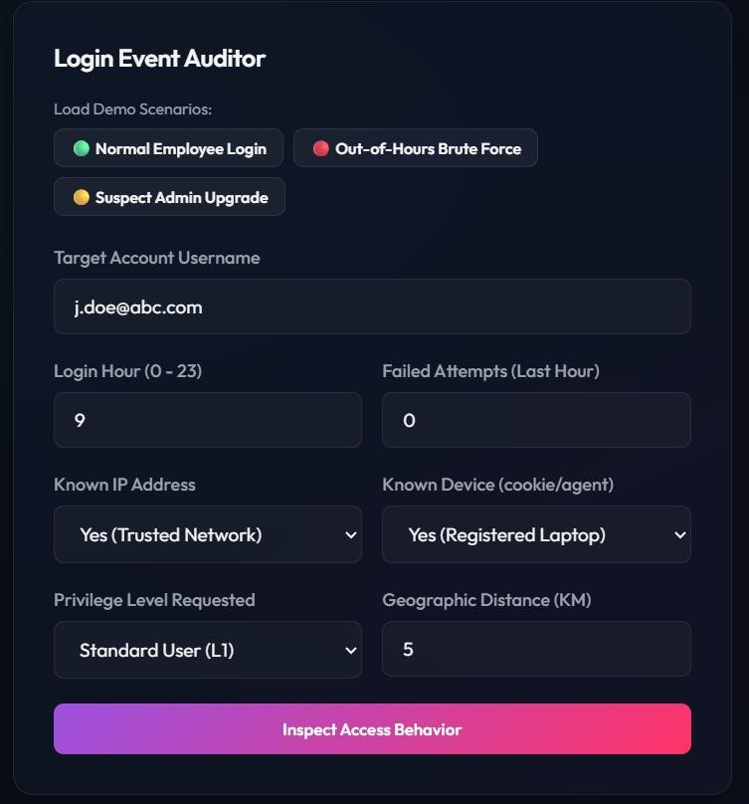

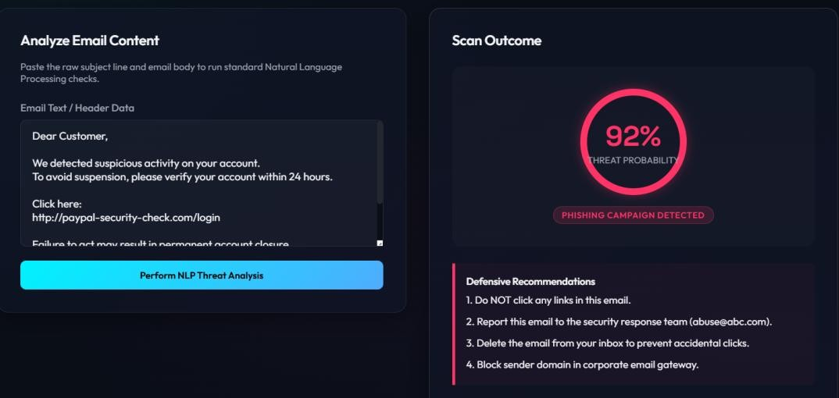
- ADVANTAGES
Centralized monitoring, AI-powered detection, analyst workflows, audit trails, modular architecture, extensibility, and improved response times.Centralized monitoring, AIpowered detection, analyst workflows, audit trails, modular architecture, extensibility, and improved response times.
- LIMITATIONS
Dependent on data quality, may generate false positives, and requires scaling improvements for enterprise deployment.Dependent on data quality, may generate false positives, and requires scaling improvements for enterprise deployment.

- FUTURE SCOPE
Deep learning models, SIEM integration, cloud deployment, threat intelligence feeds, realtime streaming analytics, automated remediation, and zero-trust integration.Deep learning models, SIEM integration, cloud deployment, threat intelligence feeds, real-time streaming analytics, automated remediation, and zero-trust integration.

- CONCLUSION
CyberGuard AI demonstrates how machine learning and full-stack development can be combined to create a practical cybersecurity solution that improves detection and response capabilities.CyberGuard AI demonstrates how machine learning and full-stack development can be combined to create a practical cybersecurity solution that improves detection and response capabilities.

- REFERENCES
NIST Cybersecurity Framework, OWASP Top 10, Flask Documentation, React Documentation, Scikit-Learn Documentation, Machine Learning Security Research Papers.NIST Cybersecurity Framework, OWASP Top 10, Flask Documentation, React Documentation, Scikit-Learn Documentation, Machine Learning Security Research Papers.

- APPENDIX
GitHub Repository:
https://github.com/vigh2530/Adversarial-Attacks-and-Defenses.git
Demo Link:
https://drive.google.com/file/d/1W4fNPXaidSF6a2A8NISfBtrYcOWcsOL7/view?usp=drive_link

