Deep Learning Fundus Image Analysis for Early Detection of Diabetic Retinopathy
Using Transfer Learning (Xception) with Flask Web Application and IBM Cloudant Integration
Sr. No. | Section Title
1 | Introduction
2 | Problem Statement
3 | Proposed Solution
4 | System Architecture
5 | Prediction Flow
6 | Technology Stack
7 | Model Architecture (Xception)
8 | MongoDB Database
9 | How to Run the Application
10 | Output & Results
11 | Conclusion
12 | Future Enhancements

1. Introduction & Objective
Diabetic Retinopathy (DR) is a severe complication of diabetes that damages the retina and may lead to blindness if not detected early.
This project develops a Deep Learning-based web application that detects and classifies DR severity using fundus retinal images.
The system uses Transfer Learning with Xception architecture and provides predictions through a Flask web interface.
Objectives:
• Develop an automated DR detection system
• Classify retinal images into five severity levels
• Implement transfer learning using Xception
• Build a secure Flask web application
• Integrate IBM Cloudant NoSQL database

2. Technology Stack & Dependencies
Programming Language: Python
Deep Learning Framework: TensorFlow, Keras
Model Architecture: Xception (Pre-trained on ImageNet)
Web Framework: Flask
Frontend: HTML, CSS
Database: IBM Cloudant NoSQL
Key Libraries:
tensorflow, keras, flask, numpy, pandas, matplotlib, cloudant, werkzeug

3. System Architecture & Workflow
System Architecture:
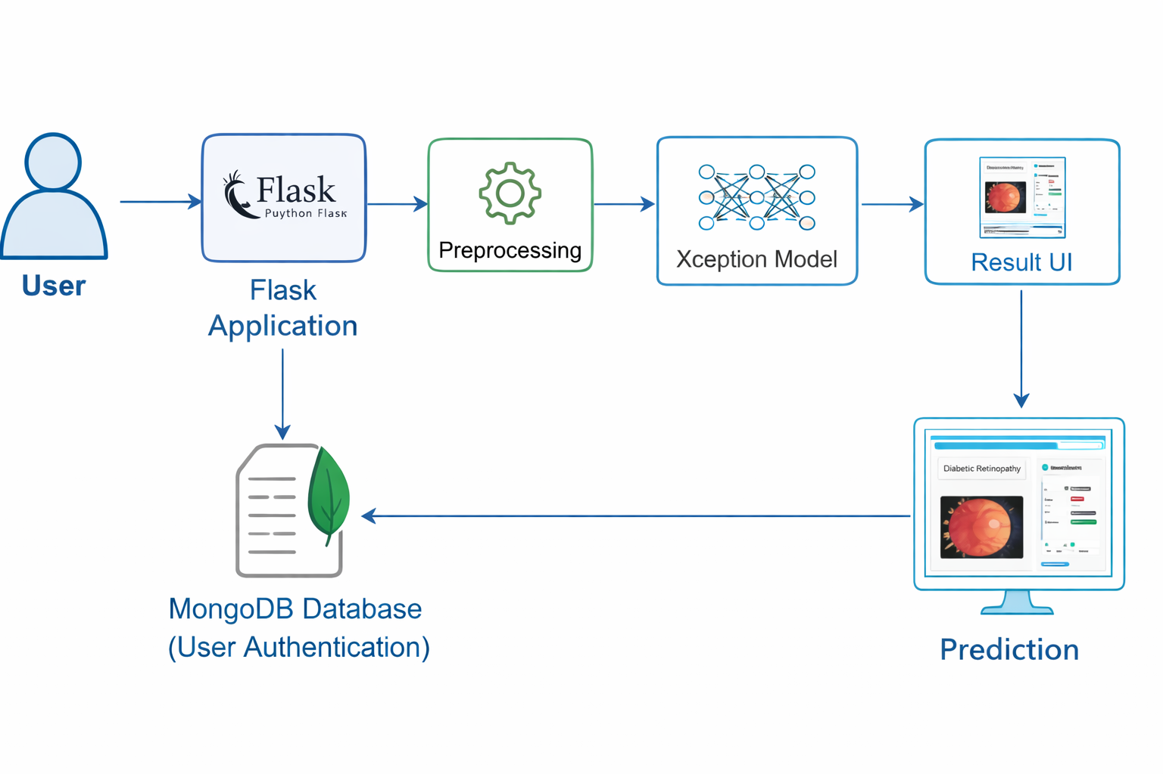
Workflow:
1. User logs in.
2. User uploads retinal image.
3. Image is resized to 229x229 and preprocessed.
4. Model predicts probability scores.
5. Highest probability class is selected.
6. Result with confidence score is displayed.

4. Data Collection & Preprocessing
Dataset Source: Kaggle
Classes:
0 – No DR
1 – Mild
2 – Moderate
3 – Severe
4 – Proliferative DR
Preprocessing Steps:
• Resize images to 229x229
• Apply Xception preprocess_input normalization
• Use ImageDataGenerator for augmentation

5. Model Architecture
Input Layer: (229x229x3)
Xception Base Model (Frozen Layers)
Flatten Layer
Dense Layer (256, ReLU)
Output Layer (5 Classes, Softmax)
Loss Function: Categorical Crossentropy
Optimizer: Adam
Epochs: 30

6. Model Training Process
Transfer learning approach is used.
Base Xception layers are frozen.
Custom dense layers are trained on retinal dataset.
Model is trained for 30 epochs.
Best model saved as Updated-Xception-diabetic-retinopathy.h5

7. Flask Web Application
Features:
• User Registration and Login
• Secure Session Handling
• Image Upload
• Image Preprocessing
• Model Prediction
• Confidence Score Display
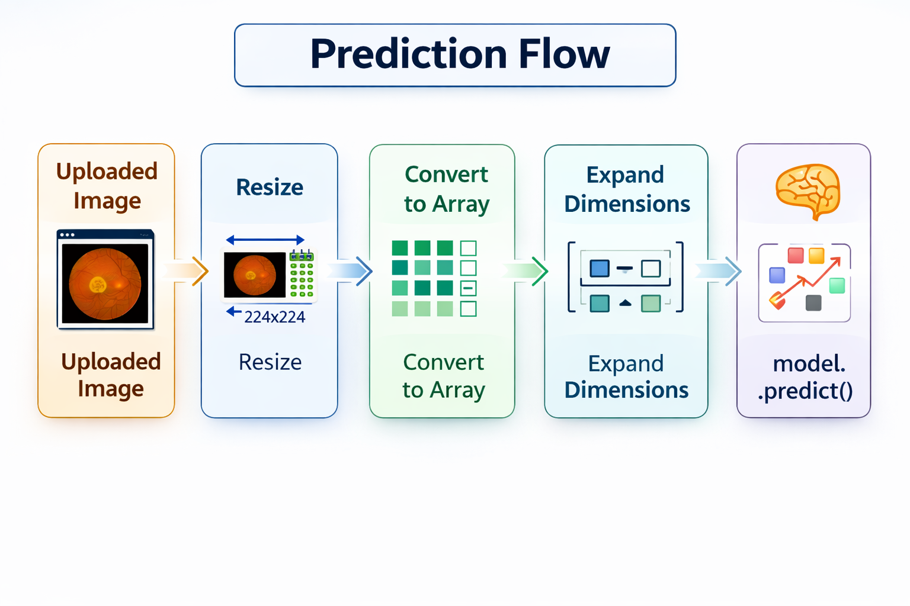

8. MongoDB Database

MongoDB is a NoSQL database used for storing application data in JSON-like documents.

In this project, MongoDB is used to:

Store user registration details

Validate login credentials during authentication

Manage user session-related data

MongoDB provides fast, scalable, and flexible data storage, making it suitable for web applications integrated with Flask.

9. How to Run the Application

Step 1: Install Dependencies

pip install -r requirements.txt

Step 2: Place the trained model file

Place the trained .h5 model inside the project directory (or specified model folder).

Step 3: Start MongoDB Server

Ensure MongoDB service is running:

net start MongoDB

Step 4: Run Flask Application

python app.py

Step 5: Open in Browser

http://127.0.0.1:5000

10. Output & Results

The system classifies retinal fundus images into the following categories:

No DR

Mild

Moderate

Severe

Proliferative DR

The application displays:

Uploaded retinal image

Predicted disease stage

Confidence score percentage

11. Conclusion & Future Enhancements

Conclusion

This project demonstrates the effectiveness of Transfer Learning using the Xception Convolutional Neural Network for automated Diabetic Retinopathy detection.

Integration of Deep Learning with Flask and MongoDB enables a scalable, efficient, and user-friendly diagnostic support system.

Future Enhancements

Implement Grad-CAM visualization for model explainability

Use EfficientNet or Vision Transformers for improved accuracy

Deploy the application on cloud platforms (AWS, Azure, Render)

Implement secure password hashing and encryption

Develop a mobile-friendly or Android application version

Format this properly for README.md

Convert this into a project report section

Prepare viva explanation points

Create PPT content for presentation

Tell me what you need next.

