Source code available at -

<https://github.com/vighambe/Assignment.git>

Technical details –

Restful service – Web API

Framework – Asp net core 2.0

Visual Studio – 2017 community edition

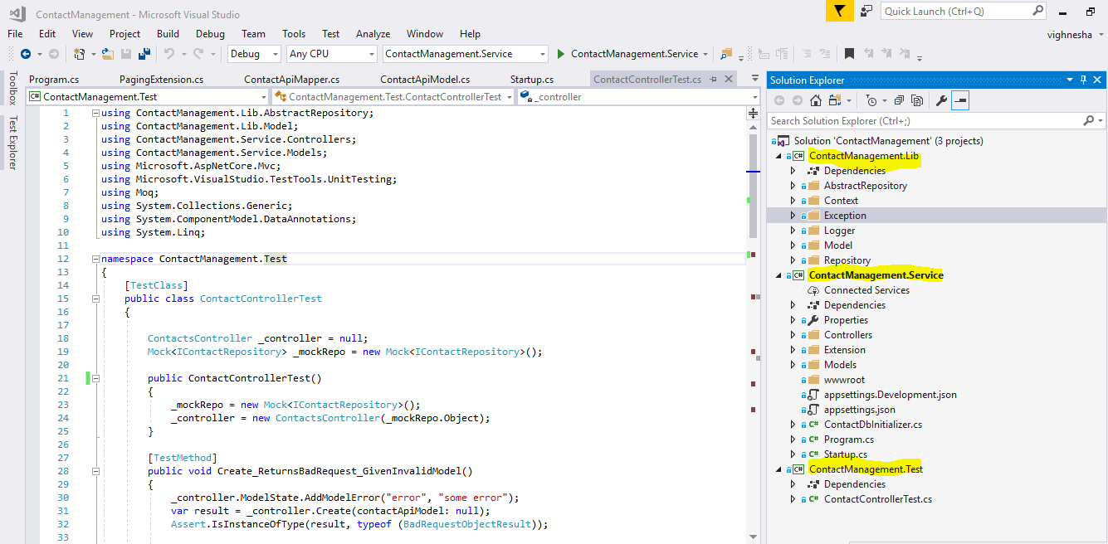

1. Open the solution file ContactManagement.sln in visual studio
2. After all Nuget package restore Rebuild the solution
3. Make sure that the project “ContactManagement.Service” set as startup project
4. After executing ContactManagement.Service project the Service is hosted

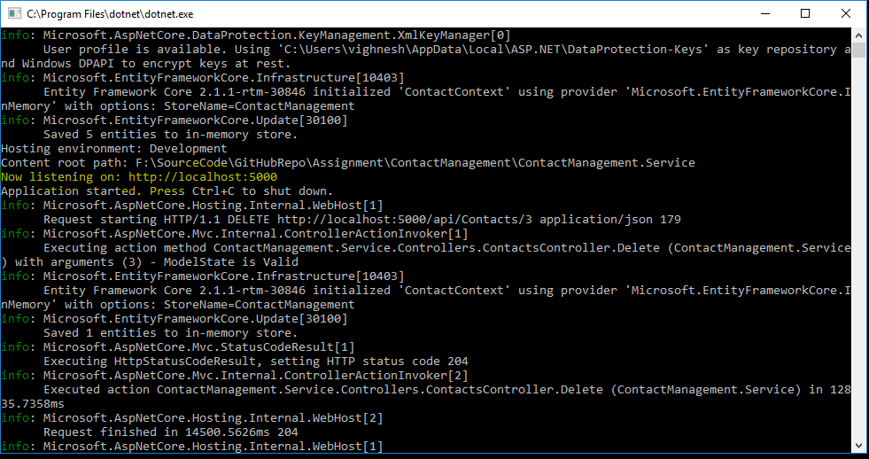

Test the apis by using Postman, postman collection is available at –

<https://github.com/vighambe/Assignment/tree/master/Testing>

