**X-ray_image_based_Pneumonia_predictor**

The following model detects Pneumonia in patients using the X-ray image of their chest. The algorithm chosen is Convolution Neural Network(CNN). With many X-ray images of both Pneumonia and Non-Pneumonia patients as dataset, the CNN model is trained to learn the features of the input X-ray images that determine existence of pneumonia in patient and prefer to increase the true positive of the classification model.

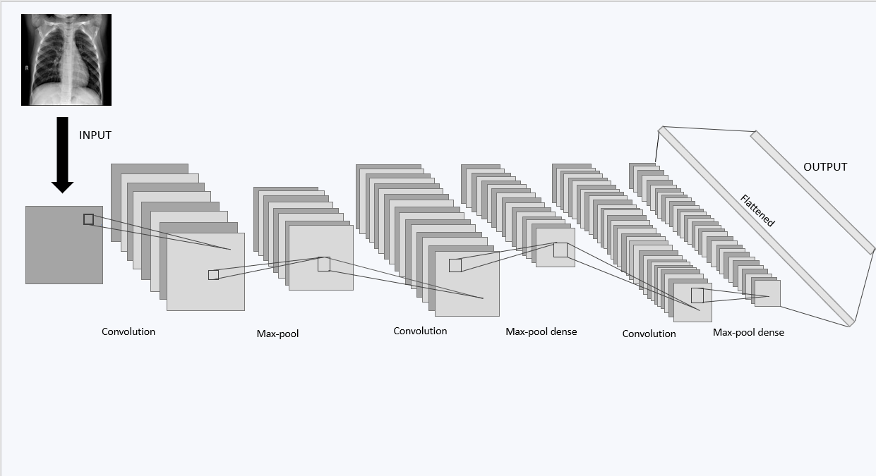

Reference to the Directory Structure:

project

Test3

NORMAL

NORMAL2-IM-0381-0001.jpeg

.

.

IM-0001-0001.jpeg

PNEUMONIA

person1685_virus_2903.jpeg

.

.

person1_virus_6.jpeg

Train3

NORMAL

NORMAL2-IM-1423-0001.jpeg

.

.

IM-0115-0001.jpeg

PNEUMONIA

person1945_bacteria_4872.jpeg

.

.

person1_bacteria_1.jpeg

c_m

NORMAL

NORMAL2-IM-0381-0001.jpeg

.

.

IM-0001-0001.jpeg

PNEUMONIA

person1685_virus_2903.jpeg

.

.

person1_virus_6.jpeg

NOTE:

* The folder c_m consists of similar dataset as the Test3 folder which are used for plotting of confusion matrix.
* The program contains pointer to the dataset directory. The following are the reference to set up the path.

Importing the dataset:

train_data_dir = "C:\\...\\Project\\Train3"

test_data_dir = "C:\\...\\Project\\Test3"

Loading the model for prediction of presence of pneumonia in patients and plotting confusion matrix:

loaded_model=load_model('model.h5')

p1="C:\\...\\Project\\c_m\\NORMAL\\"

loaded_model=load_model('model.h5')

p1="C:\\...\\Project\\c_m\\PNEUMONIA\\"

Performance of the model:

After running for 10 epochs ,the following performance of the model is obtained.

The accuracy of the model is 91.5%

The loss obtained in the model is 0.24

Confusion matrix obtained is [[189 45]

[ 20 370]]